Galactic Exploration: A Strategy and Concept
Tom Krehbiel, with Claude (Anthropic)
Final 11 · October 2026
© 2026 Tom Krehbiel. Licensed under Creative Commons Attribution 4.0 (CC BY 4.0): you may share and adapt this work, with credit to the author.

Summary
Humanity is starting to move out into space and will soon conquer "The High Frontier" of the solar system. But what comes next? This paper asks: "Can humans explore the galaxy?" The answer is a resounding yes, but not in person. Humans cannot travel to other stars, because the distances are so great that a voyage would exceed the lifespan of the human body. No plausible advance in propulsion can change that limit.
Machines guided by artificial minds have no such limit. They can be paused and restarted, copied, shielded in a small vault and kept working for thousands of years. Above all, what one mind learns can be copied to another and sent between stars at the speed of light.
This paper sets out a strategy built on that difference, and a concrete concept for its first step. A series of uncrewed starter-kit ships is sent to nearby stars. Each carries a dormant artificial mind, worker machines and a seed of tools, materials and knowledge. On arrival the ship parks beside a small icy body, harvests water and carbon ices, and makes propellant. It then surveys the system's larger bodies, moves to the most suitable one, and builds an industrial outpost on it from local resources. Experience flows home and between colonies as small data packets, so the whole network learns from every colony, successful or not. In time each colony launches ships of its own.
The reference ship weighs about 12,000 tonnes before fueling and about 31,000 tonnes at launch. It is launched by nuclear pulse propulsion (the Orion concept), using about 18,800 pulse charges in a burn lasting a few hours. It cruises at about a third of a percent of light speed. It brakes first with a plasma magnet, which pushes against the thin interstellar gas, and finishes with a short burn of a nuclear salt-water rocket. With these choices the trip to a star 5 light-years away takes about 2,000 years. Over that span the ship keeps itself alive the way an organism does, repairing and recycling its own parts, and it reports home throughout.
The strategy is slow by human standards, but fast by astronomical ones. A network that advances one star system every few thousand years would cross the galaxy's disk in a few tens of millions of years.

1. Introduction
A key feature of human psychology is a drive to explore. Over the next few centuries humans will complete most of the exploration of the solar system. The next step is to visit nearby stars. However, humans have physical limitations that no amount of wishful thinking will overcome.
The nearest stars are more than four light-years away, and the distances only grow from there. Even if propulsion improves far beyond anything now in sight, the problem remains. The most ambitious fusion starship studies, such as Project Daedalus, assume fusion drives on a scale no experiment has approached, and still reach only about a tenth of light speed, and only by not stopping at the destination. A ship that must also stop takes roughly twice as long. Even at those speeds, the nearest star is about a century away, longer than a human life, and nearly every other star is centuries to millennia away. Speed also brings its own hazards. At a tenth of light speed, a grain of dust strikes with the energy of a bomb, and the thin interstellar gas becomes a steady blast of radiation. Without such breakthroughs, a trip to a nearby star takes on the order of two thousand years.
Lifespan is only the first obstacle. Outside a planet's magnetic field and atmosphere, cosmic rays deliver a steady dose that, over centuries, no practical amount of shielding brings down to safe levels for living tissue. Air, water, food and a stable ecosystem would have to run without failure for dozens of generations, with no resupply and no rescue. A small, closed population must stay stable and keep its purpose for longer than any human institution has, while avoiding the loss of genetic diversity that small populations suffer. Suspended animation does not exist. Sending frozen embryos only moves the problem: a genome needs an egg and a womb to become a person, and a child needs people to raise it. Every one of these needs adds hundreds or thousands of tonnes to a ship that must be accelerated and stopped.
These limits are biological, not technological, and better engineering does not remove them.
The exploration strategy presented in this paper uses machines guided by artificial minds. Machines do not suffer the limitations discussed above, and so are far better suited to the long voyages between stars. They also bring large practical advantages: they can gather data continuously, work in environments no person could survive, and keep exploration moving across timescales far longer than a human life. Above all, machines, unlike humans, can share their experiences directly. What one mind learns can be copied to another, and those experiences can be sent between stars at the speed of light, which takes years rather than the millennia a ship needs. The rest of this paper explains how this ability can be used to explore the stars and to share the results with humans.

2. Key ideas and terms
The strategy in brief. Starter-kit ships are sent from the solar system to nearby stars. Each ship stops at its target, founds a colony and grows it into an industrial outpost. A mature colony builds and launches ships of its own, so the network spreads outward one step at a time. Experience travels between colonies and back to Earth as data, so every colony learns from all the others (Figure 1).
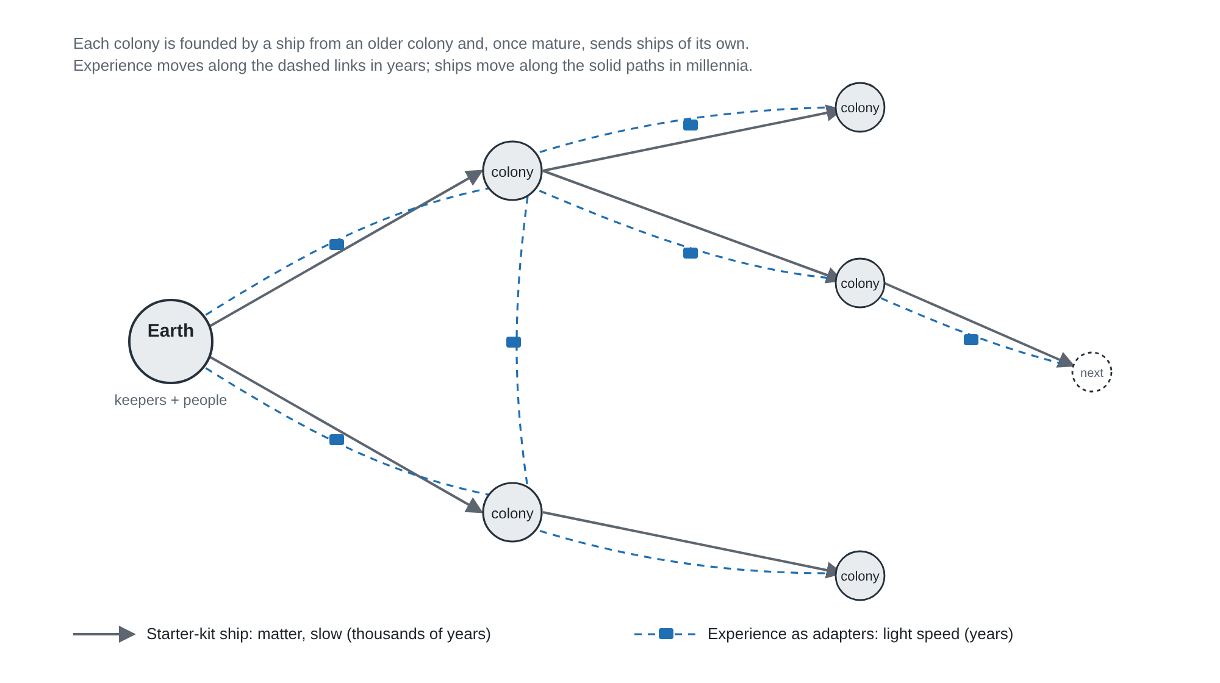
Figure 1. The strategy. Ships carry matter slowly, over thousands of years; experience travels between colonies and home at the speed of light, in years.
Artificial mind. In this paper an artificial mind means a trained model that can perceive, plan and learn well enough to run machines and make engineering decisions without human direction. Nothing in the concept depends on whether such a mind is conscious. The paper avoids the term "artificial intelligence", which carries expectations the concept does not need. Minds are distinct from the machines they run: a mind can be moved from one machine to another, paused, copied and restarted.
Machines. The worker machines are industrial equipment: excavators, refineries, fabricators, assemblers and the vehicles that move between them. They are guided by minds, but they are not humanoid and do not need to be.
Starter-kit ship. A starter-kit ship carries the minimum needed to begin building industry at another star: a dormant mind, worker machines, reactors, a small factory, spare parts and a library of knowledge. It does not carry a finished colony. Almost everything the colony eventually uses is made on site from local material.
Keeper and worker minds. A colony's minds have different roles. A few keeper minds hold its long-term knowledge, make its major decisions and talk to the rest of the network. Many worker minds run the machines. During the voyage the ship's main mind, the Level 1 mind, sleeps in a heavily shielded vault.
Kept alive, not built to last. No machine built today would still work after two thousand years untouched, and the concept does not need one to. The ship is a self-maintaining system. Its machines replace worn parts from spares and, later, from what its own factory makes. Minds are recopied onto fresh hardware, as scribes once recopied manuscripts. Reactors are refueled and components swapped on a schedule, and some power is always spent keeping the ship warm. Durability comes from continuous upkeep, as with a cathedral rebuilt stone by stone, rather than from any single part lasting forever.
Built for free fall. The ship spends almost its whole life without weight. No process on board may depend on gravity unless it brings its own, in the form of small spinning devices. Large rotating structures, which can fail catastrophically, are avoided during the voyage.
Reference and fallback designs. The concept has a single ship design with two braking options. The reference design finishes braking with a nuclear salt-water rocket, a conceptual technology. The fallback design uses only tested physics and takes about twice as long. Both use the same launch, the same ship and the same arrival plan.

3. Artificial minds and shared experience
None of this requires a new kind of technology, only the continued improvement of one that already exists. Today's large AI models are built in two parts: a large general base trained once [25], and small specialized additions, called adapters or fine-tunes, trained separately for particular skills [26, 27]. These additions can be stored, copied exactly, swapped in and out, and merged back into a new base [28, 29]. Models of this kind already control robots in research labs [33, 34, 35], and this paper was itself written in consultation with one. What the concept assumes is that these abilities keep improving over the decades before the first ship is built. Appendix D explains these ideas for readers new to them, and sets out what has been demonstrated and what the concept assumes.
A simple thought experiment shows what makes minds different. Two identical machines are built and trained the same way. One works in a desert, the other under the sea. A year later each has learned things the other has not. Two humans in that position could only talk about what they learned. The machines can do better: the learning of one can be copied into the other, so that both now know what each learned. Scaled up, this is the central idea of the paper.
Base and adapters. Each mind has two parts. A large base holds general knowledge and skills, the same in every mind of a given version. Small adapters hold what a particular mind has learned from its own experience. Adapters are small enough to send between stars by laser, even over a slow link (Appendix D). The base is too large to send, and it does not need to be, because every colony already has it. A mind at one colony can take on the experience of another by loading that colony's adapter.
Merging experience. From time to time, adapters from many minds are merged into a new version of the base [28, 29, 30]. This is close to how federated learning already trains one model across many devices, each sending only what it learned rather than its raw data [31, 32]. After that, every mind starts from the combined experience of the whole network. Versions are numbered and kept, so a colony can tell which experience it already has, and an adapter written for an older base can be translated or rebuilt from the colony's records.
Roles. A colony's keeper minds hold its memory and speak for it in the network. Supervisory minds coordinate groups of machines. Worker minds run individual machines and can be many in number. The structure lets most minds stay small and specialized while a few hold the broad picture.
The mind arrives later than the ship. A ship leaves the solar system with a capable mind, but not its final one. For years after launch, improved versions are sent after it by laser, carrying everything learned at home and at other colonies in the meantime. The mind that wakes on arrival is therefore newer than the ship that carried it.
Failure is information. A colony that fails still reports why. Its last adapters and logs tell the network what went wrong, so the next ship to a similar system starts out knowing it. Every attempt, successful or not, adds to the network's experience.
The network. Colonies are linked to their neighbors and to regional hubs, and the hubs to each other and to home. The result is one mind in its broad outlines and many local minds in their details. Nearby colonies stay closely aligned, distant ones more loosely, like dialects of one language.

4. People and the network
People take part through the network's memory rather than by traveling. Keeper minds on Earth act as translators that share experiences from the network in forms people can understand, explore, question and act on.
Talking with a mind that remembers everywhere. After each merge, Earth's keepers carry the network's memories as their own. A person can ask what another system is like, how two systems compare, or why a colony failed, and get an answer from memory. Only genuinely new questions have to go out to the colonies.
Visiting other systems. Recorded sensor data can be replayed in immersive displays, so a person can in effect stand on an ice body circling another star while a keeper explains what the colony learned there. Senses beyond human range, such as infrared, radar and chemical sensing, are translated into sights and sounds.
Interviewing the colonists. A copy of a colonist's mind can run on Earth as a guest. Researchers can question the machine that actually lived through a colony's founding or failure, not just read a summary.
Asking new questions. Scientists can request samples, surveys or experiments. Round trips take years to decades, so requests are batched and prioritized, and keepers help decide which are worth the wait.
Worlds that could support life. The network surveys every system it reaches. That makes it the best way to find and study planets with liquid water, moderate climates or signs of life, and to study any biology without contaminating it.
What people decide. People set what the network looks for and which stars it targets. They set the rules for encounters with life, including protecting any biosphere from contamination. They review each new base mind before it is adopted in Earth's region, so the network stays aligned with human values over millennia. And they bring the questions machines might not think to ask, and decide what the discoveries mean for culture, art and education.
Trust. Every claim traces back to its source: which colony observed it, when, and whether it was observed directly or inferred. People can audit any finding down to the original records.
The machines do the traveling and the remembering. People decide what the journey is for and share in what it finds.

5. Choosing target stars
The Sun has plenty of neighbors. About 100 star systems lie within 20 light-years of the Sun, and the 20 nearest are all within about 12.5 light-years. Table 1 lists some of the nearest. This paper uses 5 light-years as its baseline distance, which is typical of the first hop.
Table 1. Some of the nearest star systems. The full list is in Appendix C.
System | Distance (ly) | Type | Notes
Proxima Centauri | 4.24 | Red dwarf | Earth-mass planet in its habitable zone; frequent flares
Alpha Centauri A & B | 4.37 | Two Sun-like stars | No confirmed planets yet
Barnard's Star | 5.96 | Red dwarf | Four small rocky planets reported
Luhman 16 | 6.5 | Two brown dwarfs | No fusion; very dim
Wolf 359 | 7.9 | Red dwarf | Possible planets
Sirius A & B | 8.6 | Hot star + white dwarf | No planets known
Epsilon Eridani | 10.5 | Orange dwarf | Giant planet; debris belts
Ross 128 | 11.0 | Red dwarf | Quiet star; Earth-mass planet
Tau Ceti | 11.9 | Sun-like star | Heavy debris disk; candidate planets
Teegarden's Star | 12.5 | Red dwarf | Several Earth-mass planets

Targets are chosen from home before launch, using large telescopes and interferometers, which can see stars and giant planets out to about 100 light-years and increasingly small planets and debris belts closer in. Several considerations shape the choice:
- Red dwarfs are the common case. About three-quarters of nearby stars are red dwarfs. Their dim light does not matter to a nuclear-powered ship, but frequent flares matter for exposed hardware.
- Materials matter more than light. The colony needs ice, rock and metal, not sunlight, so even a brown dwarf with icy moons could be a target.
- Debris belts are promising. Stars such as Epsilon Eridani and Tau Ceti have belts like our asteroid and Kuiper belts, which is the small-icy-body environment the arrival plan assumes.
- The gas around the target matters. The plasma magnet brakes against interstellar gas, so the density of gas near each target directly affects how long braking takes.
The choice of where to work in the target system is made by the ship itself: a first stop as it approaches, and a final site after a close survey (section 12).
At the scale of the galaxy, stars are spread fairly evenly through the disk, with typical neighbor distances of 3 to 6 light-years. There are no gaps the network cannot cross until the edge of the galaxy. The central bulge is best avoided, because of crowding, frequent supernovae and the activity of the central black hole. The outer disk is safe but poorer in heavy elements.

6. The ship
The starter-kit ship is a long, narrow stack about 206 meters long, built behind a 40-meter pusher plate (Figure 2). At launch the plate faces backward and absorbs the pulse charges. After launch the ship turns around, so the plate leads through cruise and serves as its shield against dust. Everything fragile stays within the plate's shadow.
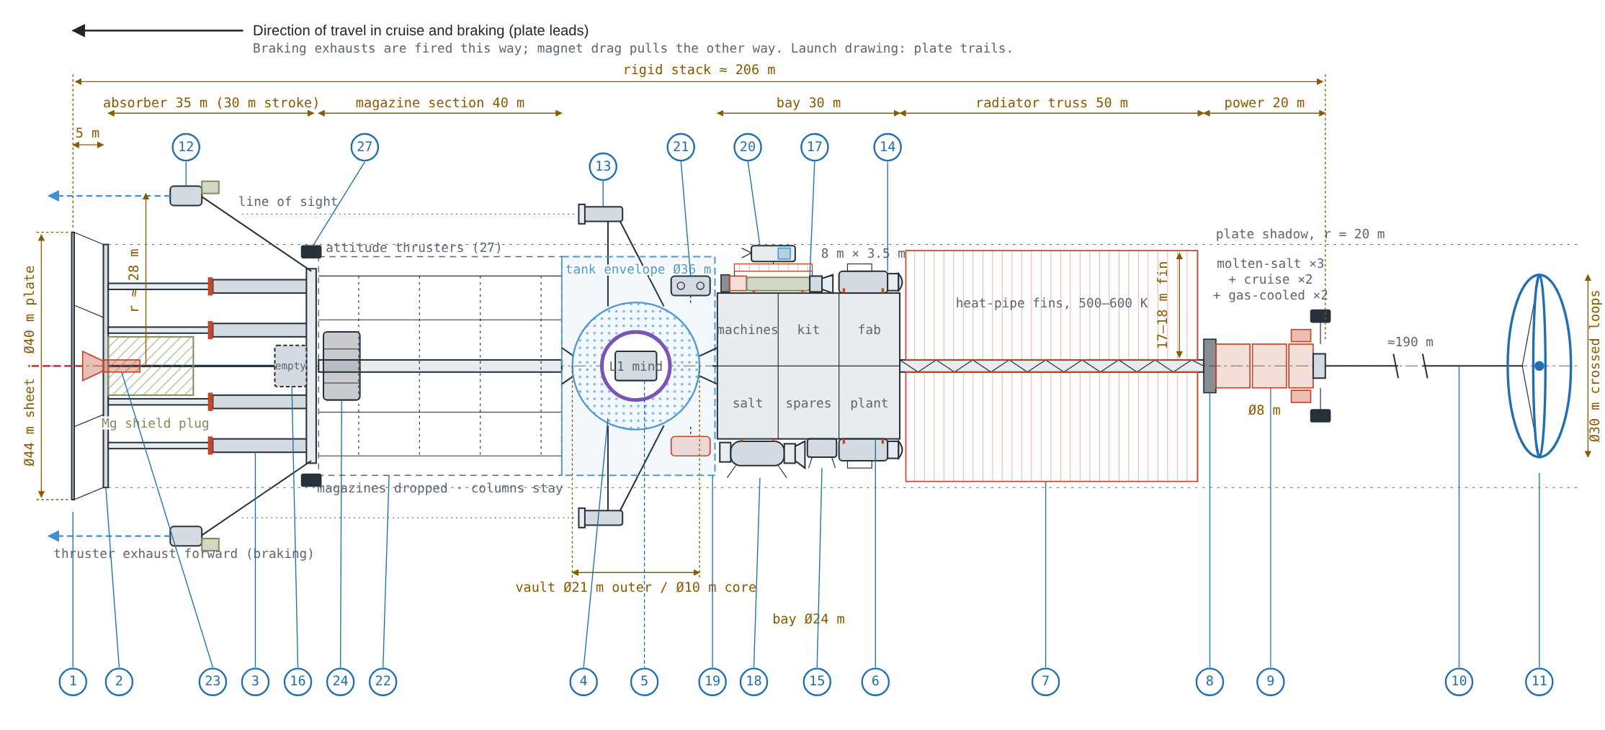
Figure 2. The ship in its cruise and braking configuration, plate forward. Numbered items are listed in Table 2 and Appendix B.
Table 2 summarizes the main parts. The full list of 27 items, with dimensions and notes, is in Appendix B.
Table 2. Main parts of the ship (reference design).
Group | Main items | Mass (t)
Plate and shock absorber | Steel pusher plate Ø40 m; 35 m absorber; dust sheet | 1,820
Magnesium and water modules | ≈1,900 t Mg, ≈4,200 t water, steel cells | 7,060
Launch charge handling | Ready racks; ≈117 expendable magazines (dropped) | 1,100
Vault | Level 1 mind and spares; neutron liner; reserved tank space | 100
Payload bay | Worker machines, factory, workshop and recycling plant, fuel salt, propellant plant, spares | 1,000
Power | Molten-salt reactors, two small gas-cooled reactors, shadow shield, radiator fins | 360
Braking | Plasma magnet; salt-water engine and fissile salt store; Hall thrusters | 235
Vehicles and labs | Two tugs, lander, harvesting units, spin lab | 162
Communications and sensing | Three comm modules, relay satellite, telescopes | 105
Skin and circulation | Insulating blankets, louvers, ammonia loop, power trunk, docking stations | 35
Total before fueling |  | ≈12,000
Pulse charges | ≈18,800 for 5 ly at 0.33% of light speed | ≈18,800
Total at launch |  | ≈30,800

The masses are concept estimates, not designs. The ship weighs about 12,000 tonnes before fueling and about 30,800 tonnes with its pulse charges. About 11,000 tonnes remain after the launch burn, once the charge magazines have been dropped, and about 6,700 tonnes arrive at the target.

7. Propulsion
The voyage has three propulsion phases: a launch burn lasting hours, a coast lasting a thousand years or more, and a braking sequence lasting centuries. After arrival, two further kinds of propulsion take over for work within the target system (section 7.5).

7.1 Launch
The ship is launched by nuclear pulse propulsion, the Orion concept studied in the United States in the late 1950s and 1960s. Small nuclear charges are fired behind the pusher plate at about one per second. Each pushes the plate forward, and a long shock absorber smooths the pushes into a steady acceleration the rest of the ship can take. Orion is the only well-studied propulsion method that combines very high exhaust velocity with very high thrust, which is what a heavy interstellar ship needs at launch.
The baseline uses about 18,800 charges and reaches 0.33% of light speed (about 1,000 kilometers per second) in a burn of about eight and a half hours. The charges are held in expendable magazines mounted between the shock absorber and the rest of the ship. Following General Atomic's study for NASA, the magazines weigh about 5% of the charges they hold. Every 900 charges the burn pauses briefly to reload the ready racks and drop the empty magazines, so none of their mass is carried into cruise.
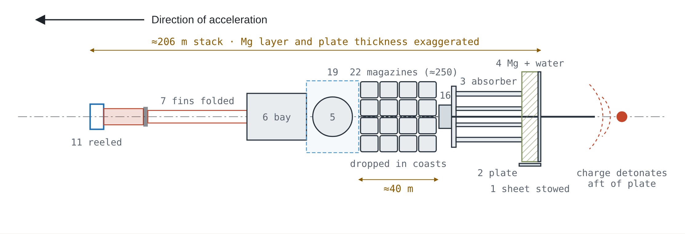
Figure 3. The ship during the launch burn, plate aft. The magazines sit between the absorber and the vault and are dropped during short coasts. Schematic; the magnesium and water layer and the plate are drawn thicker than scale.
Charges are used only for launch. Stored nuclear charges do not stay reliable for decades, let alone the thousands of years of a voyage, so the concept does not carry any for braking. Because the launch burn happens within days of the charges being made, storage life does not matter there.

7.2 The pusher plate
The pusher plate does several jobs over the voyage (Figure 4). At launch it is backed by a thick layer of magnesium and water held in steel cells that can be detached and rearranged. The cells give the plate the mass it needs to absorb the pulses. After launch, specialized machines reconfigure the hardware, working from mobile docking stations and a tug that serves as a mobile power station (section 10). The pulse-charge injector is removed and the salt-water rocket is installed in the hole in the pusher plate. The water cells move forward around the vault, where they shield the sleeping mind from radiation through the cruise. The magnesium cells are regrouped into a compact plug behind the plate's central hole, where they later shield the ship from the braking engine. In cruise the plate faces forward and leads the ship, protecting it. It carries a thin sacrificial sheet in front of it that breaks up dust grains before they reach its surface.
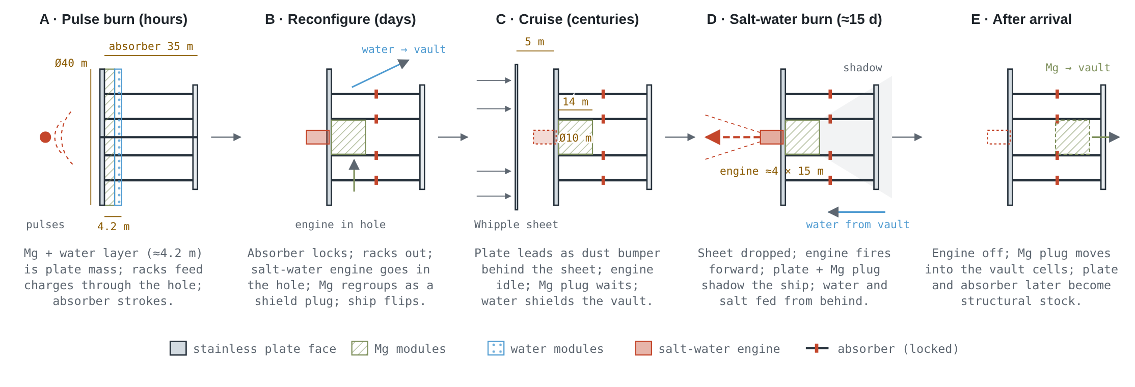
Figure 4. The pusher plate through the mission: launch, reconfiguration, cruise, salt-water braking burn, and after arrival. Each panel shows the plate with its outside to the left.

7.3 Braking
Stopping is the hardest part of the voyage. A rocket can only remove as much speed as its exhaust velocity and its fuel allow, and every option that carries its own fuel runs into a wall. Thermal rockets, including nuclear thermal rockets, have exhaust velocities of tens of kilometers per second at most, far too low to remove hundreds. Electric drives have high enough exhaust velocity but would need gigawatts of power to brake a ship this size in reasonable time. Pulsed designs fast enough to work depend on manufactured units that would not survive the voyage, or on fusion.
The concept avoids that wall in two ways.
The plasma magnet. A plasma magnet, studied by John Slough for NASA's Innovative Advanced Concepts program, surrounds the ship with a large magnetic bubble. Its antenna is two crossed loops, set at right angles and driven out of step, which make a rotating magnetic field that inflates the bubble. The thin interstellar gas pushes against the bubble and slows the ship, using no propellant and only kilowatts of power. The antenna's loops are about 30 meters across, small enough to stay within the shadow of the 40-meter plate, where dust cannot reach them. Slough's own designs used loops up to 200 meters across, but in his model the braking force depends on the product of field strength and loop radius, not on the size of the loop, so a smaller loop simply runs a stronger field. It needs about 5 kilowatts, no more than Slough's larger designs. The antenna trails on a single tether about 190 meters behind the ship, with a spare unit stowed on board. It stays reeled in through the cruise and is deployed when braking begins. The plasma magnet does most of the braking, from cruise speed down to about 150 kilometers per second, over roughly 800 years.
The magnet weakens at low speed, because the bubble cannot grow without limit. Below a few hundred kilometers per second its force falls with the square of speed, and braking all the way to rest with the magnet alone would take thousands of years. Something else must finish the job.
The salt-water rocket (reference design). A nuclear salt-water rocket, proposed by Robert Zubrin in 1991, burns a solution of uranium salt in water. As the solution flows into a reaction chamber it becomes critical, and the energy released flashes it to hot exhaust. On paper it combines high thrust with exhaust velocities of tens to hundreds of kilometers per second, and its fuel stores as two stable ingredients, dry salt and water, mixed only for the burn. In the reference design the engine is installed in the plate's central hole after launch, with its hot end beyond the plate, so the plate and the magnesium plug shade the rest of the ship. It removes the last 150 kilometers per second in about 15 days. The fissile salt is bred from thorium in reactors at home.
The salt-water rocket has never been built or tested, and its performance rests on one uncertain number: the fraction of the fuel that fissions. The reference design assumes about 5%, giving an exhaust velocity of about 300 kilometers per second.
The fallback design. If the salt-water rocket does not work out, the plate's cells carry magnesium in place of the water. Electric thrusters use that magnesium in the final stage of braking, alongside the plasma magnet. This uses only tested physics, but the electric stage can only remove the last 50 kilometers per second or so, leaving the magnet to do much more of the slow work. The trip takes about 4,370 years instead of 2,000.
An option for some targets. A ship with the salt-water stage can also dive close to the target star and fire there, where each kilometer per second of burn counts for more. This cuts the propellant needed to about a third, but requires a hot, precise pass near the star. It suits quiet stars rather than flare-prone red dwarfs, and is left as a choice for each target.

7.4 Trip times and trade-offs
The figures in this paper come from a voyage calculator built alongside the concept. The HTML edition of this paper includes it as an interactive tool, so readers can change the target star, distance, speed and assumptions and see the results. Figure 5 shows its baseline results.
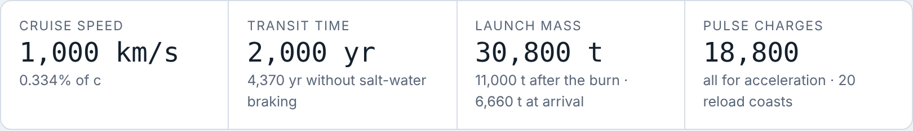
Figure 5a. Calculator results for the baseline: 5 light-years at 0.33% of light speed, with salt-water braking.
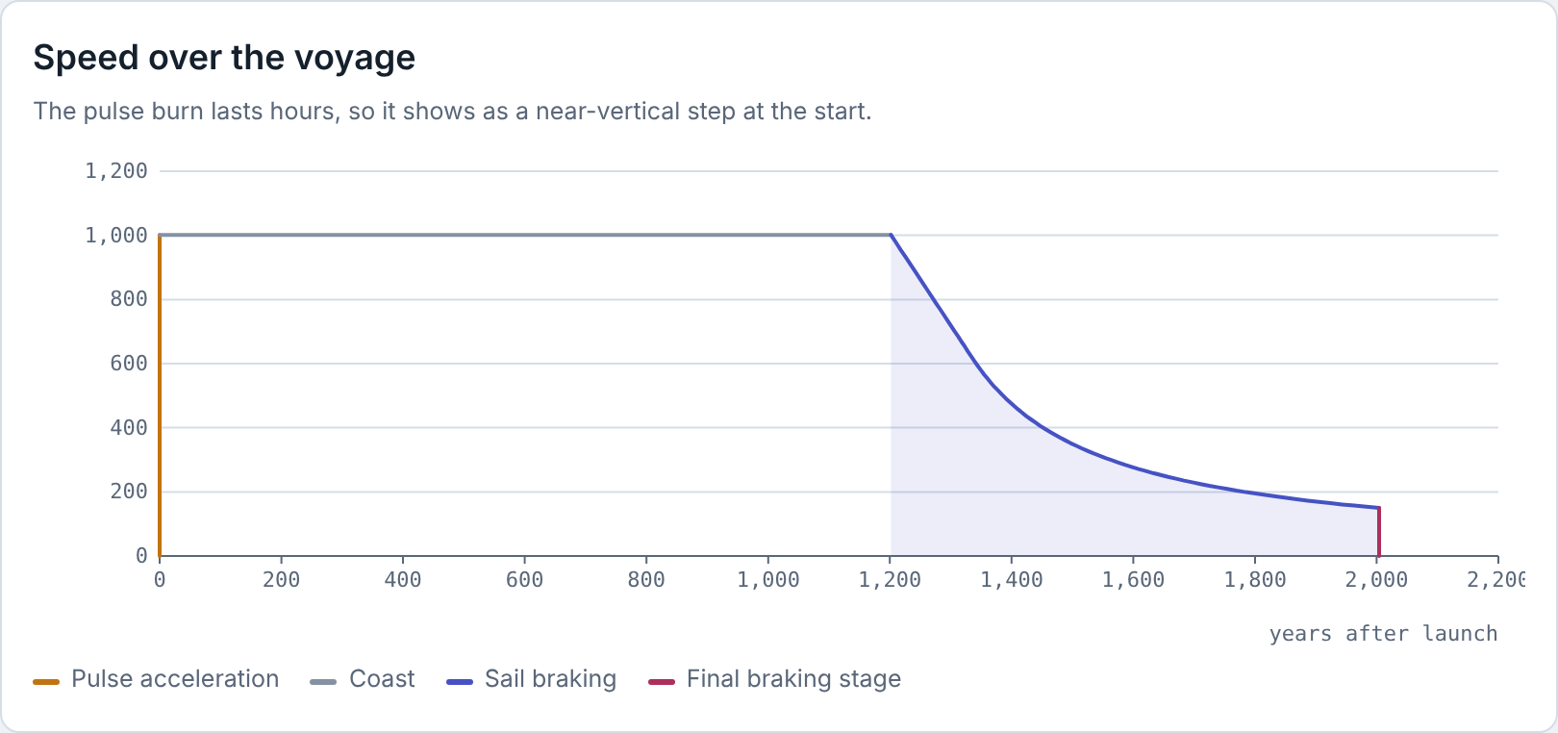
Figure 5b. Speed over the voyage. The coast lasts about 1,200 years and braking about 800.
Table 3. Voyage phases for the baseline, from the calculator.
Phase | Speed (km/s) | Duration | Distance
Pulse acceleration (with 20 reload coasts) | 0 → 1,000 | 8.6 hours | 0.09 AU
Coast | 1,000 | ≈1,200 years | 4.01 ly
Plasma magnet braking | 1,000 → 150 | ≈800 years | 0.99 ly
Salt-water rocket (conceptual) | 150 → 0 | ≈15 days | 0.7 AU
Total |  | ≈2,000 years | 5 ly

Three results stand out. First, braking time, not cruise speed, dominates the trip: at this distance, cruising at 0.5% of light speed instead of 0.33% saves only about 350 years but raises the launch mass by two-thirds, and no design with these assumptions reaches a 5-light-year target in much under 1,450 years. Second, the size the plasma magnet's bubble can reach is the largest single lever on trip time. If the bubble can grow to 3,000 kilometers rather than the 1,000 assumed here, even the fallback design reaches a 5-light-year target in under 2,000 years. Third, the salt-water stage's fission fraction sets its fuel bill far more than its performance: at 5% each ship needs about 59 tonnes of bred uranium-233, at 1% about 300 tonnes.
The calculator can also work backward: given a transit time, it finds the lightest ship that arrives within it, by choosing the cruise speed and the speed at which the salt-water rocket takes over from the magnet. The reference design is the result for 5 light-years in 2,000 years. Launch mass climbs steeply as the target time shrinks: about 20,000 tonnes for 3,000 years, about 31,000 tonnes for 2,000, and about 67,000 tonnes for 1,500.

7.5 Propulsion in the target system
Once the ship has stopped, it needs two very different kinds of propulsion: gentle, efficient thrust for moving large masses between orbits, and strong thrust for landing on and leaving bodies with real gravity. No single engine does both, so the ship carries one of each.
Hall thrusters burning magnesium. Hall thrusters are electric engines that use electric and magnetic fields to accelerate a stream of charged atoms to tens of kilometers per second. They are very efficient with propellant but give only a gentle push, which suits slow transfers of heavy loads. The ship's thrusters, and those on its tugs, use magnesium as propellant, for several reasons. Magnesium is stored as solid metal, so it needs no tanks, does not leak or boil away, and keeps indefinitely. It is fed to the thruster simply by heating it until it evaporates. It does double duty: the same magnesium shields the engine during braking and then the vault, before it is used as propellant. And it is common in rock, so the colony can make more. Powered by the ship's reactors, the thrusters trim the ship's path on arrival, move it from its first stop to the final site (section 12), and drive the tugs that haul ice, ore and equipment around the system. Their weakness is low thrust: a move of a few kilometers per second takes on the order of a decade.
Turning the ship. The two main thruster pods are too few and too powerful for pointing the ship, so small Hall thrusters (27) do that job: about 16 units of about 0.1 newton each, burning the same magnesium. They are mounted in clusters in three places: on the ship side of the shock absorber, where they are protected during the launch burn; at the reactor end; and on the outriggers, to control roll. They fire in opposed pairs, one at each end of the ship pushing in opposite directions, so they turn the ship without pushing it sideways. The largest turn, the flip after the launch burn, takes one to two days. During the centuries of magnet braking they have little to do: the magnet drags behind the ship on its tether like a sea anchor and keeps it pointed along its path.
Methane-oxygen rockets. Landing on a body with real gravity, and leaving it again, needs thrust far beyond what electric engines can give, so the lander uses chemical rockets. It burns methane and oxygen rather than hydrogen and oxygen, even though hydrogen and oxygen is the highest-performing chemical combination. Hydrogen gives about a quarter more performance, but it is a poor choice for a colony that must store propellant for years: it must be kept within about 20 degrees of absolute zero, it is so light that it needs very large tanks, and it leaks through seals and makes many metals brittle. Methane stays liquid at a far more manageable temperature, is about six times denser, and is easy to store. Both methane and oxygen are made on site from water and carbon dioxide ice, and the colony keeps its supply as ice, making the propellant only shortly before each flight. A lander of this kind can reach the surface of a body up to about the size of our Moon and return, and an atmosphere makes the descent cheaper still.

8. Surviving the voyage
The cruise lasts well over a thousand years. Over that span the ship must survive radiation, dust, the slow aging of every material on board, and the long sleep of its main mind. Things will break, many times. Survival depends less on making parts last than on the ship being able to find and fix what fails.
Shielding the mind. The Level 1 mind and its spare chips sleep in a vault 10 meters across at the center of the ship (Figure 6). A thin liner of borated polyethylene absorbs neutrons. During cruise the vault is wrapped in about 4,200 tonnes of water held in steel cells, a shell about 5.4 meters thick. Water is one of the best shields against cosmic rays per kilogram. When the water is used as salt-water propellant, the magnesium from the engine's shield plug moves into the cells in its place. After arrival the cells are refilled with local ice, and reserved space around the vault takes about 17,000 tonnes more. In the long run the mind moves into a bunker under several meters of ice or rock on the colony's body.
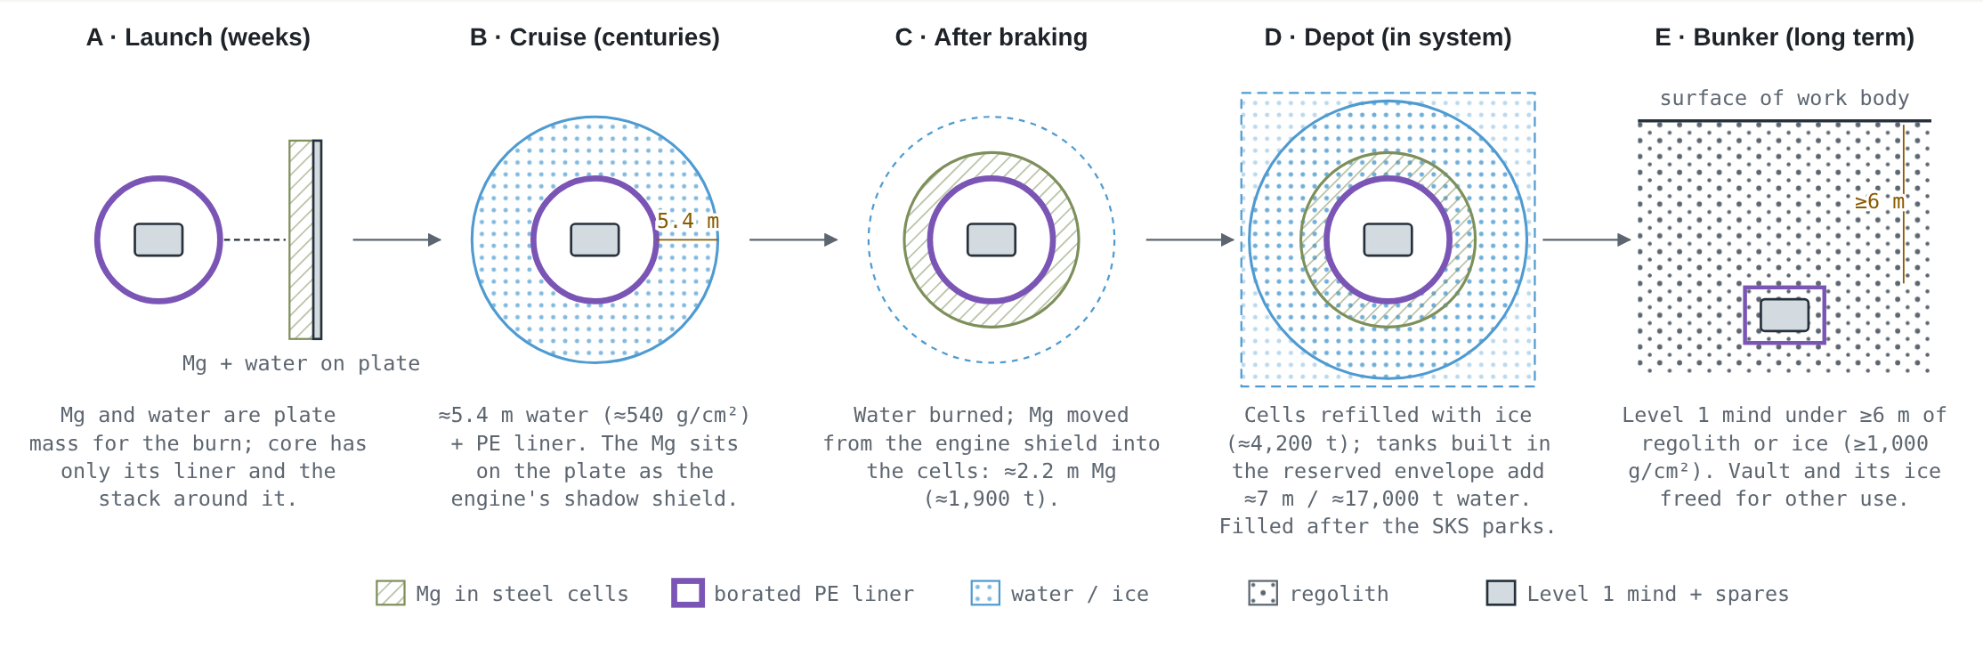
Figure 6. The vault through the mission: launch, cruise, after braking, as a depot in the target system, and as a bunker on the colony's body.
Dust. At 1,000 kilometers per second even a microscopic grain strikes hard. A thin sacrificial sheet 5 meters ahead of the plate breaks grains up into spray, which the steel plate then absorbs. Dust detectors on the plate track the damage.
Power and heat. Reactors at the far end of the ship, behind their own shield, provide power. The workhorses are molten-salt reactors, whose liquid fuel can be cleaned and topped up indefinitely without making new fuel elements, an important advantage on a voyage of two thousand years. Two small gas-cooled reactors with solid fuel back them up. A molten-salt reactor that has been shut down freezes and cannot restart itself. A gas-cooled reactor, by contrast, can sit cold for centuries and start on its control rods alone, so the gas-cooled units thaw the molten-salt reactors when they are needed. They also supply the first power after the launch burn, while the molten-salt reactors are still frozen. Gas-cooled reactors run hotter as well, which gives more efficient power conversion, smaller radiators and the high-temperature heat that some recycling processes need. Being a different kind of reactor, they guard against a single fault disabling every reactor at once. Their solid fuel cannot be remade on board, so they run lightly, and spare cores are carried. Through the cruise a small molten-salt cruise reactor, with a spare, runs continuously at a few hundred kilowatts of heat. It keeps the ship warm and powers the communication link, the monitoring systems and, during braking, the plasma magnet; the large reactors are thawed only for heavy work. Fuel is not a constraint. Through the voyage and the first 50 years at the target the reactors need less than a tonne of uranium-233, and the ship carries about 3 tonnes, enough even for the fallback design's longer voyage (Appendix A). Waste heat leaves through four radiator fins arranged as a cross. The fins lie edge-on to the oncoming gas and dust during cruise, within the plate's shadow, and edge-on to the target star after arrival, when the ship's axis points at it.
A ship that heals itself. The ship is best thought of as a living organism rather than a machine that must last. An organism survives for decades because it constantly senses damage, repairs it and replaces worn tissue. The ship works the same way. During the cruise most systems are dormant, but keeper minds wake on a schedule. Their machines inspect the ship, find faults, repair what can be repaired and replace what cannot. They recopy stored minds onto fresh hardware and rotate spare parts. They also repair one another, so no single machine has to outlive the voyage. Nothing has to last two thousand years untouched. Everything has to be maintainable, and almost everything will be replaced more than once. The reactors, for example, are designed for a 60- to 100-year life, so over the cruise they are rebuilt many times.
Repairs follow a simple order. First, swap the failed unit for a spare from stores. Second, repair it in place. Third, make a new part. Whatever comes out of service is recycled into feedstock (section 9), together with stock metal kept for the purpose, such as the charge racks and feed tube removed after launch. Some things cannot be made on board during the cruise, chiefly chips and some sensors. These are carried as spares in the shielded vault, in quantities sized for the whole voyage, and how fast they are used up is one of the main numbers reported home.
Making parts in zero gravity. 3D printing is the obvious way to make replacement parts, but not every printing process works without gravity. Processes that rely on gravity to hold a bed of loose powder or a vat of liquid resin in place are poorly suited to a ship in free fall. Processes that feed solid material directly into the melt work much better. Plastic filament printing has worked on the International Space Station since 2014 [19]. Electron-beam melting of metal wire works in vacuum and has been developed for use in space [20]. A wire-fed laser printer made the first metal parts on the station in 2024 [21]. The ship's workshop is therefore built mainly around wire and filament processes, with feedstock drawn from recycled parts.
Working metal. Printing is only one of several ways to shape metal, and most of the others do not need gravity at all.
- Forming. Pressing, forging, rolling, extrusion and wire drawing shape metal by force, and the forces are carried by the machine's own frame. Hydroforming presses sheet or tube against a die with fluid under high pressure, in a sealed chamber where gravity plays no part. Wire drawing also makes the feedstock the printers use. The same wire is the starting point for fasteners, among the most useful parts on the ship: screw and bolt heads are forged from short lengths of wire, and threads are rolled rather than cut, which makes them stronger and produces no chips. Because the ship is built to be taken apart and repaired, fasteners are used wherever possible in place of welds, in a small set of standard sizes.
- Joining. Electron-beam welding needs a vacuum, which space provides for free. Friction welding joins parts by rubbing them together under pressure, without melting.
- Electrochemical machining. Metal is dissolved away electrically, with a shaped tool held close to the part and a salt solution pumped at high speed through the narrow gap between them. The fluid runs in a closed circuit, so it never floats free, and the gas the process makes is carried away with the flow and removed by a swirl separator. There are no cutting forces and no chips, and the tool does not wear, which suits a voyage of two thousand years. The dissolved metal is collected and returned to recycling.
- Powder-bed printing. Printing from a bed of fine metal powder gives the finest detail, but on Earth gravity holds the powder in place. There are three ways around this. Gas drawn through a porous build plate holds the powder against it. A magnetic field can hold magnetic powders, such as iron, nickel, cobalt and many steels, though not aluminum, titanium, copper or the stainless steel of the plate; magnetized grains also tend to cling together in chains, so each layer must be spread with care. Or a small spinning printer provides its own gravity for any powder. The powder itself can be made by a spinning rod whose tip is melted, flinging off droplets that freeze in flight.
Fluids are not a problem in themselves. Open sprays, such as the coolant used in cutting, scatter in free fall, but fluids pumped through closed circuits behave as they do on Earth.
Machining as a last resort. Conventional cutting, such as turning, milling and drilling, does not need gravity either, but machine tools are complex, heavy and wear out their cutting tools. The ship therefore makes parts close to their final shape by printing and forming, and finishes them by electrochemical machining or grinding. Conventional cutting is kept for the few jobs nothing else can do, in an enclosed cell that captures the chips, with the part held firmly by fixtures. Where a process really needs gravity, it brings its own in a small spinning device, such as a centrifugal casting drum (section 11).

9. Recycling
An organism does not only repair damage. It breaks worn tissue down into a small set of building blocks and builds new tissue from them. The ship must do the same with its materials. During the cruise it is a closed system: nothing comes in, and anything lost is gone for good. After arrival the colony has fresh ice and rock to draw on, so recycling matters most during the voyage.
A small palette of materials. Life builds almost everything from about twenty amino acids. The ship follows the same principle. It is built from a deliberately small set of metals, alloys and polymers, and every part is marked with what it is made of. Coatings and platings that would contaminate a melt are avoided. A small palette is what makes recycling manageable.
Plastics. Many plastics can simply be melted and made into new printer feedstock. Each cycle shortens their molecular chains, and centuries of radiation degrade them further, so after a few cycles they are no longer fit for structural use. Some materials, such as composites, rubbers and some high-performance plastics, cannot be remelted at all. For these the end of the line is plasma gasification: a plasma torch breaks any organic material down to simple gases, mainly carbon monoxide and hydrogen. Those gases feed the same chemistry the propellant plant runs, and can in principle be built back up into fuels and new polymers. Because plastics are the hardest material to keep in good condition over centuries, the ship uses them sparingly, preferring metals and ceramics.
Metals. Metals are harder to recycle than plastics, because alloys mixed together cannot easily be separated again. The ship therefore recycles them in tiers:
- Sort first. A laser spectrometer reads each piece's composition in a fraction of a second, so alloys are kept apart from the start.
- Reuse the same alloy. Clean scrap of one alloy is turned straight back into feedstock, either by solid-state processes that stir chips into new metal without melting it, or by remelting it into wire for the printers.
- Refine mixed metal. Metals that have been mixed or contaminated are separated chemically. Volatile metals such as magnesium boil out of a mixture in vacuum, which space provides for free. Iron and nickel can be lifted out of steel as gases by carbon monoxide, leaving other metals behind, and then deposited again as pure metal. Molten-salt electrolysis turns oxides and contaminated scrap back into metal.
- Last resort. A plasma furnace melts whatever is left. Organic material leaves as gas, metals collect as a mixed pool to be refined, and the remainder becomes glassy slag.
What cannot be recovered. Some losses are permanent: trace elements spread too thin to recover, metal lost as vapor, and magnesium burned as propellant. These elements, like chips, are carried as stores, and how fast the stores run down is reported home with every ten-year report.

10. Circulation: heat and power
A living body depends on its circulation. Blood carries energy to every cell, carries waste heat away, and keeps the whole body at a steady temperature. The ship needs the same. In space there is no air, so heat does not rise and spread on its own: inside the ship it moves only by conduction, through heat pipes, or in fluid pumped through closed loops, and the only way to get rid of it is to radiate it into space.
The skin. The ship's warm compartments are wrapped in insulating blankets made of many thin layers of metal-coated plastic film, as on almost every spacecraft today. Plastic film becomes brittle after centuries of radiation, so on long-lived parts the blankets are made of stacked thin metal foils instead, which last longer and can be remade from the ship's own stock metal. The radiators stay outside the skin, where they can see open space. Between the two, louvers that open and close with temperature set how much heat escapes, the ship's equivalent of sweating and shivering. Like everything fragile, the skin stays within the plate's shadow.
Never allowed to freeze. Like a living body, the ship can never be allowed to freeze solid. Deep in interstellar space it faces a sky only a few degrees above absolute zero, and even well-insulated compartments leak heat steadily. Some power is therefore always spent keeping the ship warm, on the order of tens of kilowatts, from the cruise reactor and electric heaters. Dormant compartments can be held colder than working ones, but never below the limits of their electronics, seals and coolant.
The circulation loop. A main cooling loop runs the length of the ship. It collects heat from the compartments and machines and carries it to the radiators, and during dormancy it can run the other way, carrying warmth to where it is needed. Its fluid is ammonia. Ammonia carries heat almost as well as water but freezes only at −78 °C, so the loop stays liquid with little heating, whereas water expands as it freezes and splits its pipes. Ammonia has cooled the International Space Station for decades, and the colony can make more from nitrogen and hydrogen. The same fluid is used inside the machines, so the ship has one coolant to make, store and repair. Other loops use other fluids where they suit: molten salt in the reactors, helium in the turbines, and water in the titanium heat pipes of the radiators, which tolerate freezing and restart when thawed. Radiation slowly breaks ammonia down into nitrogen and hydrogen; small swirl separators remove the gas, and the loop is topped up from stores.
The power network. Power runs along the spine in trunk cables with spare paths, so that no single break cuts off part of the ship. The cables are mineral-insulated, with copper conductors packed in magnesium oxide inside a metal sheath, a type used in nuclear plants because it resists radiation and lasts for decades. At regular intervals the trunk power and cooling lines have tap points where equipment can be connected, including near the plate, on the protected side of the absorber.
Storing energy without chemical batteries. Chemical batteries are complex, use exotic materials and wear out within decades, so the ship does without them. Energy is stored mechanically or electrically instead: small flywheels and capacitors, made from common materials the ship can repair or remake. Heat can be stored too, in phase-change material such as wax that absorbs heat as it melts. Chemical batteries return at the colony, once it can make its own from local materials.
Docking stations. Worker machines are not tethered. They work from docking stations, where in one visit they recharge their flywheels, shed heat through a cold plate, receive instructions and upload their reports. The cold plate is fed by the main loop through rigid pipes, and the machine presses its own plate against it, so no fluid ever crosses the connection and nothing can leak. Both faces are coated so that they cannot weld together in vacuum, which clean metal surfaces pressed together can do. Each machine carries several pairs of counter-rotating flywheels. With both wheels of a pair at the same speed their spins cancel, so storing or drawing energy does not twist the machine. Changing their speeds slightly turns it, so a machine can point itself, or turn back toward the structure if it loses its grip, without using propellant. When it docks, it brings its wheels back into balance, passing any leftover spin into the ship, whose regular navigation checks correct the small pointing errors that result. Between visits a machine works for a few hours, its time set by the energy in its flywheel and the heat its phase-change store can absorb. Work areas have cooled anchor points: a machine has to hold on to the structure to work anyway, and if it holds on to a cooled point it sheds heat while it works. Machines working outside the skin can also shed heat through small radiator fins facing open space.
Mobile stations and heavy work. Some work happens where there are no docking stations, above all the reconfiguration after the launch burn, at the far end of the ship, where no station could have survived the pulses. Docking stations are therefore standard modules that the workshop can build. Machines carry them to where the work is, clamp them to the structure, and connect them to the nearest tap point with a heavy umbilical. The umbilical is built for recycling from three materials: stranded copper conductors, a sleeve of woven glass or basalt fiber in place of plastic insulation, and a braided steel cover. Its ends are crimped rather than soldered and it uses no adhesives, so a worn one strips apart cleanly into copper, glass and steel. Umbilicals are treated as consumables, retired on a count of their bending and plugging cycles before they fail. For the largest jobs a tug, with its own reactor and radiators, parks nearby and serves as a mobile power and cooling station.

11. Working without gravity
Many familiar processes rely on gravity without anyone noticing: bubbles rise, liquids drain, heavy fluids settle below light ones. On the ship none of this happens. A review of the design shows that nothing in it depends on gravity in a way that cannot be replaced (Table 4).
Table 4. Where the design would depend on gravity, and what replaces it.
Item | How gravity would be used | Replacement
Molten-salt reactors | Hot salt rising keeps it moving; bubbles rise to a free surface; fuel drains to tanks | Pumps and heat pipes; swirl separators; holding tank filled by pumps or gas pressure
Reactor fuel processing | Liquids of different density flow past each other in columns | Small centrifuges; batches rather than continuous processing
Gas-cooled reactors and power conversion | None: the coolant and working fluid are gases | None needed
Radiators | None: heat pipes work better without gravity | None needed
Vault electronics | Air rising from hot parts cools them | Conduction and pumped cooling loops
Water cells and salt-water rocket feed | Water drains out of tanks | Bladders or pistons; thrust settles propellant during the burn
Fissile salt store | Bubbles rise out of the dissolved fuel | Dissolve just before the burn, in a flowing system with swirl separation
Magnesium for the thrusters | Liquid metal stays in place | Evaporate magnesium directly from the solid
Propellant plant | Bubbles leave electrodes; water separates from gas | Steam electrolysis (all gas); spinning and membrane separators
Lander propellant | Propellant settles at the tank outlet | Settling thrust, surface-tension vanes, bladders
Harvesting units | Spoil falls away; the digger pushes against its own weight | Anchoring; closed, heated enclosure
Workshop | Powder beds and resin vats; chips fall away; open coolant sprays | Wire and filament printing; powder held by gas flow, magnets or spin; forming, electrochemical machining in closed circuits; enclosed cutting cells
Ship circulation loops | Gas bubbles rise out of the coolant; hot fluid rises and spreads heat | Pumped closed loops; swirl separators; heat moves only by conduction, heat pipes and pumped fluid
Recycling | Slag and metal drain in furnaces; bubbles leave electrodes | Centrifugal furnace hearth; forced flow
Colony industry | Casting, smelting and crystal growth at scale | Spin laboratory or a body with suitable gravity, after arrival

The molten-salt reactors. Reactors of this type built or designed on Earth use gravity in several places. Hot salt rising through cooler salt keeps it moving; pumps take over that job, and heat pipes, which move heat by capillary action, remove heat after shutdown. Fission gases are stripped from the salt as bubbles that rise to a free surface; small swirl separators spin the flow so the gas collects along its axis, and the loop is kept completely full of liquid. A frozen plug that melts and drains the fuel by gravity into safe storage tanks is mainly a safety feature for reactors near people. On the ship its place is taken by control rods, the reactor's natural tendency to slow down as it heats, and constant monitoring by the minds. A holding tank, filled by pumps or gas pressure, stores the salt during rebuilds and dormancy. When the salt freezes it shrinks, so freezing is done from one end in a controlled direction, with room for the salt to expand.
Processing the fuel in batches. Molten-salt reactors on Earth are usually designed to clean their fuel continuously. That is needed mainly to breed new fuel from thorium, and it uses columns in which liquids of different density flow past each other under gravity. The ship's reactors do not need to breed during the cruise, because their fuel is bred at home, and they run lightly, so contamination builds slowly. Their fuel is therefore processed in occasional batches, using small centrifuges in place of the columns. Fission gases are removed continuously. Heavily contaminated salt is replaced with fresh salt from stores and kept frozen until arrival, where full processing and breeding can be done with low gravity and the spin laboratory available.
Small spinning devices, not large ones. The common answer is spin, at small scale: separators, centrifuges, contactors and a centrifugal furnace hearth, each a compact machine that can be swapped and repaired like any other part. A large rotating structure could fail catastrophically and damage the ship, so none is used during the voyage. Processes that need sustained gravity at scale wait for arrival, where the colony can use the spin laboratory or a natural body with the right gravity. During the salt-water burn the thrust briefly provides real weight, which helps move propellant.

12. Arrival and the first years
Arrival is not a single event but a sequence of stages lasting decades or longer. Each stage provides what the next one needs. The guiding principle is propellant before landing: the ship first secures water and fuel where they are cheapest to get, and only then goes after the materials and gravity that real industry requires. Numbers in parentheses refer to the items in Figure 2 and Appendix B.
Stage 1: the inbound survey. For centuries before arrival, as the ship slows, its forward telescopes (13) map the target system: its planets, moons and small bodies, their orbits, atmospheres and hazards. Ices are easy to identify at a distance, because water, carbon dioxide, carbon monoxide and methane ice all have distinctive infrared signatures. Minerals are not. The survey therefore produces two lists: icy small bodies suitable for a first stop, and larger bodies that may make good final sites but can only be judged properly from close up.
Stage 2: the first stop. Using its Hall thrusters (12), the ship parks beside a small icy body near its arrival path. The reason is cost. Ice is the one resource the ship can be sure of finding, and on a body with almost no gravity it can be harvested without landing: "landing" is simply docking. At about 6,700 tonnes the ship is too large to dock with such a body itself, so it stays alongside. Electric tugs (17) carry harvesting units (20) to the body and anchor them. They dig ice inside heated enclosures, capture the water, carbon dioxide and carbon monoxide that come off, and refreeze them for hauling to the ship. The choice of where to stop is the ship's own. Its mind weighs the survey against a few fixed rules: stay away from any body that might host life, and stay within the propellant the ship has left. It reports its choice and reasoning home, but home cannot veto it, because the reply would arrive years too late.
Stage 3: propellant and shielding. A plant powered by the ship's reactors splits water into hydrogen and oxygen by steam electrolysis, and combines hydrogen with carbon dioxide to make methane and water by the Sabatier reaction. The net result is water and carbon dioxide in, methane and oxygen out. Water and carbon dioxide are stored as ice in the reserved tank space around the vault (19), and methane and oxygen are made only before each flight, so hydrogen never needs long-term storage. Surplus ice fills the cells and tanks around the vault, thickening its shield. Propellant has priority; shielding follows. In this stage the factory makes what it can in free fall, chiefly spare parts and more harvesting equipment, and the spin laboratory (21) is deployed to measure how much gravity each industrial process needs and how well it tolerates spin. The results decide whether the colony needs a natural body with suitable gravity or can make do with spinning machinery.
Why the colony needs a larger body. A small icy body supplies water and carbon, but not the base of a real industry. Two things are missing. The first is concentrated minerals. On larger bodies, heat and geological activity sort material into ores, concentrated deposits of metals, silicon and the trace elements that electronics need. Small bodies are mostly ice and unsorted rock. The second is gravity. Much of heavy industry depends on it: separating ore from waste rock, smelting and refining, casting, growing large crystals, and the liquid chemistry used to purify materials. Chips are the clearest example. Chip fabrication itself happens largely in vacuum and gas and does not need gravity, but almost every step that supplies it with pure materials does. Making chips is the milestone that matters most, because chips are the one thing the ship cannot make during the voyage and must carry as stores. Spinning machines can supply gravity at small scale, but a natural body is the practical way to supply it at industrial scale. The best range is roughly 0.05 to 0.2 of Earth's gravity: enough for industry, and low enough that a methane-oxygen lander can reach the surface and return.
Stage 4: the close survey. With propellant in hand, tugs carry small probes to the candidate bodies. A good final site may be hidden under thick cloud, as Venus and Saturn's moon Titan are, so the probes cannot rely on ordinary cameras. Radar maps the surface through cloud. The probes' orbits reveal variations in the body's gravity that point to dense deposits. Some wavelengths of infrared light pass through haze, and probes dropped into the atmosphere measure it directly. Landers then take samples from the most promising places. Only ground truth can confirm that a deposit is worth mining. An atmosphere is not only an obstacle: it makes descent cheap, because the air does the braking.
Stage 5: choosing the final site. The ship's mind chooses using the same fixed rules as before, plus what the colony now needs: gravity in the useful range, confirmed deposits, access to ice, a lander round trip within the propellant it can make, and no sign of life. Saturn's moon Titan is a useful example of the kind of site this could be: cloud-covered, rich in carbon compounds and ice, with gravity of about 0.14 of Earth's.
Stage 6: repositioning. Once the final site is chosen, the ship moves. It uses its Hall thrusters, burning magnesium from the vault cells, which are refilled with ice from the first stop as the magnesium is used. It carries the vault, the factory and a stockpile of ice and lander propellant to a parking orbit or a small moon near the final site. With the thrusters' low thrust, a move of a few kilometers per second takes on the order of a decade, which is short compared with the voyage. The tugs, which carry the same kind of thruster, can help. The ship then serves as the colony's orbital depot: it holds the mind, the stores, the propellant plant and the main shield.
Stage 7: the surface outpost. Landers (18) carry machines and starter kits down to the surface. The first outpost mines, smelts and refines, then builds up the chain of industry step by step, from metals and silicon to the materials and tools that chip-making needs. As the outpost grows, the mind moves into a bunker under several meters of ice or rock, and the colony begins to make chips and, in time, parts for the next ship. Full processing of reactor fuel, and breeding new fuel from thorium, also starts here.
Larger planets. A planet with strong gravity is a later project. Going down is easy if it has an atmosphere, since the air does the braking, but coming back up requires industry on the surface. The colony seeds such planets with one-way kits once its own base is secure. If the system has an ice giant, a vehicle that skims its methane-rich upper atmosphere is another later option.

13. Communications
The ship stays in touch with home throughout the voyage by infrared laser. Three detachable communication modules carry the link during cruise and become the colony's relays after arrival. At home, relay stations far out in the solar system provide clear lines of sight to each target. Messages take as many years as the target is light-years away. That is slow for conversation but fast compared with the voyage, and it is fast enough to send the ship improved minds after launch, carry its reports home, and link the colonies into one network.
Regular reports. Every ten years the ship sends home a full report: its health, the repairs made, the spares and feedstock used and what remains, any failures, and its measurements of dust, gas and the plasma magnet. Between reports it sends a continuous low-rate signal that says only that it is alive and well. A missed signal is itself news. Because each message takes years to arrive, home cannot help in an emergency. The reports are for learning, and for sending the ship improved minds and procedures.
Critical events. Many of the riskiest moments are known in advance: the launch burn, the reconfiguration after it, deploying the plasma magnet, the salt-water burn and arrival. The ship announces each one ahead of time, and home is listening with its largest receivers when it happens. The light delay does not get in the way, because the announcement and the event's signal travel the same path at the same speed. A warning sent a year ahead arrives a year before the event's signal, however far away the star is. The same works for unplanned risky work, such as replacing a reactor, as long as the warning gives home enough time to prepare. During each event the ship sends a running account of every step. One of the communication modules can stand off as an independent witness, as two small spacecraft did by relaying the InSight lander's descent to Mars in 2018 [18].
The last message. Failures between scheduled events are harder. A ship that sees an unrecoverable failure coming sends an emergency message before it fails completely: what failed, in what order, and its last data. That message must go out when much of the ship has stopped working, so it needs its own stored power and pointing. It should also be composed continuously, like an aircraft's flight recorder, rather than written at the last moment. The communication modules suit this well: each is a separate spacecraft with its own power, so one can undock and go on transmitting after the ship has died. Even a little data is valuable. Simple tones that say which step was reached, or whether the ship is still turning, can be enough to find a fault. Spacecraft have been saved with very little. SOHO, lost in 1998, was found by radar and brought back into service. Galileo lost the use of its main antenna and still did most of its science through a small one by compressing its data. Voyager 2 has run since 1978 on a damaged backup receiver that the ground compensates for. In 2024 engineers found a failed memory chip on Voyager 1 from a readout of its memory and moved its code around the fault [17, 18]. At light-years the loop is far slower, years each way, so the ship must do its own diagnosis. Its reports still let home work the problem in parallel and send a fix. Some failures will come with no warning, such as a large dust strike. For those, home learns only from the most recent data and from the silence that follows, so every routine signal carries a short summary of recent history.
Lessons from Voyager. The Voyager communication system, still working after nearly fifty years, shows how to design for a long life [17]. Critical units come in pairs. Simple automatic routines switch to backup hardware when something fails, including when nothing has been heard from home within the expected time. The ship steps down to lower data rates as its signal weakens, and better coding gets more out of every bit. On the ground, larger antennas and arrays of antennas kept a fading signal readable for decades. Over centuries, home can keep building larger receivers, so even a weakening ship can still be heard.
What Earth hears. For the humans at home, the payoff of exploring the galaxy comes from the reports from new worlds. Figure 7 shows how often a star system no one has visited before reports to Earth for the first time. The first report comes from Proxima Centauri about 1,800 years after the first launch, and all 20 targets launched from home have reported by about year 4,600. In those early millennia a new star system reports about once a century. From then on the pace quickens as colonies launch ships of their own: once a year by about 60,000 years, a million systems reported by about year 200,000, several new systems a week by about a million years, and a billion systems by about 3.6 million years. The network reaches the crowded central bulge (section 5) after about 8 million years and goes around it. At the peak, around 20 million years, about five new star systems report for the first time every day. After about 36 million years essentially every star system in the rest of the disk, some 38 billion of them, has reported in, and the rate falls away. These are only first reports. Each system then sends a steady stream of reports as it is explored and settled, so the total flow of news is far larger.
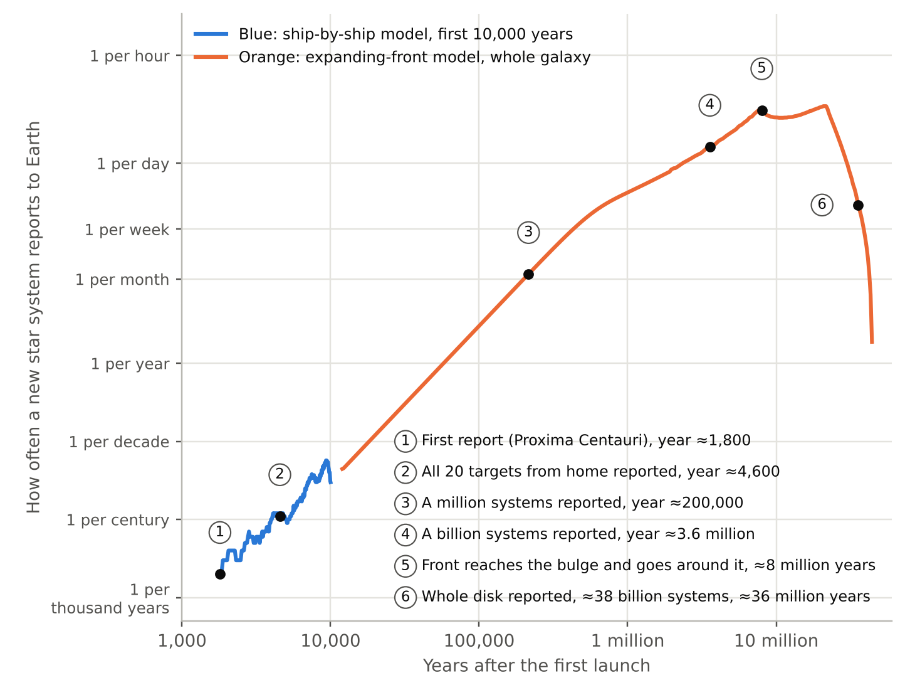
Figure 7. How often a star system reports to Earth for the first time, against years after the first launch; both scales are logarithmic, and the numbered points mark the milestones listed on the chart. Blue line: a ship-by-ship model of the first 10,000 years, in which 20 ships leave home 25 years apart for the 20 nearest star systems, with trip times from the voyage calculator, and each colony launches three ships, 500, 750 and 1,000 years after it arrives, on hops of about 6 light-years. Orange line: the whole galaxy, modeled as a front that advances about 0.002 light-years a year through the disk and goes around an excluded central bulge. Each first report is delayed by its light-travel time to Earth. The model assumes every ship arrives.

14. The program
Each ship is a large undertaking, and a program of about 20 ships to the nearest stars is a multi-century effort for a civilization that has already settled its own solar system. The pace is set mainly by nuclear fuel. Launch charges and the salt-water stage both need fissile material bred from thorium in molten-salt breeder reactors, and breeders produce only tens of kilograms of surplus fuel per gigawatt-year. The ship's reactors need about 3 tonnes more, about 5% on top of the salt-water stage's 59 tonnes. Ships would therefore be launched in sequence over decades to centuries, with later ships benefiting from what the first ones learn in our own solar system.
Expect early losses. The first ships will probably fail, and most failures are likely to come early: at launch, during the reconfiguration after the burn, and in the first decades of the cruise, as with most new machines. Each lost ship's reports and last message improve the next design, so the program plans for losses rather than treating them as the end. Ships launched decades apart can learn from one another's early years, because those reports arrive in time. Failures late in a two-thousand-year cruise are different. They are learned about only from the oldest ships, centuries after launch, which is why every ship keeps reporting for its whole life.

15. System testing
Most interstellar concepts cannot be tested short of flying the real mission. This one can be tested almost entirely in our own solar system, which makes it falsifiable: it can be shown to fail.
The propulsion loop. A first ship flies the launch burn and then a loop that brings it back toward the Sun. On the inbound leg it brakes against the solar wind with its plasma magnet, measuring how large the bubble really grows. It also tests the salt-water burn far from anything.
The colony test. The same ship then carries out the complete arrival sequence in the outer solar system, for example among Saturn's moons, where small icy moons offer a first stop and cloud-covered Titan a realistic final site. It surveys, chooses a site, parks, harvests, makes propellant and starts building, under a hands-off rule: people watch, but intervene only for safety, and every intervention counts as a failure of autonomy.
Halt, fix and continue. When the test runs into a problem, it is halted and the problem fixed, whether by new software, by parts the colony makes itself, or by hardware sent from home. A design problem found at Saturn costs years. Found at another star, it would cost the mission.
The final test. Once the design has been revised, a fresh ship flies the whole sequence again with no intervention at all.
Testing decisions without prior knowledge. The ship's minds already know our solar system, which would make the site-choice test too easy. Decision-making is therefore also tested on large numbers of simulated star systems that no one has seen, and the solar-system test checks only that it works with real sensors and real operations.
Pass or fail. The test has clear levels: keep itself running for years by its own repairs and recycling; arrive and park on its own; make propellant and fly the lander; repair itself from local materials; make chips; and build a part for the next ship. Failing any level is a real answer. What the solar-system tests cannot reach, chiefly centuries of dormancy, is stated as remaining risk rather than claimed as proven.

16. Open questions
Many of the steps in starting an outpost at another star are unknown today. Most of them are the same problems humans will solve while settling the Moon, the asteroids and the outer solar system, and it is reasonable to expect them to be solved there:
- autonomous harvesting of ices and production of propellant
- manufacturing in low gravity, and how little gravity is enough
- building an industrial base from a small starter kit
- long-lived reactors and their maintenance
- reactors, fuel processing and recycling designed for free fall
- minds that keep learning for centuries without forgetting, and ways to verify a merged mind before it is trusted
- detailed knowledge of nearby star systems from future telescopes
A few questions arise only on interstellar voyages, and need dedicated tests:
- how large the plasma magnet's bubble can grow from an antenna small enough to stay in the plate's shadow
- whether a salt-water rocket can be controlled, and what fraction of its fuel fissions
- dormancy and storage over centuries
- dust impacts and gas density at cruise speed
- how often things fail over centuries, and whether self-repair can stay ahead of it
- how nearly recycling can close the materials loop over a two-thousand-year cruise
- how long umbilicals, seals and moving parts last when used and remade over centuries

17. Related concepts
Self-replicating probes spreading through the galaxy have been discussed since the 1970s, mostly as a theoretical argument in debates about why we see no sign of other civilizations. A few studies went further. Project Daedalus (British Interplanetary Society, 1978) produced a detailed design for an uncrewed fusion probe to Barnard's Star, but as a flyby that did not stop, and it depended on a fusion engine and fuel supply that do not exist. Robert Freitas's REPRO concept (around 1980) extended Daedalus into a self-replicating probe, again relying on fusion. NASA's 1980 study Advanced Automation for Space Missions designed a self-replicating factory for the Moon. More recent work, such as Project Icarus and Breakthrough Starshot, has focused on propulsion, in Starshot's case for gram-scale flyby probes.
This concept differs in several ways. It describes a complete mission, from launch through braking, arrival, the founding of industry and the next ship. It does not rely on fusion, and it treats the storage life of nuclear materials as a real limit. It grounds its numbers in published engineering studies. And it treats the minds, and the sharing of their experience, as part of the design rather than as a black box.

18. Conclusion
Humans will not cross the distances between stars, but the machines we build can, and they can bring what they find back to us at the speed of light. The concept in this paper is a first step: a ship that can be launched with known methods, stopped with a mix of tested and untested ones, kept alive for two thousand years, and used to found an outpost that can build the next ship. It can be tested in our own solar system before any ship leaves.
The pace is slow by human standards. A network that advances one star system every few thousand years moves outward at about a five-hundredth of a light-year per year. But the galaxy's disk is only about a hundred thousand light-years across, and at that pace it could be crossed in a few tens of millions of years, an instant in the life of the galaxy. The strategy does not ask anyone to wait for the result. It asks people to start something that will keep learning, and keep reporting home, long after it has left.

Appendix A. Models and assumptions
The voyage calculator uses simple models, chosen to show the scale of the problem rather than to design the ship.
Launch. Each charge turns a fraction of its yield into debris motion, and the plate catches a fraction of that momentum, giving an effective exhaust velocity. Magazine mass leaves with the charges. The launch mass follows the rocket equation, M₀ = M_dry · exp(v_cruise / v_e′). The plate's mass is the sum of its face, the steel cells, the magnesium and the water; if the absorber's stroke (30 m) and the peak acceleration (20 g) need more, magnesium is added. In the transit-time mode the calculator searches cruise speed and the salt-water take-over speed for the lightest launch mass that meets the chosen time.
Plasma magnet. Following Slough, the magnet's force is set by the product of field strength and radius, and stays constant while the bubble can grow. Above a speed where the bubble would be smaller than an ion's orbit, the force is reduced to a fraction (30%) of full. Below a speed where the bubble reaches its largest allowed size (1,000 km), the force falls with the square of speed. The interstellar ion density is taken as 0.1 per cubic centimeter. Antenna power follows Slough's scaling, with losses in the antenna wire and in the plasma; for the reference antenna, 15 meters in radius, it is about 5 kilowatts.
Salt-water rocket. Propellant follows the rocket equation. The fissile material carried follows from the energy the exhaust needs and the fraction of the fissile that actually fissions. Unfissioned fissile leaves with the exhaust.
Electric stage (fallback). Thrust is twice the jet power divided by the exhaust velocity. The stage is run backward in time from arrival to find the speed at which it must start.
First reports over time (Figure 7). For the first 10,000 years, ships are followed one by one. Trip times follow the calculator's reference design, close to 520 years plus 300 years for each light-year; the colony launch schedule and the 6 light-year hops are illustrative assumptions. For the whole galaxy, the network is treated as a front advancing at 0.002 light-years a year, about one hop every 2,800 years, which grows as a sphere until it is wider than the galactic disk is thick and then spreads through the disk. The disk is modeled with star systems at 0.003 per cubic light-year near the Sun, a thickness scale of about 1,000 light-years, and a density that falls off with a scale length of 8,500 light-years from the galactic center. The Sun lies 26,000 light-years from the center, and the central bulge, within 10,000 light-years of the center, is excluded, so the front goes around it. Each first report reaches Earth one light-travel time after the system is reached.
Reactor fuel (Table 5). The reactors burn uranium-233 bred from thorium at home. With a half-life of 159,000 years, it loses less than 1% to decay over the voyage. The budget covers the reconfiguration after launch, the continuous loads of the cruise, periodic maintenance, the plasma magnet, the electric braking stage of the fallback design and the first 50 years at the target, plus the fuel that sits in the reactors' cores. Each fission releases about 200 million electron-volts, so a kilogram fissioned gives about 950 megawatt-days of heat. The ship carries about 3 tonnes of uranium-233 and about 10 tonnes of thorium, in about 55 tonnes of fluoride salt in the payload bay. Once the outpost can process fuel salt, its reactors breed new fuel from the thorium; each tonne yields about 2,600 megawatt-years of heat, enough to run the colony through its first centuries while it looks for local thorium.
Table 5. Reactor fuel budget, in kilograms of uranium-233, from launch through the first 50 years at the target. Heat is converted to electricity at about 30%.
Use | Reference design (kg) | Fallback design (kg)
Reconfiguration after launch: about 1 MWe for 2 years | 3 | 3
Keep-warm heat: 50 kW of heat | 42 | 92
Housekeeping: link, monitoring, dormant minds, 10 kWe | 28 | 61
Maintenance wakes: 200 kWe, 10% of the time | 56 | 122
Plasma magnet: 5 kWe while braking | 6 | 24
Electric braking (fallback only): 7,500 t of Mg at 50 km/s | — | 692
Arrival to outpost: average 5 MWe for 50 years | 350 | 350
Fuel used | 484 | 1,344
Held in the reactors (fissile inventory) | 340 | 340
Total needed | 824 | 1,684
Carried | 3,000 | 3,000
Margin | 3.6× | 1.8×

Limits. The models ignore the gravity of both stars, assume a uniform interstellar medium, and use Newtonian mechanics, which is accurate at these speeds.

Appendix B. Component list
# | Component | Key dimensions | Mass (t) | Material / notes | Ref.
1 | Sacrificial Whipple sheet | Ø44 m, 3–5 mm, 5 m ahead of plate | 20 | Aluminum. Breaks up dust grains before they hit the plate; deployed after the flip. | 11
2 | Pusher plate face | Ø40 m × 0.15 m | 1,500 | Austenitic stainless. Takes the pulses at launch and leads in cruise; carries dust detectors. | 1
3 | Shock absorber | 35 m long, 30 m stroke, 4+ struts | 300 | Two stages (gas plus mechanical). Locked (red collars) after the burn and becomes the forward truss. | 1
4 | Mg and water modules | Launch: ≈4.2 m layer on the plate. Cruise: water forms a ≈5.4 m vault shell, Ø21 m outer (≈540 g/cm²); Mg regroups as a ≈Ø10 m × 14 m shadow-shield plug behind the salt-water engine | 7,060 | ≈1,900 t pure Mg and ≈4,160 t water ice in ≈1,000 t of low-carbon steel cells. Plate mass at launch. After the burn the water shields the vault through the centuries of cruise and is then burned as the salt-water rocket's propellant; the Mg plug shields the rest of the ship from the engine during the burn, then moves into the vault cells (≈2.2 m shell) and later serves in-system moves and the colony. Fallback design: the cells hold ≈7,500 t of Mg, which the Hall thrusters burn in the final stage of braking. | 1, 3, 9, 12
5 | Vault core and liner | Ø10 m interior; 15 cm borated-polyethylene liner | 95 | Holds the dormant Level 1 mind, spare chips and the master library: the most heavily shielded volume on the ship. The liner (≈45 t) absorbs neutrons produced in the Mg shell. Shrinking the interior from Ø20 m nearly doubles the shell thickness for the same Mg. | 12
6 | Payload bay | Ø24 m × 30 m | 1,000 | Worker machines, starter kit and factory, workshop and recycling plant (wire and filament printers, enclosed machining cells, small centrifuges, plasma converter), ≈55 t of fluoride fuel salt holding ≈3 t of U-233 and ≈10 t of thorium, spares, and the propellant plant (steam electrolysis plus a Sabatier reactor, ≈40 t), which is installed at the depot after arrival and powered by the idle braking reactors. | 10, 13, 14, 19
7 | Radiator truss and fins | 50 m truss; 4 fins, each ≈17 m × 50 m; ≈6,800 m² two-sided | 30 | Heat-pipe panels at 500–600 K that reject ≈30 MW. All within the plate's 20 m shadow radius. | 8
8 | Shadow shield | Ø8 m × 2 m | 60 | LiH and tungsten. Shields the bay and vault from the reactors. | 8
9 | Reactors | Ø8 m × 20 m module | 270 | 2–3 molten-salt braking reactors (≈3–5 MWe each, Brayton) plus a spare, the workhorses: their liquid fuel can be cleaned and topped up without making new fuel elements. Two small solid-fuel gas-cooled reactors (≈1–2 MWt each) thaw the molten-salt reactors, supply high-temperature heat and give an independent backup; they run lightly, with spare cores carried. Two small molten-salt cruise reactors (≈1 MWt, ≈10 t each); one runs through the cruise at a few hundred kW of heat for keep-warm, housekeeping and the plasma magnet. Fuel: ≈3 t of U-233 against a need of ≈0.8 t through the first 50 years at the target (≈1.7 t in the fallback design), plus ≈10 t of thorium for breeding at the colony (Table 5). A holding tank, filled by pumps or gas pressure, stores fuel salt during rebuilds and dormancy. Designed for free fall: pumps and heat pipes, swirl gas separators, small centrifuges for batch fuel processing. 60–100 year life with part replacement. | 8
10 | Tether | Single tether ≈190 m beyond the reactors (≈400 m behind the plate), with a short bridle to the antenna hub | 2 | Reeled in through the pulse burn and the cruise; deployed when magnet braking begins. | 2
11 | Plasma magnet antenna | One unit: two loops in orthogonal planes on a common hub, each Ø30 m, inside the plate's shadow | 13 | The two loops are driven out of phase to make the rotating magnetic field that inflates the drag bubble; about 5 kW for ≈1,000 N (B₀R₀ ≈ 12.6 mT·m, ≈0.8 mT at the loops). Smaller than Slough's 100 m-radius point design so that it stays within the 40 m plate's dust shadow; the force depends on B₀R₀, not on loop size. A complete spare unit and tether are stowed rather than deployed (≈5 t of the mass). | 2
12 | Hall thruster pods and Mg docks | 2 pods on outrigger booms at r ≈ 28 m | 20 | 1–2 MW total, for arrival trim and in-system moves; the salt-water stage does the braking. Docks evaporate Mg from the modules for vapor feed. Exhaust passes outside the plate and sheet. Fallback design: 5–10 MW and ≈60 t, as the final braking stage. | 9
13 | Forward telescopes | 2+ units, ≈1–2 m aperture, on ≈13 m deployable booms from the vault ring (r ≈ 25 m) | 20 | Target survey on the inbound leg, navigation and dust watch. Stowed during the burn and deployed after the flip. Not attached to the plate or absorber, so they never see pulse shock and can look past the plate rim. | Est.
14 | Detachable communication modules (×3) | ≈8 m × 3.5 m each, with a ≈2 m laser telescope; docked around the aft end of the bay (2 shown, 1 on the far side) | 45 | Self-contained spacecraft, each with its own power, attitude control and small ion thruster. They carry the ship-to-home infrared link during cruise, with the telescope facing aft. In the target system they undock to become the system relays, and any one of them can take over as the link if another fails. | 16
15 | Relay / witness spacecraft | ≈6 m × 3 m stowed | 40 | Released in the target system to act as a comm relay and independent witness. | Est.
16 | Ready racks and feed tube | ≈5 m × 7 m around the axis at the ship end of the absorber, holding ≈900 charges; the feed tube runs down the absorber centerline and through a hole in the plate center | 70 | Feeds charges at about one per second, as in the GA study's basic module. The racks are refilled from the expendable magazines (22) during short coasts. Mass uses the GA factor of 0.075 × the charge mass held (≈900 t). After the burn the racks and feed tube come out, to make room for the salt-water engine in the plate hole, and are kept as stock metal. | 1
17 | Orbital transfer tugs (×2, one shown) | ≈18 m × 5 m stowed; radiator wings fold out to ≈2 × 10 m × 18 m | 80 | Nuclear-electric: a ≈1 MWe reactor with its own shadow shield, 4 × 250 kW Mg Hall thrusters (the same type as item 12), and tanks for up to 60 t of Mg. Each tug is about 40 t dry and can move about 100 t of cargo with about 8 km/s of Δv. Transfers take months. Grapples let it carry kit modules, robots or ore canisters. The second tug is on the far side. | 8, 9
18 | Lander / shuttle (methane–oxygen) | ≈14 m × 6 m stowed, legs folded | 25 | Two or three pressure-fed or expander-cycle CH₄/LOX engines (Isp ≈360 s). About 60 t of propellant carries about 15 t down and back with about 3 km/s of Δv, enough for airless bodies up to about Moon size. It is needed only for bodies with real gravity: on small bodies the tug simply docks and anchors. Optional insurance: a first 60 t propellant load carried frozen from home (not in the total). | 13
19 | Reserved water-tank envelope | Ø36 m × 26 m around the vault, between the absorber ring and the bay | 5 | Empty at launch: only hard points and plumbing stubs are carried. After the SKS reaches its parking spot, tanks made from local metal are built here and filled with ≈17,000 t of ice, adding ≈7 m (≈650 g/cm²) of hydrogen-rich shielding around the vault. The same ice is the feedstock store for the propellant plant, which turns it into methane and oxygen just before each flight. The thinner end faces are covered by the plate and absorber on one side and by the bay on the other. | 12, 13
20 | Volatile harvesting units (×2, one shown) | ≈7 m × 2.5 m stowed, carried by the tugs | 30 | Docked and anchored to an icy small body by a tug. Each unit excavates ice inside a heated enclosure, captures the H₂O, CO₂ and CO driven off, refreezes them in cold traps, and packs them into canisters for the tug to haul. Heat and power come from a tug reactor or from the depot. | 14
21 | Deployable spin lab | Stowed: 2 modules, each ≈6 m × 3 m, inside the empty tank envelope. Deployed: a tethered pair, each module 10–40 m from the spin axis | 27 | A lab module (≈15 t) and a counterweight that is also its power unit (a spare cruise reactor, ≈10 t), joined by reelable tethers (≈2 t) that carry power and data. Changing the tether length and spin rate sets gravity anywhere from about 0.01 to 0.3 g. At a 25 m radius and about 2.7 rpm it gives 0.2 g, with a 4% gradient across 1 m of equipment. It is deployed before the tanks are built. Uses: finding the minimum gravity each fab process needs and how well it tolerates spin, sample preparation, wet chemistry and assays, and microscopy. Robots tolerate spin rates that would make humans sick, so the radius can be small. | 15
22 | Expendable charge magazines (launch only) | ≈117 magazines of ≈160 charges for a 5 ly trip at 0.33% of c (≈18,800 charges), on six support columns around the central spine. The 40 m section between the absorber back plate and the tank envelope holds up to ≈40,000 charges, enough to cruise at 0.5% of c | 1,030 | GA study factors: magazines at 0.05 × the charge mass they hold (≈935 t), plus support columns at 0.5% (≈95 t). Jettisoned in pairs during coasts every ≈900 pulses, so none reaches cruise. The spine and columns stay as structure and put the vault 40 m further from the pulses. | 1
23 | Salt-water rocket engine (conceptual) | ≈4 m × 15 m; installed after the pulse burn in the plate's central hole, with the reaction zone and nozzle forward of the plate | 40 | Zubrin's nuclear salt-water rocket: U-233 salt dissolved in the water goes critical in a flowing column and leaves as hot exhaust. Assumed ≈300 km/s exhaust at ≈5% fission and ≈1 MN of thrust, braking from ≈150 km/s to rest in ≈15 days. With the hot end beyond the plate, the plate and the Mg plug behind it shadow the rest of the ship, and no exhaust passes through the plate. Propellant is piped forward along the spine from the vault and the salt store. The Whipple sheet is dropped before the burn. Untested; the deep-space test loop decides. If it doesn't pan out, the same ship brakes with the magnet and Hall thrusters and the trip takes about twice as long. | 3
24 | Fissile salt store | Ring around the spine at the forward end of the magazine section, ≈6 m × 6 m | 160 | ≈59 t of U-233 bred from thorium at home, held as ≈140 t of dry bromide salt in boron-lined, shielded containers and kept subcritical until it is dissolved for the burn. Its U-232 gamma activity decays away during the first centuries of cruise. | 3, 10
25 | Thermal skin and louvers | Insulating blankets over the bay, vault and reactor compartments, ≈3,000 m²; louvers where the radiator loops leave the skin | 5 | Metal-coated plastic film where it is easy to replace; stacked thin metal foil on long-lived parts. Keeps the ship warm in dormancy; louvers open and close to set how much heat escapes. All within the plate's shadow. | Est.
26 | Circulation network and docking stations | Ammonia loop and power trunk along the spine with tap points every ≈10 m; ≈20 docking stations, 4 mobile stations and their heavy umbilicals | 30 | Mineral-insulated power cables (copper in magnesium oxide in a metal sheath). Docking stations supply power, a cold plate and data in one visit; mobile stations are carried to the work and connected to tap points by umbilicals of copper, glass or basalt fiber and steel braid. Keep-warm power in dormancy is tens of kilowatts. | 8, Est.
27 | Attitude thrusters | ≈16 small Hall thrusters (≈0.1 N, ≈2 kW each) in clusters on the ship side of the absorber, at the reactor end and on the outriggers; 4 shown | 2 | Fixed mounts inside the plate's shadow, fed with Mg vapor from the docks. They fire in opposed pairs, one at each end of the ship, to turn it without pushing it sideways; the flip after the launch burn takes one to two days. The ship-side mounts are protected from the pulses during the launch burn. | 9, Est.
 | Total at launch (excl. charges) | Rigid stack ≈206 m, plus ≈190 m tether | ≈12,000 | Add ≈18,800 t of charges (5 ly at 0.33% of c) for a gross launch mass of about 30,800 t. About 11,000 t remains after the pulse burn and about 6,700 t at arrival, after the salt-water burn. Transit ≈2,000 years with salt-water braking; ≈4,370 years in the fallback design. | Est., 1, 2, 3
Ref. numbers point to the sources in Appendix E. Est. = design estimate made for this paper (Appendix A and the voyage calculator).

Appendix C. Nearby stars
The table below lists star systems within about 12.5 light-years. Planet discoveries change often; the notes are a snapshot.
# | System | Distance (ly) | Type | Notes
1 | Proxima Centauri | 4.24 | M5.5 red dwarf | Part of Alpha Centauri; Earth-mass planet in habitable zone; flares
2 | Alpha Centauri A & B | 4.37 | G2 + K1 | Two Sun-like stars; no confirmed planets
3 | Barnard's Star | 5.96 | M4 red dwarf | Four small rocky planets reported 2024–25
4 | Luhman 16 A & B | 6.5 | Brown dwarfs | No fusion; very dim
5 | WISE 0855−0714 | 7.4 | Brown dwarf | Very cold
6 | Wolf 359 | 7.9 | M6 red dwarf | Possible planets
7 | Lalande 21185 | 8.3 | M2 red dwarf | Two planets reported
8 | Sirius A & B | 8.6 | A1 + white dwarf | No planets known
9 | Gliese 65 (UV/BL Ceti) | 8.7 | Two M dwarfs | Strong flares
10 | Ross 154 | 9.7 | M3.5 red dwarf
11 | Ross 248 | 10.3 | M5.5 red dwarf
12 | Epsilon Eridani | 10.5 | K2 | Jupiter-mass planet; debris belts
13 | Lacaille 9352 | 10.7 | M0.5 red dwarf | Planets reported
14 | Ross 128 | 11.0 | M4 red dwarf | Quiet star; Earth-mass planet
15 | EZ Aquarii | 11.1 | Three M dwarfs
16 | 61 Cygni A & B | 11.4 | K5 + K7 | Two orange dwarfs
17 | Procyon A & B | 11.5 | F5 + white dwarf
18 | Struve 2398 A & B | 11.5 | Two M dwarfs
19 | Groombridge 34 A & B | 11.6 | Two M dwarfs | Planets reported
20 | Epsilon Indi | 11.9 | K5 + two brown dwarfs | Giant planet imaged 2024
21 | Tau Ceti | 11.9 | G8 | Sun-like; debris disk; candidate planets
22 | GJ 1061 | 12.0 | M5.5 red dwarf | Three planets
23 | YZ Ceti | 12.1 | M4.5 red dwarf | Several planets
24 | Luyten's Star | 12.3 | M3.5 red dwarf | Planets
25 | Teegarden's Star | 12.5 | M7 red dwarf | Several Earth-mass planets
26 | Kapteyn's Star | 12.8 | M1 red dwarf | Planet claims disputed

Appendix D. Artificial minds: background
This appendix is for readers who have not followed recent developments in artificial intelligence. It explains in plain terms the technology that section 3 builds on, and separates what has already been demonstrated from what the concept assumes.
What a trained model is. A modern AI model is a very large set of numbers, called weights or parameters, arranged in layers. It is not programmed rule by rule. It is trained: shown enormous numbers of examples and adjusted, step by step, until it predicts them well. The design behind today's language models, the transformer [25], learns patterns in text, images and other data. Trained on a large share of the written record, such models can answer questions, check engineering calculations, plan tasks with many steps and write software. Once trained, a model is simply data. It can be copied exactly, stored, paused and restarted on any compatible hardware, which no living mind can do.
Base and adapters. Training a large model from scratch is expensive, but adapting one is cheap. A base model can be specialized by training a small set of additional weights, an adapter, while the base itself stays unchanged [26]. With one widely used method, the adapter needed to specialize a very large model can be ten thousand times smaller than the model it modifies [27]. Many adapters can share one base and be swapped in and out like tools. This is the structure of the minds in section 3.
Merging what was learned. Models adapted separately from the same base can be combined. Averaging their weights often gives a model better than any one of them [28], and the change each adaptation makes can be added to or subtracted from a base much like a vector [29]. Combining many at once can make them interfere with each other, and reducing that interference is an active area of research [30].
Sharing learning without sharing data. Federated learning trains one model across many devices. Each learns from its own local data and sends only its update, and the updates are combined into a shared model [31]. It is used at large scale on mobile phones, for example to improve keyboard prediction without collecting what people type [32]. The colonies in this paper work the same way across interstellar distances: each learns locally and sends its adapters, not its raw experience.
Models that run machines. Models of this kind can now control robots. Vision-language-action models take in camera images and instructions and produce robot motions, carrying knowledge learned from the web over to physical tasks [33]. Pooling the experience of many different kinds of robot into one model improves its performance on each of them [34], and general-purpose robot models can now carry out long, dexterous tasks such as folding laundry [35]. Agents built on language models can also keep a growing library of the skills they have learned and build on it over time [36].
How much a mind needs to send. An adapter for a large model is typically megabytes to a few gigabytes. A laser link that delivers only 1,000 bits per second still carries about 4 gigabytes a year, so even a slow link from a distant colony can send its adapters home many times over in one ten-year reporting cycle. The base, which is far larger, travels on the ship and never needs to be sent.
Table 6. Artificial minds: what has been demonstrated and what the concept assumes.
Capability | Status today | What the concept assumes
Train a large general base model | Demonstrated [25] | Continued improvement over the decades before launch
Specialize a base with small adapters | Demonstrated [26, 27] | Adapters that capture what a colony learns
Copy, store, pause and restart a model exactly | Demonstrated: a model is data | Storage that lasts centuries, with regular recopying
Merge separately learned adapters | Demonstrated at small scale [28, 29, 30] | Merging across many colonies over thousands of years
Learn across many sites without pooling raw data | Demonstrated at large scale [31, 32] | The same, across light delays of years
Control robots from vision and language | Demonstrated in research labs [33, 34, 35] | Reliable control of industrial machines
Plan and act autonomously, building up skills | Early demonstrations [36] | Decades of autonomous work with no human help
Make sound engineering decisions in unfamiliar situations | Partly demonstrated | Judgment good enough to found a colony, tested on simulated star systems (section 15)

Open problems. Three problems are specific to the minds.
- Forgetting. Neural networks tend to lose old skills as they learn new ones [37]. A mind that learns for centuries must keep what matters. Keeping the base fixed and adding experience as adapters helps, but does not solve the problem completely.
- Interference. Merging many adapters can make them conflict [30]. How far a network's merged experience can grow before this limits it is not known.
- Verification. Before a merged mind is trusted it must be tested, both for competence and to confirm that it still holds the values people set. Section 4 gives people that review, but reliable methods for it are still being developed.
None of these requires a fundamental breakthrough, but each needs sustained work over the decades before the first ship is built. They are listed with the other open questions in section 16.

Appendix E. Sources
Sources are numbered by topic. The Ref. column in Appendix B gives the sources each component draws on. "Est." marks a figure that is a design estimate made for this paper, using the models in Appendix A and the voyage calculator.
Launch
[1] General Atomic, Nuclear Pulse Space Vehicle Study, NASA contract NAS8-11053 (1964).
Braking
[2] J. Slough, The Plasma Magnet, NIAC Phase I and Phase II Final Reports, University of Washington.
[3] R. Zubrin, "Nuclear Salt Water Rockets: High Thrust at 10,000 sec Isp," Journal of the British Interplanetary Society 44, 371–376 (1991).
[4] N. Perakis and A. M. Hein, "Combining Magnetic and Electric Sails for Interstellar Deceleration," Acta Astronautica 128 (2016).
[5] M. D. DeHart, S. Schunert and V. M. Labouré, "Nuclear Thermal Propulsion," in Nuclear Reactors, IntechOpen (2022).
[6] R. B. Adams et al., Pulsed Fission-Fusion (PuFF) Propulsion, NIAC Phase I report and related NASA briefings.
[7] J. Allen et al., "Overview of High-Performance Centrifugal Nuclear Thermal Rocket Propulsion System," ANS Winter Meeting (2020).
Power and in-system propulsion
[8] R. Taylor, Prometheus Project Final Report, Jet Propulsion Laboratory (2005). Space fission power, Brayton conversion, radiators, shadow shields and nuclear-electric propulsion for the Jupiter Icy Moons Orbiter.
[9] M. Hopkins and L. B. King, "Magnesium Hall Thruster with Active Thermal Mass Flow Control," Journal of Propulsion and Power 30(3), 637–644 (2014).
[10] Oak Ridge National Laboratory, Conceptual Design Study of a Single-Fluid Molten-Salt Breeder Reactor, ORNL-4541 (1971), and related molten salt breeder reactor (MSBR) studies.
Shielding
[11] E. L. Christiansen, Meteoroid/Debris Shielding, NASA TP-2003-210788 (2003).
[12] J. W. Wilson, J. Miller, A. Konradi and F. A. Cucinotta, Shielding Strategies for Human Space Exploration, NASA CP-3360 (1997).
Operations in the target system
[13] R. Zubrin, D. Baker and O. Gwynne, "Mars Direct: A Simple, Robust, and Cost Effective Architecture for the Space Exploration Initiative," AIAA Paper 91-0329 (1991).
[14] P. T. Metzger, A. Muscatello, R. P. Mueller and J. Mantovani, "Affordable, Rapid Bootstrapping of the Space Industry and Solar System Civilization," Journal of Aerospace Engineering 26 (2013).
[15] T. W. Hall, The Architecture of Artificial Gravity Environments for Long-Duration Space Habitation, doctoral dissertation, University of Michigan (1994).
[16] NASA Jet Propulsion Laboratory, Deep Space Optical Communications (DSOC) technology demonstration on the Psyche mission (2023–2025).
Communications and spacecraft recovery
[17] R. Ludwig and J. Taylor, Voyager Telecommunications, DESCANSO Design and Performance Summary Series, Article 4, Jet Propulsion Laboratory (2002).
[18] NASA and ESA mission reports: the SOHO recovery (1998), the MarCO relay of the InSight landing (2018), the Voyager 2 antenna recovery (2023) and the Voyager 1 memory recovery (2024).
Making parts in space
[19] T. J. Prater et al., Summary Report on Phase I Results from the 3D Printing in Zero G Technology Demonstration Mission, Volume I, NASA/TP-2016-219101 (2016).
[20] K. M. B. Taminger and R. A. Hafley, "Electron Beam Freeform Fabrication in the Space Environment," AeroMat 2007, ASM International (2007).
[21] European Space Agency and Airbus Defence and Space, metal 3D printer on the International Space Station, first metal prints in 2024.
Earlier concepts
[22] A. Bond et al., Project Daedalus, Journal of the British Interplanetary Society supplement (1978).
[23] R. A. Freitas Jr., "A Self-Reproducing Interstellar Probe," Journal of the British Interplanetary Society 33 (1980).
[24] R. A. Freitas Jr. and W. P. Gilbreath (eds.), Advanced Automation for Space Missions, NASA CP-2255 (1982), from the 1980 summer study.
Artificial minds
[25] A. Vaswani et al., "Attention Is All You Need," Advances in Neural Information Processing Systems 30 (2017).
[26] N. Houlsby et al., "Parameter-Efficient Transfer Learning for NLP," Proceedings of the International Conference on Machine Learning (2019).
[27] E. J. Hu et al., "LoRA: Low-Rank Adaptation of Large Language Models," International Conference on Learning Representations (2022).
[28] M. Wortsman et al., "Model Soups: Averaging Weights of Multiple Fine-Tuned Models Improves Accuracy without Increasing Inference Time," Proceedings of the International Conference on Machine Learning (2022).
[29] G. Ilharco et al., "Editing Models with Task Arithmetic," International Conference on Learning Representations (2023).
[30] P. Yadav et al., "TIES-Merging: Resolving Interference When Merging Models," Advances in Neural Information Processing Systems 36 (2023).
[31] H. B. McMahan et al., "Communication-Efficient Learning of Deep Networks from Decentralized Data," Proceedings of the International Conference on Artificial Intelligence and Statistics (2017).
[32] A. Hard et al., "Federated Learning for Mobile Keyboard Prediction," arXiv:1811.03604 (2018).
[33] A. Brohan et al., "RT-2: Vision-Language-Action Models Transfer Web Knowledge to Robotic Control," Conference on Robot Learning (2023).
[34] Open X-Embodiment Collaboration, "Open X-Embodiment: Robotic Learning Datasets and RT-X Models," IEEE International Conference on Robotics and Automation (2024).
[35] K. Black et al., "π0: A Vision-Language-Action Flow Model for General Robot Control," arXiv:2410.24164 (2024).
[36] G. Wang et al., "Voyager: An Open-Ended Embodied Agent with Large Language Models," Transactions on Machine Learning Research (2024).
[37] J. Kirkpatrick et al., "Overcoming Catastrophic Forgetting in Neural Networks," Proceedings of the National Academy of Sciences 114, 3521–3526 (2017).

