ECM2414 Pair Programming Coursework

**Thomas Newbold** – 71000126

**Steven Jangcan** – 710042102

Weighting 50:50

Development Log

|  |  |  |  |  |
| --- | --- | --- | --- | --- |
| Date | Time | Duration (hh:mm) | Roles | |
| 71000126 | 710042102 |
| 08/11/2022 | 11:30 | 01:00 | Observer | Driver |
| 08/11/2022 | 12:30 | 01:00 | Driver | Observer |
| 12/11/2022 | 10:00 | 01:30 | Driver | Observer |
| 12/11/2022 | 11:30 | 01:30 | Observer | Driver |
| 12/11/2022 | 01:00 | 01:00 | Driver | Observer |
| 12/11/2022 | 02:00 | 01:00 | Observer | Driver |
| 15/11/2022 | 11:30 | 01:00 | Observer | Driver |
| 15/11/2022 | 12:30 | 01:00 | Driver | Observer |
| 15/11/2022 | 02:30 | 00:30 | Observer | Driver |
| 18/11/2022 | 01:30 | 01:00 | Driver | Observer |
| 18/11/2022 | 02:30 | 01:00 | Observer | Driver |
| 18/11/2022 | 03:30 | 00:30 | Driver | Observer |
| 20/11/2022 | 04:30 | 01:00 | Driver | Observer |

Design

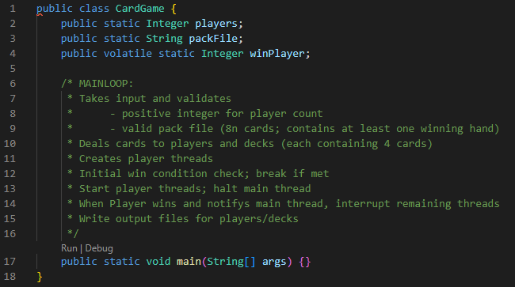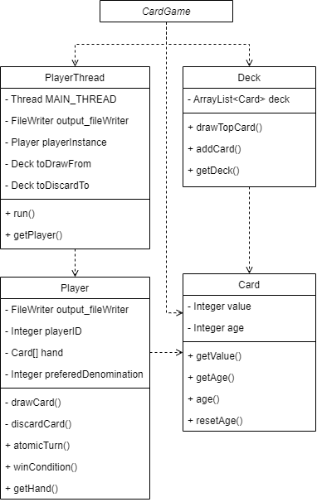The overall (high-level) design for the system can be see in this UML diagram. Most classes are used by the CardGame class, within its main loop.

The main CardGame class deals with input validation, dealing the cards, player thread creation, and initialising the associated output files.

Provided are the outlines for supporting classes, with docstrings describing each function to be implemented.

Instance variables have been confined by using private variables and getter methods.

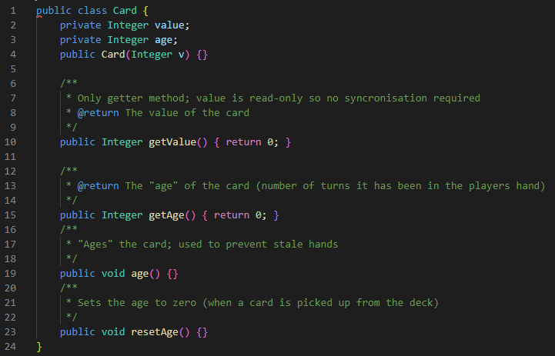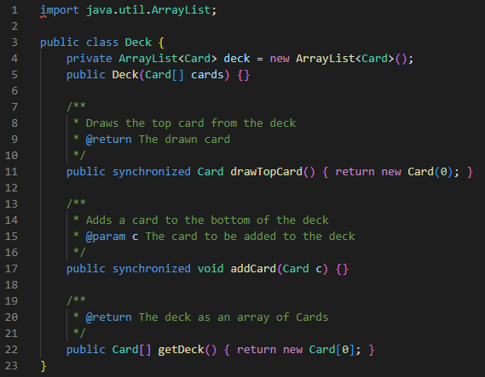

The Deck class has been synchronised, as it is likely that different player threads will be adding/removing cards simultaneously. This is the only data structure that will be accessed by multiple threads (at the same time; instances of Card will be passed between threads but never modified during this time).

The Player class defines drawCard and discardCard methods, which will be contained within the atomicTurn method. This effectively makes the drawing/discarding of a card an atomic action, so outside of this, the Player’s hand will always have a constant number of cards.

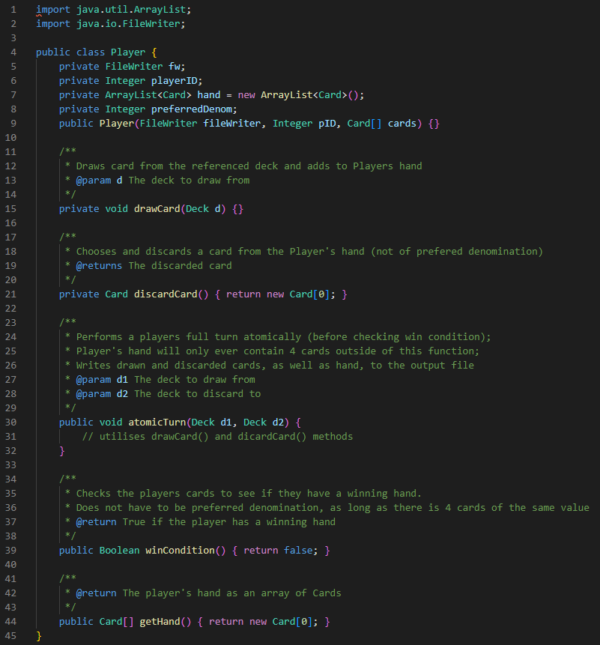The PlayerThread class will encapsulate an instance of the Player class, and implement the threaded behaviour, calling atomic turn method and checking the win condition, notifying the main thread when this is met.

