The Ogone payment extension for NopCommerce is developed by M@ke-IT Consulting bvba. If you need additional support, please contact me at info@make-it-consulting.be.
Ogone Payment Extension for NopCommerce
What do you need to get started with the Ogone payment extension?
- A test account at Ogone. Please visit www.ogone.com to open a free test account. Contact Ogone support to configure your supported payment methods.
- A NopCommerce installation.

Installation of the extension in NopCommerce
- Copy the Payments.Ogone folder (under the install folder) to your NopCommerce store plugin folder.
- Setup your Ogone account. (See ‘Configuring your Ogone account’ for more information)
- Restart your NopCommerce application
- Install, activate and configure your payment method under Configuration > Payment Methods in your NopCommerce store administration website. (See ‘Configuring Ogone payment method’ for more information).

Configuring your Ogone Account
Visit www.ogone.com to create an Ogone test account. Please contact Ogone support if you need any help activating your payment methods. Once your payment methods are configured, go to Configuration > Technical Information to configure your Ogone account.
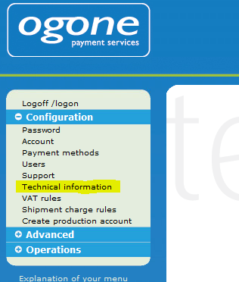
Please configure your Ogone account to your personal preferences, but make sure that the following settings are configured correctly:

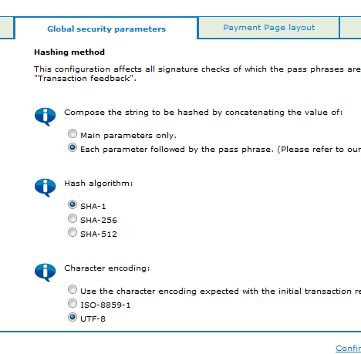
On the tab ‘Global Security parameters’, set the configuration as in the screenshot above.
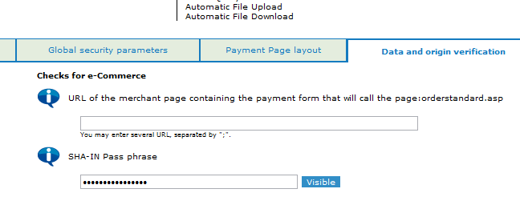
On the tab ‘Data and origin verification’ please configure and remember the SHA-IN Pass phrase, you need it later on to configure the NopCommerce payment extension.
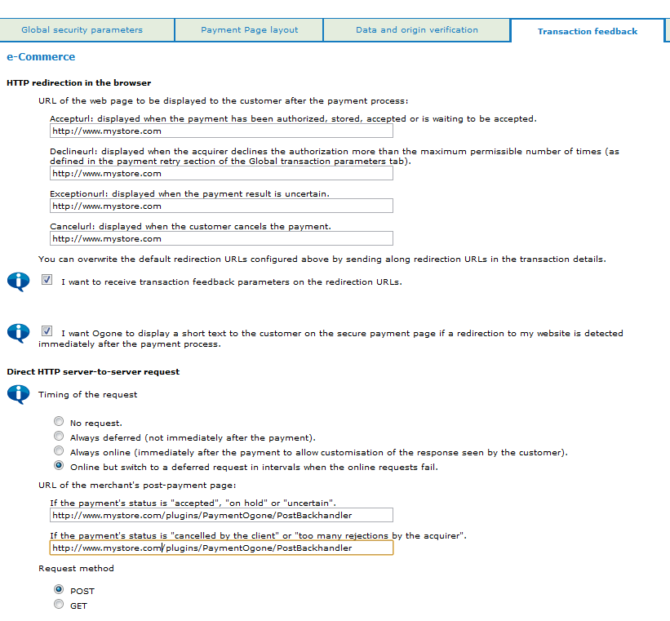
Check the checkbox in front of ‘I want to receive transaction feedback parameters on the redirection URLs’
Configure the ‘URL of the post-payment page’ in both textboxes with the following URL: http://www.mystore.com/plugins/PaymentOgone/PostBackhandler
(Replace www.mystore.com with your own store URL)
Set the ‘Request Method’ on ‘POST’
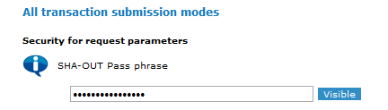
Configure and remember the ‘SHA-OUT Pass phrase’. You need it later on to configure the NopCommerce payment extension
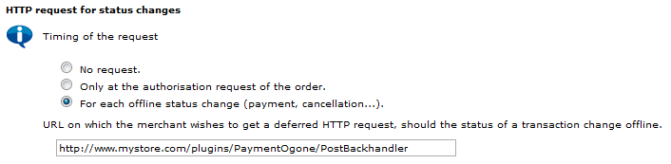
Use the same ‘URL for the HTTP Request for status changes’ as for the ‘URL of the post-payment page’.

Configuring the Ogone Payment Method
After configuring your Buckaroo account you can install, activate and configure the correct payment methods in your NOP commerce webshop.
Login as administrator and open Administration > Configuration > Plugins.
Locate and install the Ogone Payment by clicking on the ‘Install’ link.
Login as administrator and open Administration > Configuration >
Payment Methods.
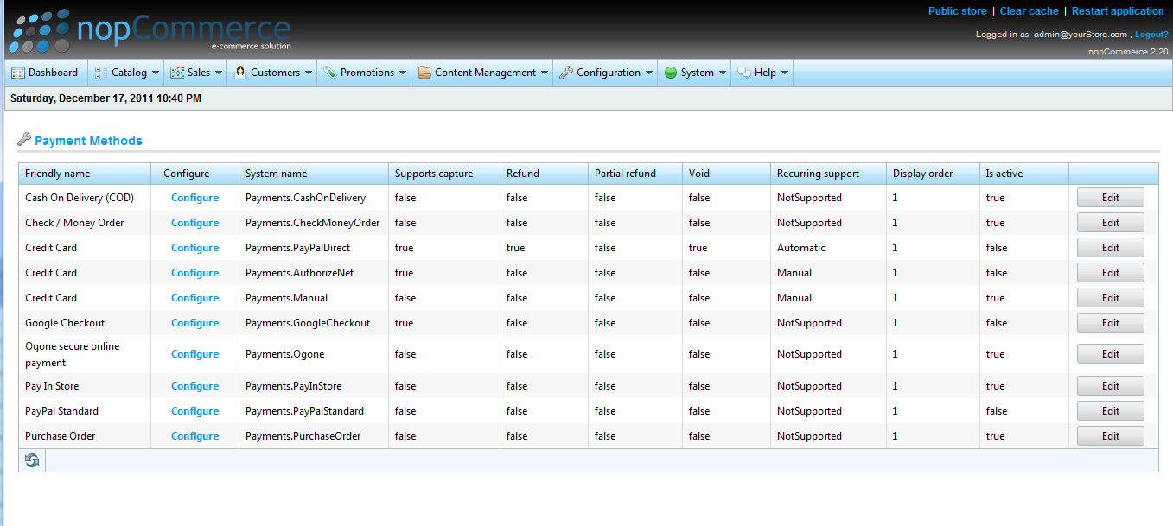
By default all payment methods are deactivated. You need to activate the payment methods you want to offer in your webshop. Before activating the payment methods you need to configure them as follows:
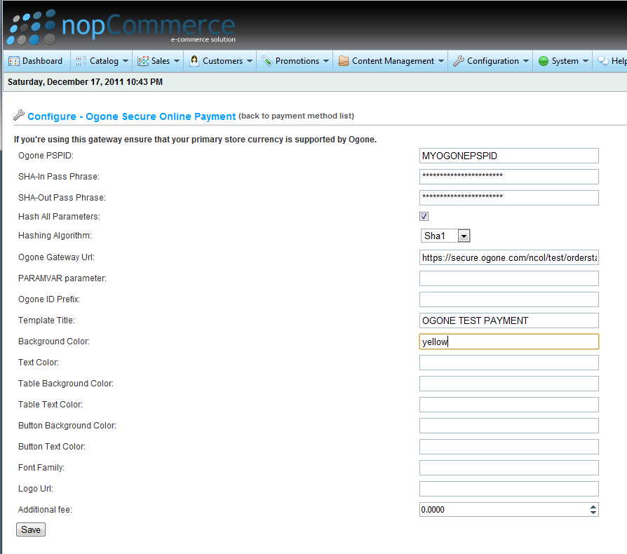
Ogone PSPID: The PSPID of your Ogone Account
SHA-IN Pass Phrase: Use the same pass phrase as you configured on the Ogone website
SHA-OUT Pass Phrase: Use the same pass phrase as you configured on the Ogone website
Hash-All Parameters: <NOT USED
Hashing Algorithm: <NOT USED>
Ogone Gateway URL: Use the following URL: https://secure.ogone.com/ncol/test/orderstandard.asp (Note: Replace the ‘test’ with ‘prod’ in order to use the Ogone production environment. This is very important, do not forget to change this parameter when your site goes life, otherwise the payment of your production site will arrive on your test account!)
Paramvar parameter: Please read the Ogone Integration manual for the use of this parameter
Ogone ID Prefix: Use this parameter to automatically prefix the ordernumbers send to Ogone by your website with the string specified. Leave it blank if you don’t want to use this feature.
Template title: The title of the payment form on the Ogone website.
Background Color, Text Color,… : Use these settings to configure the visual appearance of the Ogone payment form.

Appendix: Customizing the checkout process
1. The Payment info screen:
This screen is shown after the customer had chosen the Ogone payment method in the checkout process.
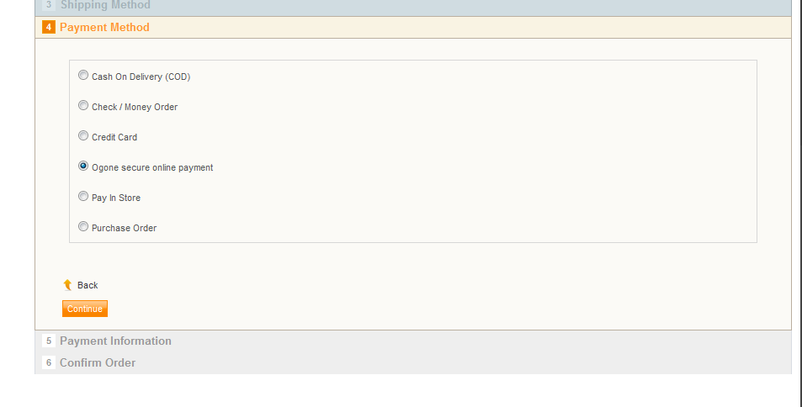
After selecting the Ogone payment method, the Payment Information step is shown. This message can be customized by creating a topic called ‘OgonePaymentInfo’ in the administration website.
In the administration website, go to ‘Content Management’ > ‘Topics’. Create a topic with system name ‘OgonePaymentInfo’. Fill in the title and body of the topic as desired.
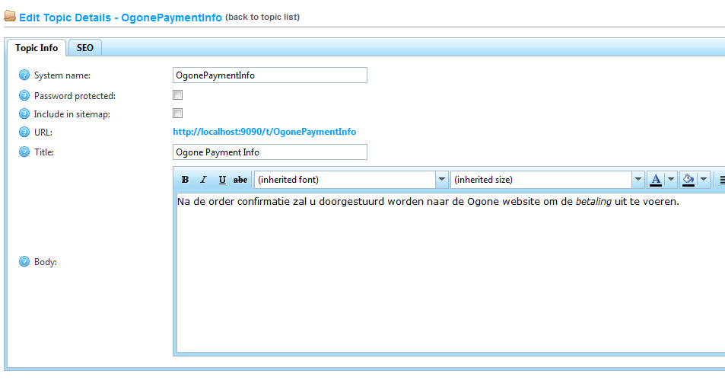
This topic will be shown in the ‘Payment Information’ step.
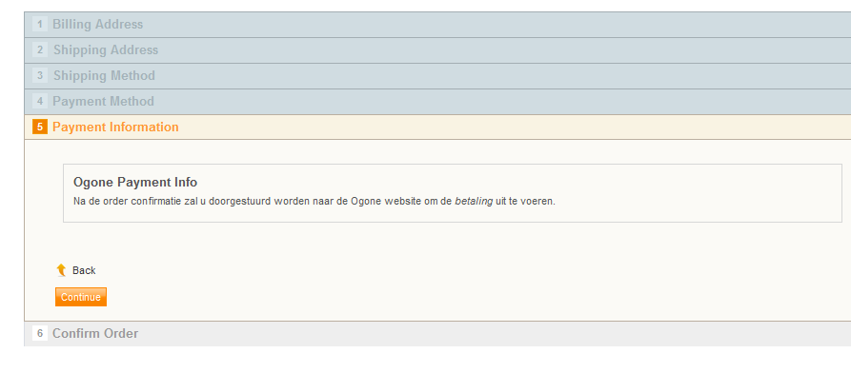
2. Payment cancelled screen.
When the customer chooses to cancel the payment on the Ogone website, he is returned to your store. The text on this page is customizable by creating a topic with system name ‘OgonePaymentCancel’ on the administration website.
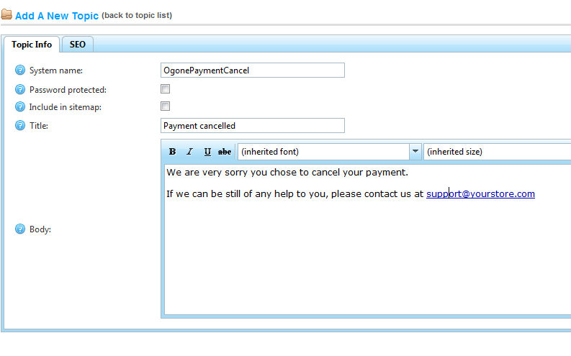
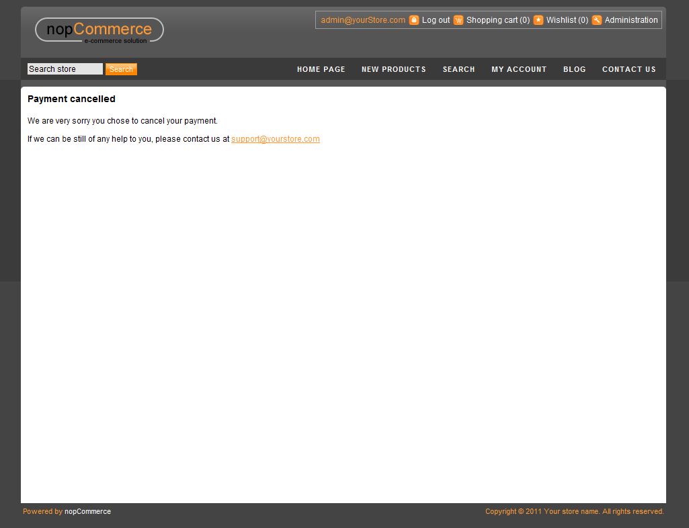
3. Payment declined screen.
When the payment of the customer is declined on the Ogone website, he is returned to your store. The text on this return page is also customizable by creating a topic with system name ‘OgonePaymentDecline’ on the administration website.
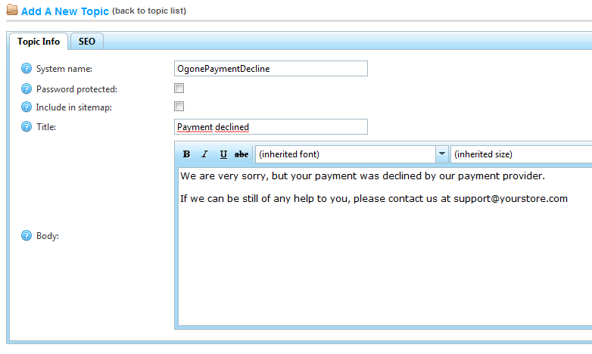
4. Payment exception return screen
When an exception occurs on the Ogone website when processing the payment of a customer, he is returned to your store. The text on this return page is also customizable by creating a topic with system name ‘OgonePaymentException’ on the administration website.
