tactics_pi
a performance enhancement to dashboard_pi
Rev 0.7
Everything started with the question : “Do we make it around the corner of that island when we tack now and sail the same apparent wind angle on the other tack ?“
Disclaimer :
This is still alpha code (not even beta), and you should not use it for live – real sailing.
I will not be liable for any harm, damage or whatever strange things happen if you use this plugin and rely on its data.

What tactics_pi can do :
- Calculate true wind data : TWA, TWD, TWS from true heading (HDT), speed through water (STW) and app. Wind speed (AWS), with optional correction by heel-angle. Calculation is enabled via a preference setting and disables available true wind data from the bus throughout the tactics_pi plugin.
- Calculate the “leeway”, the boat drift based on heel. A common formula is used for that purpose.
- Calculate the surface sea current and display it as single instruments (current speed/direction) as part of the “Bearing compass” or as overlay on the chart (semi transparent). The routines take boat heel and leeway into account. If you don't have a heel sensor, there is a simply workaround, see below. Current display on the chart can be disabled by a preference setting.
- Calculate and display the boat laylines for the current tack, and the same AWA on the other tack. Sea current is taken into account, if available ! Laylines may be toggled on/off. Boat forward direction and for the same AWA on the other tack. Adjustable length and max. width (triangle, with one corner at the boat). The width of the tip shows the boat's yawing (COG changes over time).
- You can load a polar file and calculate/display performance data, like VMG (velocity made good up-/downwind), Target-VMG, Target-TWA (the opt. TWA up-/downwind), CMG (course made good towards a waypoint), Target-CMG (opt. CMG angle and speed), polar speed (the speed you should be able to sail at current TWA/TWS based on your polar),...
- you can set a (one !) temporary tactics waypoint and display the laylines to the mark, based on a Target-TWA calculation, while taking your polar into account.
- it has a “dial instruments” which I called “Bearing compass”. Boat true heading (HDT) points “up”, it shows the boat laylines as well, the surface current, a pointer to the waypoint (either set manually as the temporary Tactics waypoint or read from a NMEA RMB sentence), AWA, TWA and a marker for the Target-TWA. Also it shows pointers for AWA and TWA.
- There are various settings, which I grouped in a separate tab. To access the preferences screen, right mouse click on the tactics_pi window, then select “Preferences ...”
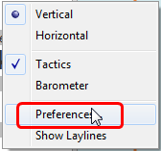

You'll find all seetings in a separate tab “Performance Parameters” :
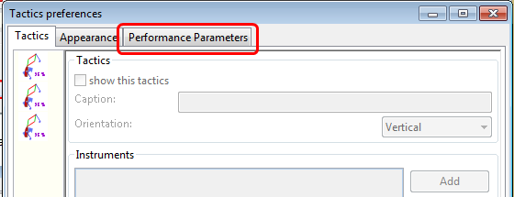

Prerequisites :
- You will need to activate Open GL, if you want to use the chart based functions.
- SOG, COG from the GPS
- preferably True Heading from an electronic compass.
if not available, magnetic heading will do, as long as you have magnetic variance available (either from the GPS RMC sentence or from the wmm_pi plugin)
- Boat speed through water from a log / “paddlewheel” sensor
- Apparent wind angle and apparent wind speed
- Heel sensor which supplies your boat heel angle to O as XDR sentence
If not available, there's a workaround with manual input
- You need a polar file of your boat to use all polar based performance calculations
- Calibrate AWA, Compass HDG/HDT, STW (Speed through water), and AWS (apparent wind speed) as good as possible. Especially the compass heading calibration tends to be neglected. But this is vital for a proper surface current calculation. All I can say is : shit in – shit out … ;-)

See also the Terminology at the very end for explanation of terms

Basic functions which work without a polar file

1. Calculate true wind data
The plugin can calculate true wind data (TWA, TWS, TWD) but keeps the calculated data inside the plugin (it does not broadcast it to O)!
True wind calculation is done silently if you don’t have TWA, TWS, TWD available in your NMEA stream. Furthermore you can force the true wind calculation in the plugin by a preference setting. If the tick “Force True Wind Calculation” is set
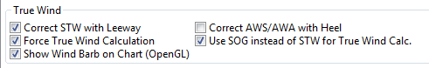

it does not matter if TWA, TWS and TWD are already available on the system or not. Calculation is done in the plugin then. It does calculate TWA, TWS and TWD.
This is e.g. useful, if you have a heel sensor, which is not integrated in your instrument bus. You can use the corrections then to get more accurate true wind data.
Input is AWA, AWS, STW, and for TWD also true heading HDT.
If you don't have HDT on your system bus (but only HDG), you can use wmm_pi.
wmm_pi supplies the magnetic variation and if running is taken into account to calculate HDT from HDG
If you have a heel sensor in your system, and its data is available in O, you can use two corrections
- Correct STW with Leeway :
the plugin can calculate your leeway (drift angle) based on on your heel sensor (see below). That means your boat is possibly moving sideways, which adds an error to the True Wind calculation. Standard instruments normally do not take this effect into account, as far as I know. NKE does this correction in its regatta processor only, but not on their normal instruments.
- Correct AWS/AWA with Heel
This option corrects your AWS and AWA data by the heel angle. Use this option with great care !. Manufacturers normally already do correct this, if you have a heel sensor integrated in your instrument bus. O will simply receive the already corrected data for AWS / AWA then. The result would be wrong data ! I implemented this option for those sailors using an external (or DIY) heel sensor, which is not recognized by their instrument system. You'll get a warning popup as soon as you set the tick.
- Use SOG instead of STW for True Wind Calc.
replaces STW (Speed through water, the “log”) with SOG (from the GPS) in the internal true wind calculation. The idea is simply to have a fallback for the true wind calculation in case your log fails and also to eliminate side effects on the calculation by surface current.

2. Calculate “Leeway”
Leeway describes the drift of the boat due to the force of the wind. Leeway is the basic input for the surface current calulation described later on. Input for the leeway calculation is your heel angle. Normally you'd say : the more you heel, the more you drift . But that's only part of the truth. Other significant inputs are boat speed and the shape of your hull…
A widely (NKE, B&G,...) used formula calculates the leeway with 3 input values : heel, boat speed (STW), and hullshape-factor.
Leeway = hullshape-factor*heel/(STW*STW)
To make this work, you have to estimate the hullshape-factor.
The attribute in the preferences is called “Boat's Leeway factor [0..20]:”
The input range is 0...20, 10 is a good value to start with.
If you don't have a heel sensor on board, you can either set a fixed value ( e.g. 0 when motoring without sails), or try to set up a very simple “heel polar”.
Heel polar :
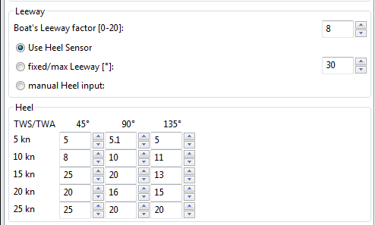

The idea is that almost every magnetic compass installed in the cockpits has a scale, where you can read the degrees of heel.
Then simply compare the O instruments display, for TWA and TWS, read the values from the scale and put it into the small table above.
Please be sure to read True Wind Angle and True Wind Speed and not apparent wind angle and speed !!!
I tried it on my own boat, comparing the heel polar values with those of my sensor. It works astonishingly well.
Even if you use the heel-polar, you have to estimate the “Boat's Leeway factor [0..20]:”
You have 3 choices for heel input, depending on where you set the radiobutton in the preferences. You can switch the radio buttons forth and back while sailing to compare the results, no problem
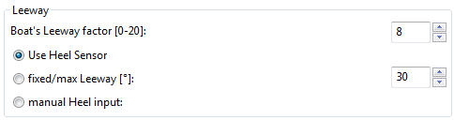

The attribute “fixed/max Leeway [°]:” is dual purpose:
- The given value is always taken into account as maximum possible Leeway value.In the screenshot below, I set it to 30°. If your heel polar or calculation with the formula above outputs values >30°, the program takes 30°.
- If you set the radio button here, the routines always take 30°, no matter what your sensor calculates or your heel-polar would tell you.

3. Calculate the surface current
If you compare your HDT and COG vectors in O (the 2 forward vectors on the chart at your boat), the difference between both is a mixture between Leeway (the boat's drift) and surface current. Once we can determine Leeway, the rest is surface current.
The surface current calculation is simply a triangle calculation with vectors.
Always seen from the current position, the first vector is HDT (degrees) / STW (length).
As your boat drifts with the wind, the second vector is “course through water” (CRS, degrees) and STW (length)
“course through water” is actually HDT with applied leeway.
The resulting vector between CRS/STW and COG/SOG is the surface current.

HDT / STW
Leeway

CRS / STW
COG / SOG
Current
speed / direction

To calculate the current, you need as input HDT, STW, Leeway, COG and SOG and your GPS latitude / longitude.
In the preferences you can set 2 options for the current :
the damping factor : the lower the values are the more filtering is applied, and the reading gets more stable. On the other hand, it starts lagging a bit.
The lower the value, the more damping is applied. Actually I'm experimenting in the range of 0.001 to 0.025. Keep this value at the lower end, the start to increase, until it gets unstable.
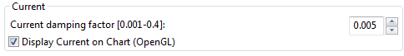

When you set the tick “Display Current on Chart:” you will see a semi transparent blue current symbol underneath your boat, showing the surface current direction

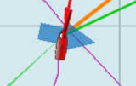

4. Calculate and display the boat laylines
You can show the boat laylines on the chart. They refer to COG.
The colours mean
red = wind from port
green = wind from starboard.
The width is defined by the yawing of your boat, the more you yaw, the wider they get
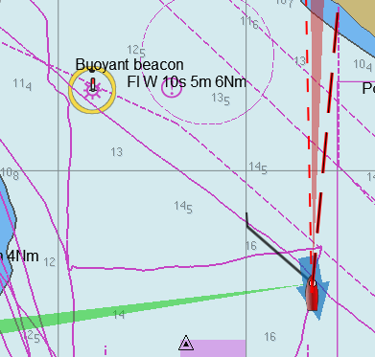

The second layline (green in this example) simply shows you where you would get on the other tack / gybe when you sail the same TWA after the tack. Leeway and current are taken into account for the calculation of the second layline.
In the preferences, you can set the following options :
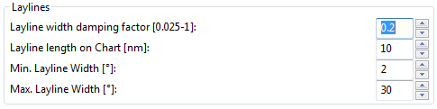

The Layline width damping factor is the rate how fast the layline width reacts on COG changes.
It's done with exponential smoothing, the smaller the factor, the higher the damping rate.
You can define the length of the laylines on the chart, as well as a minimum and maximum width.
If you don't like the yawing effect simply set min and max both to 1 or 2 degrees.
To toggle the layline display on the chart on/off, right-click on the tactics_pi main window and select “Show laylines”
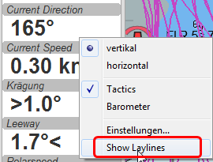

5. Show wind barbs
You can also show a wind barb at the boat position, showing you direction and speed (feather length) in 5 kt steps
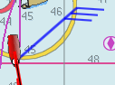

Wind barbs are toggled on/off with a preference setting :
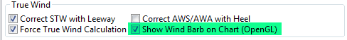

I took the basic code for the wind barbs from the tack and laylines plugin, but had to adopt the transit from one barb to the next level. Furthermore it to show the barbs up to 47 knots correctly now (it ends at 30 kts in the original code)
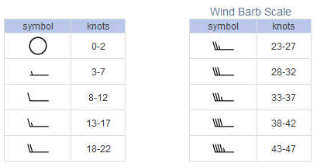
This is the currently implemented wind barb scale (0-2kts has no feather at all) :

6. Instruments :

Current Direction and Current Speed :
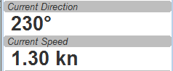

Current direction means “current sets into ...”
Heel :
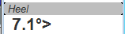

In this example we heel to starboard !
Leeway :
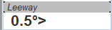

Boat drifts 0.5° to starboard due to heel
TWA to Waypoint
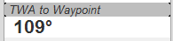

It's meant to do a quick check of the TWA on the (new) tack prior to sailing the tack/gybe maneuver.
Either place a WP in the GPS( NMEA--> RMB) or simply drop the TacticsWP on the new course line.
As with the other functions, the “Tactics temp.WP” overrules the RMB coming in from a GPS.
It should give you an idea which gennaker/spi or sail to select on the next tack.

“App.& True Wind Angle” dial instrument with TWD display
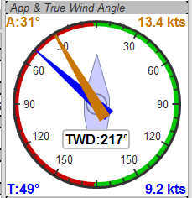

I added the TWD to the dial instrument; this saves some space on the screen for an extra instrument

Performance functions which need a polar file

1. Load a polar file
You can load a polar file from the preferences screen
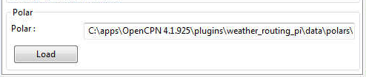

Click on the load button and select a polar file.
The format is the same that polar_pi uses (or better: used last summer). I took the basic code from there, to keep the plugins consistent. This is also the reason why I did not spend time in displaying the polar again. You can use polar_pi instead.
When loading the polar, it is written to a 2 dimensional static array with 181 lines for each TWA degree (0...180°) and 61 rows (0...60) for each knot of windspeed. It's a simple lookup table for the latter use, with the purpose to reduce the processor load and increase access speed in normal use.
Loading Procedure :
1. The whole array is prefilled with NAN values.
2. The values from the polar file are placed at their corresponding spots in the array
3. The missing data in between given values (= not NAN) is then filled with average values.

Please note :
- only polars with TWA / TWS / STW, and TWS/STW in knots make sense
- I do not extrapolate polars beyond their outside limits.
If you run in a 30kt wind, and your polar ends at 25 kts, then the performance instruments will give you a “no polar data” text. I suggest that you turn polar_pi / vdr_pi on at that point and record your data :-)
The only exception of the extrapolation is the range between the 0 kts windspeed and the first given value.
I do simple averaging here.
In other words : if yellow is the whole polar from TWS 0-60 kts and TWA 0-180°prefilled with NAN, and red is your polar data, you will get the green square filled with data.

TWS
0 60kts
TWA
180 0

See the ini file chapter, how you can read out the array as a text file.
At the current state of implementation, I don't do any averaging at runtime in the array, although I planned that for the near future.
Before accessing the lookup table, I'm rounding the input to the next full knot / degree.
It makes life a hole lot easier while debugging, if you really find the returned values in the array ...

2. Performance data
various performance data is available as text instruments. See the following chart for reference on the different terms in relation to a polar curve
VMG
True Wind
Polar Speed
Act. Boat Speed
Target Speed
Target Speed
Target VMG angle
= Target TWA
Waypoint
CMG

For some of the instruments I split the display in a % value for your current speed in relation of the polar data value as 100%.
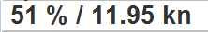

In this example, we're currently doing (only) 51%, of what the polar has stored as optimum value. According to the polar we should be able to do 11.95 knots.
The reason to do so was simply that the data belongs together anyway and so to save space on the screen

Polarspeed :

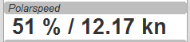

This is simply the reference of what speed we should be able to sail based on our current TWA / TWS values. The % value is the reference to STW.
This is actual boat speed versus polar speed in the drawing above.
Values below 100% mean, where slower than the polar says, above 100% mean where faster than the polar (we should run vdr_pi now to record the data) :-)
Useful in crosswind / reaching conditions without a waypoint
It shows the optimum speed for the given wind conditions.

Actual VMG:
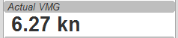

Is the “Velocity made good” refering to the wind direction. The means we're moving with 6,27 kts into wind direction. Also works when we sail downwind (then it's off the wind)
VMG = STW * cosine (True Wind Angle)

Target VMG-Angle :
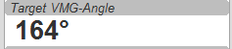

Also known as Target TWA; this is the optimum TWA (True Wind Angle) when sailing upwind or downwind for a given wind speed, based on your polar data. Very useful when sailing up-/downwind without a waypoint.
The program simply searches the polar with a given TWS for the optimum TWA up-/downwind. It's defined as the tangens on the polar.

Target VMG :
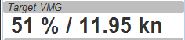

Also known as “target boat speed” (target speed in the diagram above)
This is the reference to the Target VMG-Angle. In our example it means :
If we would sail with 164° TWA (from ex. above), then we could make 11.95 knots according polar), but currently we're doing only 51% of that.

Actual CMG:
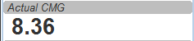

Actual Course Made Good = aka VMC; speed towards a waypoint. We're moving with 8.36 knots towards a waypoint
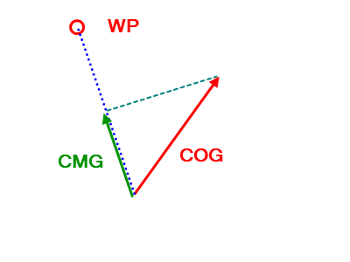
CMG = STW * cosine (Heading - Marks bearing)

Quite valuable on reaching courses towards a waypoint.

Target CMG Angle :
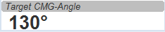

Optimum angle to sail fastest to a waypoint, based on your polar data (Like VMG, but not up-/downwind but towards a waypoint).

Target CMG :
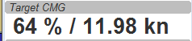

Same as Target VMG, but towards a waypoint. Means : “If we would sail 130° (Target CMG Angle, from ex. Above), we would move towards the waypoint with 11.98 knots, but currently we're only doing 64% of that.
Comment : Calculation is verified, but it doesn't tell you (yet) if you're on the correct tack
Polar Performance
– sail trimming aid --
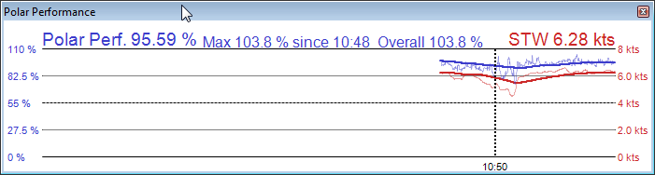
A new graphical instrument like Wind-History or Baro-History.
It simply plots the STW (speed through water) as percentage of the polar speed data (=100%) for the actual true wind speed TWS and true wind angle TWA. It is this comparison in the polar chart above, plotted as %
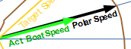

The idea is a simple sail trimming aid, as the percentage value is quite stable in comparison to the real speed values. And TWA / TWS is constantly adjusted while reading the polar data.
Message : as long as the filtered curve points upwards your trim adjustments were right, if it points down, you're sailing worse than before ...
Comment : Still needs probably adjustments with the damping factor, # of points plotted, etc.

Temporary waypoint and Target-TWA laylines
You can right-click on any place in the chart and drop a temporary waypoint (exactly one).
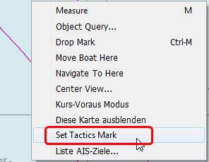

As soon as you activate the layline display, the plugin will do a Target-TWA calculation to that WP, based on the current TWD and your boat polar. Surface current is taken into account.
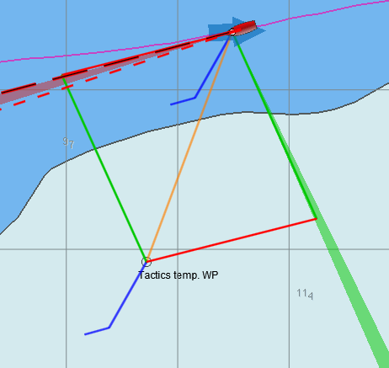

You can delete that waypoint as any other WP. Select it with right click and choose “Delete”.
You can drag the waypoint on the chart, it behaves like a normal waypoint. Depending on your settings in O you may have to open the WP properties to drag.
Currently it takes the Target-VMG (Target-TWA) angle up-/downwind and applies it to our boat as well as to the mark (Tactics temp. WP).
If there is a line intersection, it chops off the lines at the intersection, et voilà ….
Colours green and red are again the wind directions green = wind from starboard, red = wind from port
Additionally I do a polar based calculation to see if the direct course would be faster compared to the Target-VMG calculation.
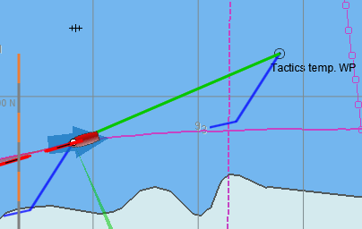
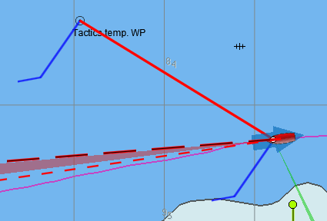
In that case you'll get a red or green line directly to the waypoint. Colour depends on the side the wind is blowing from. Wind from port → red, wind from starboard → green

As you can see here I'm placing a wind barb also on the tactics waypoint.
Please note :
In contrast to weather routing, I'm explicitly not using grib files here for current/wind info. The “Temp. Tactics Waypoint” is meant for a quick, near run around a buoy, cape of an island, etc. using the live wind data we currently experience and the momentary surface current. Just drop a mark on the chart and off you go. Delete it, drop it somewhere else, and boom, off you go again. Maximum one tack/gybe not more.

Bearing compass
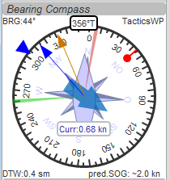

Nice dial instrument, inspired by NKEs tactics page, which I called Bearing Compass.
UP- direction is HDT, in this example (356°T)
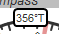

Surface Current:
We see the blue surface current arrow based on boat heading (HDT) and the current speed “Curr: 0.68 kn”
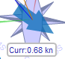

Needles for TWA and AWA :
Furthermore we have the blue, thin arrow, which is TWA on boat axis. It also shows the TWD on the degree scale (315°) and the AWA arrow in orange/yellow (standard dashboard colour)
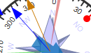

Laylines :
You see the red/green laylines, which are based on COG. As with the laylines on the chart,
the second layline shows you where you end up sailing the same TWA on the other tack.
Leeway and current are taken into account.
Use the second layline together with the waypoint marker described below.
Please note : the calculation is based on TWA. Especially when sailing downwind with a gennaker, your apparent wind angle depends very much on the speed of the boat. As soon as the gennaker start working aerodynamically, it’ll speed up the boat and your AWA will show lower values (points more foreward). If you gybe now, your boat speed will drop, and although sailing the same TWA, your app. wind angle will be higher than before. You will have to bring you boat back up to speed to see the same AWA than before the tack.
This can be tricky when you’re close to a buoy and don’t have much space/time to speed up your boat again.

Target VMG Angle indicator :
The blue triangle outside the degree scale is the Target-VMG Angle (Target TWA)
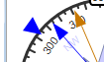

Simply adopt your course to place your blue TWA-arrow on the Target-VMG pointer, and you sail optimum (polar based) speed up-/or downwind.

Waypoint marker :
If a waypoint is active, either by a NMEA-RMB sentence from your GPS or the temporary tactics WP which you can place on the chart, you will see the WP as a red dot.
The manually placed tactics WP overrules a parallel available RMB sentence
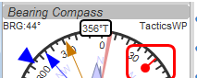

Change your course and place it under the layline ( the red one in this example) and you will directly bump into it.
Or use the second layline to determine when it is time to tack towards the waypoint and when you will make it around the WP (the red dot should be outside the second layline then)

Additional data :
The top 2 corners show the bearing to the WP and the name of the WP (See screenshot above).
The lower 2 corners give you
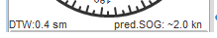

DTW = the distance to the WP and predicted speed over ground on the other tack, assuming that you sail the same TWA on the other tack. This simply drops out of the surface current calculation …

Settings in the INI file
I added a complete tab “Performance parameters” with all the settings
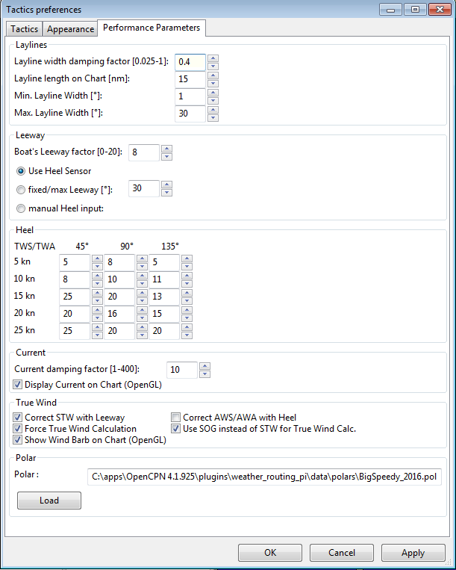
The Apply button set the global variables which are used for the preferences directly, without closing the pref’s window.
All parameters are written to the opencpn.ini file using the standard “dashboard” functionality, i.e. when closing tactics_pi itself. I’ll add a “Save” button here, which directly writes to the ini file.
You'll find all keys under section [PlugIns/Tactics] and subsequent sections starting with [PlugIns/Tactics/...]
The basic setup is inherited from dashboard_pi, I did not change any of the “original dashboard” keys, but added some

Relevant are :
[PlugIns/Tactics]
…
CurrentDampingFactor=0.003
MinLaylineWidth=2
MaxLaylineWidth=30
LaylineWidthDampingFactor=0.2
ShowCurrentOnChart=1
LaylineLenghtonChart=5
[PlugIns/Tactics/BearingCompass]
DampingDeltaCoG=0.4
MinLaylineDegrees=2
MaxLaylineDegrees=30
[PlugIns/Tactics/Performance]
PolarFile=C:\\apps\\OpenCPN 4.1.925\\plugins\\weather_routing_pi\\data\\polars\\Aki950routage.pol
PolarLookupTableOutputFile=C:\\temp\\Polar.txt
BoatLeewayFactor=8
fixedLeeway=30
UseHeelSensor=1
UseFixedLeeway=0
UseManHeelInput=0
UseSOGforTWCalc=1
Heel_5kn_45Degree=5
Heel_5kn_90Degree=5
Heel_5kn_135Degree=10
Heel_10kn_45Degree=8
Heel_10kn_90Degree=10
Heel_10kn_135Degree=11
Heel_15kn_45Degree=25
Heel_15kn_90Degree=20
Heel_15kn_135Degree=13
Heel_20kn_45Degree=20
Heel_20kn_90Degree=16
Heel_20kn_135Degree=15
Heel_25kn_45Degree=25
Heel_25kn_90Degree=20
Heel_25kn_135Degree=20
I think they are selfexplaining, if you compare the settings with the preferences screenshot above.
All damping factors are “alpha” from the standard exponential smoothing formula, except CurrentDampingFactor where I'm using double exponential smoothing at the moment.
They should range between something above 0 and 1, the smaller the number, the higher the damping, 1 means no filtering at all
Recommendation : Use CurrentDampingFactor with low values, like 0.03 to get a stable reading
One interesting key, which is not available in the preferences screen is PolarLookupTableOutputFile
As explained earlier, the polar file is loaded into an array. When you set this key, you can dump that array to a (tab delimited) text file, which can be read e.g. with notepad++.
As mentioned earlier, this array is prefilled with NAN values, NANs are reflected in the file as “-1.#J”.
If you want to see/check that, just add that key manually under section [PlugIns/Tactics/Performance]
Make sure the path exists and the given file is writeable. There's no safety checks implemented here, so use at your own risk.

There are more keys and sections for tactics_pi but all others came with dashboard_pi and were not touched by me.

Restrictions/known issues at the time being :

- If you play around with loading and playing different VDR files, sometimes the “Bearing Compass” hangs up. Looks like a GPS timeout problem to me. It never happened to me in live sailing though...
- “Target CMG” is working correctly but does not yet tell you neither the correct tack, nor a possibly existing second (but lower) maximum for the other tack
- Foolproofness is still missing :
I didn not fully verify yet what happens when you do not load a polar file at all, or if all polar files can be loaded correctly or what happens if you enter an invald setting, invalid polar file, etc.
- Wind barb display on chart ends at 47 knots. Any windspeed higher than that is displayed as “45 knots”

Terminology :
Term | Description
AWA | Apparent Wind Angle; the relative wind angle measured by your wind sensor, related to the boat axis(0°...180°)
AWS | Apparent Wind Speed; the relative speed of the wind measured by your wind sensor
CMG | Course Made Good; the speed approaching a waypoint
COG | Course Over Ground; generally supplied by the GPS
HDG | Magnetic heading of your compass; not compensated with mag. variation
HDT | True heading of your compass. “True” means compensated with magnetic variation
Heel | The angular degrees how your boat is heeled (leaning) sideways due to any force from outside (wave, wind, water ballast on one side of the boat, swing keel etc....)
CRS | Course through water; HDT + Leeway, but without currents
Leeway | the drift of your boat based on the wind. As soon as the wind is blowing it implies a force on your boat, the boat starts drifting. Leeway is NOT including any drift due to surface currents ! That's actually the challenge :-)
SOG | Speed Over Ground; generally supplied by the GPS
STW | Speed Through Water; the info that is returned by your “paddlewheel” sensor
Target CMG | The optimum speed / angle towards a waypoint; aka VMC
Target VMG | The optimum speed / angle up- or downwind with reference to the true wind direction (without a waypoint)
TWA | True Wind Angle; the angle of the true wind relative to the boat axis (0°...180°). The unit then gives you the direction as “>”=port, “<”=starboard
TWD | True Wind Direction; true wind direction related to the compass rose (0°..359°)
TWS | True Wind Speed; the speed of the wind in the atmosphere
VMC | Velocity Made on Course; same as CMG
VMG | Velocity Made Good; the speed up-/downwind with reference to the true wind direction

How to align/check your magnetic compass with O
- Swing your compass as described by the manufacturer
- Connect your GPS to O to get a stable position
- make sure you have true heading available (use wmm_pi, in case you don't get the mag. variation from the GPS)
- directly in O, set your heading predictor to a high value, e.g. 10 miles
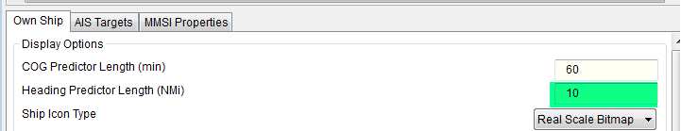

- Put the mouse onto the (thin HDT) preditor line towards the end of the line (the long line reduces the error)
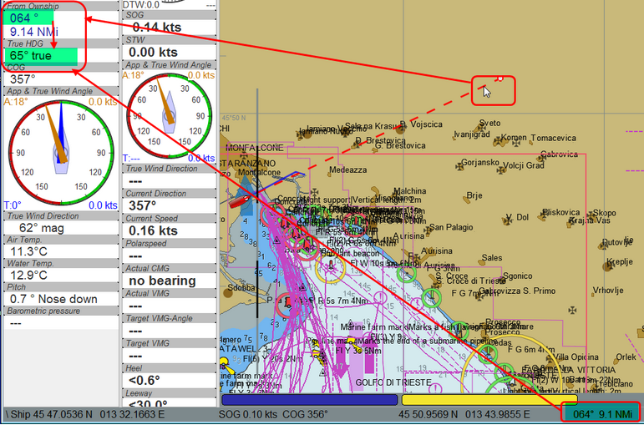

- simply compare now true heading with the status line or the "From Ownship" display...
- then adjust your compass (in this case : -1°)
That's it…
History
Rev | Date | Remark
1.0 | 24.05.2016 | Initial release
1.1 | 24.05.2016 | Corrected description of true wind calculation
1.2 | 25.05.2016 | Wind barbs corrected; steps corrected and enhanced up to 45kts
1.3 | 07.06.2016 | “TWA to Waypoint” instrument implemented
0.4 | 11.06.2016 | Laylines-to-waypoint reworked, documentation updated  Changed Rev from 1.4 to 0.4 to keep the plugin version inline with the doc version
0.5 | 14.06.2016 | Preferences with scrollbar, internal icons updated
0.6 | 27.06.2016 | - Added TWD to the “App. & True Wind Angle” dial instrument;  - Option added to use SOG instead of STW for true wind calculation  - code cleanup  - “Apply” button added to the preferences
0.7 | 04.07.2016 | - Polarspeed, Target-VMG, Target-CMG, Target-CMG Angle instruments corrected for user speed settings  - Added STW to Polar Performance instrument as second graph  - minor corrections
0.7.3 | 16.07.2016 | - User settings for wind / boat speed implemented  - Watchdog for RMB implemented to recognize the loss of waypoint data in “Bearing Compass” and “TWA to Waypoint” instruments  - usage of default plugin svg icons for “journeyman” styles  - picture added for CMG

