**INSTRUCTION HOW TO CREATE COMPILATION ENVIRONMENT**

1. Unzip the Windows Port zipped file into directory: C:\SOFTWARE\UCOS-II

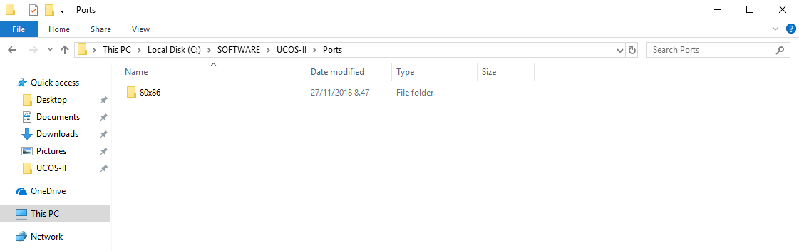

**Figure 1: Unzip Port file into C:\SOFTWARE\UCOS-II**

1. Unzip the general part of uCOS into C:\SOFTWARE\UCOS-II\SOURCE

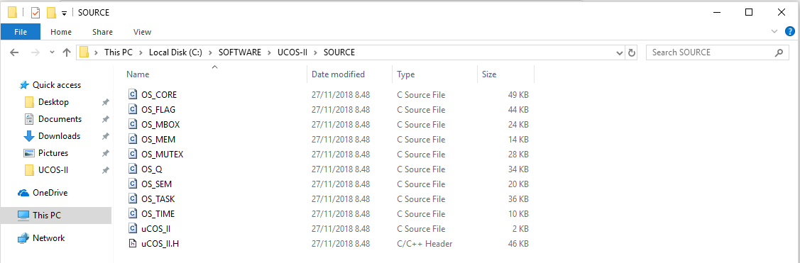

**Figure 2: Unzip the general part of uCOS into C:\SOFTWARE\UCOS-II\SOURCE**

1. unzip the first exercise RTOS_1 in to directory C:\SOFTWARE\uCOS-II\Ports\80x86\WIN32\VC\exercises\

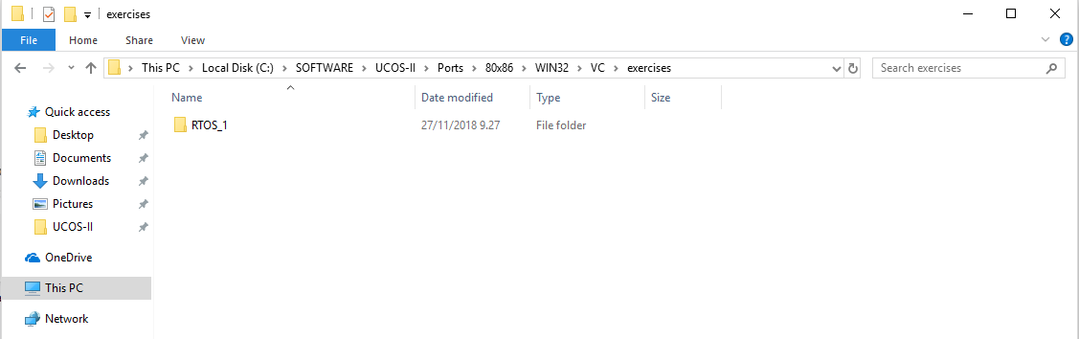

**Figure 3: RTOS_1 file in C:\SOFTWARE\uCOS-II\Ports\80x86\WIN32\VC\exercises\**

1. In the rtos_1.c file, command the line 38

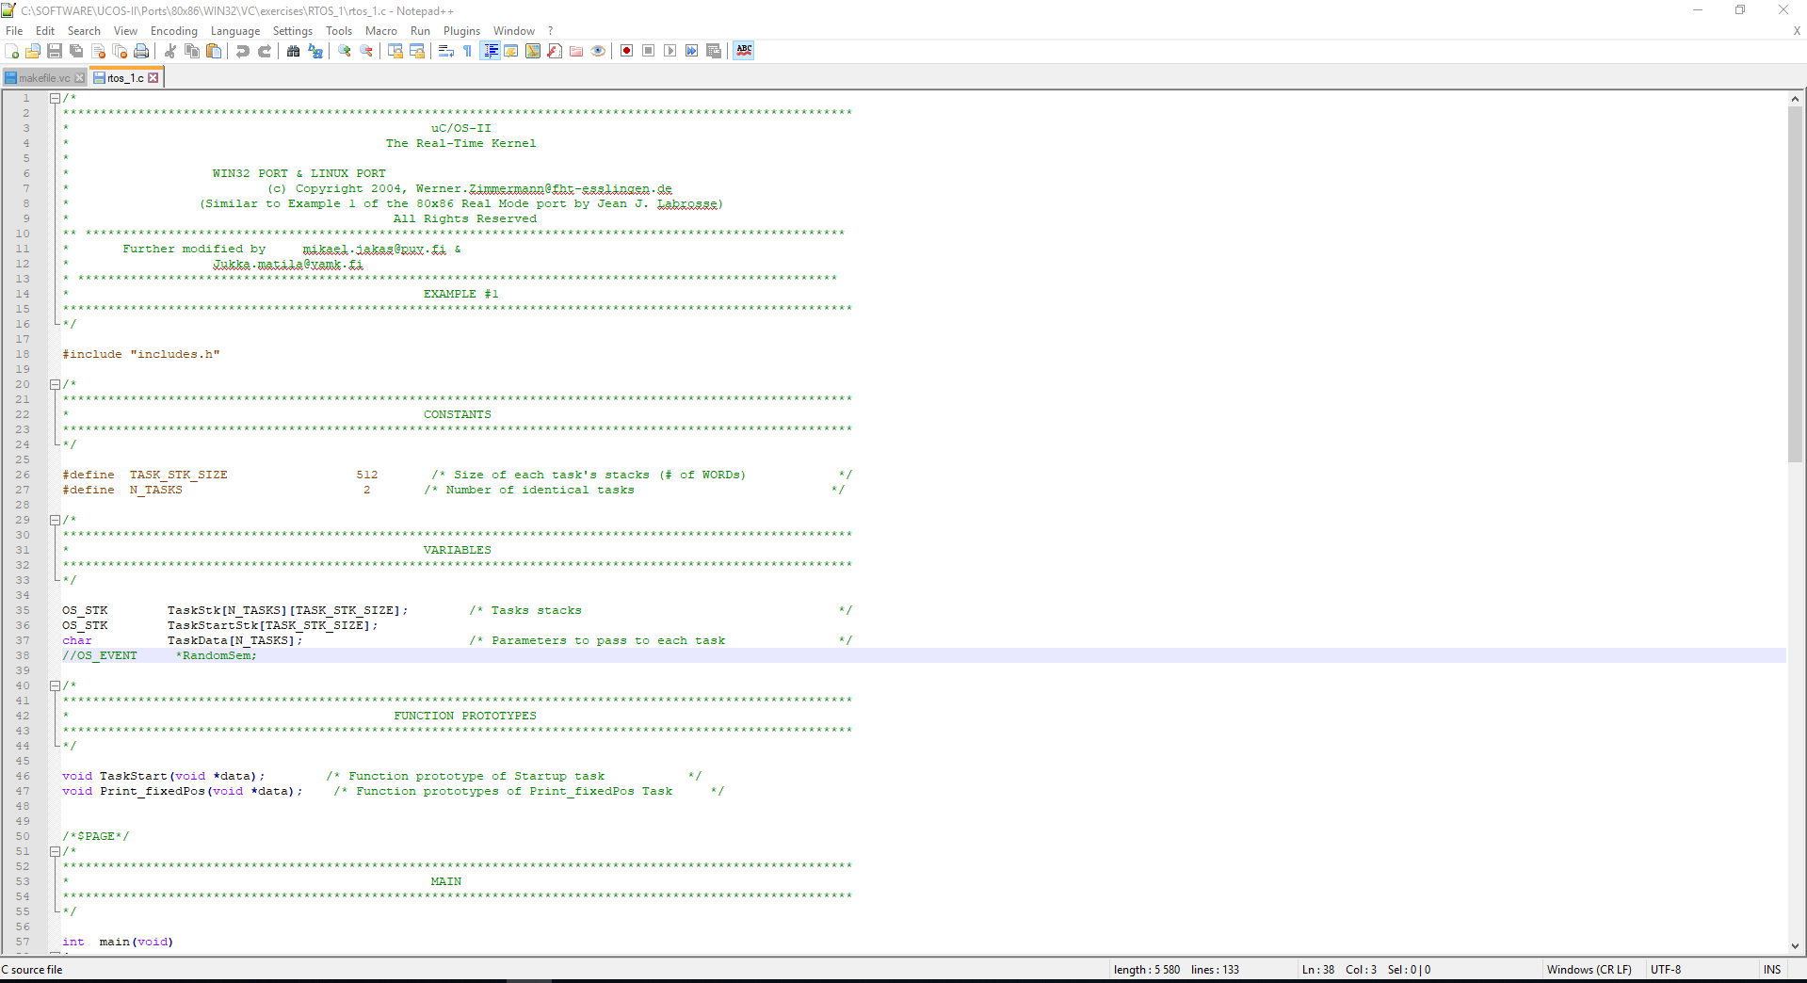

**Figure 4: Change the rtos_1.c file**

1. Move to the working directory to place where the makefile is (C:\SOFTWARE\UCOS-II\Ports\80x86\WIN32\VC\exercises\RTOS_1) and use Visual Studio Command Prompt to run the command: **nmake /f makefile.vc all**

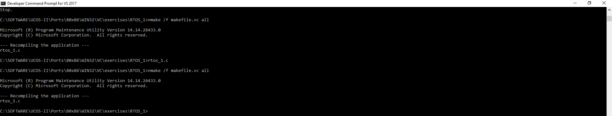

**Figure 5: makefile command**

1. Run the program using rtos_1.exe

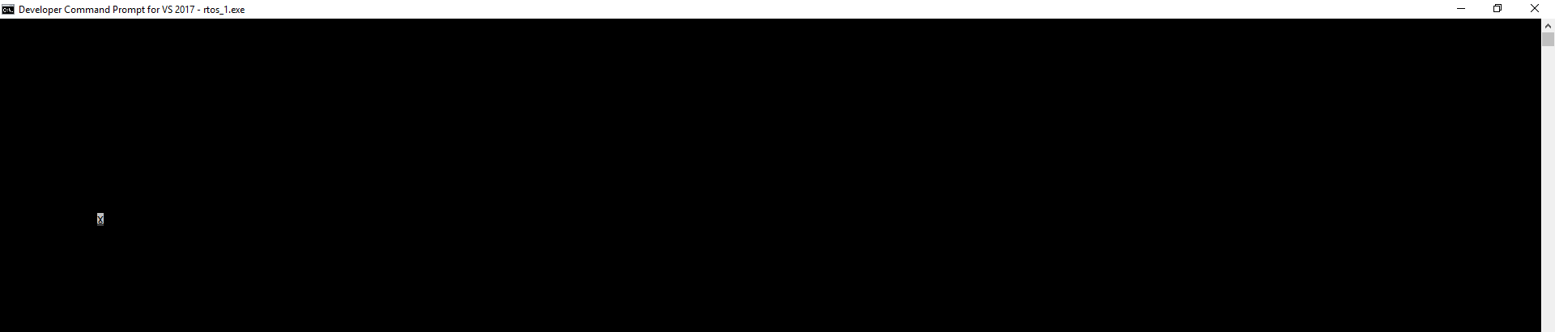

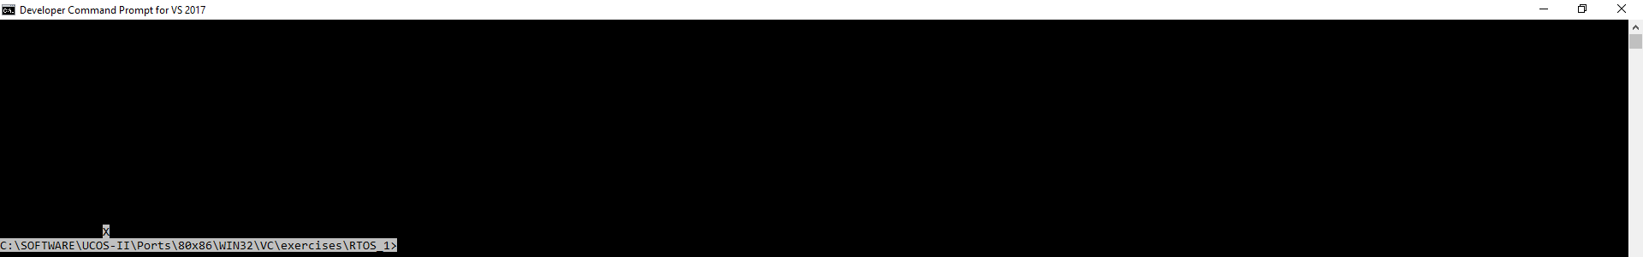

**Figure 6: Run the program**