ETH Policy Paper Input

Michiel van Dijk

February 14, 2017

# Maize in Ethiopia

This section should provie an overview why maize is an important food crop in Ethiopia/Ghana. Tom will prepare a table with key data from FAOSTAO and maize yield trends in comparison with other countries. We also might add some references to past/current policies to improve maize production.

**Table 1: Key data on the maize sector in Ethiopia/Ghana** To support this reasoning we can use the following information: - Area % of total crop area - Share of hybrid seeds - Average yield - Fertilizer use per ha - Share of calories - % of import/export

|  |  |  |  |
| --- | --- | --- | --- |
| Variable | Last Recorded Year | Value in Last Year | 5 Year Average |
| maize Yield | 2,014 | 3,421.00 | 3,045.62 |
| Maize Area Share | 2,014 | 14.00 | 13.50 |
| Fertilizer Use per 1000 ha | 2,010 | 10.42 | 7.93 |
| SSR | 2,013 | 100.01 | 99.81 |
| Maize Calories | 2,013 | 18.69 | 19.03 |

##### Source: FAOSTAT [accessed XX-XX-2017]

**Figure 1: Yield development in Ethiopia compared to other regions** 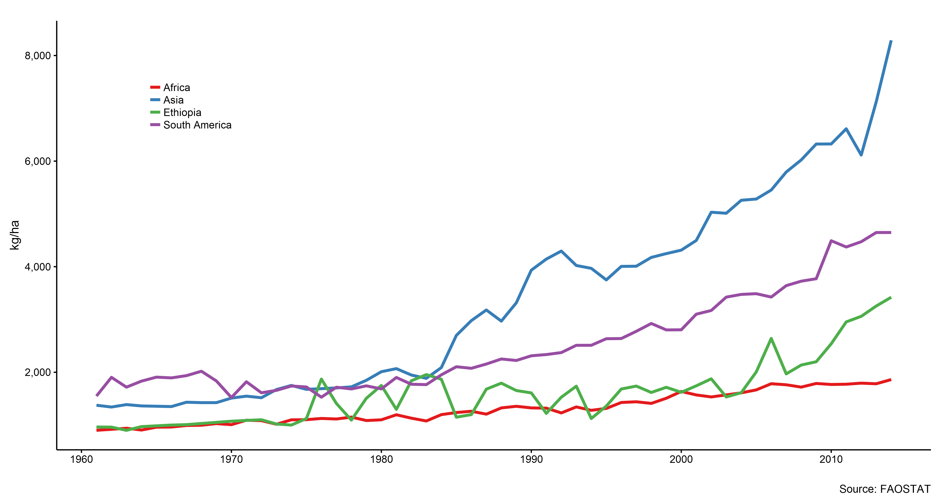

##### Source: FAOSTAT [accessed XX-XX-2017]

# What are yield gaps and why are they important?

The notion of yield gap originates from agronomy and production ecology. It is the difference between the potential yield and the actually observed yield at the farm, field or plot level (Van Ittersum and Rabbinge 1997, Fischer (2015)). It can be either expressed as a difference (in tonnes per hectare) or as a fraction. Potential yield is defined as *"the yield of a cultivar when grown in environments to which it is adapted, with nutrients and water non-limiting and with pests, diseases, weeds, lodging, and other stresses effectively controlled”* (Evans and Fischer 1999). It refers to the biophysical maximum production level of a crop with growth only constrained by so-called *growth defining factors*, which including atmospheric CO2 emissions, solar radiation, temperature and plant characteristics. In large parts of Africa, crop systems (including maize cultivation in (**???**)) are rainfed. As water is structurally limitated for these systems, water-limited potential yield, which assumes water is limited by natural rainfall is the suitable benchmark. The preferred approach to estimate potential yield is by means of crop models that simulate all details of the plant growth process (Ittersum et al. 2013).

In practice, actual farmers’ yield is lower than potential yield due to a wide number of interrelated agronomic and socio-economic factors that differ by region (Fischer, Byerlee, and Edmeades 2014). According to a survey of expert opinions (Gibbon, Dixon, and Flores Velazquez 2007), the main agronomic factors that constrain maize yield in Sub-Saharan Africa are soil constraints, weeds and drought. These are largely technical problems, which are caused by deeper socio-economic and institutional factors. It is well known that a key reason for low yields in Africa is the low use of fertilizer, which, in turn, is caused by a combination of high fertilizer prices and low crop prices, limited information and, weak distribution and marking systems (Morris et al. 2007). Similarly, other studies found strong relationships between yield (and yield gaps) and the quality of infrastructure, provision of credit and avaiability of extension services (Neumann et al. 2010, Dorosh et al. (2012), Bravo-Ureta et al. (2007), Ogundari (2014)).

According to the latest FAO projections, agricultural production in Sub-Saharan Africa (SSA) will have to triple to fulfil demand by 2050 (Alexandratos and Bruinsma 2012). Around 80 % of the projected growth will have to come from intensification, predominantly an increase in yields through better use of inputs. Yield gap estimations and explanations provide important information on the scope for production increases on existing agricultural land through better farming systems, farm management and enabling policies (Mueller et al. 2012, Laborte et al. (2012)).

# Maize yield gaps in Ethiopia

The Global Yield Gap Atlas (GYGA) is an international project that presents consistent estimates of potential yield and yield gaps for nine major food crops in a large number of countries, including maize in Ethiopia/Ghana (Ittersum et al. 2013, Grassini et al. (2015)). Potentiel yield is calculates using robust crop simulation models using local weather station data and (**???**) as imput. Information on actual yield has been collected from local and national statistical sources and input from country agonomists and experts. Figure 2 and 3 present a map of the water-limited maize yield potential and the corresponind yield gap in Ethiopia. Potential maize yield ranges from over 18 tons/ha in the West to below 9 tons/ha in the East of Ethiopia. Actual farmers' yield lies below 1.7 and 2.5 tons/ha resulting in yield gaps of between 88 and 63 percent. Hence, there is large scope to increase maize yield in the future.

**Figure 2: Water-limited Maize yield potential in Ethiopia**

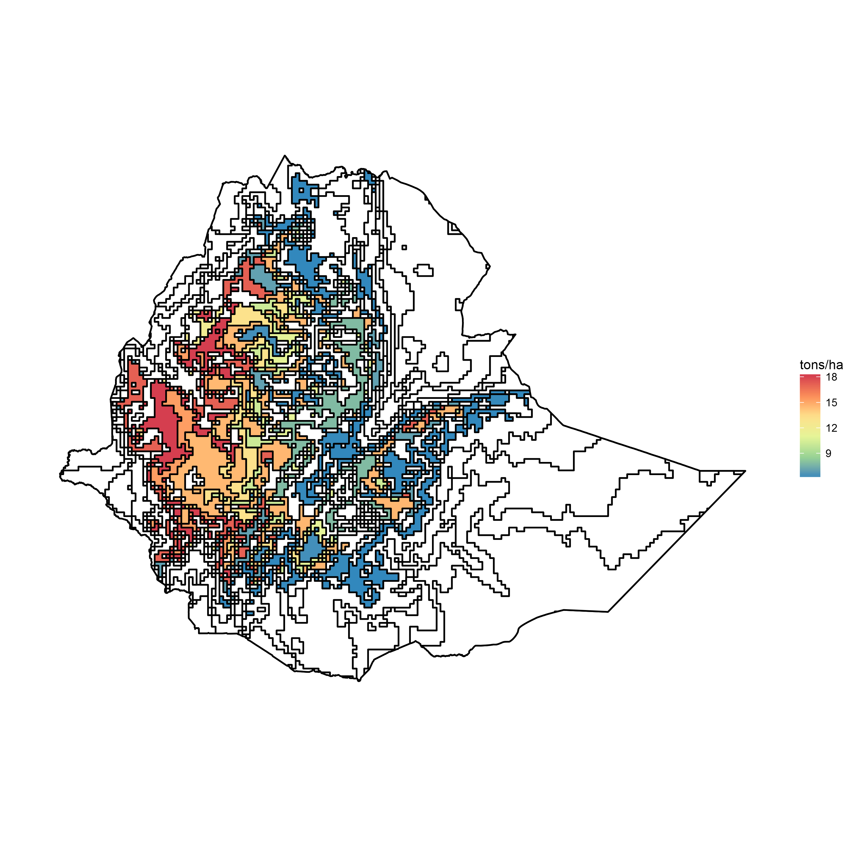

**Figure 3: Maize yield gap in Ethiopia**

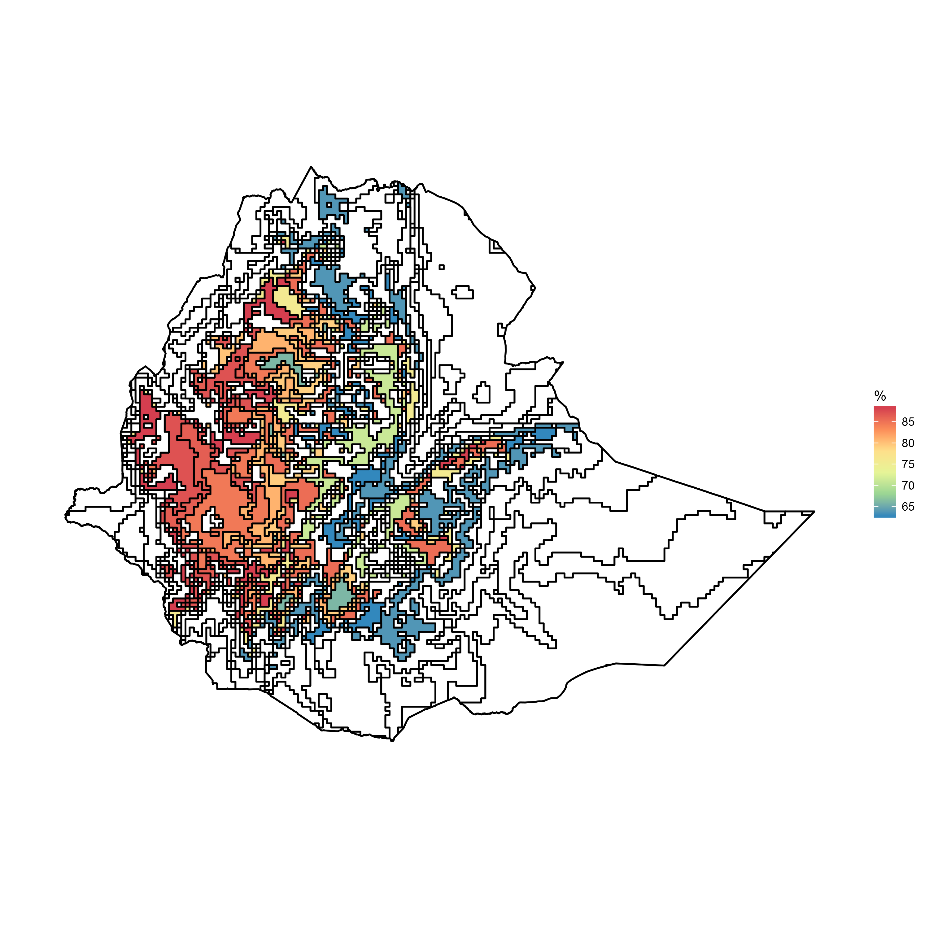

# Improving future food security by closing the yield gap

The results from GYGA can be used to answer the question if Africa (including Ethiopia/Ghana) can feed itself in the future.

**Figure 4: Maize yield gap in Ethiopia**

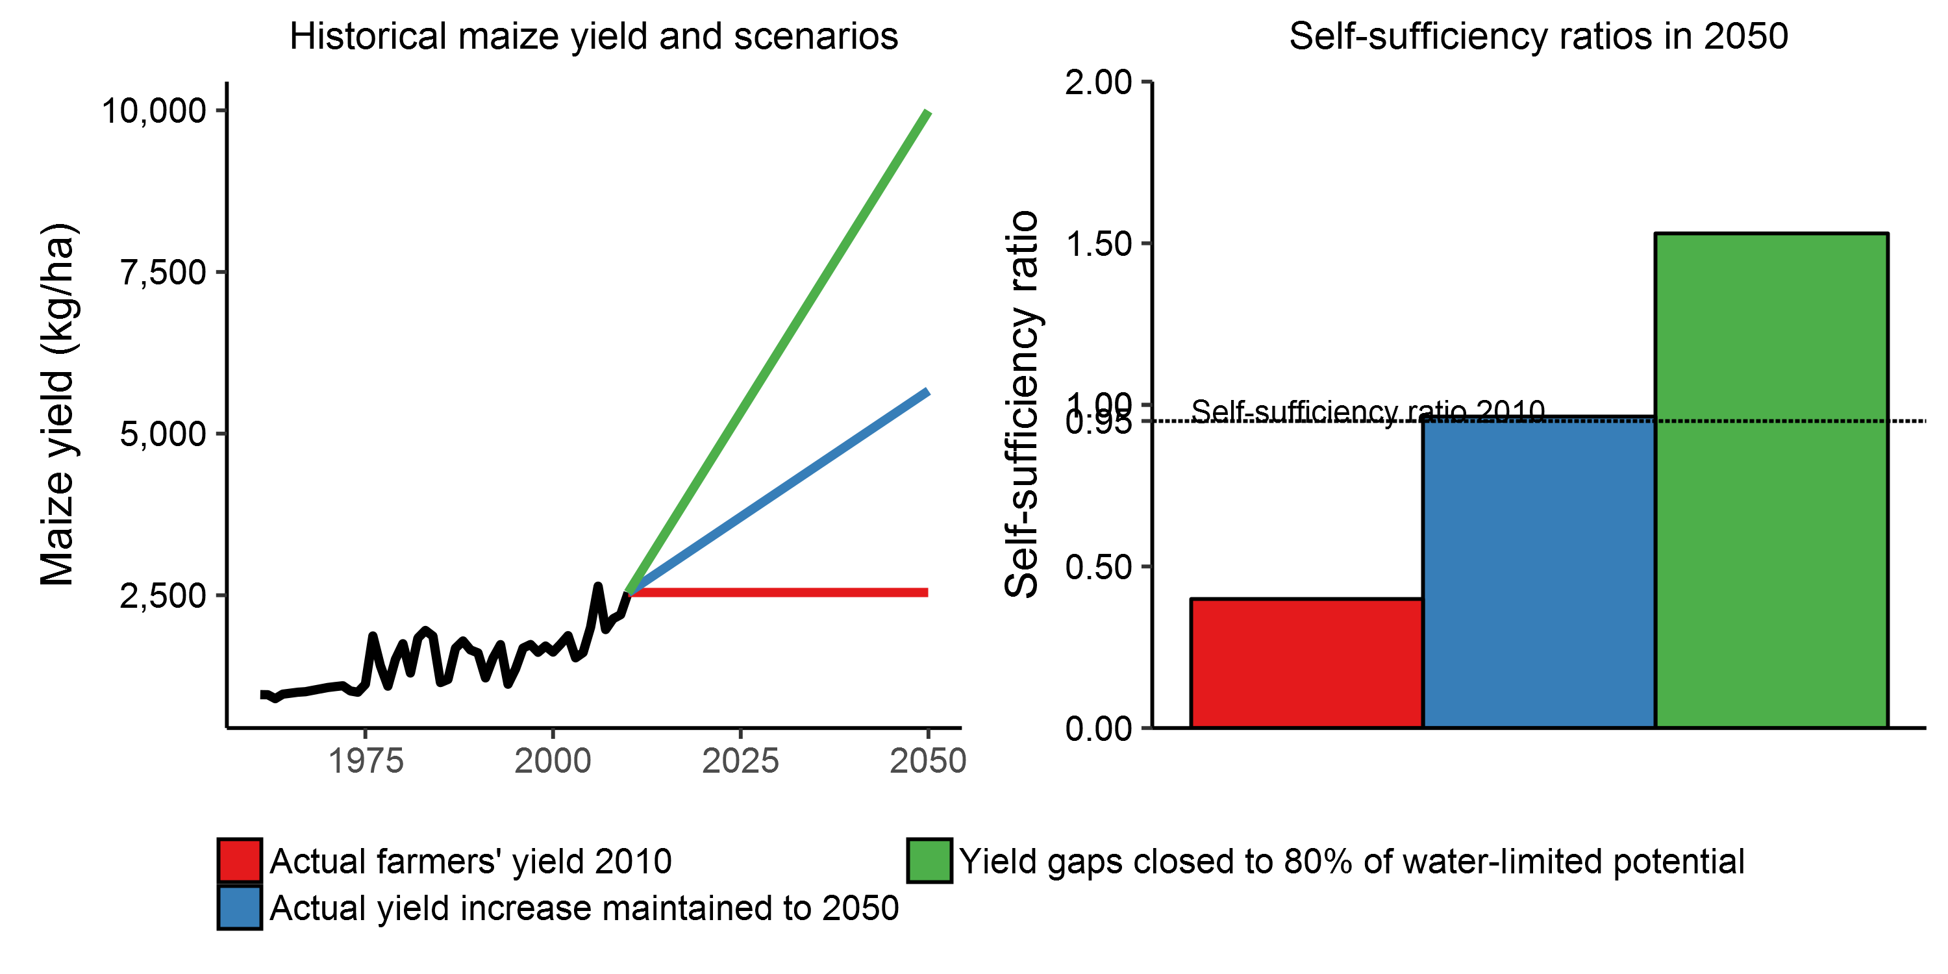

# Recommendations

# References

Alexandratos, N., and J. Bruinsma. 2012. “World agriculture towards 2030/2050: The 2012 Revision.” ESA Working Paper. Food; Agriculture Organization of the United Nations. doi:[10.1016/S0264-8377(03)00047-4](https://doi.org/10.1016/S0264-8377(03)00047-4).

Bravo-Ureta, Boris E., Daniel Solís, Víctor H. Moreira López, José F. Maripani, Abdourahmane Thiam, and Teodoro Rivas. 2007. “Technical efficiency in farming: a meta-regression analysis.” *Journal of Productivity Analysis* 27 (1). Kluwer Academic Publishers-Plenum Publishers: 57–72. doi:[10.1007/s11123-006-0025-3](https://doi.org/10.1007/s11123-006-0025-3).

Dorosh, Paul, Hyoung Gun Wang, Liangzhi You, and Emily Schmidt. 2012. “Road connectivity, population, and crop production in Sub-Saharan Africa.” *Agricultural Economics* 43 (1): 89–103. doi:[10.1111/j.1574-0862.2011.00567.x](https://doi.org/10.1111/j.1574-0862.2011.00567.x).

Evans, L.T., and R.A. Fischer. 1999. “Yield Potential.” *Crop Science* 39 (6). Crop Science Society of America: 1544. doi:[10.2135/cropsci1999.3961544x](https://doi.org/10.2135/cropsci1999.3961544x).

Fischer, R.A. 2015. “Definitions and determination of crop yield, yield gaps, and of rates of change.” *Field Crops Research* 182: 9–18. doi:[10.1016/j.fcr.2014.12.006](https://doi.org/10.1016/j.fcr.2014.12.006).

Fischer, R.A., Derek Byerlee, and Greg. O. Edmeades. 2014. “Crop yields and global food security: will yield increase continue to feed the world?” doi:[10.1093/erae/jbv034](https://doi.org/10.1093/erae/jbv034).

Gibbon, D., J. Dixon, and D. Flores Velazquez. 2007. “Beyond drought tolerant maize: study of additional priorities in maize.” CIMMYT.

Grassini, Patricio, Lenny G.J. J van Bussel, Justin Van Wart, Joost Wolf, Lieven Claessens, Haishun Yang, Hendrik Boogaard, Hugo de Groot, Martin K. van Ittersum, and Kenneth G. Cassman. 2015. “How good is good enough? Data requirements for reliable crop yield simulations and yield-gap analysis.” *Field Crops Research* 177. Elsevier B.V.: 49–63. doi:[10.1016/j.fcr.2015.03.004](https://doi.org/10.1016/j.fcr.2015.03.004).

Ittersum, Martin K. van, Kenneth G. Cassman, Patricio Grassini, Joost Wolf, Pablo Tittonell, and Zvi Hochman. 2013. “Yield gap analysis with local to global relevance-A review.” *Field Crops Research* 143. Elsevier B.V.: 4–17. doi:[10.1016/j.fcr.2012.09.009](https://doi.org/10.1016/j.fcr.2012.09.009).

Laborte, Alice G., Kees C A J M de Bie, Eric M A Smaling, Piedad F. Moya, Anita A. Boling, and Martin K. Van Ittersum. 2012. “Rice yields and yield gaps in Southeast Asia: Past trends and future outlook.” *European Journal of Agronomy* 36 (1). Elsevier B.V.: 9–20. doi:[10.1016/j.eja.2011.08.005](https://doi.org/10.1016/j.eja.2011.08.005).

Morris, Michael, Valerie a Kelly, Ron J Kopicki, and Derek Byerlee. 2007. *Fertilizer Use in African Agriculture*. Vol. 44. 01. doi:[10.1596/978-0-8213-6880-0](https://doi.org/10.1596/978-0-8213-6880-0).

Mueller, Nathaniel D., James S. Gerber, Matt Johnston, Deepak K. Ray, Navin Ramankutty, and Jonathan A. Foley. 2012. “Closing yield gaps through nutrient and water management.” *Nature* 490 (7419). Nature Research: 254–57. doi:[10.1038/nature11420](https://doi.org/10.1038/nature11420).

Neumann, Kathleen, Peter H. Verburg, Elke Stehfest, and Christoph Müller. 2010. “The yield gap of global grain production: A spatial analysis.” *Agricultural Systems* 103 (5): 316–26. doi:[10.1016/j.agsy.2010.02.004](https://doi.org/10.1016/j.agsy.2010.02.004).

Ogundari, Kolawole. 2014. “The Paradigm of Agricultural Efficiency and its Implication on Food Security in Africa: What Does Meta-analysis Reveal?” *World Development* 64 (1920). Elsevier Ltd: 690–702. doi:[10.1016/j.worlddev.2014.07.005](https://doi.org/10.1016/j.worlddev.2014.07.005).

Van Ittersum, Martin K., and R. Rabbinge. 1997. “Concepts in production ecology for analysis and quantification of agricultural input-output combinations.” *Field Crops Research* 52 (3): 197–208. doi:[10.1016/S0378-4290(97)00037-3](https://doi.org/10.1016/S0378-4290(97)00037-3).