COMP 353

Fall 2016, Databases

Alexander Chu 26602568

Bo Li 40038086

**Project description**

The end goal of this project is to create a website that will ultimately simulate the popular ride-sharing application Uber. This website is written using HTML, PHP, CSS, as well as MySQL for database related features. Its most attractive feature is its simplicity which will facilitate ease-of-use.

**Assumptions**

When changing the privilege or status of an account, it is assumed that that username is known.

It is assumed that the receiver’s username is known when sending out a message.

It is assumed that users will not cause trouble by inputting bad information.

**Limitations**

The project started off with 5 team members which dwindled down to 2, a lot of time was wasted at first due to lack of communication.

**Applications supported**

Administrators may suspend accounts, post public postings etc.

Members may post trips, special trips and search for trips as riders amongst other features.

They may also send messages to each other.

Only registered members may view postings

**Over view of User Interface**

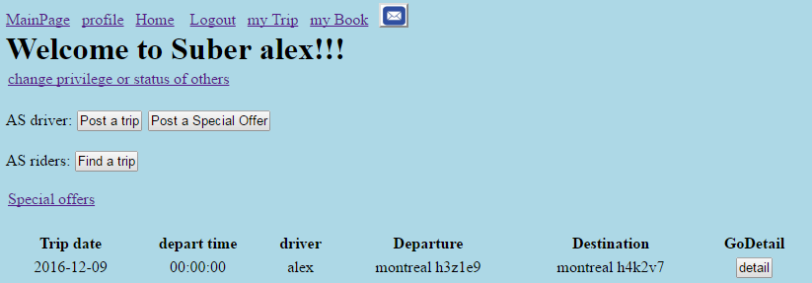

The user interface was designed to be as simple as possible in order to improve ease of use. Users may access the majority of the controls from the home page.

**Post-Demo Changes**

Added and implemented feature for posting a special trip such as a delivery or a pickup through postSpOffer.php

Added myTrip.php

Added myBook.php

Added balance in table member + profile.php recharge button

**Member Responsibility**

The work was equally shared amongst the 2 members of the team as others have left.

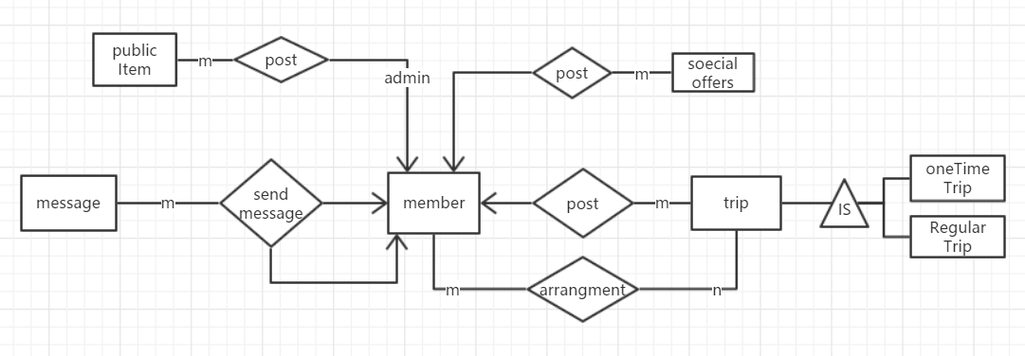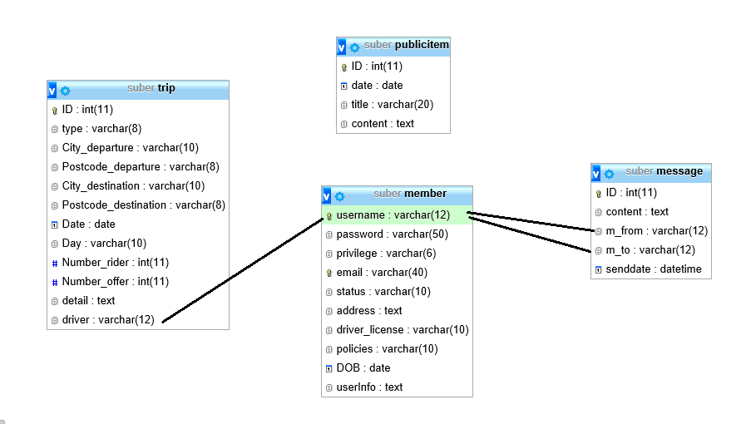

**A-- phpMyAdmin SQL Dump**

**-- version 4.6.4**

**-- https://www.phpmyadmin.net/**

**--**

**-- Host: 127.0.0.1**

**-- Generation Time: Dec 09, 2016 at 05:43 AM**

**-- Server version: 5.7.14**

**-- PHP Version: 5.6.25**

**SET SQL_MODE = "NO_AUTO_VALUE_ON_ZERO";**

**SET time_zone = "+00:00";**

**/*!40101 SET @OLD_CHARACTER_SET_CLIENT=@@CHARACTER_SET_CLIENT */;**

**/*!40101 SET @OLD_CHARACTER_SET_RESULTS=@@CHARACTER_SET_RESULTS */;**

**/*!40101 SET @OLD_COLLATION_CONNECTION=@@COLLATION_CONNECTION */;**

**/*!40101 SET NAMES utf8mb4 */;**

**--**

**-- Database: `suber`**

**--**

**-- --------------------------------------------------------**

**--**

**-- Table structure for table `book`**

**--**

**CREATE TABLE `book` (**

**`username` varchar(12) NOT NULL,**

**`tid` int(11) NOT NULL,**

**`type` varchar(8) NOT NULL,**

**`price` float NOT NULL,**

**`rate` int(1) NOT NULL DEFAULT '3'**

**) ENGINE=InnoDB DEFAULT CHARSET=latin1;**

**--**

**-- Triggers `book`**

**--**

**DELIMITER $$**

**CREATE TRIGGER `decrease_offer_number` AFTER INSERT ON `book` FOR EACH ROW BEGIN**

**DECLARE off_number int;**

**DECLARE rid_number int;**

**set off_number = (SELECT Number_offer FROM trip WHERE ID = NEW.tid);**

**set rid_number = (SELECT Number_rider FROM trip WHERE ID = NEW.tid);**

**if(off_number < rid_number)THEN**

**set off_number = off_number +1;**

**UPDATE trip SET Number_offer = off_number WHERE ID = NEW.tid;**

**ELSE**

**SIGNAL SQLSTATE '45000'**

**set MESSAGE_TEXT = 'cannot book more!';**

**END IF;**

**END**

**$$**

**DELIMITER ;**

**-- --------------------------------------------------------**

**--**

**-- Table structure for table `member`**

**--**

**CREATE TABLE `member` (**

**`username` varchar(12) NOT NULL,**

**`password` varchar(50) NOT NULL,**

**`privilege` varchar(6) NOT NULL DEFAULT 'member',**

**`email` varchar(40) NOT NULL,**

**`status` varchar(10) NOT NULL DEFAULT 'inactive',**

**`address` text,**

**`driver_license` varchar(10) DEFAULT NULL,**

**`policies` varchar(10) DEFAULT NULL,**

**`DOB` date DEFAULT NULL,**

**`balance` float NOT NULL DEFAULT '0',**

**`userInfo` text**

**) ENGINE=InnoDB DEFAULT CHARSET=latin1;**

**--**

**-- Dumping data for table `member`**

**--**

**INSERT INTO `member` (`username`, `password`, `privilege`, `email`, `status`, `address`, `driver_license`, `policies`, `DOB`, `balance`, `userInfo`) VALUES**

**('admin', '21232f297a57a5a743894a0e4a801fc3', 'admin', 'admin@encs.concordia.ca', 'active', 'Concordia university\r\nCOMP 353, group 18', 'CE123F', 'H2CNC4', '2013-01-18', 50, '{"policies":"123","DOB":"2013-01-18"}'),**

**('root11', '202cb962ac59075b964b07152d234b70', 'member', '123@123.com', 'suspended', 'concordia 601', '321386876', 'N3HG3', '2016-12-24', 20, '[]');**

**-- --------------------------------------------------------**

**--**

**-- Table structure for table `message`**

**--**

**CREATE TABLE `message` (**

**`ID` int(11) NOT NULL,**

**`content` text NOT NULL,**

**`m_from` varchar(12) NOT NULL,**

**`m_to` varchar(12) NOT NULL,**

**`senddate` datetime NOT NULL**

**) ENGINE=InnoDB DEFAULT CHARSET=latin1;**

**--**

**-- Dumping data for table `message`**

**--**

**INSERT INTO `message` (`ID`, `content`, `m_from`, `m_to`, `senddate`) VALUES**

**(8, 'Test send message function!!', 'root11', 'admin', '2016-12-09 00:40:27'),**

**(9, 'check!!check!!', 'admin', 'root11', '2016-12-09 00:40:56');**

**-- --------------------------------------------------------**

**--**

**-- Table structure for table `publicitem`**

**--**

**CREATE TABLE `publicitem` (**

**`ID` int(11) NOT NULL,**

**`date` date NOT NULL,**

**`title` varchar(20) NOT NULL,**

**`content` text NOT NULL**

**) ENGINE=InnoDB DEFAULT CHARSET=latin1;**

**--**

**-- Dumping data for table `publicitem`**

**--**

**INSERT INTO `publicitem` (`ID`, `date`, `title`, `content`) VALUES**

**(1, '2016-12-09', 'Hello', 'Hello, welcome Suber.'),**

**(2, '2016-12-09', 'Test', 'This public item just test the function.');**

**-- --------------------------------------------------------**

**--**

**-- Table structure for table `specialoffer`**

**--**

**CREATE TABLE `specialoffer` (**

**`ID` int(11) NOT NULL,**

**`type` varchar(8) NOT NULL,**

**`City_departure` varchar(12) NOT NULL,**

**`Postcode_departure` varchar(8) NOT NULL,**

**`City_destination` varchar(12) NOT NULL,**

**`Postcode_destination` varchar(8) NOT NULL,**

**`Date` date NOT NULL,**

**`depart_time` time NOT NULL,**

**`detail` text NOT NULL,**

**`driver` varchar(12) NOT NULL,**

**`customer` varchar(12) DEFAULT NULL,**

**`price` float NOT NULL DEFAULT '0',**

**`rate` int(1) NOT NULL DEFAULT '3'**

**) ENGINE=InnoDB DEFAULT CHARSET=latin1;**

**--**

**-- Dumping data for table `specialoffer`**

**--**

**INSERT INTO `specialoffer` (`ID`, `type`, `City_departure`, `Postcode_departure`, `City_destination`, `Postcode_destination`, `Date`, `depart_time`, `detail`, `driver`, `customer`, `price`, `rate`) VALUES**

**(1, 'pickup', 'montreal', 'h3h 2n7', 'montreal', 'h3h 2n4', '2016-12-18', '10:00:00', 'puckup service, anyone need it ??', 'admin', NULL, 0, 3);**

**-- --------------------------------------------------------**

**--**

**-- Table structure for table `trip`**

**--**

**CREATE TABLE `trip` (**

**`ID` int(11) NOT NULL,**

**`type` varchar(8) NOT NULL,**

**`City_departure` varchar(10) NOT NULL,**

**`Postcode_departure` varchar(8) NOT NULL,**

**`City_destination` varchar(10) NOT NULL,**

**`Postcode_destination` varchar(8) NOT NULL,**

**`Date` date DEFAULT NULL,**

**`Day` varchar(10) DEFAULT NULL,**

**`depart_time` time NOT NULL,**

**`Number_rider` int(11) NOT NULL DEFAULT '1',**

**`Number_offer` int(11) NOT NULL DEFAULT '0',**

**`detail` text NOT NULL,**

**`driver` varchar(12) NOT NULL**

**) ENGINE=InnoDB DEFAULT CHARSET=latin1;**

**--**

**-- Dumping data for table `trip`**

**--**

**INSERT INTO `trip` (`ID`, `type`, `City_departure`, `Postcode_departure`, `City_destination`, `Postcode_destination`, `Date`, `Day`, `depart_time`, `Number_rider`, `Number_offer`, `detail`, `driver`) VALUES**

**(1, 'oneTime', 'montreal', 'H3H 2N7', 'toronto', 'M5S 3H7', '2016-12-24', NULL, '12:03:00', 4, 0, 'driving to Toronto, is there anyone come with me ?\r\n4 riders available.', 'admin');**

**--**

**-- Indexes for dumped tables**

**--**

**--**

**-- Indexes for table `book`**

**--**

**ALTER TABLE `book`**

**ADD PRIMARY KEY (`username`,`tid`),**

**ADD KEY `tid` (`tid`);**

**--**

**-- Indexes for table `member`**

**--**

**ALTER TABLE `member`**

**ADD PRIMARY KEY (`username`),**

**ADD UNIQUE KEY `email` (`email`);**

**--**

**-- Indexes for table `message`**

**--**

**ALTER TABLE `message`**

**ADD PRIMARY KEY (`ID`),**

**ADD KEY `m_to` (`m_to`),**

**ADD KEY `m_from` (`m_from`);**

**--**

**-- Indexes for table `publicitem`**

**--**

**ALTER TABLE `publicitem`**

**ADD PRIMARY KEY (`ID`);**

**--**

**-- Indexes for table `specialoffer`**

**--**

**ALTER TABLE `specialoffer`**

**ADD PRIMARY KEY (`ID`),**

**ADD KEY `driver` (`driver`);**

**--**

**-- Indexes for table `trip`**

**--**

**ALTER TABLE `trip`**

**ADD PRIMARY KEY (`ID`),**

**ADD KEY `driver` (`driver`);**

**--**

**-- AUTO_INCREMENT for dumped tables**

**--**

**--**

**-- AUTO_INCREMENT for table `message`**

**--**

**ALTER TABLE `message`**

**MODIFY `ID` int(11) NOT NULL AUTO_INCREMENT, AUTO_INCREMENT=10;**

**--**

**-- AUTO_INCREMENT for table `publicitem`**

**--**

**ALTER TABLE `publicitem`**

**MODIFY `ID` int(11) NOT NULL AUTO_INCREMENT, AUTO_INCREMENT=3;**

**--**

**-- AUTO_INCREMENT for table `specialoffer`**

**--**

**ALTER TABLE `specialoffer`**

**MODIFY `ID` int(11) NOT NULL AUTO_INCREMENT, AUTO_INCREMENT=2;**

**--**

**-- AUTO_INCREMENT for table `trip`**

**--**

**ALTER TABLE `trip`**

**MODIFY `ID` int(11) NOT NULL AUTO_INCREMENT, AUTO_INCREMENT=2;**

**--**

**-- Constraints for dumped tables**

**--**

**--**

**-- Constraints for table `book`**

**--**

**ALTER TABLE `book`**

**ADD CONSTRAINT `book_ibfk_3` FOREIGN KEY (`username`) REFERENCES `member` (`username`) ON DELETE CASCADE,**

**ADD CONSTRAINT `book_ibfk_4` FOREIGN KEY (`tid`) REFERENCES `trip` (`ID`) ON DELETE CASCADE;**

**--**

**-- Constraints for table `message`**

**--**

**ALTER TABLE `message`**

**ADD CONSTRAINT `message_ibfk_3` FOREIGN KEY (`m_from`) REFERENCES `member` (`username`) ON DELETE CASCADE,**

**ADD CONSTRAINT `message_ibfk_4` FOREIGN KEY (`m_to`) REFERENCES `member` (`username`) ON DELETE CASCADE;**

**--**

**-- Constraints for table `specialoffer`**

**--**

**ALTER TABLE `specialoffer`**

**ADD CONSTRAINT `specialoffer_ibfk_2` FOREIGN KEY (`driver`) REFERENCES `member` (`username`) ON DELETE CASCADE;**

**--**

**-- Constraints for table `trip`**

**--**

**ALTER TABLE `trip`**

**ADD CONSTRAINT `trip_ibfk_1` FOREIGN KEY (`driver`) REFERENCES `member` (`username`) ON DELETE CASCADE;**

**/*!40101 SET CHARACTER_SET_CLIENT=@OLD_CHARACTER_SET_CLIENT */;**

**/*!40101 SET CHARACTER_SET_RESULTS=@OLD_CHARACTER_SET_RESULTS */;**

**/*!40101 SET COLLATION_CONNECTION=@OLD_COLLATION_CONNECTION */;**