[Question]

Suppose the demand curve for a tour package to Thailand is downward sloping. Which of the following CANNOT be constant when we move from one point to another on the demand curve?

[Choices]

The price of the tour package to Thailand

The price of a tour package to Japan

People’s income

The price of a travel guidebook to Thailand

[Answer]

A

[Topic]

Changes in demand and supply

[Question]

Due to a good harvest of Japanese lobsters, the quantity transacted of Japanese lobsters increases while the price decreases. Which of the following are correct?

(1) The quantity demanded of Japanese lobsters increases.

(2) The demand for Japanese lobsters increases.

(3) The quantity transacted of Boston lobsters decreases.

(4) The demand for Boston lobsters decreases.

[Choices]

(1) and (4) only

(2) and (3) only

(1), (3) and (4) only

(2), (3) and (4) only

[Answer]

C

[Topic]

Changes in demand and supply

[Question]

Faithful Department Store launches a gift redemption scheme to celebrate its 10th anniversary: a customer who spends over $200 can receive a stamp and the number of stamps required to redeem various types of gifts are shown below:

|  |  |
| --- | --- |
| **Number of stamps required** | **Gifts** |
| 10 | A pack of chopsticks |
| 50 | A teapot |
| 100 | A wok |

What is the cost of redeeming a teapot with 50 stamps?

[Choices]

A pack of chopsticks

0.5 wok

5 packs of chopsticks

None of the above

[Answer]

C

[Topic]

Basic concepts in economics

[Question]

Refer to the diagram below.



What kind of animal is this?

[Choices]

Dog

Duck

Cat

Whale

[Answer]

C

[Topic]

Changes in demand and supply

[Question]

Compare the following pictures.

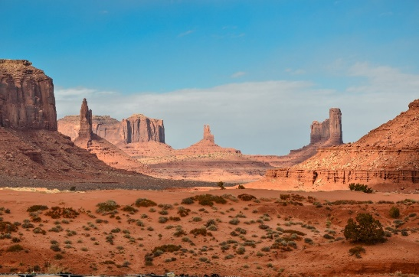



Which place is hot?

[Choices]

The first one

The second one

Both of them are hot

Both of them are cold

[Answer]

A

[Topic]

Basic concepts in economics

[Question]

Which of the following is a fruit?

[Choices]

Fried rice

Apple

Chicken

[Answer]

B