The i2c format for the Mysa

Features:
Speed: 400KHz
Operating Temperature: -40℃to +105℃

The device address of the i2c slave:.
SLAW: 0xE6
SLAR: 0xE7

The i2c slave register address function:
0x00 | Status register (tbd)
0x01 | Read current MS byte
0x02 | Read current LS byte
0x03 | Read line voltage MS byte
0x04 | Read line voltage LS byte
0x05 | HS temperature MS byte
0x06 | HS temperature LS byte
0x07 | Read 3V3 voltage
0x08 | Read 5V voltage
0x09 | Watchdog counter clear

The Description of the i2c slave register:
Red ID | Length | ADDR | Type | Description
REG_STATU | 1 | 0x00 | RO | The status
REG_CUR | 2 | 0x01 | RO | The current's adc value, the unit is “mV”.
REG_VOL | 2 | 0x03 | RO | The line voltage's adc value, the unit is “mV”.
REG_TEMPER | 2 | 0x05 | RO | The temperature's value ( (t+100) * 10 ). For example,if the temperature is 25℃,then the value saved in the REG_TEMPER is 1250. if the temperature is -50℃,then the value saved in the REG_TEMPER is 500.
REG_V33 | 1 | 0x07 | RO | The multiplier 10x +3V3's adc value. For example,if the +3V3's value is 3.3v,then the value saved in the REG_V33 is 33.
REG_V5 | 1 | 0x08 | RO | The multiplier 10x +5V's adc value. For example,if the +5v's value is 5.0v,then the value saved in the REG_V5 is 50.
REG_WDCLR | 1 | 0x09 | WR | Clear the watchdog counter. Write 1 to the register in less than 3 seconds every time.

The write and read operations for the i2c slave register:
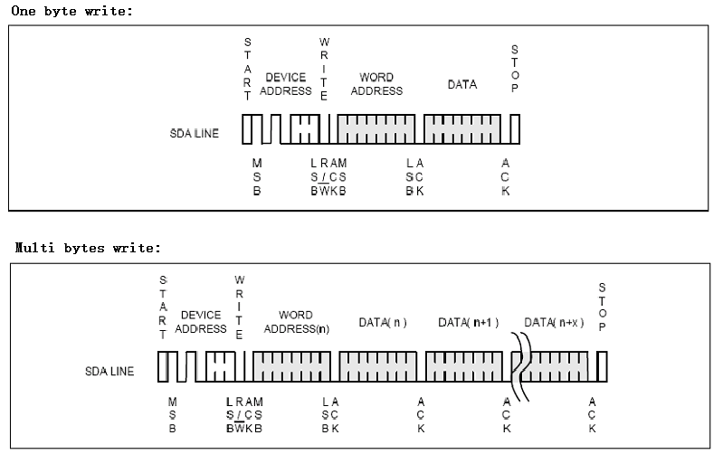
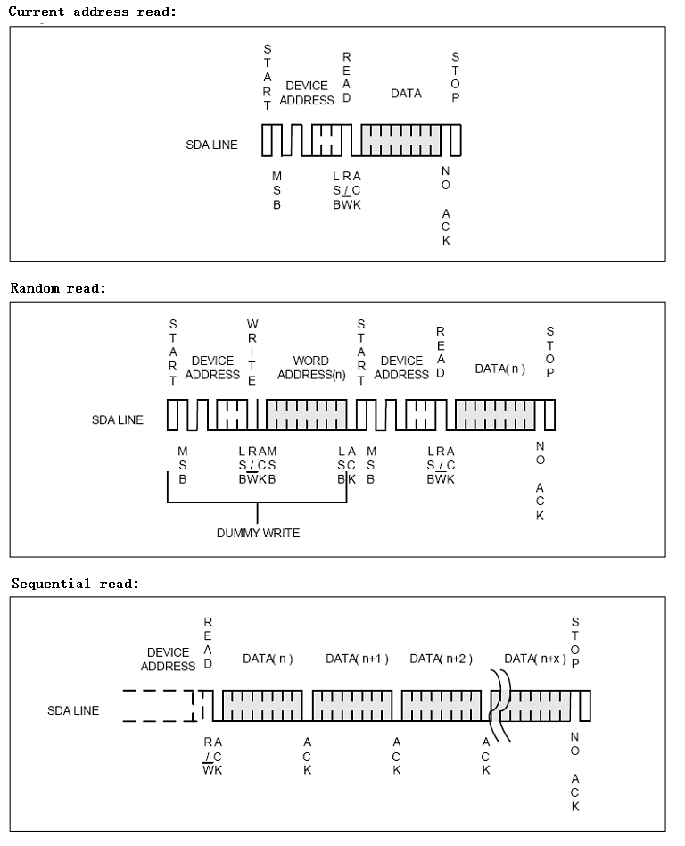
The device address for write is SLAW(0xE6), and the device address for read is SLAR(0xE7).
The word address is the address of the register of the slave, such as the register of the line voltage(REG_VOL).

The exsample code for the clients main MCU to read the data from the i2c slave register:

#define REG_STATU 0x00
#define REG_CUR 0x01
#define REG_VOL 0x03
#define REG_TEMPER 0x05
#define REG_V33 0x07
#define REG_V5 0x08
#define REG_WDCLR 0x09

void readslavereg (void)
{
UINT8 sbuf[20]={0};
UINT16 iadc_cur=0;
UINT16 iadc_vol=0;
double ftempvalue =0;
UINT16 itempvalue =0;
UINT8 ivol33=0;
double fvol33=0;
UINT8 ivol5=0;
double fvol5=0;

//read status
memset(sbuf,0,9);

i2c_read(REG_STATU, sbuf, 1);
iadc_statu = sbuf[0];

//read current adc
i2c_read(REG_CUR, sbuf, 2);
iadc_cur = (UINT16)(sbuf[0] <<4) + sbuf[1];

//read voltage adc
i2c_read(REG_VOL, sbuf, 2);
iadc_vol = (UINT16)(sbuf[0] <<4) + sbuf[1];

//read temperature
i2c_read(REG_TEMPER, sbuf, 2);
itempvalue = (UINT16)(sbuf[0] <<4) + sbuf[1];
ftempvalue = (double)itempvalue /10 -100;

// read +3V3
i2c_read(REG_V33, sbuf, 1);
ivol33 = sbuf[0];
fvol33 = (double)ivol33 /10;

// read +5V
i2c_read(REG_V5, sbuf, 1);
ivol5 = sbuf[0];
fvol5 = (double)ivol5 /10;
}

void write_watchdogreg (void)
{
UINT8 sbuf[20]={0};

sbuf[0]=1;
at24c02_write(REG_WDCLR, sbuf, 1);
Delay_nms(2);
}

