The i2c format for the ALC

- Features:
Speed: 400KHz
Operating Temperature: -40℃to +105℃

- The device address of the ALC:
SLAW: 0xE2
SLAR: 0xE3

3. The i2c slave register function:
Reg Address | Reg ID | Length | Type | Description
0x00 | REG_STATU | 1 | read | Status Register
0x01 | REG_ENERGY | 1 | read | Echo Energy Register
0x02 | REG_PEAK | 1 | read | Echo Peak Register
0x03 | REG_RANGE | 1 | read | Range Register
0x04 | REG_ENERGY_TH | 1 | write | Energy Threshold Register
0x05 | REG_PEAK_TH | 1 | write | Peak Threshold Register
0x00 | REG_CONTROL | 1 | write | Control Register

- The Description of the ALC register:
Status Register (read) 0x00 (REG_STATU)
Bit7 | Bit6 | Bit5 | Bit4 | Bit3 | Bit2 | Bit1 | Bit0
- | - | - | - | - | Motion Detected | Anechoic Detected | ALC running

Bit definitions:
BIT2: Motion Detected
BIT1: Anechoic Detected
BIT0: ALC running
Echo Energy Register (read) 0x01 (REG_ENERGY)

Bit7 | Bit6 | Bit5 | Bit4 | Bit3 | Bit2 | Bit1 | Bit0
Energy  [bit 7] | Energy  [bit 6] | Energy  [bit 5] | Energy  [bit 4] | Energy  [bit 3] | Energy  [bit 2] | Energy  [bit 1] | Energy  [bit 0]

Bit definitions:
BIT7-0: Echo Energy value. The formula is as follow:
Echo Energy value = REG_ENERGY * 16

Echo Peak Register (read) 0x02 (REG_PEAK)
Bit7 | Bit6 | Bit5 | Bit4 | Bit3 | Bit2 | Bit1 | Bit0
Peak  [bit7] | Peak  [bit6] | Peak  [bit5] | Peak  [bit4] | Peak  [bit3] | Peak  [bit2] | Peak  [bit1] | Peak  [bit0]

Bit definitions:
BIT7-0: Echo peak value.

Range Register (read) 0x03 (REG_RANGE)
Bit7 | Bit6 | Bit5 | Bit4 | Bit3 | Bit2 | Bit1 | Bit0
Range  [bit 7] | Range  [bit 6] | Range  [bit 5] | Range  [bit 4] | Range  [bit 3] | Range  [bit 2] | Range  [bit 1] | Range  [bit 0]

Bit definitions:
BIT7-0: Range value. The formula is as follow:
Range value = REG_RANGE/10 (m)

Energy Threshold Register (write) 0x04 (REG_ENERGY_TH)
Bit7 | Bit6 | Bit5 | Bit4 | Bit3 | Bit2 | Bit1 | Bit0
Energy_th  [bit 7] | Energy_th  [bit 6] | Energy_th  [bit 5] | Energy_th  [bit 4] | Energy_th  [bit 3] | Energy_th  [bit 2] | Energy_th  [bit 1] | Energy_th  [bit 0]

Bit definitions:
BIT7-0: Energy threshold value.

Peak Threshold Register (write) 0x05 (REG_PEAK_TH)
Bit7 | Bit6 | Bit5 | Bit4 | Bit3 | Bit2 | Bit1 | Bit0
Peak_th  [bit 7] | Peak_th  [bit 6] | Peak_th  [bit 5] | Peak_th  [bit 4] | Peak_th  [bit 3] | Peak_th  [bit 2] | Peak_th  [bit 1] | Peak_th  [bit 0]

Bit definitions:
BIT7-0: Peak threshold value.

Control Register (write) 0x00 (REG_CONTROL)
Bit7 | Bit6 | Bit5 | Bit4 | Bit3 | Bit2 | Bit1 | Bit0
- | - | - | - | - | - | - | TX ON/OFF

Bit definitions:
BIT0: TX ON/OFF.

- The write and read operations for the i2c slave register:
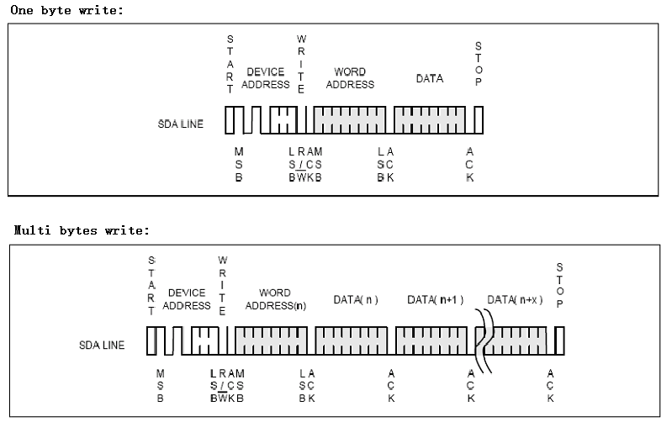
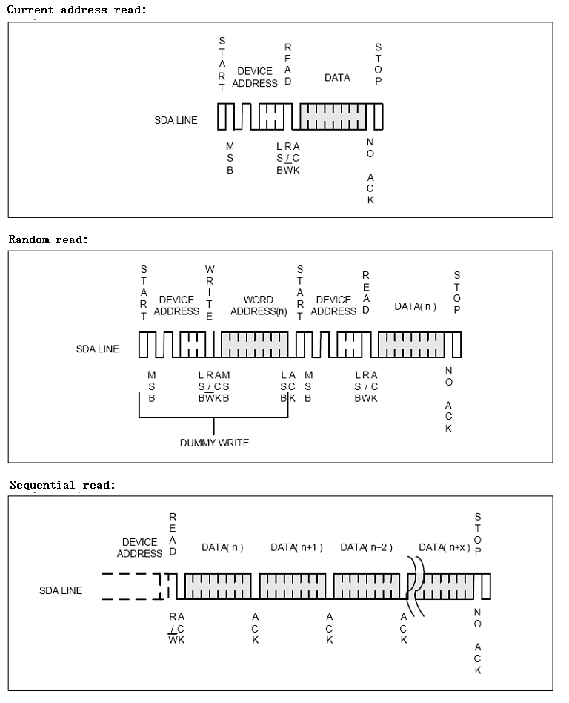
The device address for write is SLAW(0xE2), and the device address for read is SLAR(0xE3).
The word address is the address of the register of the slave, such as the status register (REG_STATU).

