Instruction for DTM test

- Please run the software “nRF Connect for Desktop” on the PC.

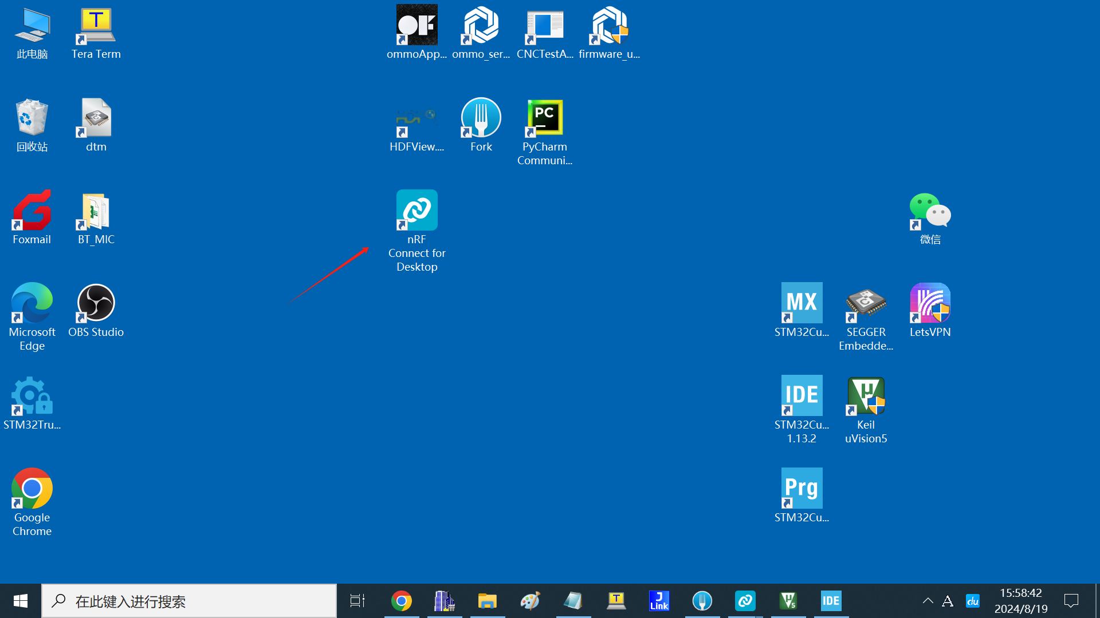

- Open the “Direct Test Mode” 。

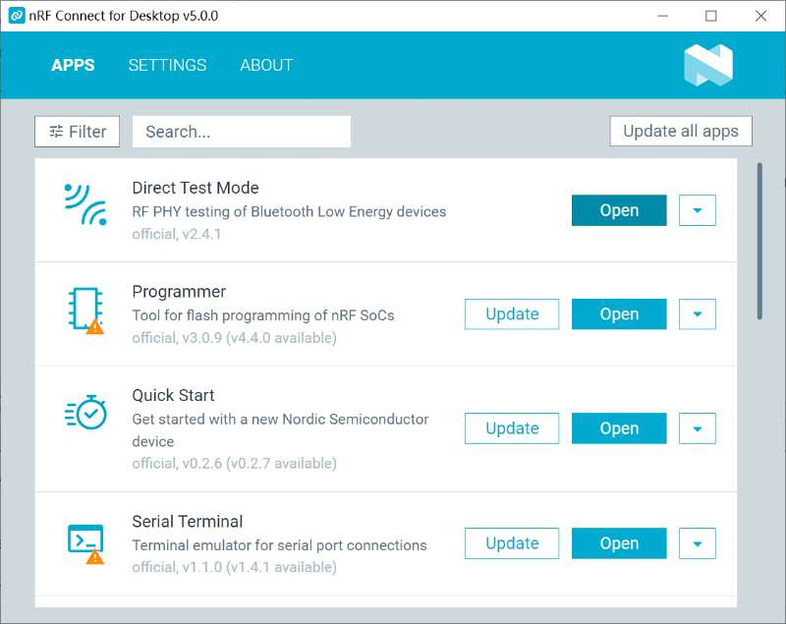

- Click “SELECT DEVICE”, and select the UART device such as “COM1”.

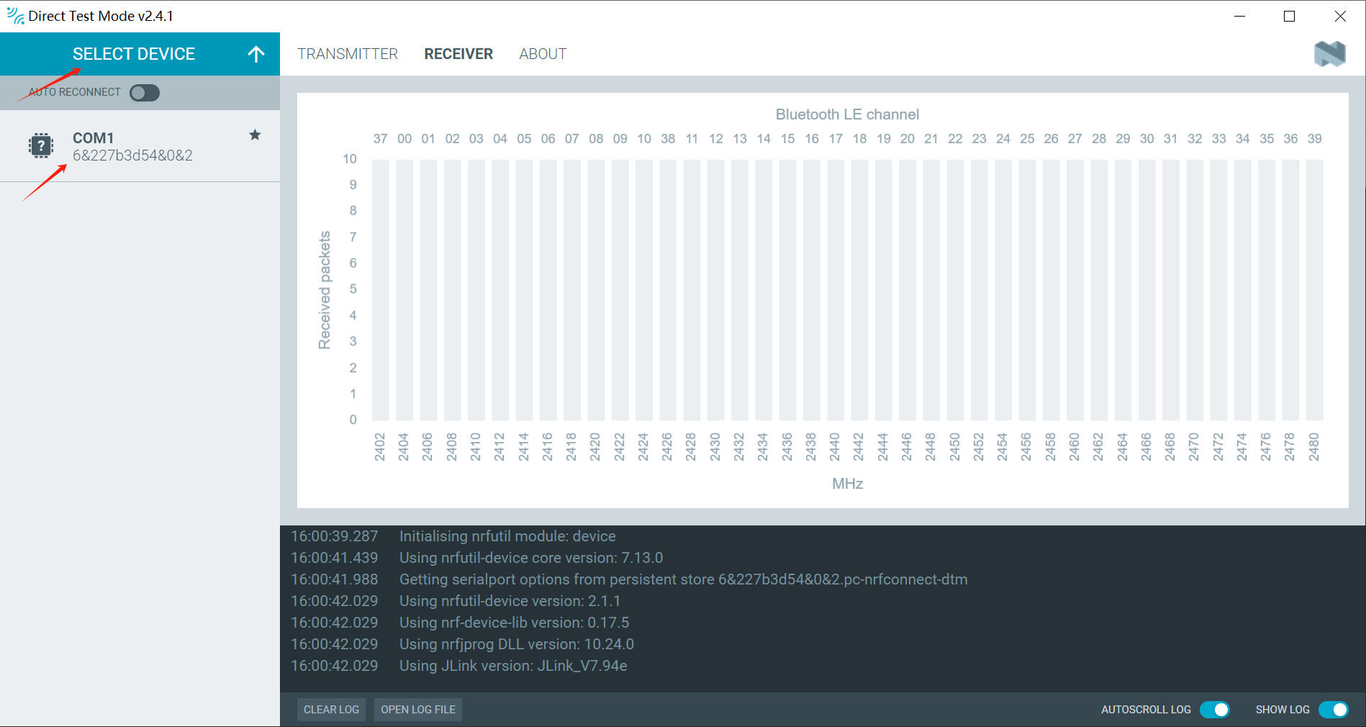

- Test transmit, select the “Single”, input the “transmit on channel” to 17, then click the “Start test”.

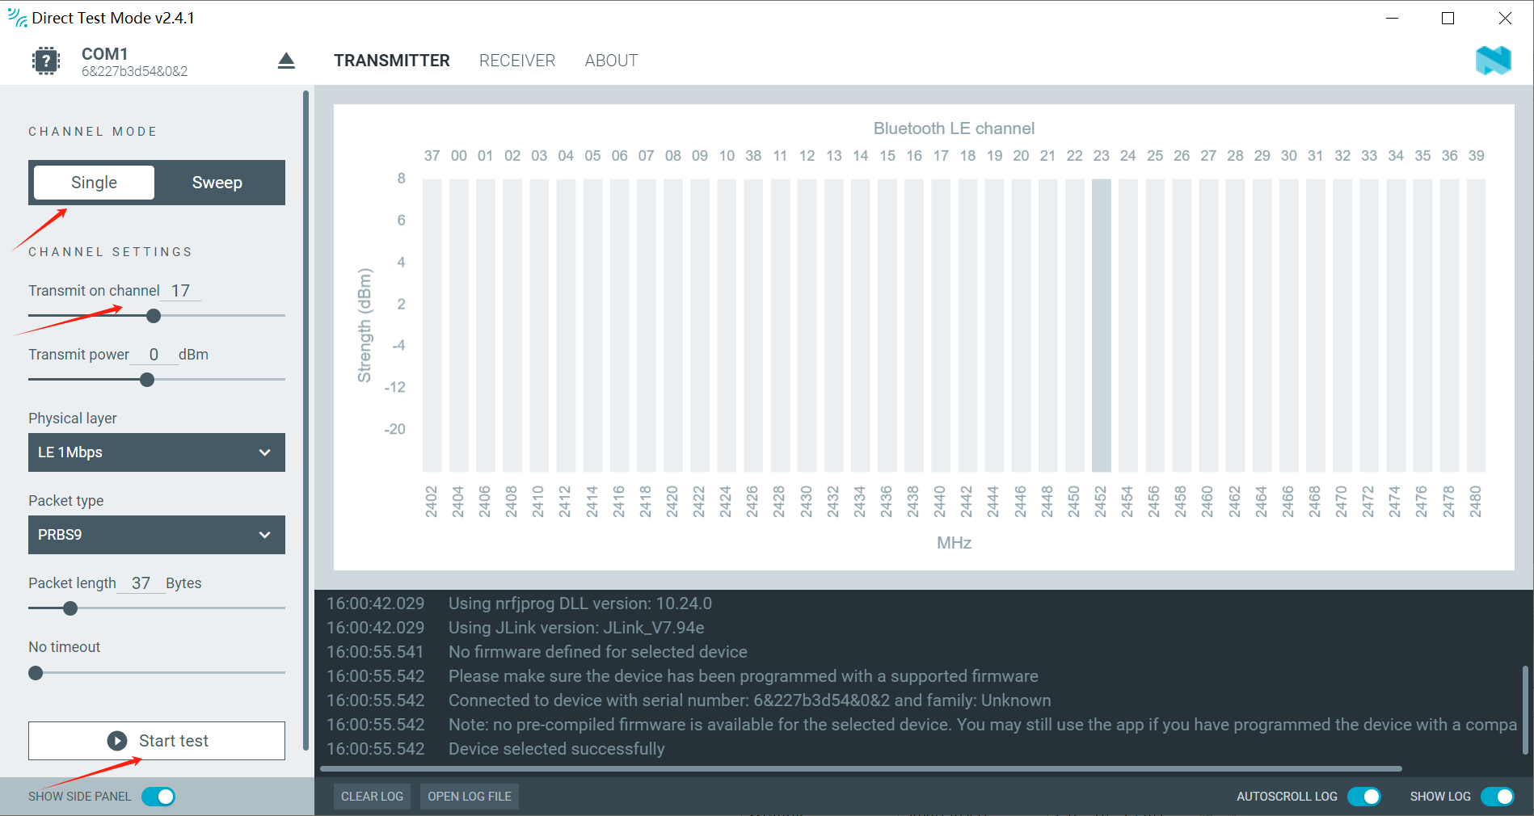

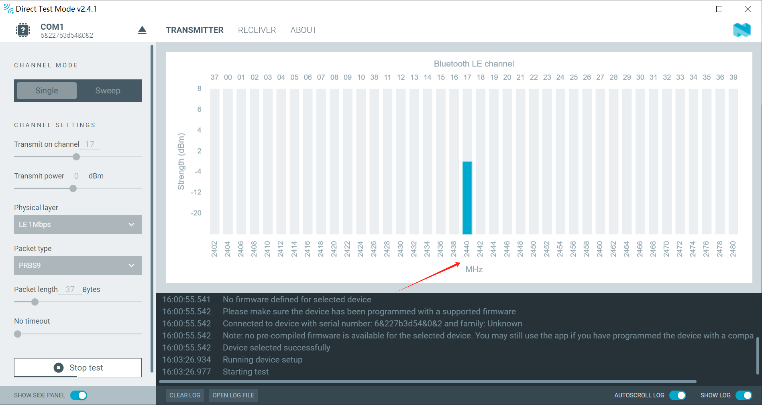

- Test receiver, select the “Sweep”, input the “receive on channel” to 37 to 39, then click the “Start test”.

