Instruction for BT upgrade, for V2.0

- Install BT programming software Media Product Tool V2.10.05 from https://drive.google.com/file/d/1sDIpBoRpTI0spnrso8B8LOXcQjUbzPOO/view?usp=sharing

- Please run the BT programming software “Launch.exe” in the PC.
- Select “FACTORY_INFORMATION_ERASE”, as shown. (Ignore the warning.)

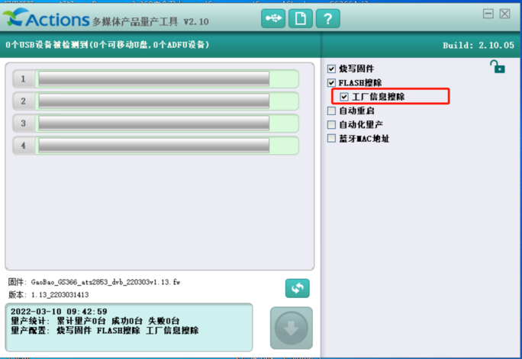

- Click the “Update” button, select the new BT firmware file for programming, and then click the "Replace" button。

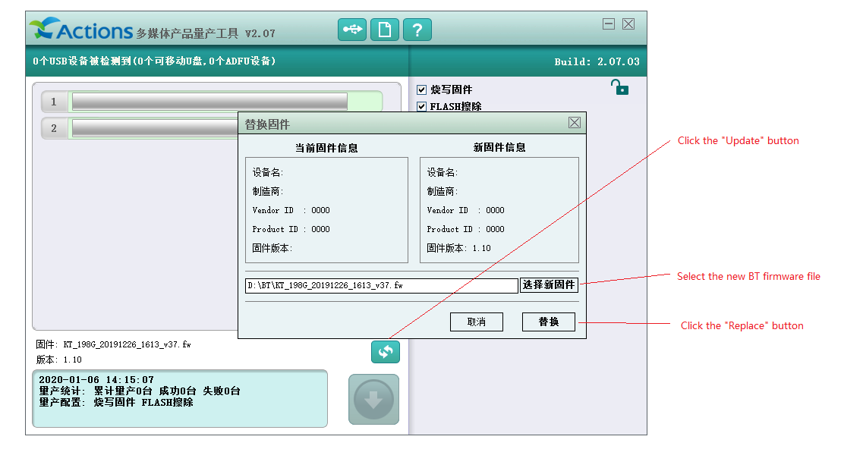

- Connect the unit to PC with type C and turn the unit ON.

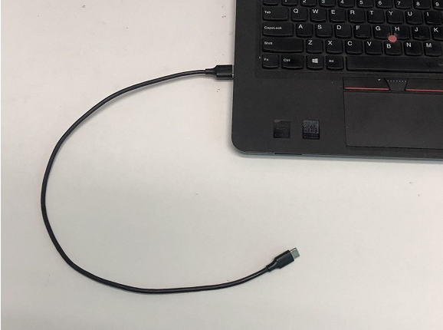

- Long press the MODE button to enter the BT programming mode. (Note: For V1.5, quick press the “mode” button twice instead of one long press.)

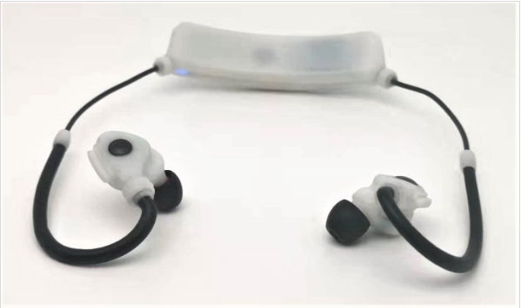

- Wait for the "Download" button to turn blue, as below.

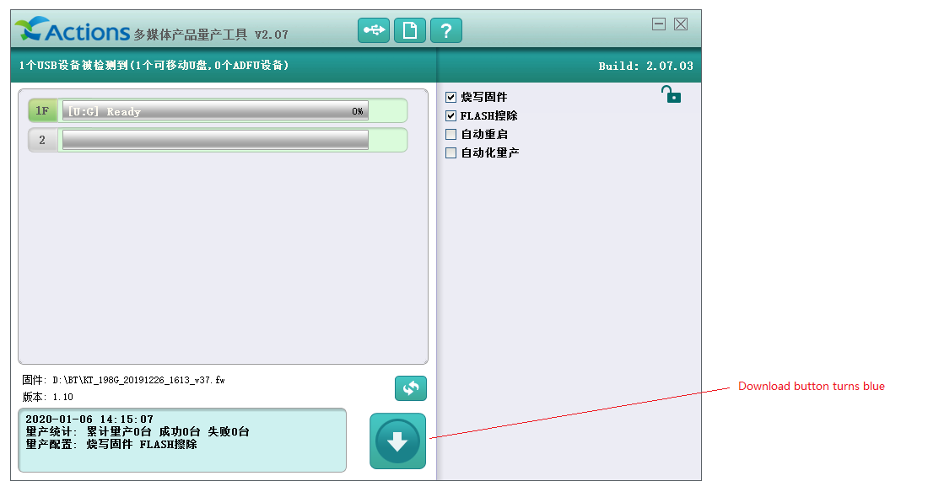

- Click the blue "Download" button. When you see the following success prompt, it indicates that the new BT firmware has been upgraded successfully.

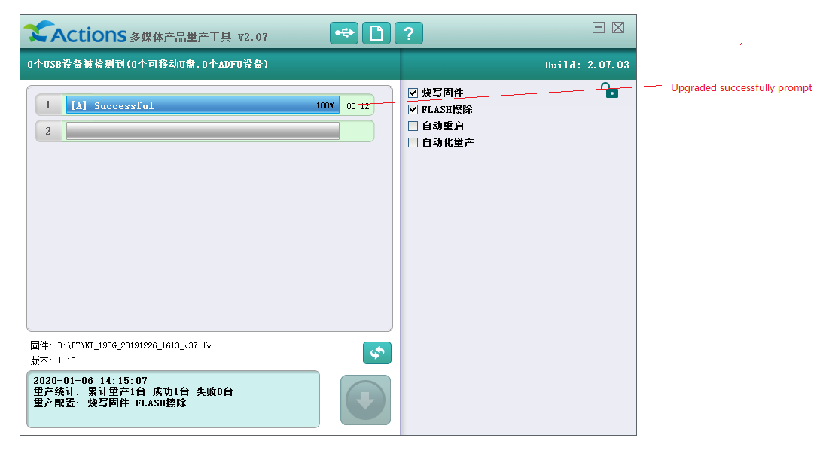

Appendix: Key function description:

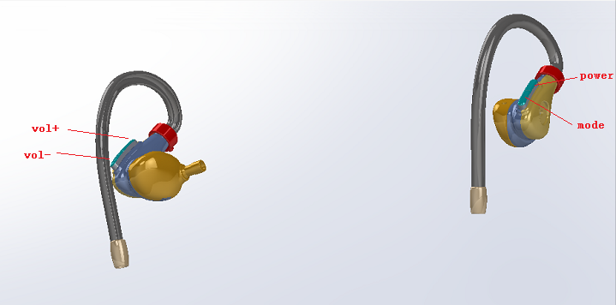

“vol+”:
QUICK PRESS ONCE： UP VOLUME
“vol-“:
QUICK PRESS ONCE： DOWN VOLUME

“power”:
QUICK PRESS ONCE： POWER ON
QUICK PRESS ONCE： POWER OFF

“mode”
ASI V2.0: LONG PRESS: ENTER BT PROGRAMMING MODE
ASI V1.5: QUICK PRESS ONCE： CHANGE MODE ( BT, MIC, BT+MIC );
QUICK PRESS TWICE： ENTER BT PROGRAMMING MODE
.

