Instruction for MCU upgrade

- Connected the unit to PC via the J-TAG programmer adapter (JLINK V9).
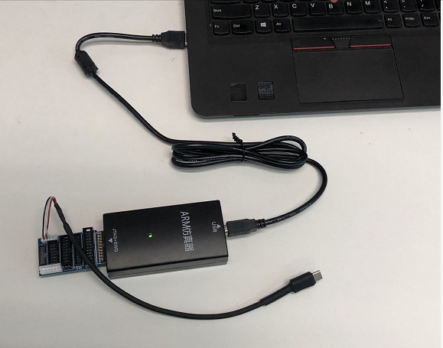

- Please run the MCU programming software “JFlash.exe” in the PC.
(Reference download URL address for software “JFlash.exe”: https://www.segger.com/downloads/jlink/)

- Create Project.
  - Click File and select New project
  - Select Target Device Microchip ATSAMD21G18A Cortex-M0 and click OK
  - Click OK
  - Click File and select Save project
  - Enter 3DLE
  - Click Save

- Click the menu” Options->Project settings”.

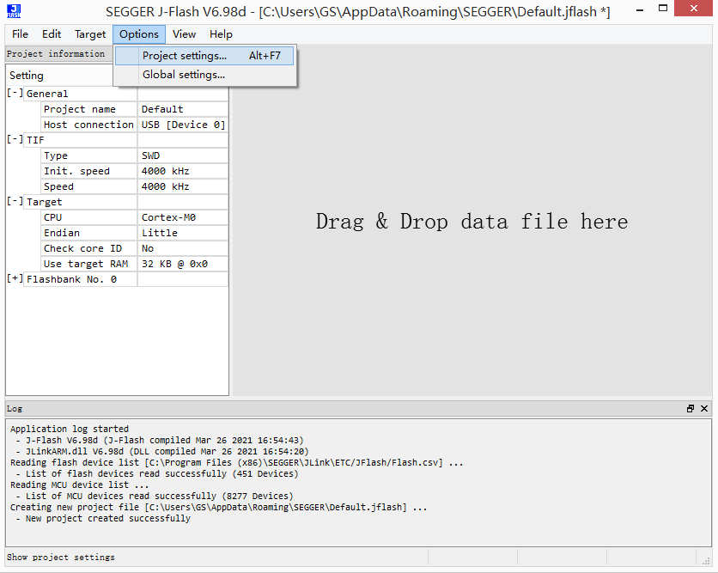

- Please make sure the “Target Interface” is the setting as following.
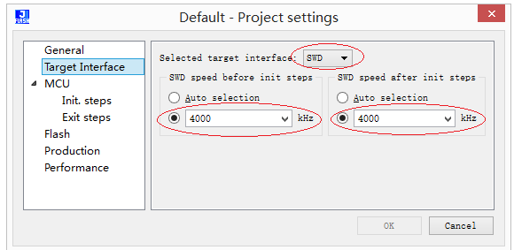

- Please make sure the “MCU” is the setting as following.

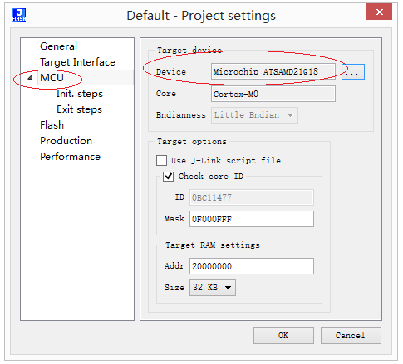

- Please make sure the “Production” is the setting as following. Please note that the “Start application” option must be selected.
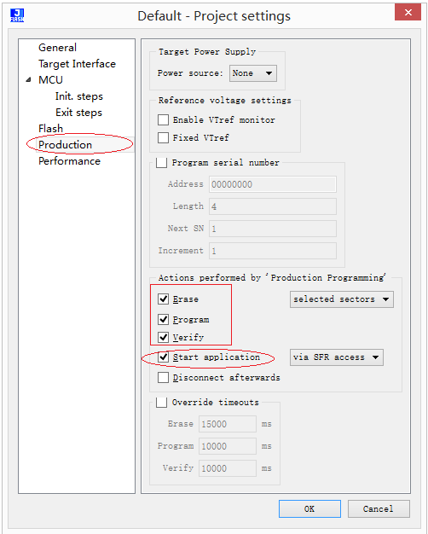

- Click the menu” File->Open data file”, Select the hex file (firmware) for programming.
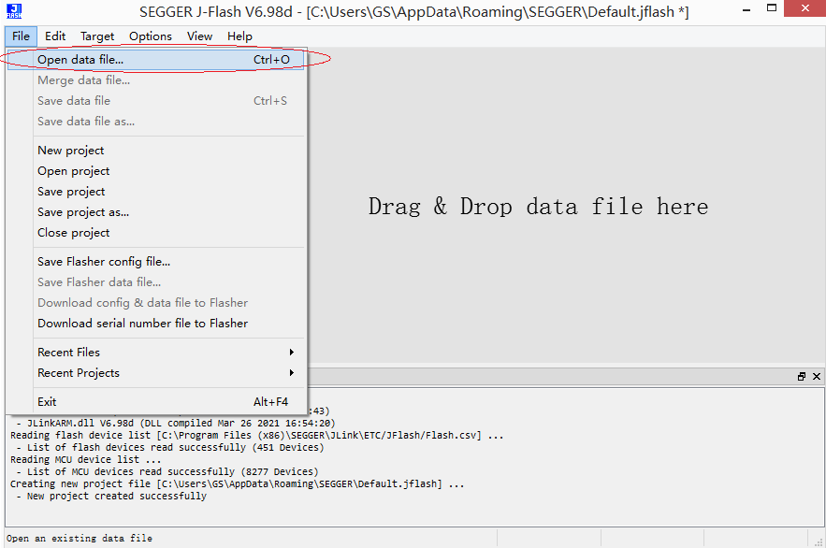

- Click the menu” Target->Production Programming”. And upgrade the new firmware to MCU.

