Test_report_QTAG_I_30_Ohm
All QTags: R5 is modified to 30 ohms.
Initiator
- QTag 2/3/4
- QTag-QANI-FreeRTOS_Initiator.hex
(which will start as Initiator with 2ms slot 300ms block after 10 seconds)

Responder:
- QTag 1
- QTag-Polaris_CLI-FreeRTOS_Responder.hex
(which will automatically do Responder with 2ms slot 300ms block)

Test result
 | Min/µA | Avg/mA | Max/mA
QTag 2 | 577.93 | 1.99 | 20.71
QTag 3 | 581.13 | 1.99 | 20.30
QTag 4 | 592.24 | 2.02 | 21.28

Result of QTag 2
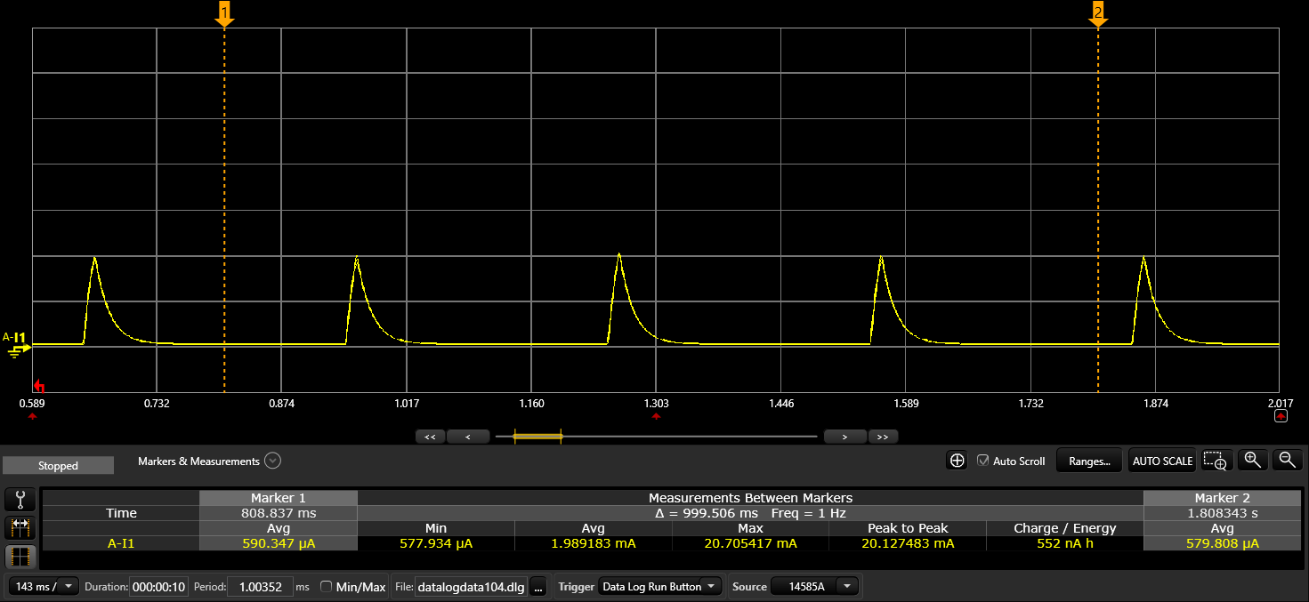

Result of QTag 3
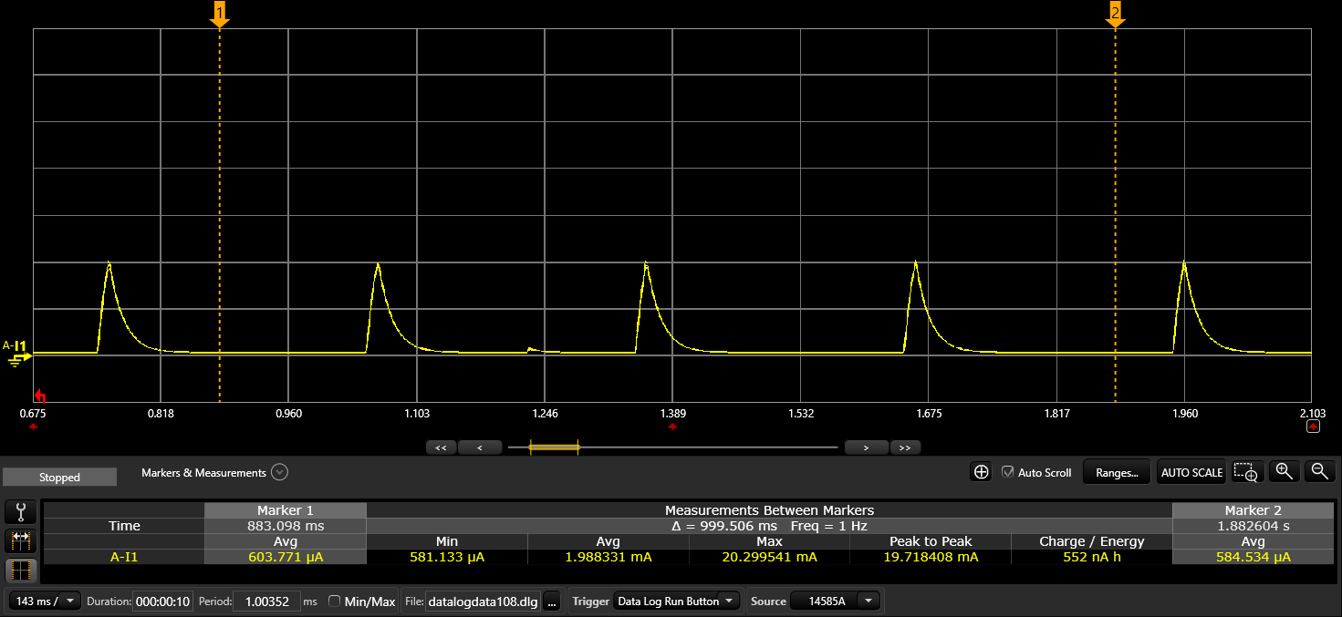

Result of QTag 4
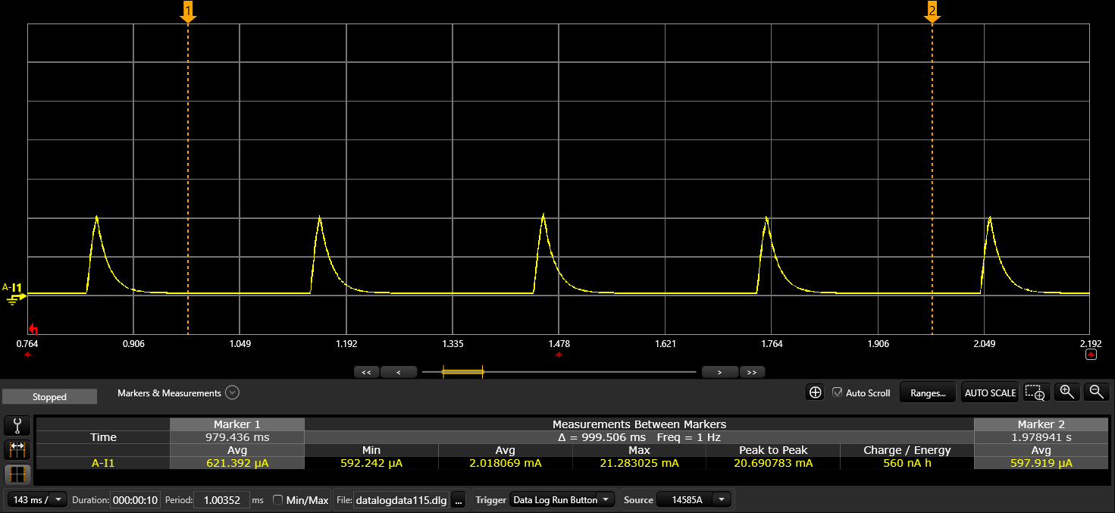

Picture of QTags
After R5 was modified to 30 ohms
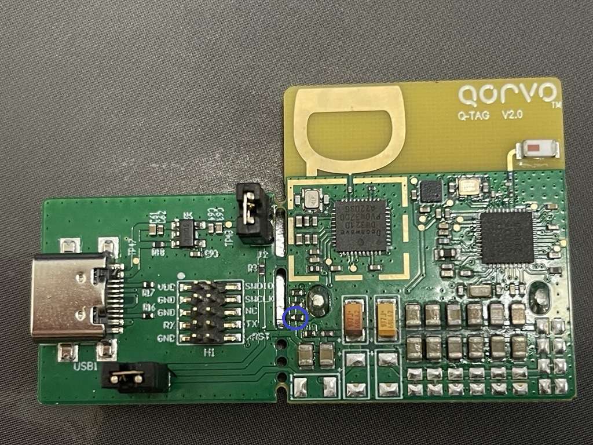

Front Side of 4 QTags
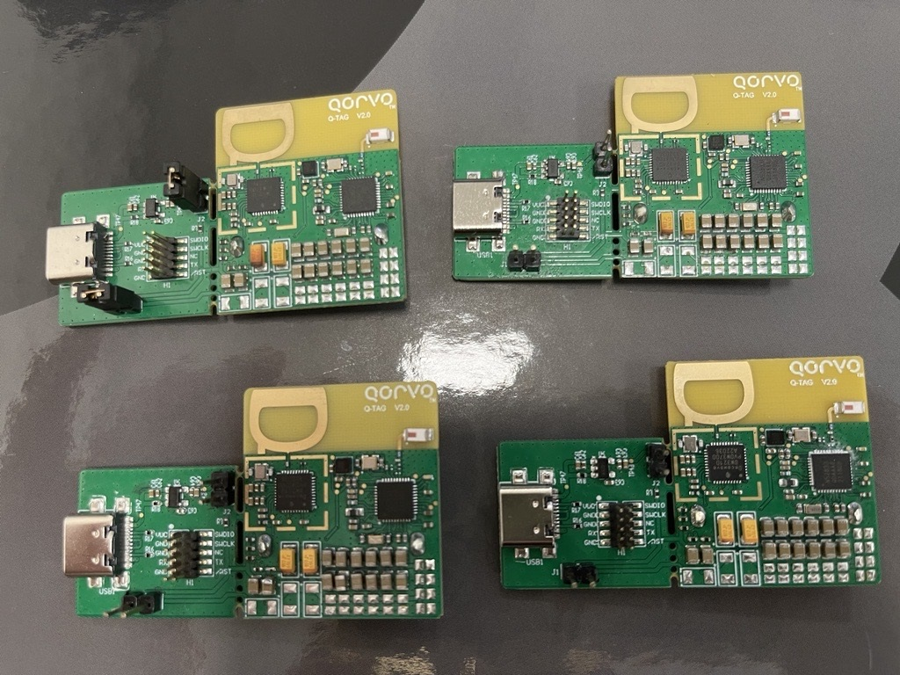

Back Side of 4 QTags
