STM32C011F6U6 DFU BOOTLOAD Report
- Following is the flowchart of the BOOTLOAD.
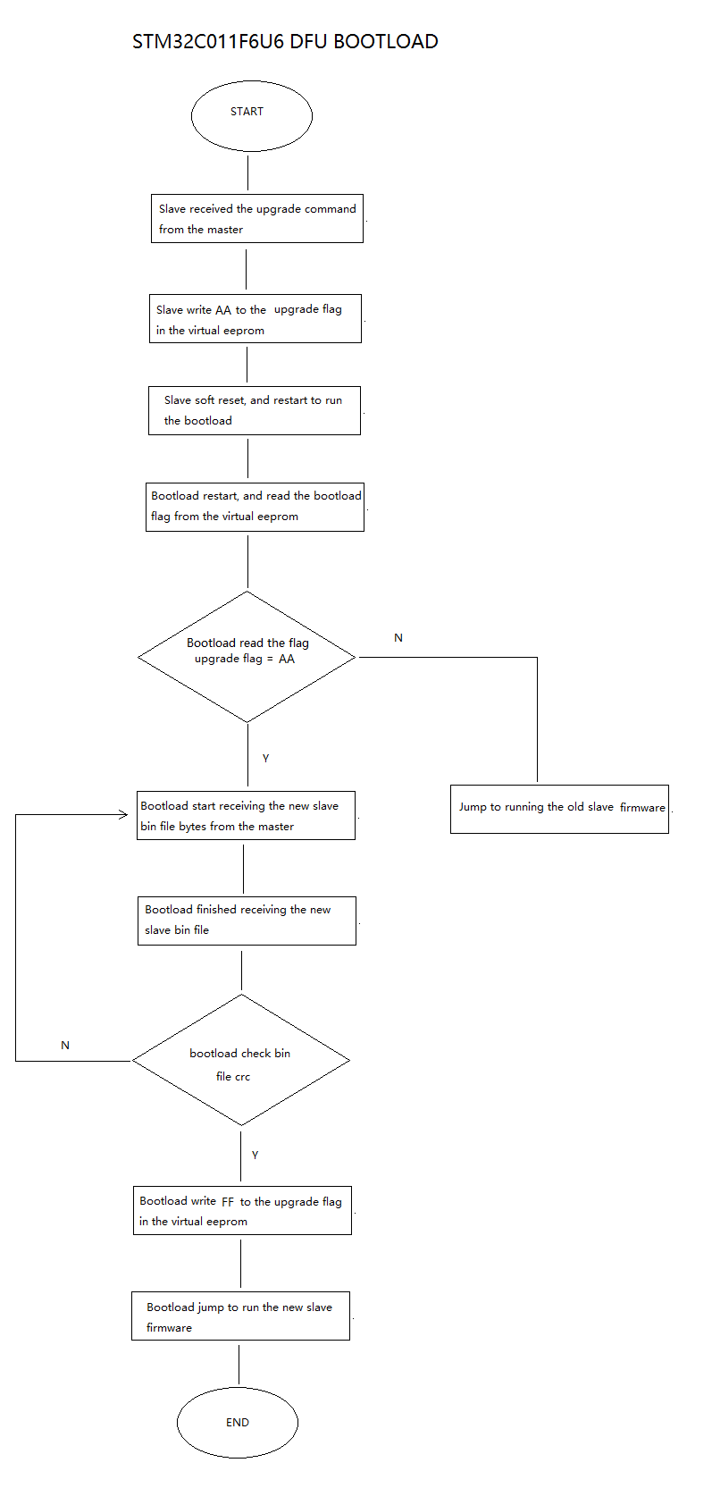

- The current progress of the DFU BOOTLOAD.
1). Have finished the firmware of the BOOTLOAD and uploaded to the GITHUB.
2). Have completed the 90%.
3). The Next step is to add the relative module about the BOOTLOAD to the slave firmware.
4). I’ll finish it on MAY 11th.

