华东师范大学期中试卷

2010—2011学年第二学期

课程名称： 数据结构与算法
姓 名：___________________ 学 号：__________________
专 业：___________________ 年级/班级：__________________
课程性质：专业必修

一 | 二 | 三 | 四 | 五 | 六 | 七 | 八 | 总分 | 阅卷人签名

- 单项选择题(共18分，每题3分)
1. Which of the following describes the property of Queue?
a) Last in and first out
b) First in and last out
c) First in and first out
d) None of above

2. If the sequence
6, 2, 7, 13, 5, 4 is added to a stack, in the order given, which number will be the first number to be removed from the stack?
a) 6
b) 2
c) 5
d) 4

3. Which of following member function is not necessary for a linked stack with safeguards?
a) Destructors
b) Copy constructors
c) Clear function
d) Overloaded assignment operators

4. If the following function is called with a value of 3 for n, what is the resulting output?
void Recursive( int n ){
if ( (n % 2) > 0)
{
cout << 0;
Recursive (n - 1);
cout << 1;
Recursive (n - 1);
}
}
  - 01
  - 0101
  - 0011
  - 000111
  - 010101

5. Shell sort finally perform an ordinary ( )?
a) Heap sort
b) Insertion sort
c) Selection sort
d) Quick sort

6. Which of the following will be true when the pointer variable cur references the last node in a linear linked list?
- cur == NULL
- head == NULL
- cur->next == NULL
- head->next == NULL

- 填空题（共22分，每空2分）
1. Given the recursive function
int Func( /* in */ int i,
/* in */ int j ){
if (i < 11)
if (j < 11)
return i + j;
else
return j + Func(i, j - 2);
else
return i + Func(i - 1, j);
}
what is the value of the expression Func(12, 15) ________【1】__________.

2. Give the declaration of circle queue. Please fill the blank to complete the method.
enum Error_code{underflow, overflow, success};
const int maxqueue = 10; // small value for testing

template<class Queue_entry>
class CirQueue {
public:
CirQueue();
bool empty() const;
Error_code serve();
Error_code append(const Queue_entry &item);
Error_code retrieve(Queue_entry &item) const;
Error_code serve_and_retrieve(Queue_entry &item);
private:
int count;
int front, rear;
Queue_entry entry[maxqueue];
};
template<class Queue_entry>
Error_code CirQueue<Queue_entry>::append(const Queue_entry &item)
/*
Post: item is added to the rear of the Queue. If the Queue is full
return an Error_code of overflow and leave the Queue unchanged.
*/
{
if (count >= maxqueue) return overflow;
________【2】_________;
rear = ________【3】__________;
entry[rear] = item;
return success;
}

3. Read the following program and fill the blank to complete the method.
template<class Node_entry>
Error_code Stack<Node_entry>::pop()
/*
Post: The top of the Stack is removed. If the Stack
is empty the method returns underflow; otherwise it returns success.
*/
{
Node<Node_entry> *old_top = top_node;
if (________【4】__________) return underflow;
top_node = ________【5】_________;
delete old_top;
return success;
}

4. Read the following program and fill the blank to complete the method.
template <class Node_entry>
struct Node {
// data members
Node_entry entry;
Node<Node_entry> *next;
Node<Node_entry> *back;
// constructors
Node( );
Node(Node_entry item, Node<Node_entry> *link_back = NULL, Node<Node_entry> *link_next = NULL);
};
template <class List_entry>
void List<List_entry> :: set_position(int position) const
/* Pre: position is a valid position in the List : 0 <=position < count .
Post: The current Node pointer references the Node at position . */
{
if (current_position <= position)
for ( ; current_position != position; current_position++)
【6】 ;
else
for ( ; current_position != position; 【7】 )
current = current->back;
}

5. Read the following program and fill the blank to complete the method.
Error_code recursive_binary_1(const Ordered_list &the_list, const Key &target, int bottom, int top, int &position)
/* Pre: The indices bottom to top define the range in the list to search for the target .
Post: If a Record in the range from bottom to top in the list has key equal to
target , then position locates one such entry, and a code of success is returned. Otherwise, not_present is returned, and position is undefined.
Uses: recursive_binary_1, together with methods from the classes Ordered_list and Record . */
{
Record data;
if (bottom < top) { // List has more than one entry.
int mid = 【8】 ;
the_list.retrieve(mid, data);
if (target > data) // Reduce to top half of list.
return recursive_binary_1(the_list, target, 【9】 , top, position);
else // Reduce to bottom half of list.
return recursive_binary_1(the_list, target,bottom, 【10】 , position);
}
else if (top < bottom) // Can be remarked?
return not_present; // List is empty.
else { // List has exactly one entry.
position = bottom;
the_list.retrieve(bottom, data);
if ( 【11】 ) return success;
else return not_present;
}
}

- 编程题（共60分）
- （15分）Write a C++ function to implement the inverse operation for the simple linked list with the head pointer h. (The following figure shows the inversing process.)
template<class List_entry> void List<List_entry> :: Inverse ( ) {…}
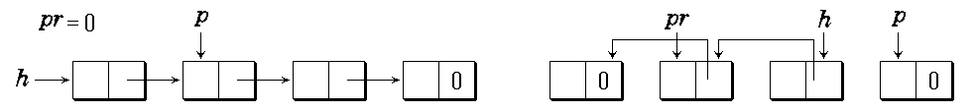

- （15分）Write the following overload operator for stack by using the basic methods of stack:
template <class Stack_entry>
bool operator== (const MyStack<Stack_entry>& s1,
const MyStack<Stack_entry>& s2)

- （10分）By hand, trace though the steps insertion sort will use on the following numbers to be sorted into increasing order:
26, 15, 67, 92, 9, 16, 72, 86, 49

- （20分）
The recursion function f(n) is defined as follows,
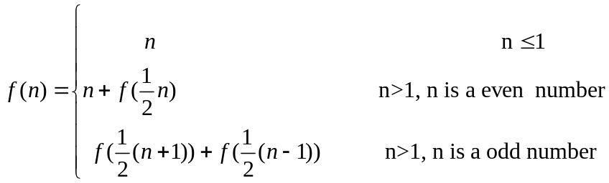
  - Write a recursive function to the function f(n). (10分)
  - Draw the recursion tree of f(7). (10分)

