# 单实例数据库Data Guard+Grid Infrastructure+Oracle restart配置实例

本文约定：

1.备库已经事先安装了Oracle数据库软件

2.备库从安装grid infrastructure开始，

3.主库为文件系统，备库为ASM存放数据库文件

## 1.备库操作系统参数配置

### 1.1备库创建用户和用户组

**建立组**

groupadd -g 1000 oinstall

groupadd -g 1031 dba

groupadd -g 1032 asmdba

groupadd -g 1033 asmadmin

**建立grid用户**

useradd -u 1100 -g oinstall -G asmdba,dba,asmadmin grid

echo "oracle" |passwd grid --stdin

mkdir -p /u01/app/grid_base/grid_home

chown -R grid:oinstall /u01/app/grid_base

chmod -R 775 /u01/app/grid_base

**建立Oracle用户（本文Oracle用户已经存在）**

useradd -u 1101 -g oinstall -G dba,asmdba oracle

mkdir -p /u01/app/oracle/product/12.2.0

chown -R oracle:oinstall /u01/app/oracle

chmod -R 775 /u01/app/oracle

**如果Oracle用户存在则添加附加组：**

usermod -G dba,asmdba oracle

### 1.2为grid用户设置环境变量

**环境变量文件编辑**

vi /home/grid/.bash_profile

新增下列内容：

export ORACLE_SID=+ASM1

export ORACLE_BASE=/u01/app/grid_base

export ORACLE_HOME=$ORACLE_BASE/grid_home

export GRID_HOME=$ORACLE_HOME

export PATH=/usr/sbin:$PATH:$ORACLE_HOME/bin

export LD_LIBRARY_PATH=$ORACLE_HOME/lib:/lib:/usr/lib

export CLASSPATH=$ORACLE_HOME/JRE:$ORACLE_HOME/jlib:$ORACLE_HOME/rdbms/jlib

umask 022

### 1.3为备库虚拟机添加两个磁盘（20G）

磁盘1作为数据磁盘组，磁盘2作为快速恢复区的磁盘组

对磁盘进行分区：

fdisk /dev/sdc

输入：n 新建分区，

p主分区，

1 第一个主分区，默认开始柱面-回车，默认结束柱面-回车，

w写入分区信息

fdisk /dev/sdd

输入：n 新建分区，

p主分区，

1 第一个主分区，默认开始柱面-回车，默认结束柱面-回车，

w写入分区信息

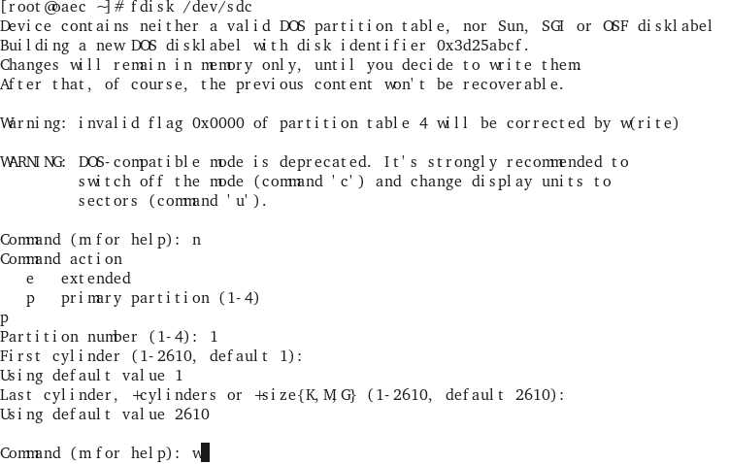

### 1.4用udev管理磁盘

cd /etc/udev/rules.d

然后创建一个规则文件，后缀一定要是.rules：

vi 99-ASM.rules

**写入如下内容：**

ACTION=="add", KERNEL=="sdc1", RUN+="/bin/raw /dev/raw/raw1 %N"

ACTION=="add", KERNEL=="sdd1", RUN+="/bin/raw /dev/raw/raw2 %N"

KERNEL=="raw[1-2]*", OWNER="grid", GROUP="asmdba", MODE="775"

**启动udev**

[root@oaecdg rules.d]# start_udev

Starting udev: udevd[5968]: GOTO 'pulseaudio_check_usb' has no matching label in: '/lib/udev/rules.d/90-pulseaudio.rules' [ OK ]

[root@oaecdg rules.d]# raw -qa

/dev/raw/raw1: bound to major 8, minor 33

/dev/raw/raw2: bound to major 8, minor 49

## 2.切换到grid用户安装GI（grid infrastructure）软件

[root@oaecdg rules.d]xhost +

[root@oaecdg rules.d]su – grid

grid用户解压安装文件linuxx64_12201_grid_home.zip到$GRID_HOME

cd $GRID_HOME

./gridSetup.sh

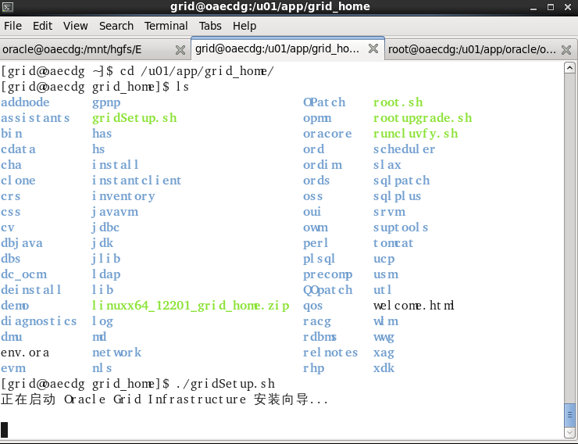

**选择独立服务器配置，因为不是集群**

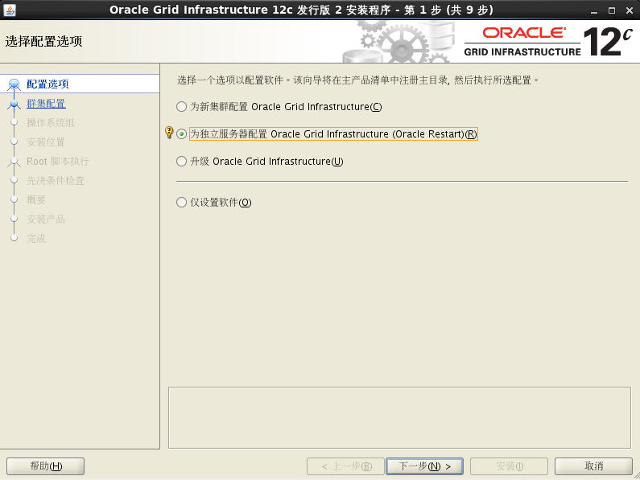

**如果选择仅配置软件就不会出现下面建立磁盘组的界面**

**建立磁盘组时，需要通过”更改搜索路径”去选择裸设备**

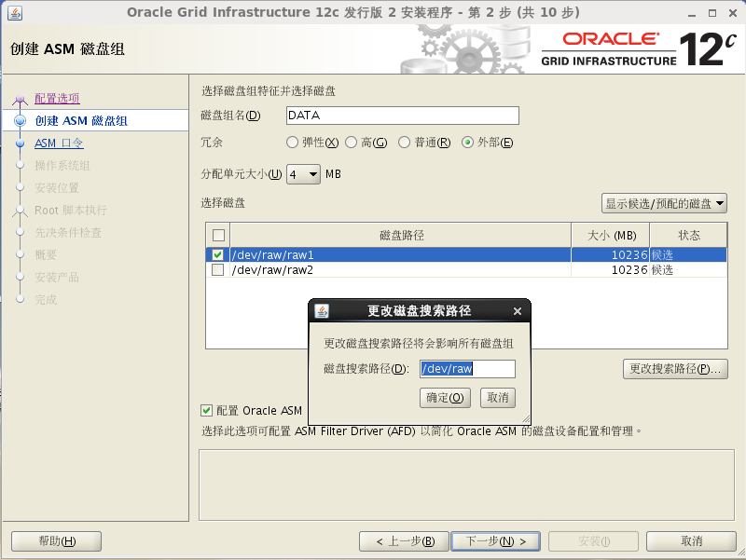

**选择使用同一口令，口令：oracle**

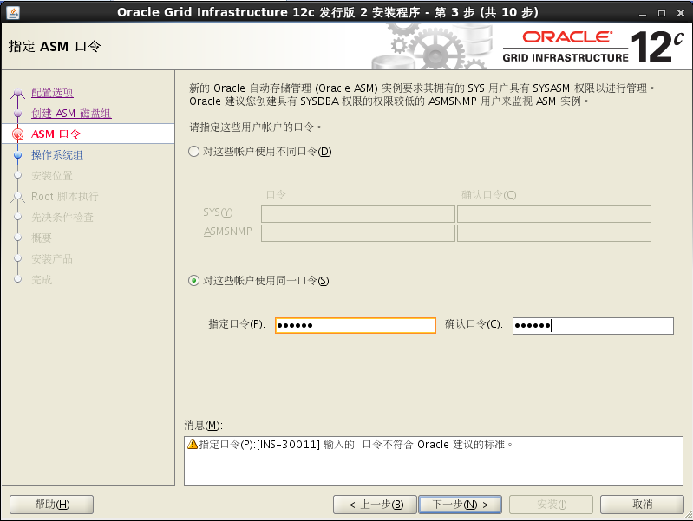

**提示口令太短**

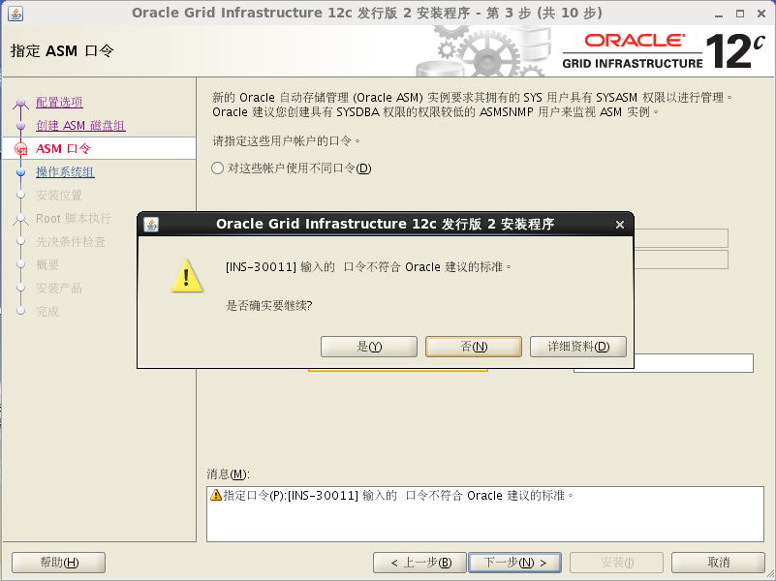

**不用去注册到cloud control**

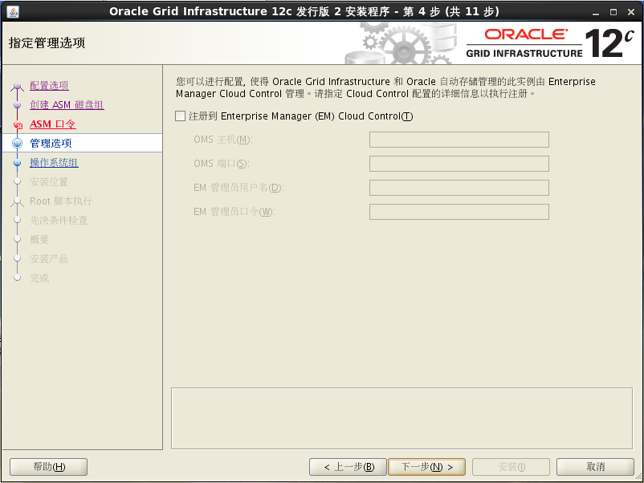

**选择ASM操作者组**

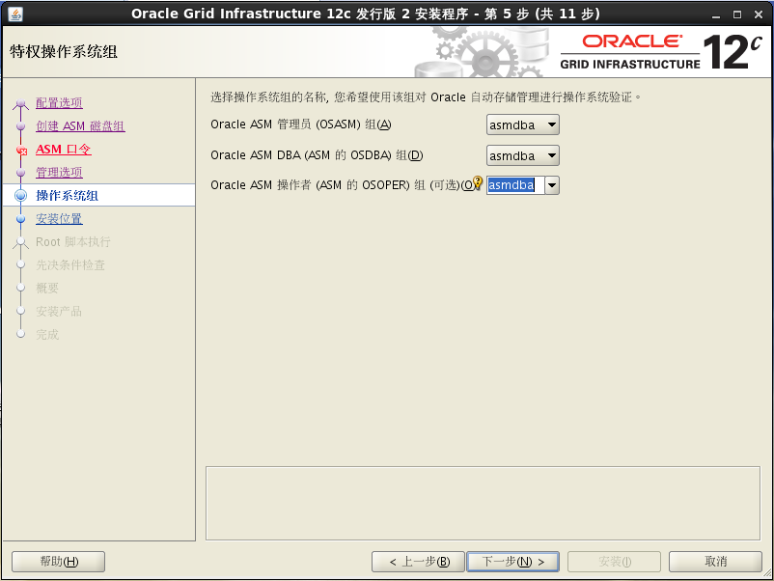

**选择grid软件的base目录**

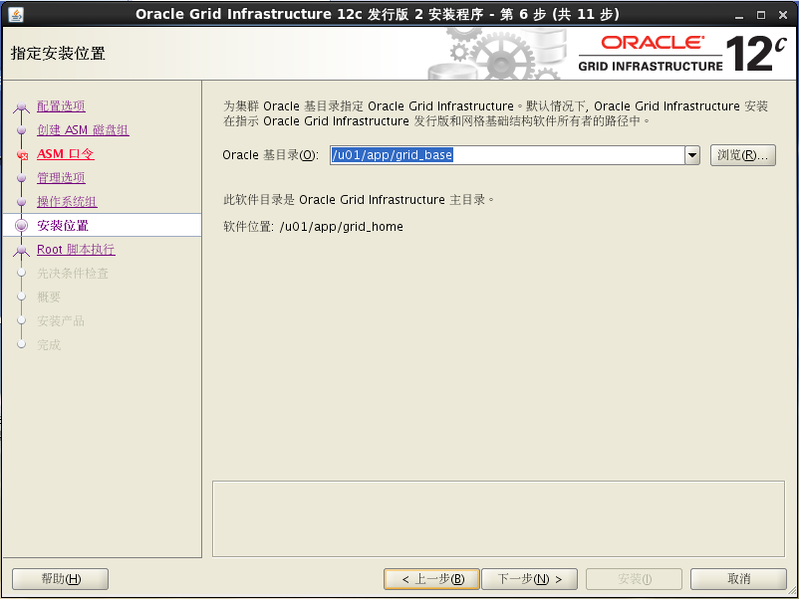

**提示base目录不包含home目录，所以修改目录位置和环境变量设置为base包含home**

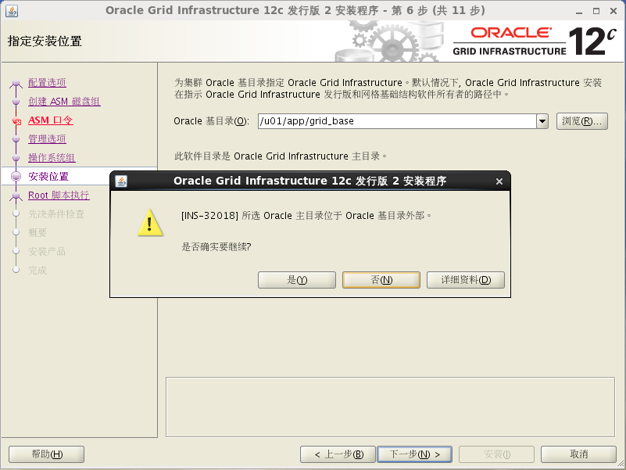

mkdir /u01/app/grid_base/grid_home

vi .bash_profile

# Get the aliases and functions

export ORACLE_SID=+ASM1

export ORACLE_BASE=/u01/app/grid_base

export ORACLE_HOME=$ORACLE_BASE/grid_home

export GRID_HOME=$ORACLE_HOME

export PATH=/usr/sbin:$PATH:$ORACLE_HOME/bin

export LD_LIBRARY_PATH=$ORACLE_HOME/lib:/lib:/usr/lib

export CLASSPATH=$ORACLE_HOME/JRE:$ORACLE_HOME/jlib:$ORACLE_HOME/rdbms/jlib

umask 022

**这次不报错了**

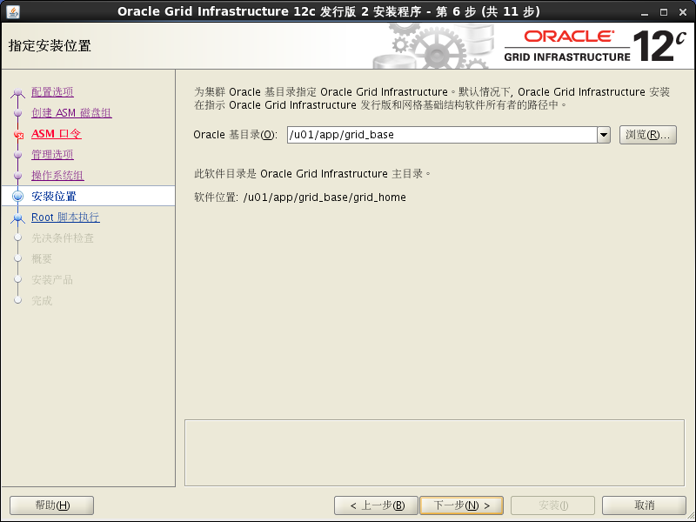

安装后需要用root运行一个脚本，这里时做成自动的了，如果不选择自动运行，就是要手动切换到root用户去执行

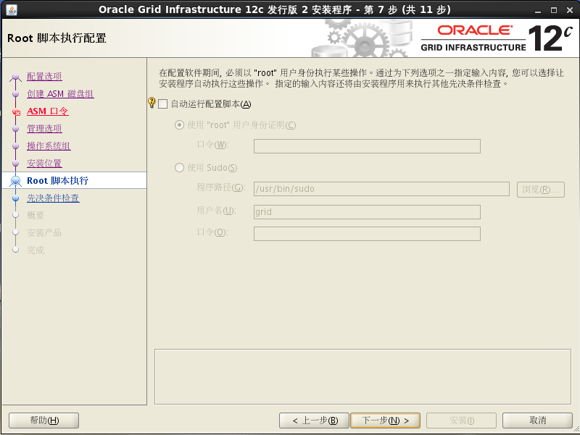

**先决条件检查**

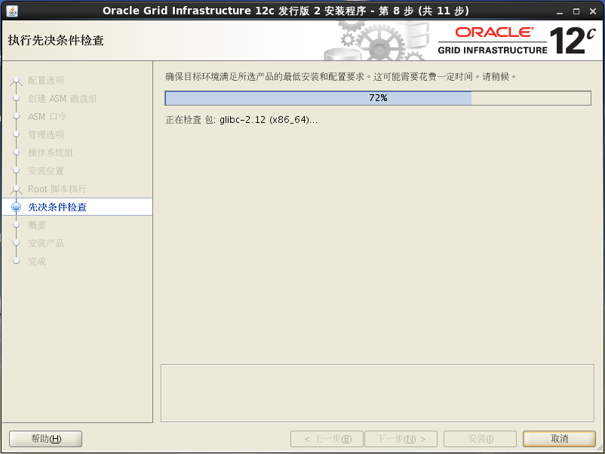

**有一些先决条件没通过**

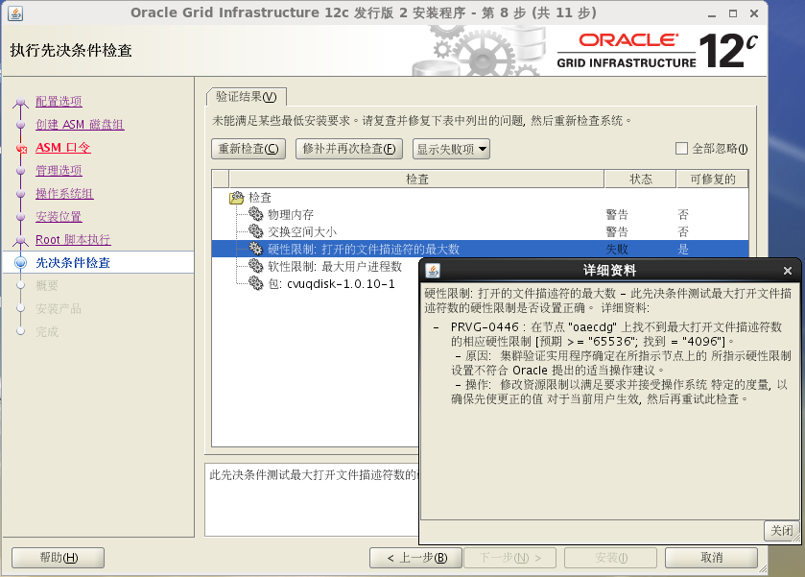

**root用户添加**

**vi /etc/security/limits.conf**

grid soft nproc 2047

grid hard nproc 16384

grid soft nofile 1024

grid hard nofile 65536

grid soft stack 10240

grid hard stack 10240

root用户添加

vi /etc/profile

if [ $USER = "grid" ]; then

if [ $SHELL = "/bin/ksh" ]; then

ulimit -p 16384

ulimit -n 65536

else

ulimit -u 16384 -n 65536

fi

umask 022

fi

需要安装cvuqdisk的rpm包

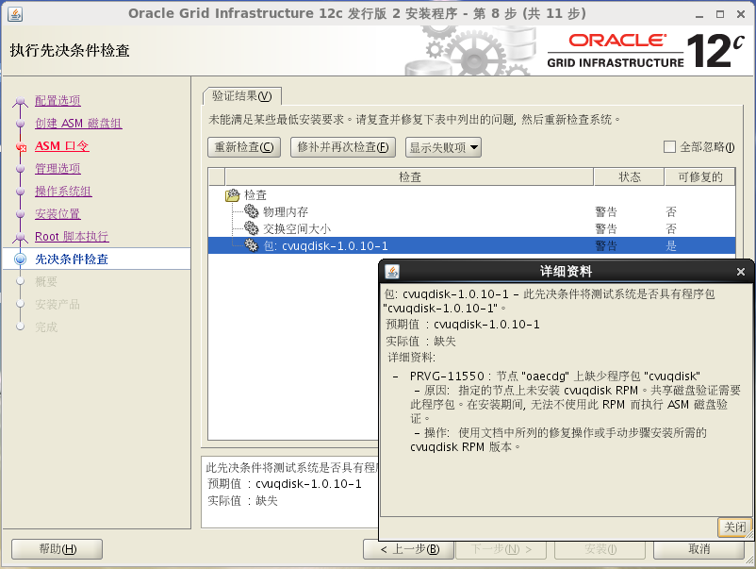

先把CVUQDISK_GRP环境变量加上

groupadd asmadmin

export CVUQDISK_GRP=asmadmin

[root@oaecdg app]# cd /u01/app/grid_base/grid_home/cv/rpm/

[root@oaecdg rpm]# ls

cvuqdisk-1.0.10-1.rpm

[root@oaecdg rpm]# rpm -ivh cvuqdisk-1.0.10-1.rpm

Preparing... ########################################### [100%]

1:cvuqdisk ########################################### [100%]

先决条件检查发现内存和交换分区不足，因为时测试环境，选择”全部忽略”

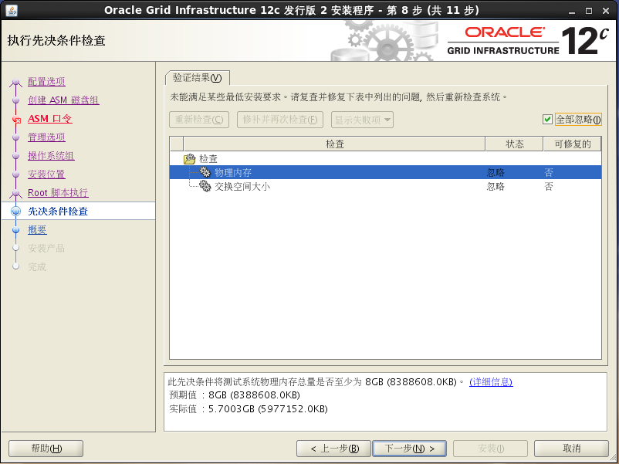

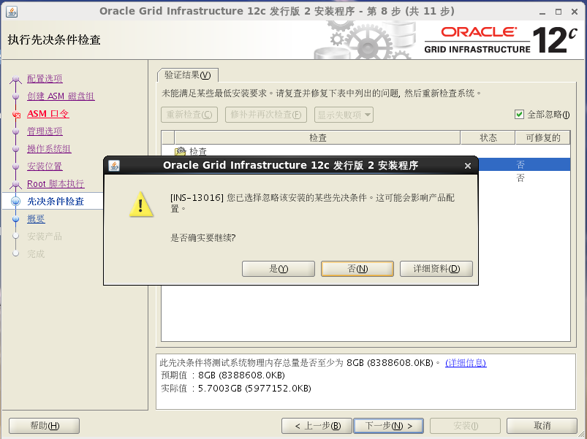

最后显示安装的概览信息

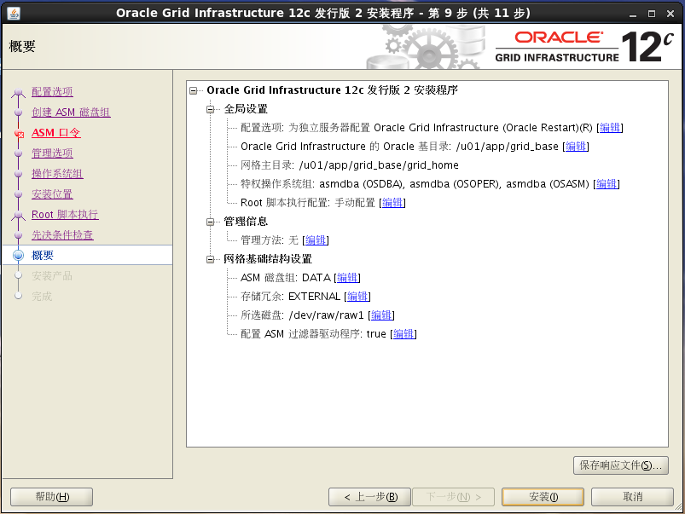

安装进度显示

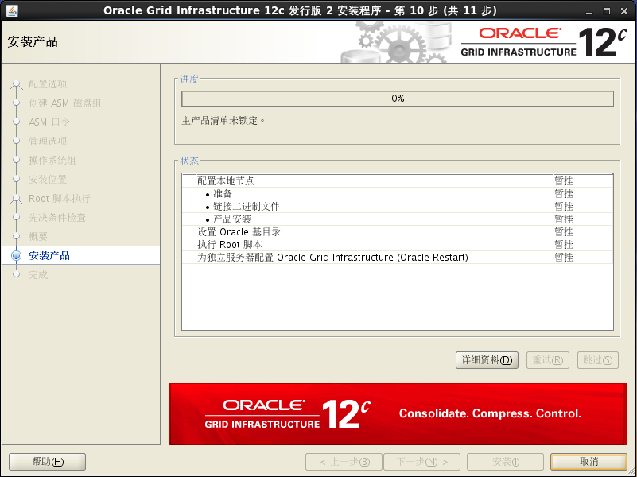

这里需要root用户手动运行脚本：/u01/app/grid_base/grid_home/root.sh

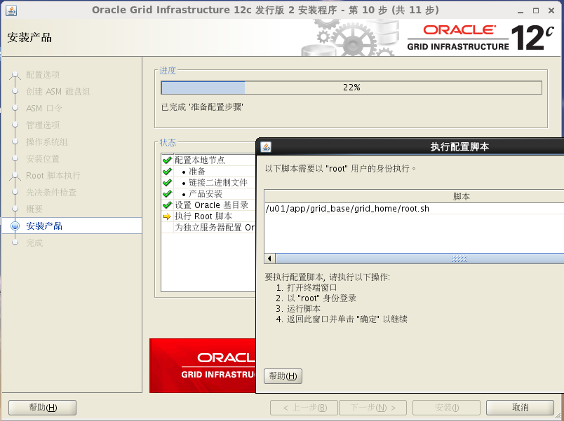

脚本运行结果

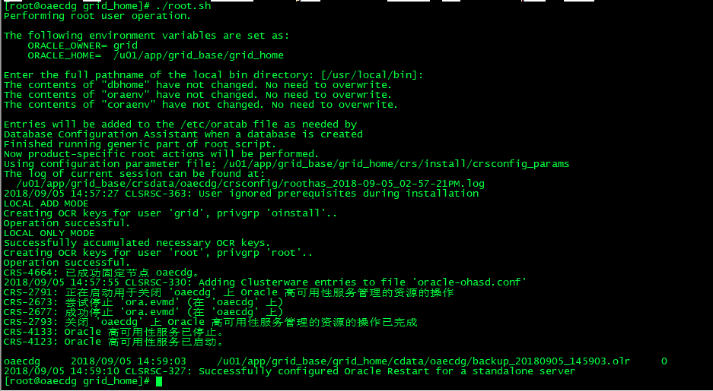

进度条走完

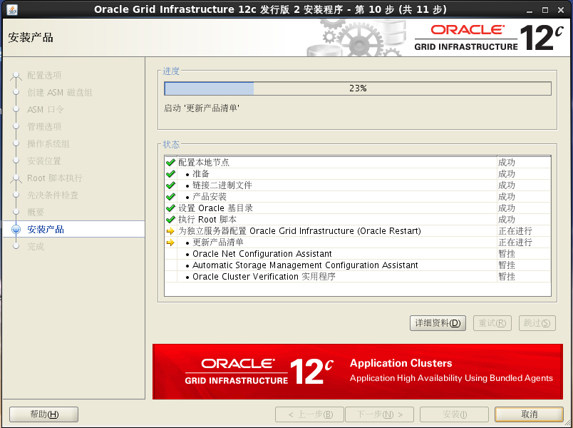

图形安装调用asmca建立磁盘组报错，查看日志

INFO: [2018-9-5 15:00:13] Executing ASMCA

INFO: [2018-9-5 15:00:13] Command /u01/app/grid_base/grid_home/bin/asmca -silent -oui_internal -configureASM -diskString '/dev/raw' -diskGroupName DATA -diskList /dev/raw/raw1 -redundancy EXTERNAL -au_size 4

INFO: [2018-9-5 15:00:13] ... GenericInternalPlugIn.handleProcess() entered.

INFO: [2018-9-5 15:00:13] ... GenericInternalPlugIn: getting configAssistantParmas.

INFO: [2018-9-5 15:00:13] ... GenericInternalPlugIn: checking secretArguments.

INFO: [2018-9-5 15:00:13] ... GenericInternalPlugIn: starting read loop.

INFO: [2018-9-5 15:00:17] Read: SYS_PASSWORD_PROMPT

INFO: [2018-9-5 15:00:17] SYS_PASSWORD_PROMPT

INFO: [2018-9-5 15:00:17] Processing: SYS_PASSWORD_PROMPT for argument tag -sysAsmPassword

INFO: [2018-9-5 15:00:17] Read: ******

INFO: [2018-9-5 15:00:17] ******

WARNING: [2018-9-5 15:00:17] Skipping line: ******

INFO: [2018-9-5 15:00:17] Read: ASMSNMP_PASSWORD_PROMPT

INFO: [2018-9-5 15:00:17] ASMSNMP_PASSWORD_PROMPT

INFO: [2018-9-5 15:00:17] Processing: ASMSNMP_PASSWORD_PROMPT for argument tag -asmMonitorPassword

INFO: [2018-9-5 15:00:17] End of argument passing to stdin

INFO: [2018-9-5 15:00:17] Read: *******

INFO: [2018-9-5 15:00:17] *******

WARNING: [2018-9-5 15:00:17] Skipping line: *******

INFO: [2018-9-5 15:00:20] Read:

WARNING: [2018-9-5 15:00:20] Skipping line:

INFO: [2018-9-5 15:00:20] Read: 未能配置 ASM。

INFO: [2018-9-5 15:00:20] 未能配置 ASM。

WARNING: [2018-9-5 15:00:20] Skipping line: 未能配置 ASM。

INFO: [2018-9-5 15:00:20] Read: 未能配置 HA 资源。

INFO: [2018-9-5 15:00:20] 未能配置 HA 资源。

WARNING: [2018-9-5 15:00:20] Skipping line: 未能配置 HA 资源。

INFO: [2018-9-5 15:00:20] Read: PRCA-1003 : 无法创建 ASM asm 资源 ora.asm

INFO: [2018-9-5 15:00:20] PRCA-1003 : 无法创建 ASM asm 资源 ora.asm

WARNING: [2018-9-5 15:00:20] Skipping line: PRCA-1003 : 无法创建 ASM asm 资源 ora.asm

INFO: [2018-9-5 15:00:20] Read: PRCR-1071 : 无法注册或更新 资源 ora.asm

INFO: [2018-9-5 15:00:20] PRCR-1071 : 无法注册或更新 资源 ora.asm

WARNING: [2018-9-5 15:00:20] Skipping line: PRCR-1071 : 无法注册或更新 资源 ora.asm

INFO: [2018-9-5 15:00:20] Read: CRS-2877: Owner 'grid' of the entity 'ora.asm' does not belong to the 'asmdba' group.

INFO: [2018-9-5 15:00:20] CRS-2877: Owner 'grid' of the entity 'ora.asm' does not belong to the 'asmdba' group.

WARNING: [2018-9-5 15:00:20] Skipping line: CRS-2877: Owner 'grid' of the entity 'ora.asm' does not belong to the 'asmdba' group.

INFO: [2018-9-5 15:00:20] Read:

WARNING: [2018-9-5 15:00:20] Skipping line:

INFO: [2018-9-5 15:00:20] Completed Plugin named: Automatic Storage Management Configuration Assistant

以上执行ASMCA报错

CRS-2877: Owner 'grid' of the entity 'ora.asm' does not belong to the 'asmdba' group

**解决：需要更改grid用户的从属组**

[root@oaecdg grid_home]# id grid

uid=1100(grid) gid=501(oinstall) 组=501(oinstall),1033(asmadmin)

[root@oaecdg grid_home]# id oracle

uid=500(oracle) gid=501(oinstall) 组=501(oinstall),500(dba),1032(asmdba)

grid用户加入asmdba组

[root@oaecdg grid_home]# usermod -G asmdba grid

[root@oaecdg grid_home]# id grid

uid=1100(grid) gid=501(oinstall) 组=501(oinstall),1032(asmdba)

更改权限再次执行asmca命令

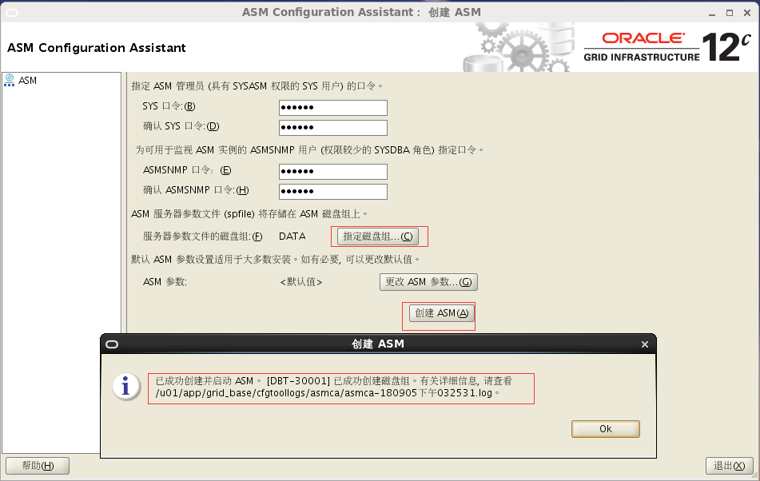

选择创建ASM

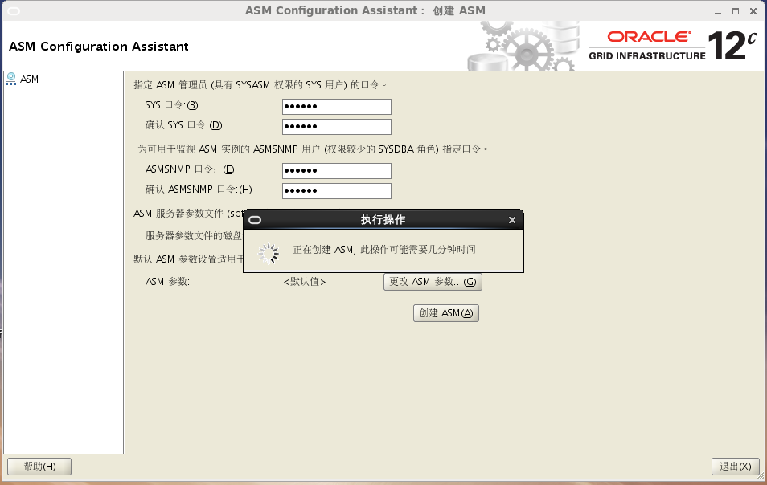

选择”更改磁盘搜索路径”

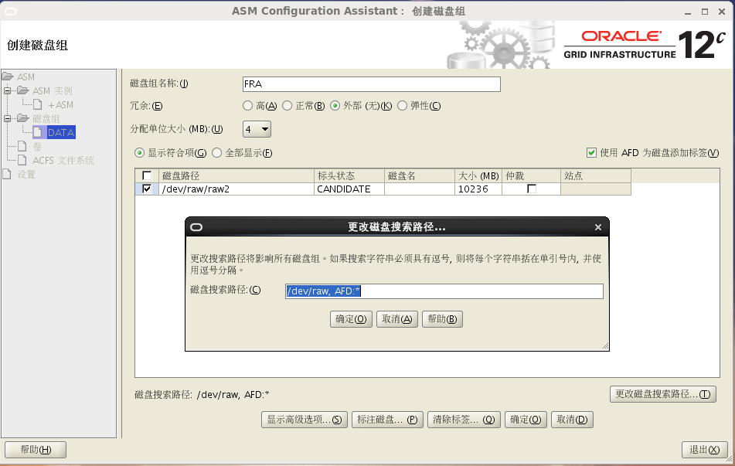

建立快速恢复区

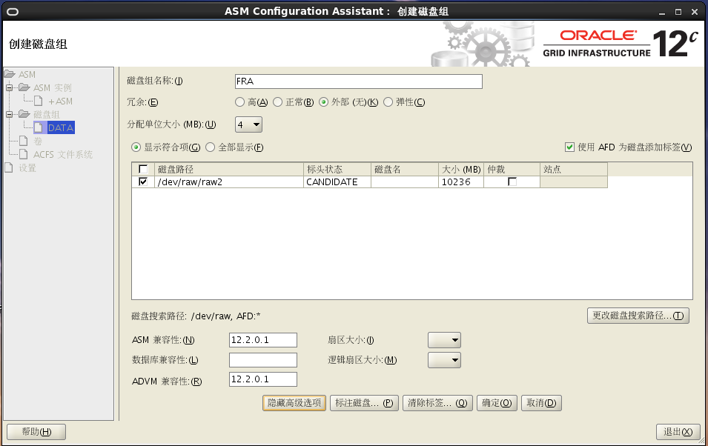建立完成，大小应该为20G，这里10G有点小

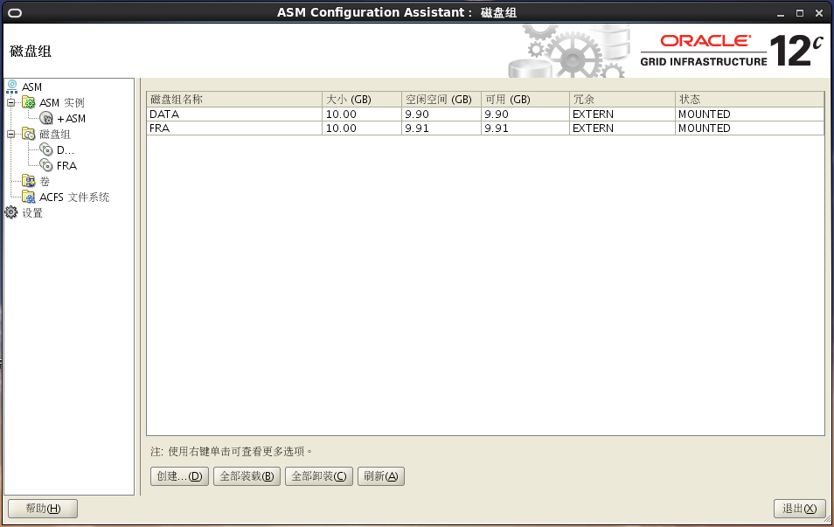

## 3.创建样例数据库

### 3.1把这个数据库建立到ASM上，（此步骤可以省略，主要为了生产数据库restart资源）

dbca

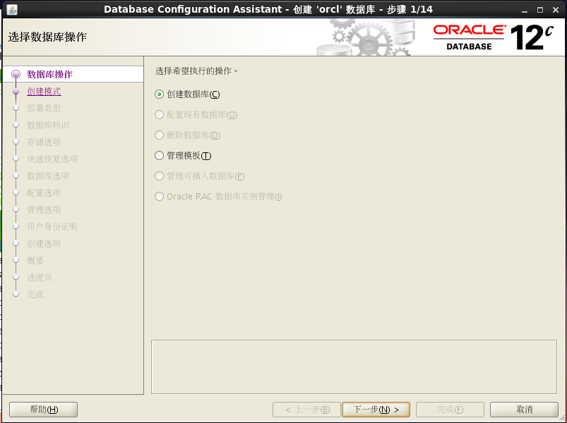

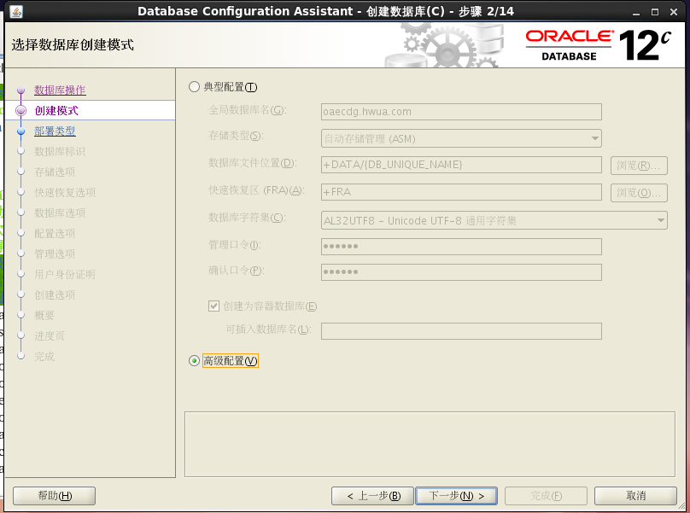 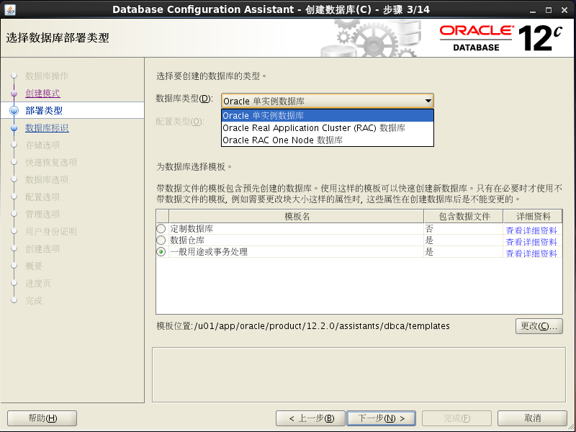 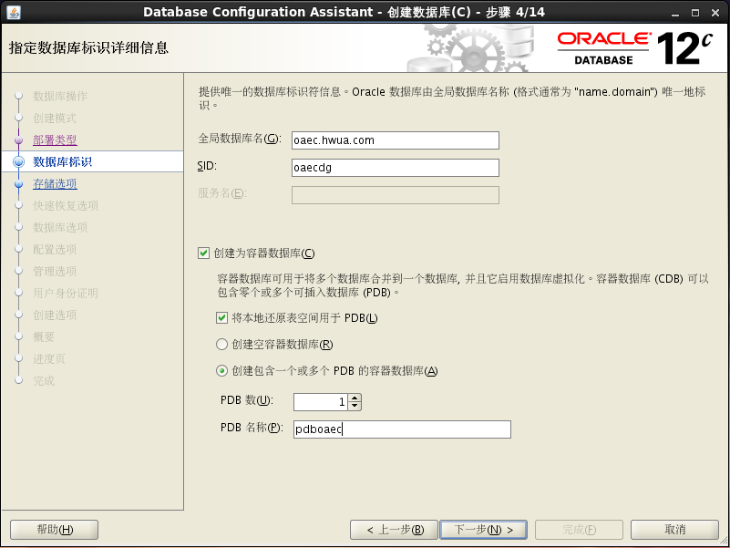 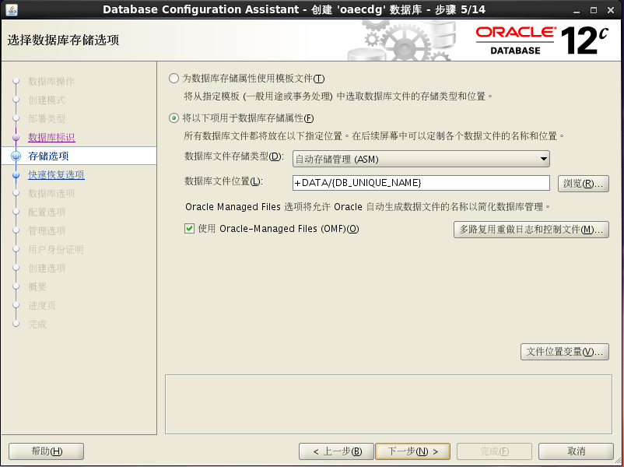 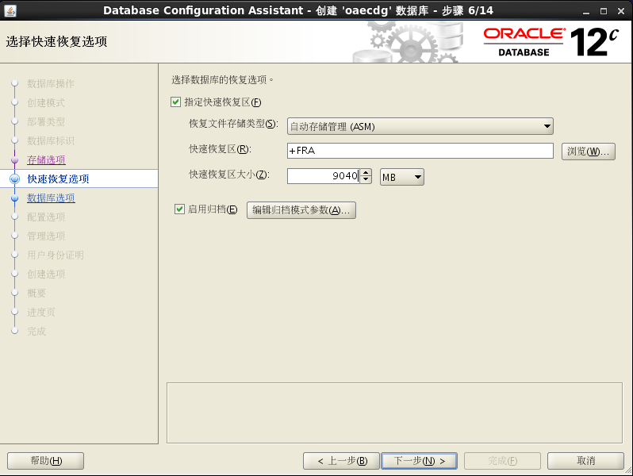

[oracle@oaecdg admin]$ lsnrctl start

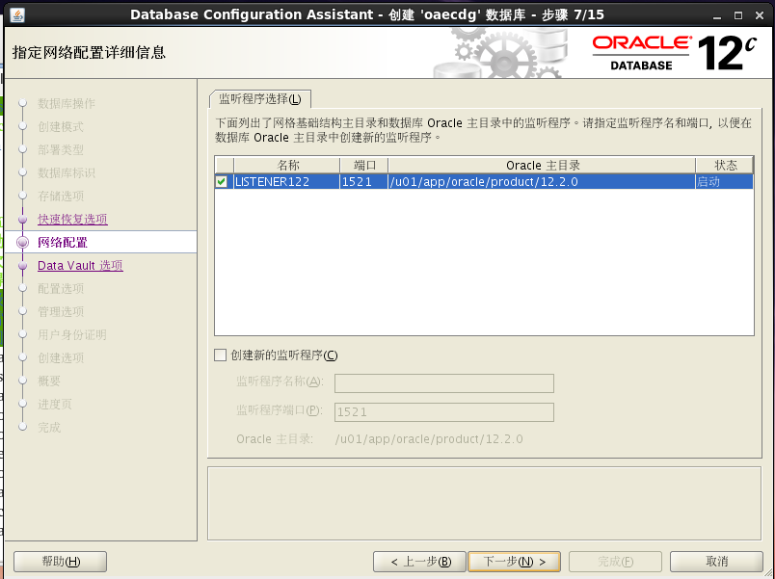 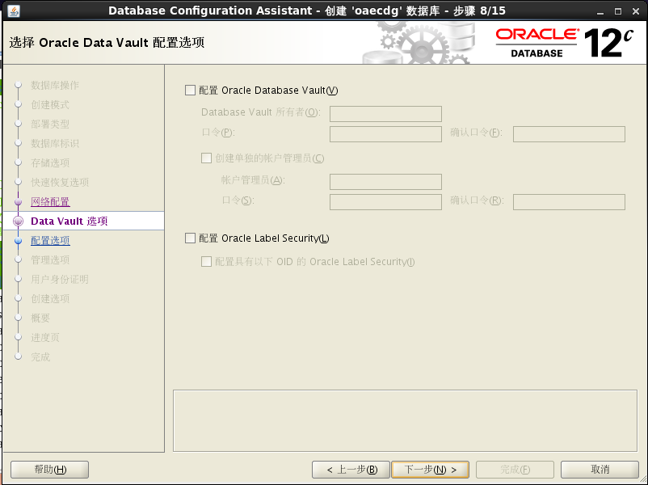 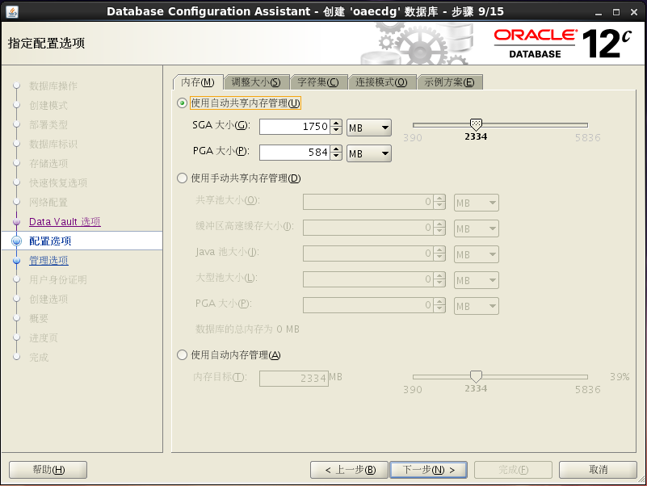 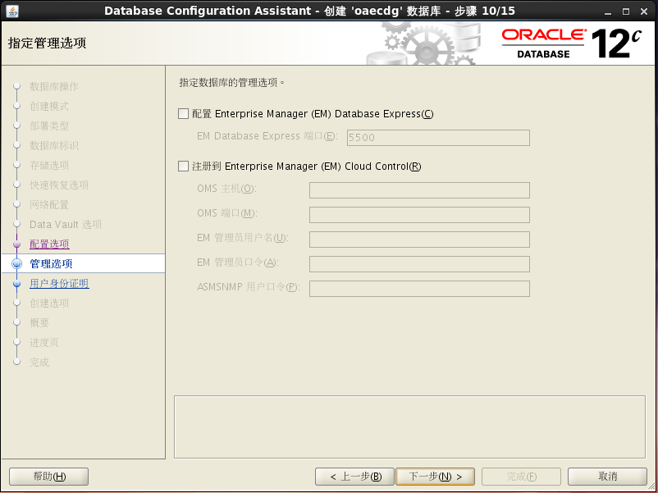

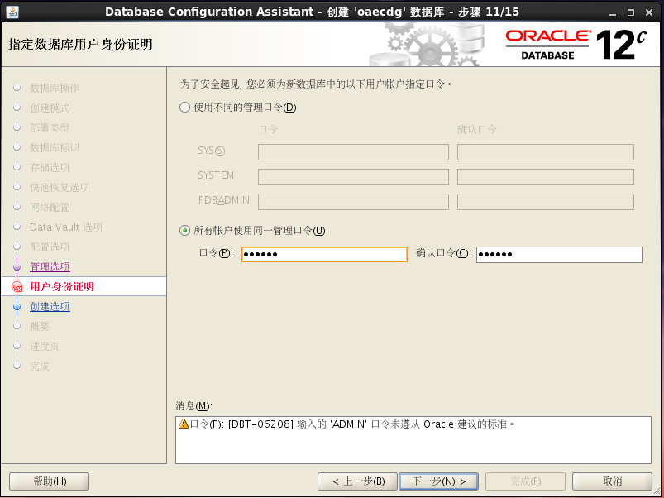

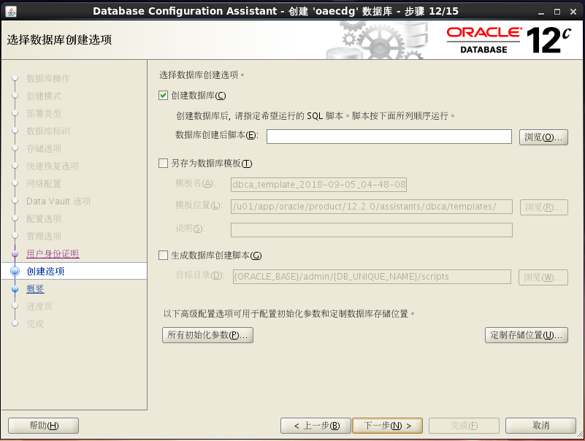

修改快速恢复区大小，为建议值9040

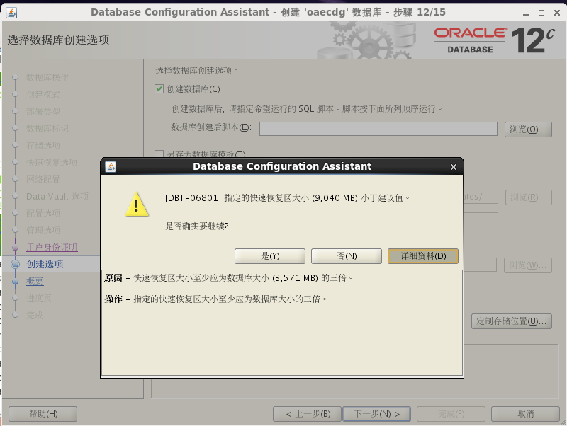

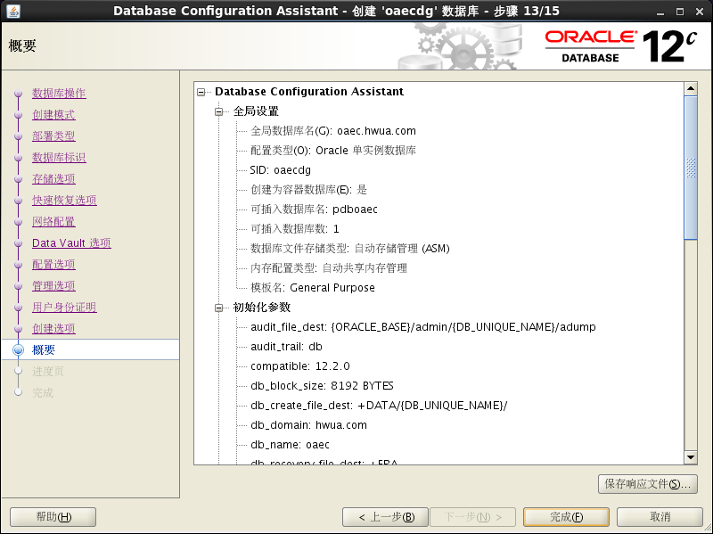

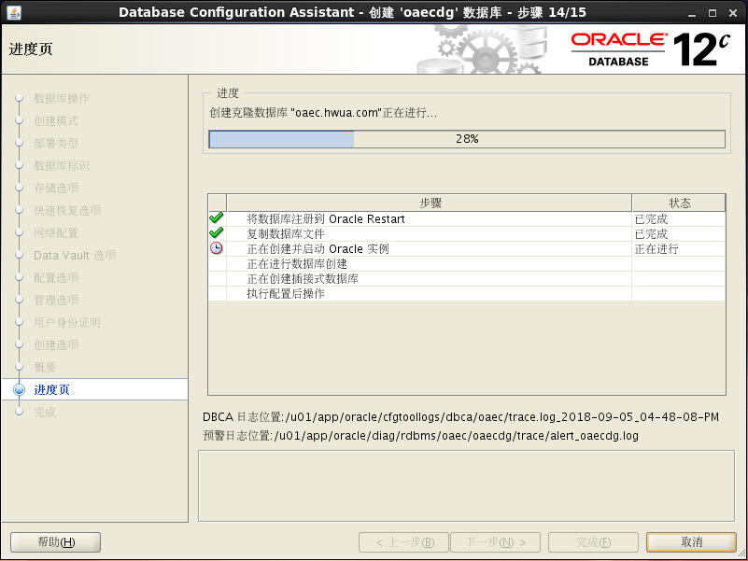

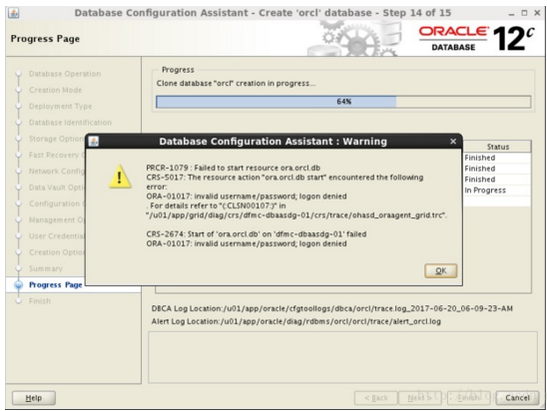

**DBCA报错解决：**

**dbca CRS-2674: Start of 'ora.orcl.db' on 'rac1' failed ORA-01017: invalid username/password; log**

解决方法：

01) Add the user "grid" to OSDBA group (for example, dba)

# id grid

uid=501(grid) gid=502(oinstall) groups=502(oinstall)

# usermod -a -G dba grid

# id grid

uid=501(grid) gid=502(oinstall) groups=502(oinstall),503(dba)

02) Recompile the DB binaries (execute as oracle user)

$ export ORACLE_BASE=/u01/app/oracle

$ export ORACLE_HOME=/u01/app/oracle/product/12.1.0/dbhome_1

$ export PATH=$ORACLE_HOME/bin:$PATH

$ relink all

03) If there are no errors reported in $ORACLE_HOME/install/relink.log, then proceed with creating the database

$ dbca

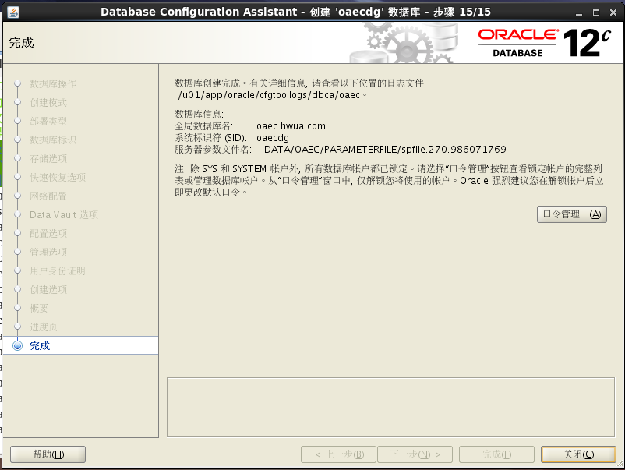

### 3.2数据库建立完成，为了建立备库这个数据库可以删除：

[grid@oaecdg ~]$ asmcmd

ASMCMD> ls

DATA1/

FRA/

ASMCMD> cd data1

ASMCMD> ls

oaecdg/

ASMCMD> cd oaecdg

ASMCMD> ls

PARAMETERFILE/

controlfile/

datafile/

onlinelog/

ASMCMD> ls datafile

SYSAUX.282.986568785

SYSTEM.283.986568787

UNDOTBS1.285.986568747

USERS.284.986568747

pdb1/

pdboaec/

pdbseed/

sysaux01.dbf

system01.dbf

undotbs01.dbf

users01.dbf

ASMCMD>pwd

+DATA1/oaecdg/ datafile

rm –rf *.dbf

rm –rf SYS*

rm –rf U*

rm –rf pdb1/*

rm –rf pdboaec/*

rm –rf pdbseed/*

## 4.DATA GUARD配置

### 4.1配置DG备库参数文件

**定义备库的参数文件vi /home/oracle/pfile**

**（红色字体为dataguard参数，蓝色字体为需要注意的参数）**

*.audit_file_dest='/u01/app/oracle/admin/oaec/adump'

*.audit_trail='DB'

*.compatible='12.2.0.1.0'

*.control_files='+DATA1/OAECDG/CONTROLFILE/current.268.986218981'

*.db_block_size=8192

*.db_domain='hwua.com'

*.db_file_name_convert='/u01/app/oracle/oradata/oaec/','+DATA1/oaecdg/datafile/'

*.db_name='oaec'

**\*.db_recovery_file_dest='+FRA'**

**\*.db_recovery_file_dest_size=4781506560**

*.db_unique_name='oaecdg'

*.diagnostic_dest='/u01/app/oracle'

*.dispatchers='(PROTOCOL=TCP) (SERVICE=oaecXDB)'

*.enable_pluggable_database=TRUE

*.fal_server='oaec'

**\*.local_listener='LISTENER_OAECDG'**

**\*.log_archive_config='dg_config=(oaec,oaecdg)'**

*.log_archive_dest_1='location=+FRA'

*.log_archive_dest_2='SERVICE=oaec LGWR SYNC AFFIRM VALID_FOR=(ONLINE_LOGFILES,PRIMARY_ROLE) DB_UNIQUE_NAME=oaec'

*.log_archive_dest_state_1='ENABLE'

*.log_archive_dest_state_2='ENABLE'

*.log_file_name_convert='/u01/app/oracle/oradata/oaec/','+DATA1/oaecdg/onlinelog/'

*.memory_target=3388997632

*.nls_language='SIMPLIFIED CHINESE'

*.nls_territory='CHINA'

*.open_cursors=300

*.processes=300

*.remote_login_passwordfile='EXCLUSIVE'

*.standby_file_management='auto'

*.undo_tablespace='UNDOTBS1'

**\*.remote_listener='LISTENER_OAECDG'**

**\*.db_create_file_dest='+DATA1'**

### 4.2修改listener.ora

**由于数据安装在ASM，监听器受GI管理所以listener.ora在目录**

**/u01/app/grid_base/grid_home/network/admin**

**cat listener.ora**

SID_LIST_LISTENER =

(SID_LIST =

(SID_DESC =

(GLOBAL_DBNAME = oaecdg)

(ORACLE_HOME = /u01/app/oracle/product/12.2.0)

(SID_NAME = oaecdg)

)

)

VALID_NODE_CHECKING_REGISTRATION_LISTENER = SUBNET

LISTENER =

(DESCRIPTION_LIST =

(DESCRIPTION =

(ADDRESS = (PROTOCOL = TCP)(HOST = oaecdg.hwua.com)(PORT = 1521))

(ADDRESS = (PROTOCOL = IPC)(KEY = EXTPROC1521))

)

)

ENABLE_GLOBAL_DYNAMIC_ENDPOINT_LISTENER = ON

**生产备库的tnsnames.ora文件**

OAECDG =

(DESCRIPTION =

(ADDRESS_LIST =

(ADDRESS = (PROTOCOL = TCP)(HOST = oaecdg)(PORT = 1521))

)

(CONNECT_DATA =

(SERVER = DEDICATED)

(SERVICE_NAME = oaecdg)

)

)

LISTENER_OAEC =

(ADDRESS = (PROTOCOL = TCP)(HOST = oaec)(PORT = 1521))

OAEC =

(DESCRIPTION =

(ADDRESS = (PROTOCOL = TCP)(HOST = oaec)(PORT = 1521))

(CONNECT_DATA =

(SERVER = DEDICATED)

(SERVICE_NAME = oaec.hwua.com)

)

)

PDBOAEC =

(DESCRIPTION =

(ADDRESS = (PROTOCOL = TCP)(HOST = oaec)(PORT = 1521))

(CONNECT_DATA =

(SERVER = DEDICATED)

(SERVICE_NAME = pdboaec.hwua.com)

)

)

[oracle@oaecdg dbs]$ echo $ORACLE_SID

oaecdg

[oracle@oaecdg dbs]$ sqlplus / as sysdba

SQL*Plus: Release 12.2.0.1.0 Production on 星期三 9月 5 16:15:00 2018

Copyright (c) 1982, 2016, Oracle. All rights reserved.

已连接到空闲例程。

**用grid用户启动监听**

[grid@oaecdg ~]$ lsnrctl start

[grid@oaecdg ~]$ lsnrctl status

LSNRCTL for Linux: Version 12.2.0.1.0 - Production on 14-SEP-2018 17:59:05

Copyright (c) 1991, 2016, Oracle. All rights reserved.

Connecting to (DESCRIPTION=(ADDRESS=(PROTOCOL=TCP)(HOST=oaecdg.hwua.com)(PORT=1521)))

STATUS of the LISTENER

------------------------

Alias LISTENER

Version TNSLSNR for Linux: Version 12.2.0.1.0 - Production

Start Date 14-SEP-2018 17:42:54

Uptime 0 days 0 hr. 16 min. 11 sec

Trace Level off

Security ON: Local OS Authentication

SNMP OFF

Listener Parameter File /u01/app/grid_base/grid_home/network/admin/listener.ora

Listener Log File /u01/app/grid_base/diag/tnslsnr/oaecdg/listener/alert/log.xml

Listening Endpoints Summary...

(DESCRIPTION=(ADDRESS=(PROTOCOL=tcp)(HOST=oaecdg.hwua.com)(PORT=1521)))

(DESCRIPTION=(ADDRESS=(PROTOCOL=ipc)(KEY=EXTPROC1521)))

Services Summary...

Service "+ASM" has 1 instance(s).

Instance "+ASM", status READY, has 1 handler(s) for this service...

Service "+ASM_DATA" has 1 instance(s).

Instance "+ASM", status READY, has 1 handler(s) for this service...

Service "+ASM_DATA1" has 1 instance(s).

Instance "+ASM", status READY, has 1 handler(s) for this service...

Service "+ASM_FRA" has 1 instance(s).

Instance "+ASM", status READY, has 1 handler(s) for this service...

Service "oaecdg" has 1 instance(s).

Instance "oaecdg", status UNKNOWN, has 1 handler(s) for this service...

The command completed successfully

### 4.3创建备库的spfile动态参数文件

**使用编辑好的pfile创建spfile**

SQL> create spfile='+DATA/oaecdg/spfileoaecdg.ora' from pfile='/home/oracle/initoaecdg.ora';

File created.

**添加spfile到ORACLE_HOME中用于启动数据库**

cd $ORACLE_HOME/dbs

echo "spfile='+DATA/oaecdg/spfileoaecdg.ora'" > initoaecdg.ora

[oracle@oaecdg dbs]$ cat initoaecdg.ora

spfile='+DATA/oaecdg/spfileoaecdg.ora'

### 4.4准备恢复备库

**启动备库到nomount状态**

[oracle@oaecdg dbs]$ sqlplus / as sysdba

已连接到空闲例程。

SQL> startup nomount;

ORACLE 例程已经启动。

Total System Global Area 3388997632 bytes

Fixed Size 8798408 bytes

Variable Size 1946160952 bytes

Database Buffers 1426063360 bytes

Redo Buffers 7974912 bytes

**发现是spfile启动的**

SQL> show parameter spfile;

NAME TYPE VALUE

------------- --------- ------------------------

spfile string +DATA/oaecdg/spfileoaecdg.ora

**验证通过网络连接备库实例，遇到错误解决：**

[oracle@oaecdg dbs]$ sqlplus system/oracle@oaecdg

SQL*Plus: Release 12.2.0.1.0 Production on 星期三 9月 5 16:43:14 2018

Copyright (c) 1982, 2016, Oracle. All rights reserved.

ERROR:

ORA-01033: ORACLE ????????

进程 ID: 0

会话 ID: 0 序列号: 0

这个问题解决：重新生成密码文件在主库，然后sys as sysdba登录

[oracle@oaec dbs]$ scp orapwoaec oracle@192.168.5.131:`pwd`/orapwoaecdg

**再次验证备库网络访问通过**

[oracle@oaecdg dbs]$ sqlplus sys/ora_1234@oaecdg as sysdba

SQL*Plus: Release 12.2.0.1.0 Production on 星期四 9月 6 11:15:43 2018

Copyright (c) 1982, 2016, Oracle. All rights reserved.

上次成功登录时间: 星期四 9月 06 2018 11:13:51 +08:00

连接到:

Oracle Database 12c

### 4.5检查主库参数文件

**vi $ORACLE_HOME/dbs/initoaec.ora**

*.audit_file_dest='/u01/app/oracle/admin/oaec/adump'

*.audit_trail='DB'

*.compatible='12.2.0.1.0'

*.control_files='/u01/app/oracle/oradata/oaec/control01.ctl','/u01/app/oracle/fast_recovery_area/oaec/control02.ctl'

*.db_block_size=8192

*.db_domain='hwua.com'

*.db_file_name_convert='+DATA1/oaecdg/datafile','/u01/app/oracle/oradata/oaec'

*.db_name='oaec'

*.db_recovery_file_dest_size=4781506560

*.db_recovery_file_dest='/u01/app/oracle/fast_recovery_area'

*.db_unique_name='oaec'

*.diagnostic_dest='/u01/app/oracle'

*.dispatchers='(PROTOCOL=TCP) (SERVICE=oaecXDB)'

*.enable_pluggable_database=TRUE

*.fal_server='oaecdg'

*.local_listener='LISTENER_OAEC'

*.log_archive_config='dg_config=(oaec,oaecdg)'

*.log_archive_dest_1='location=/u01/app/oracle/archivelog'

*.log_archive_dest_2='service=oaecdg valid_for=(online_logfiles,primary_role) db_unique_name=oaecdg'

*.log_archive_dest_state_1='ENABLE'

*.log_archive_dest_state_2='ENABLE'

*.log_file_name_convert='+DATA1/oaecdg/onlinelog','/u01/app/oracle/oradata/oaec'

*.memory_target=3388997632

*.nls_language='SIMPLIFIED CHINESE'

*.nls_territory='CHINA'

*.open_cursors=300

*.processes=300

*.remote_login_passwordfile='EXCLUSIVE'

*.standby_file_management='auto'

*.undo_tablespace='UNDOTBS1'

### 4.6主库进行rman备份，备份脚本

**备份脚本：vi rmanlevel0.sh**

#!/bin/bash

date=`date '+%Y%m%d'`

rmanlogdir=/u01/app/oracle/backup

rman target / msglog=${rmanlogdir}/rman_L0_${date}.log <<EOF

configure controlfile autobackup on;

configure controlfile autobackup format for device type disk to '/u01/app/oracle/backup/prod_%T_%F.ctl';

run{

allocate channel ch01 type disk;

allocate channel ch02 type disk;

sql 'alter system switch logfile';

sql 'alter system archive log current';

backup as compressed backupset incremental level 0 database format '/u01/app/oracle/backup/full_L0_%d_%T_%U.bak';

sql 'alter system archive log current';

backup as compressed backupset archivelog all format '/u01/app/oracle/backup/full_L0_%d_%T_%U.arc';

sql 'alter system archive log current';

release channel ch01;

release channel ch02;

}

exit

EOF

[oracle@oaec ~]$./**rmanlevel0.sh**

### 4.7把主库备库传到备库相同目录

scp /u01/app/oracle/backup/*.* oracle@oaecdg: /u01/app/oracle/backup

### 4.8备库上grid用户建立磁盘组目录

ASMCMD> cd datafile

ASMCMD> ls

SYSAUX.282.986568785

SYSTEM.283.986568787

UNDOTBS1.285.986568747

USERS.284.986568747

sysaux01.dbf

system01.dbf

undotbs01.dbf

users01.dbf

**ASMCMD> mkdir pdboaec**

**ASMCMD> mkdir pdb1**

**ASMCMD> mkdir pdbseed**

### 4.9通过rman的duplicate生成物理备库

**主库上查看备份最后的SCN号（红色字体标记）**

[oracle@oaec ~]$ rman target /

RMAN> list backup;

使用目标数据库控制文件替代恢复目录

备份集列表

===================

BS 关键字 类型 LV 大小 设备类型 经过时间 完成时间

------- ---- -- ---------- ----------- ------------ ----------

20 Incr 0 1.11M DISK 00:00:01 06-9月 -18

BP 关键字: 20 状态: AVAILABLE 已压缩: YES 标记: TAG20180906T165142

段名:/u01/app/oracle/backup/full_L0_OAEC_20180906_11tcen4v_1_1.bak

备份集 20 中的数据文件列表

File LV Type Ckp SCN Ckp 时间 Abs Fuz SCN Sparse Name

---- -- ---- ---------- ---------- ----------- ------ ----

4 0 Incr 6056654 06-9月 -18 NO /u01/app/oracle/oradata/oaec/undotbs01.dbf

6 0 Incr 6056654 06-9月 -18 NO /u01/app/oracle/oradata/oaec/users01.dbf

BS 关键字 类型 LV 大小 设备类型 经过时间 完成时间

------- ---- -- ---------- ----------- ------------ ----------

21 Incr 0 21.55M DISK 00:00:29 06-9月 -18

BP 关键字: 21 状态: AVAILABLE 已压缩: YES 标记: TAG20180906T165142

段名:/u01/app/oracle/backup/full_L0_OAEC_20180906_13tcen52_1_1.bak

备份集 21 中的数据文件列表

容器 ID: 3, PDB 名称: PDBOAEC

File LV Type Ckp SCN Ckp 时间 Abs Fuz SCN Sparse Name

---- -- ---- ---------- ---------- ----------- ------ ----

14 0 Incr 5955382 20-8月 -18 NO /u01/app/oracle/oradata/oaec/pdboaec/SAMPLE_SCHEMA_users01.dbf

15 0 Incr 5955382 20-8月 -18 NO /u01/app/oracle/oradata/oaec/pdboaec/example01.dbf

BS 关键字 类型 LV 大小 设备类型 经过时间 完成时间

------- ---- -- ---------- ----------- ------------ ----------

22 Incr 0 158.89M DISK 00:01:15 06-9月 -18

BP 关键字: 22 状态: AVAILABLE 已压缩: YES 标记: TAG20180906T165142

段名:/u01/app/oracle/backup/full_L0_OAEC_20180906_14tcen65_1_1.bak

备份集 22 中的数据文件列表

容器 ID: 3, PDB 名称: PDBOAEC

File LV Type Ckp SCN Ckp 时间 Abs Fuz SCN Sparse Name

---- -- ---- ---------- ---------- ----------- ------ ----

12 0 Incr 5955382 20-8月 -18 NO /u01/app/oracle/oradata/oaec/pdboaec/system01.dbf

13 0 Incr 5955382 20-8月 -18 NO /u01/app/oracle/oradata/oaec/pdboaec/sysaux01.dbf

BS 关键字 类型 LV 大小 设备类型 经过时间 完成时间

------- ---- -- ---------- ----------- ------------ ----------

23 Incr 0 334.08M DISK 00:02:13 06-9月 -18

BP 关键字: 23 状态: AVAILABLE 已压缩: YES 标记: TAG20180906T165142

段名:/u01/app/oracle/backup/full_L0_OAEC_20180906_12tcen4v_1_1.bak

备份集 23 中的数据文件列表

File LV Type Ckp SCN Ckp 时间 Abs Fuz SCN Sparse Name

---- -- ---- ---------- ---------- ----------- ------ ----

1 0 Incr 6056655 06-9月 -18 NO /u01/app/oracle/oradata/oaec/system01.dbf

3 0 Incr 6056655 06-9月 -18 NO /u01/app/oracle/oradata/oaec/sysaux01.dbf

BS 关键字 类型 LV 大小 设备类型 经过时间 完成时间

------- ---- -- ---------- ----------- ------------ ----------

24 Incr 0 129.47M DISK 00:00:57 06-9月 -18

BP 关键字: 24 状态: AVAILABLE 已压缩: YES 标记: TAG20180906T165142

段名:/u01/app/oracle/backup/full_L0_OAEC_20180906_15tcen8r_1_1.bak

备份集 24 中的数据文件列表

容器 ID: 2, PDB 名称: PDB$SEED

File LV Type Ckp SCN Ckp 时间 Abs Fuz SCN Sparse Name

---- -- ---- ---------- ---------- ----------- ------ ----

7 0 Incr 4663124 02-8月 -18 NO /u01/app/oracle/oradata/oaec/pdbseed/sysaux01.dbf

BS 关键字 类型 LV 大小 设备类型 经过时间 完成时间

------- ---- -- ---------- ----------- ------------ ----------

25 Incr 0 129.44M DISK 00:00:52 06-9月 -18

BP 关键字: 25 状态: AVAILABLE 已压缩: YES 标记: TAG20180906T165142

段名:/u01/app/oracle/backup/full_L0_OAEC_20180906_16tcen9b_1_1.bak

备份集 25 中的数据文件列表

容器 ID: 4, PDB 名称: PDB1

File LV Type Ckp SCN Ckp 时间 Abs Fuz SCN Sparse Name

---- -- ---- ---------- ---------- ----------- ------ ----

17 0 Incr 5955383 20-8月 -18 NO /u01/app/oracle/oradata/oaec/pdb1/sysaux01.dbf

BS 关键字 类型 LV 大小 设备类型 经过时间 完成时间

------- ---- -- ---------- ----------- ------------ ----------

26 Incr 0 108.80M DISK 00:00:30 06-9月 -18

BP 关键字: 26 状态: AVAILABLE 已压缩: YES 标记: TAG20180906T165142

段名:/u01/app/oracle/backup/full_L0_OAEC_20180906_17tcenb2_1_1.bak

备份集 26 中的数据文件列表

容器 ID: 2, PDB 名称: PDB$SEED

File LV Type Ckp SCN Ckp 时间 Abs Fuz SCN Sparse Name

---- -- ---- ---------- ---------- ----------- ------ ----

5 0 Incr 4663124 02-8月 -18 NO /u01/app/oracle/oradata/oaec/pdbseed/system01.dbf

BS 关键字 类型 LV 大小 设备类型 经过时间 完成时间

------- ---- -- ---------- ----------- ------------ ----------

27 Incr 0 109.16M DISK 00:00:40 06-9月 -18

BP 关键字: 27 状态: AVAILABLE 已压缩: YES 标记: TAG20180906T165142

段名:/u01/app/oracle/backup/full_L0_OAEC_20180906_18tcenb2_1_1.bak

备份集 27 中的数据文件列表

容器 ID: 4, PDB 名称: PDB1

File LV Type Ckp SCN Ckp 时间 Abs Fuz SCN Sparse Name

---- -- ---- ---------- ---------- ----------- ------ ----

16 0 Incr 5955383 20-8月 -18 NO /u01/app/oracle/oradata/oaec/pdb1/system01.dbf

BS 关键字 类型 LV 大小 设备类型 经过时间 完成时间

------- ---- -- ---------- ----------- ------------ ----------

28 Full 18.09M DISK 00:00:01 06-9月 -18

BP 关键字: 28 状态: AVAILABLE 已压缩: NO 标记: TAG20180906T165544

段名:/u01/app/oracle/backup/prod_20180906_c-2839120196-20180906-01.ctl

包含的 SPFILE: 修改时间: 06-9月 -18

SPFILE db_unique_name: OAEC

包括的控制文件: Ckp SCN: 6057124 Ckp 时间: 06-9月 -18

BS 关键字 大小 设备类型占用时间 完成时间

------- ---------- ----------- ------------ ----------

29 415.50K DISK 00:00:00 06-9月 -18

BP 关键字: 29 状态: AVAILABLE 已压缩: YES 标记: TAG20180906T165549

段名:/u01/app/oracle/backup/full_L0_OAEC_20180906_1btcencl_1_1.arc

备份集 29 中的已存档日志列表

线程序列 低 SCN 时间下限 下一个 SCN 下一次

---- ------- ---------- ---------- ---------- ---------

1 367 6051980 06-9月 -18 6052972 06-9月 -18

1 368 6052972 06-9月 -18 6052983 06-9月 -18

1 369 6052983 06-9月 -18 6053640 06-9月 -18

1 370 6053640 06-9月 -18 6053650 06-9月 -18

1 371 6053650 06-9月 -18 6053664 06-9月 -18

BS 关键字 大小 设备类型占用时间 完成时间

------- ---------- ----------- ------------ ----------

30 951.00K DISK 00:00:00 06-9月 -18

BP 关键字: 30 状态: AVAILABLE 已压缩: YES 标记: TAG20180906T165549

段名:/u01/app/oracle/backup/full_L0_OAEC_20180906_1atcencl_1_1.arc

备份集 30 中的已存档日志列表

线程序列 低 SCN 时间下限 下一个 SCN 下一次

---- ------- ---------- ---------- ---------- ---------

1 372 6053664 06-9月 -18 6056635 06-9月 -18

BS 关键字 大小 设备类型占用时间 完成时间

------- ---------- ----------- ------------ ----------

31 132.00K DISK 00:00:00 06-9月 -18

BP 关键字: 31 状态: AVAILABLE 已压缩: YES 标记: TAG20180906T165549

段名:/u01/app/oracle/backup/full_L0_OAEC_20180906_1ctcencm_1_1.arc

备份集 31 中的已存档日志列表

线程序列 低 SCN 时间下限 下一个 SCN 下一次

---- ------- ---------- ---------- ---------- ---------

1 373 6056635 06-9月 -18 6056646 06-9月 -18

1 374 6056646 06-9月 -18 6057150 06-9月 -18

1 375 6057150 06-9月 -18 6057158 06-9月 -18

BS 关键字 类型 LV 大小 设备类型 经过时间 完成时间

------- ---- -- ---------- ----------- ------------ ----------

32 Full 18.09M DISK 00:00:00 06-9月 -18

BP 关键字: 32 状态: AVAILABLE 已压缩: NO 标记: TAG20180906T165551

段名:/u01/app/oracle/backup/prod_20180906_c-2839120196-20180906-02.ctl

包含的 SPFILE: 修改时间: 06-9月 -18

SPFILE db_unique_name: OAEC

包括的控制文件: Ckp SCN: 6057171 Ckp 时间: 06-9月 -18

BS 关键字 类型 LV 大小 设备类型 经过时间 完成时间

------- ---- -- ---------- ----------- ------------ ----------

33 Full 18.19M DISK 00:00:02 07-9月 -18

BP 关键字: 33 状态: AVAILABLE 已压缩: NO 标记: TAG20180907T133807

段名:/u01/app/oracle/backup/ctl_OAEC_20180907_47_1.ctl

包括的控制文件: Ckp SCN: 6234757 Ckp 时间: 07-9月 -18

BS 关键字 类型 LV 大小 设备类型 经过时间 完成时间

------- ---- -- ---------- ----------- ------------ ----------

34 Full 18.22M DISK 00:00:01 07-9月 -18

BP 关键字: 34 状态: AVAILABLE 已压缩: NO 标记: TAG20180907T133812

段名:/u01/app/oracle/backup/prod_20180907_c-2839120196-20180907-00.ctl

包含的 SPFILE: 修改时间: 07-9月 -18

SPFILE db_unique_name: OAEC

包括的控制文件: Ckp SCN: 6234771 Ckp 时间: 07-9月 -18

确定启动备库到nomount状态，使用定制的参数文件

SQL>select open_mode from v$database;

### 4.10调用rman恢复数据库，使用辅助实例

[oracle@oaecdg ~]$ rman target sys/ora_1234@oaec auxiliary sys/ora_1234@oaecdg

恢复管理器: Release 12.2.0.1.0 - Production on 星期二 9月 11 15:10:55 2018

Copyright (c) 1982, 2017, Oracle and/or its affiliates. All rights reserved.

已连接到目标数据库: OAEC (DBID=2839120196)

已连接到辅助数据库: OAEC (未装载)

RMAN> run{

2> allocate auxiliary channel ac1 device type disk;

3> set until scn 6057171;

4> duplicate target database for standby DORECOVER nofilenamecheck;

5> release channel ac1;

6> }

使用目标数据库控制文件替代恢复目录

分配的通道: ac1

通道 ac1: SID=257 设备类型=DISK

正在执行命令: SET until clause

从位于 11-9月 -18 的 Duplicate Db 开始

内存脚本的内容:

{

set until scn 6057171;

restore clone standby controlfile;

}

正在执行内存脚本

正在执行命令: SET until clause

s从位于 11-9月 -18 的 restore 开始

通道 ac1: 正在开始还原数据文件备份集

通道 ac1: 正在还原控制文件

通道 ac1: 正在读取备份片段

/u01/app/oracle/backup/prod_20180906_c-2839120196-20180906-02.ctl

通道 ac1: 片段句柄 =

/u01/app/oracle/backup/prod_20180906_c-2839120196-20180906-02.ctl 标记 =

TAG20180906T165551

通道 ac1: 已还原备份片段 1

通道 ac1: 还原完成, 用时: 00:00:04

输出文件名=+DATA1/OAECDG/CONTROLFILE/current.281.986570909

在 11-9月 -18 完成了 restore

内存脚本的内容:

{

sql clone 'alter database mount standby database';

}

正在执行内存脚本

sql 语句: alter database mount standby database

将数据文件 1 以前的重复文件 +DATA1/oaecdg/datafile/system01.dbf 与 6056655 的检查点 SCN 一起使用

将数据文件 3 以前的重复文件 +DATA1/oaecdg/datafile/sysaux01.dbf 与 6056655 的检查点 SCN 一起使用

将数据文件 4 以前的重复文件 +DATA1/oaecdg/datafile/undotbs01.dbf 与 6056654 的检查点 SCN 一起使用

将数据文件 6 以前的重复文件 +DATA1/oaecdg/datafile/users01.dbf 与 6056654 的检查点 SCN 一起使用

内存脚本的内容:

{

set until scn 6057171;

set newname for tempfile 1 to

"+DATA1/oaecdg/datafile/temp01.dbf";

set newname for tempfile 2 to

"+DATA1/oaecdg/datafile/pdbseed/pdbseed_temp012017-09-24_08-17-07-pm.dbf";

set newname for tempfile 3 to

"+DATA1/oaecdg/datafile/pdboaec/pdboaec_temp012017-09-24_08-28-05-pm.dbf";

set newname for tempfile 4 to

"+DATA1/oaecdg/datafile/pdb1/pdbseed_temp012017-09-24_08-17-07-pm.dbf";

switch clone tempfile all;

set newname for datafile 1 to

"+DATA1/oaecdg/datafile/system01.dbf";

set newname for datafile 3 to

"+DATA1/oaecdg/datafile/sysaux01.dbf";

set newname for datafile 4 to

"+DATA1/oaecdg/datafile/undotbs01.dbf";

set newname for datafile 5 to

"+DATA1/oaecdg/datafile/pdbseed/system01.dbf";

set newname for datafile 6 to

"+DATA1/oaecdg/datafile/users01.dbf";

set newname for datafile 7 to

"+DATA1/oaecdg/datafile/pdbseed/sysaux01.dbf";

set newname for datafile 12 to

"+DATA1/oaecdg/datafile/pdboaec/system01.dbf";

set newname for datafile 13 to

"+DATA1/oaecdg/datafile/pdboaec/sysaux01.dbf";

set newname for datafile 14 to

"+DATA1/oaecdg/datafile/pdboaec/sample_schema_users01.dbf";

set newname for datafile 15 to

"+DATA1/oaecdg/datafile/pdboaec/example01.dbf";

set newname for datafile 16 to

"+DATA1/oaecdg/datafile/pdb1/system01.dbf";

set newname for datafile 17 to

"+DATA1/oaecdg/datafile/pdb1/sysaux01.dbf";

restore

clone datafile

5, 7, 12, 13, 14, 15, 16, 17 ;

}

正在执行内存脚本

正在执行命令: SET until clause

正在执行命令: SET NEWNAME

正在执行命令: SET NEWNAME

正在执行命令: SET NEWNAME

正在执行命令: SET NEWNAME

控制文件中的临时文件 1 已重命名为 +DATA1/oaecdg/datafile/temp01.dbf

控制文件中的临时文件 2 已重命名为

+DATA1/oaecdg/datafile/pdbseed/pdbseed_temp012017-09-24_08-17-07-pm.dbf

控制文件中的临时文件 3 已重命名为

+DATA1/oaecdg/datafile/pdboaec/pdboaec_temp012017-09-24_08-28-05-pm.dbf

控制文件中的临时文件 4 已重命名为

+DATA1/oaecdg/datafile/pdb1/pdbseed_temp012017-09-24_08-17-07-pm.dbf

正在执行命令: SET NEWNAME

正在执行命令: SET NEWNAME

正在执行命令: SET NEWNAME

正在执行命令: SET NEWNAME

正在执行命令: SET NEWNAME

正在执行命令: SET NEWNAME

正在执行命令: SET NEWNAME

正在执行命令: SET NEWNAME

正在执行命令: SET NEWNAME

正在执行命令: SET NEWNAME

正在执行命令: SET NEWNAME

正在执行命令: SET NEWNAME

从位于 11-9月 -18 的 restore 开始

通道 ac1: 正在开始还原数据文件备份集

通道 ac1: 正在指定从备份集还原的数据文件

通道 ac1: 将数据文件 00014 还原到

+DATA1/oaecdg/datafile/pdboaec/sample_schema_users01.dbf

通道 ac1: 将数据文件 00015 还原到 +DATA1/oaecdg/datafile/pdboaec/example01.dbf

通道 ac1: 正在读取备份片段

/u01/app/oracle/backup/full_L0_OAEC_20180906_13tcen52_1_1.bak

通道 ac1: 片段句柄 = /u01/app/oracle/backup/full_L0_OAEC_20180906_13tcen52_1_1.bak 标记 = TAG20180906T165142

通道 ac1: 已还原备份片段 1

通道 ac1: 还原完成, 用时: 00:00:35

通道 ac1: 正在开始还原数据文件备份集

通道 ac1: 正在指定从备份集还原的数据文件

通道 ac1: 将数据文件 00012 还原到 +DATA1/oaecdg/datafile/pdboaec/system01.dbf

通道 ac1: 将数据文件 00013 还原到 +DATA1/oaecdg/datafile/pdboaec/sysaux01.dbf

通道 ac1: 正在读取备份片段

/u01/app/oracle/backup/full_L0_OAEC_20180906_14tcen65_1_1.bak

通道 ac1: 片段句柄 = /u01/app/oracle/backup/full_L0_OAEC_20180906_14tcen65_1_1.bak 标记 = TAG20180906T165142

通道 ac1: 已还原备份片段 1

通道 ac1: 还原完成, 用时: 00:00:55

通道 ac1: 正在开始还原数据文件备份集

通道 ac1: 正在指定从备份集还原的数据文件

通道 ac1: 将数据文件 00007 还原到 +DATA1/oaecdg/datafile/pdbseed/sysaux01.dbf

通道 ac1: 正在读取备份片段

/u01/app/oracle/backup/full_L0_OAEC_20180906_15tcen8r_1_1.bak

通道 ac1: 片段句柄 = /u01/app/oracle/backup/full_L0_OAEC_20180906_15tcen8r_1_1.bak 标记 = TAG20180906T165142

通道 ac1: 已还原备份片段 1

通道 ac1: 还原完成, 用时: 00:00:45

通道 ac1: 正在开始还原数据文件备份集

通道 ac1: 正在指定从备份集还原的数据文件

通道 ac1: 将数据文件 00017 还原到 +DATA1/oaecdg/datafile/pdb1/sysaux01.dbf

通道 ac1: 正在读取备份片段

/u01/app/oracle/backup/full_L0_OAEC_20180906_16tcen9b_1_1.bak

通道 ac1: 片段句柄 = /u01/app/oracle/backup/full_L0_OAEC_20180906_16tcen9b_1_1.bak 标记 = TAG20180906T165142

通道 ac1: 已还原备份片段 1

通道 ac1: 还原完成, 用时: 00:00:45

通道 ac1: 正在开始还原数据文件备份集

通道 ac1: 正在指定从备份集还原的数据文件

通道 ac1: 将数据文件 00005 还原到 +DATA1/oaecdg/datafile/pdbseed/system01.dbf

通道 ac1: 正在读取备份片段

/u01/app/oracle/backup/full_L0_OAEC_20180906_17tcenb2_1_1.bak

通道 ac1: 片段句柄 = /u01/app/oracle/backup/full_L0_OAEC_20180906_17tcenb2_1_1.bak 标记 = TAG20180906T165142

通道 ac1: 已还原备份片段 1

通道 ac1: 还原完成, 用时: 00:00:35

通道 ac1: 正在开始还原数据文件备份集

通道 ac1: 正在指定从备份集还原的数据文件

通道 ac1: 将数据文件 00016 还原到 +DATA1/oaecdg/datafile/pdb1/system01.dbf

通道 ac1: 正在读取备份片段

/u01/app/oracle/backup/full_L0_OAEC_20180906_18tcenb2_1_1.bak

通道 ac1: 片段句柄 = /u01/app/oracle/backup/full_L0_OAEC_20180906_18tcenb2_1_1.bak 标记 = TAG20180906T165142

通道 ac1: 已还原备份片段 1

通道 ac1: 还原完成, 用时: 00:00:35

在 11-9月 -18 完成了 restore

内存脚本的内容:

{

catalog clone datafilecopy "+DATA1/oaecdg/datafile/system01.dbf",

"+DATA1/oaecdg/datafile/sysaux01.dbf",

"+DATA1/oaecdg/datafile/undotbs01.dbf",

"+DATA1/oaecdg/datafile/users01.dbf";

switch clone datafile 1 to datafilecopy

"+DATA1/oaecdg/datafile/system01.dbf";

switch clone datafile 3 to datafilecopy

"+DATA1/oaecdg/datafile/sysaux01.dbf";

switch clone datafile 4 to datafilecopy

"+DATA1/oaecdg/datafile/undotbs01.dbf";

switch clone datafile 6 to datafilecopy

"+DATA1/oaecdg/datafile/users01.dbf";

switch clone datafile all;

}

正在执行内存脚本

已将数据文件副本列入目录

数据文件副本文件名 = +DATA1/oaecdg/datafile/system01.dbf RECID=8 STAMP=986571171

已将数据文件副本列入目录

数据文件副本文件名 = +DATA1/oaecdg/datafile/sysaux01.dbf RECID=9 STAMP=986571171

已将数据文件副本列入目录

数据文件副本文件名 = +DATA1/oaecdg/datafile/undotbs01.dbf RECID=10 STAMP=986571171

已将数据文件副本列入目录

数据文件副本文件名 = +DATA1/oaecdg/datafile/users01.dbf RECID=11 STAMP=986571171

数据文件 1 已转换成数据文件副本

输入数据文件副本 RECID=8 STAMP=986571171 文件名 =

+DATA1/oaecdg/datafile/system01.dbf

数据文件 3 已转换成数据文件副本

输入数据文件副本 RECID=9 STAMP=986571171 文件名 =

+DATA1/oaecdg/datafile/sysaux01.dbf

数据文件 4 已转换成数据文件副本

输入数据文件副本 RECID=10 STAMP=986571171 文件名 =

+DATA1/oaecdg/datafile/undotbs01.dbf

数据文件 6 已转换成数据文件副本

输入数据文件副本 RECID=11 STAMP=986571171 文件名 =

+DATA1/oaecdg/datafile/users01.dbf

数据文件 5 已转换成数据文件副本

输入数据文件副本 RECID=12 STAMP=986571172 文件名 =

+DATA1/oaecdg/datafile/pdbseed/system01.dbf

数据文件 7 已转换成数据文件副本

输入数据文件副本 RECID=13 STAMP=986571172 文件名 =

+DATA1/oaecdg/datafile/pdbseed/sysaux01.dbf

数据文件 12 已转换成数据文件副本

输入数据文件副本 RECID=14 STAMP=986571172 文件名 =

+DATA1/oaecdg/datafile/pdboaec/system01.dbf

数据文件 13 已转换成数据文件副本

输入数据文件副本 RECID=15 STAMP=986571172 文件名 =

+DATA1/oaecdg/datafile/pdboaec/sysaux01.dbf

数据文件 14 已转换成数据文件副本

输入数据文件副本 RECID=16 STAMP=986571172 文件名 =

+DATA1/oaecdg/datafile/pdboaec/sample_schema_users01.dbf

数据文件 15 已转换成数据文件副本

输入数据文件副本 RECID=17 STAMP=986571172 文件名 =

+DATA1/oaecdg/datafile/pdboaec/example01.dbf

数据文件 16 已转换成数据文件副本

输入数据文件副本 RECID=18 STAMP=986571173 文件名 =

+DATA1/oaecdg/datafile/pdb1/system01.dbf

数据文件 17 已转换成数据文件副本

输入数据文件副本 RECID=19 STAMP=986571173 文件名 =

+DATA1/oaecdg/datafile/pdb1/sysaux01.dbf

内存脚本的内容:

{

set until scn 6057171;

recover

standby

clone database

delete archivelog

;

}

正在执行内存脚本

正在执行命令: SET until clause

从位于 11-9月 -18 的 recover 开始

正在开始介质的恢复

线程 1 序列 374 的归档日志已作为文件

/u01/app/oracle/archivelog/1_374_955570566.dbf 存在于磁盘上

线程 1 序列 375 的归档日志已作为文件

/u01/app/oracle/archivelog/1_375_955570566.dbf 存在于磁盘上

线程 1 序列 376 的归档日志已作为文件

/u01/app/oracle/archivelog/1_376_955570566.dbf 存在于磁盘上

归档日志文件名 = /u01/app/oracle/archivelog/1_374_955570566.dbf 线程 = 1 序列 = 374

归档日志文件名 = /u01/app/oracle/archivelog/1_375_955570566.dbf 线程 = 1 序列 = 375

归档日志文件名 = /u01/app/oracle/archivelog/1_376_955570566.dbf 线程 = 1 序列 = 376

介质恢复完成, 用时: 00:00:03

在 11-9月 -18 完成了 recover

在 11-9月 -18 完成了 Duplicate Db

释放的通道: ac1

RMAN>

### 4.11配置备库打开实时应用

[oracle@oaecdg ~]$ sqlplus / as sysdba

SQL> select open_mode from v$database;

OPEN_MODE

--------------------

MOUNTED

SQL> alter database recover managed standby database disconnect from session;

**检查备库状态**

SQL> select name, database_role, open_mode from gv$database;

NAME DATABASE_ROLE OPEN_MODE

---------- ----------------------------- --------------------------------

OAEC PHYSICAL STANDBY MOUNTED

SQL> set pagesize 999

SQL> set line 1000

SQL> col dest_name format a30

SQL> col error format a30

SQL> col DESTINATION format a30

SQL> Select max(sequence#) from v$log;

MAX(SEQUENCE#)

-------------------------

0

**查看日志同步信息**

SQL> col MESSAGE format a50

SQL> SELECT * FROM V$DATAGUARD_STATUS;

FACILITY SEVERITY DEST_ID MESSAGE_NUM ERROR_CODE CAL TIMESTAMP MESSAGE CON_ID

------------------------ ------------- ---------- ----------- ---------- --- -------------- -------------------------------------------------- ----------

Log Transport Services Informational 0 1 0 NO 11-9月 -18 Network throttle feature is disabled as mount time 0

Log Transport Services Informational 0 2 0 NO 11-9月 -18 TT00: Gap Manager starting (PID:6859) 0

Log Transport Services Informational 0 3 0 NO 11-9月 -18 ARC0: Archival started 0

Log Transport Services Informational 0 4 0 NO 11-9月 -18 ARC0: Becoming a 'no FAL' ARCH 0

Role Management Services Control 0 5 0 YES 11-9月 -18 Archiving previously deferred ORLs 0

Log Transport Services Informational 0 6 0 NO 11-9月 -18 ARC1: Archival started 0

Log Transport Services Informational 0 7 0 NO 11-9月 -18 ARC2: Archival started 0

…………………………………………………………………………………………………………………………》略

11/thread_1_seq_409.270.986571249

Log Apply Services Informational 0 58 0 NO 11-9月 -18 Media Recovery Log +FRA/OAECDG/ARCHIVELOG/2018_09_ 0

11/thread_1_seq_410.271.986571249

Log Apply Services Informational 0 59 0 NO 11-9月 -18 Media Recovery Log +FRA/OAECDG/ARCHIVELOG/2018_09_ 0

11/thread_1_seq_411.279.986571227

Log Apply Services Warning 0 60 0 NO 11-9月 -18 Media Recovery Waiting for thread 1 sequence 412 ( 0 in transit)

已选择 60 行。

**--主库查看日志序列号，发现主备库一致**

[oracle@oaec ~]$ sqlplus / as sysdba

SQL> Select max(sequence#) from v$log;

MAX(SEQUENCE#)

-------------------------

412

SQL> alter system switch logfile;

**---备库查看同步日志**

SQL> SELECT * FROM V$DATAGUARD_STATUS;

FACILITY SEVERITY DEST_ID MESSAGE_NUM ERROR_CODE CAL TIMESTAMP MESSAGE CON_ID

------------------------ ------------- ---------- ----------- ---------- --- -------------- -------------------------------------------------- ----------

Log Transport Services Informational 0 1 0 NO 11-9月 -18 Network throttle feature is disabled as mount time 0

Log Transport Services Informational 0 2 0 NO 11-9月 -18 TT00: Gap Manager starting (PID:6859) 0

Log Transport Services Informational 0 3 0 NO 11-9月 -18 ARC0: Archival started 0

Log Transport Services Informational 0 4 0 NO 11-9月 -18 ARC0: Becoming a 'no FAL' ARCH 0

Role Management Services Control 0 5 0 YES 11-9月 -18 Archiving previously deferred ORLs 0

Log Transport Services Informational 0 6 0 NO 11-9月 -18 ARC1: Archival started 0

…………………………………………………………………………………………………………………………》略

Log Apply Services Informational 0 54 0 NO 11-9月 -18 Media Recovery Log +FRA/OAECDG/ARCHIVELOG/2018_09_ 0

11/thread_1_seq_406.267.986571245

Log Apply Services Informational 0 55 0 NO 11-9月 -18 Media Recovery Log +FRA/OAECDG/ARCHIVELOG/2018_09_ 0

11/thread_1_seq_407.269.986571247

Log Apply Services Informational 0 56 0 NO 11-9月 -18 Media Recovery Log +FRA/OAECDG/ARCHIVELOG/2018_09_ 0

11/thread_1_seq_408.268.986571247

Log Apply Services Informational 0 57 0 NO 11-9月 -18 Media Recovery Log +FRA/OAECDG/ARCHIVELOG/2018_09_ 0

11/thread_1_seq_409.270.986571249

Log Apply Services Informational 0 58 0 NO 11-9月 -18 Media Recovery Log +FRA/OAECDG/ARCHIVELOG/2018_09_ 0

11/thread_1_seq_410.271.986571249

Log Apply Services Informational 0 59 0 NO 11-9月 -18 Media Recovery Log +FRA/OAECDG/ARCHIVELOG/2018_09_ 0

11/thread_1_seq_411.279.986571227

Log Apply Services Warning 0 60 0 NO 11-9月 -18 Media Recovery Waiting for thread 1 sequence 412 ( 0

in transit)

Log Transport Services Control 0 61 0 YES 11-9月 -18 ARC3: Beginning to archive T-1.S-412 (6263766-6271 0

756)

Log Transport Services Control 0 62 0 YES 11-9月 -18 ARC3: Completed archiving T-1.S-412 (0-0) 0

Log Apply Services Warning 0 63 0 NO 11-9月 -18 Media Recovery Waiting for thread 1 sequence 413 ( 0 in transit)

已选择 63 行。

**备库alert日志显示正在进行介质恢复**

[oracle@oaecdg trace]$ tailf alert_oaecdg.log

Media Recovery Log +FRA/OAECDG/ARCHIVELOG/2018_09_11/thread_1_seq_409.270.986571249

2018-09-11T16:18:27.889321+08:00

Media Recovery Log +FRA/OAECDG/ARCHIVELOG/2018_09_11/thread_1_seq_410.271.986571249

2018-09-11T16:18:37.166234+08:00

Media Recovery Log +FRA/OAECDG/ARCHIVELOG/2018_09_11/thread_1_seq_411.279.986571227

2018-09-11T16:18:38.227705+08:00

Media Recovery Waiting for thread 1 sequence 412 (in transit)

2018-09-11T16:18:38.258349+08:00

Recovery of Online Redo Log: Thread 1 Group 1 Seq 412 Reading mem 0

Mem# 0: +DATA1/oaecdg/onlinelog/stb_redo10.log

2018-09-11T16:35:07.789871+08:00

RFS[5]: Selected log 2 for T-1.S-413 dbid 2839120196 branch 955570566

2018-09-11T16:35:07.940395+08:00

Archived Log entry 37 added for T-1.S-412 ID 0xaaf4cef5 LAD:1

2018-09-11T16:35:07.958384+08:00

Media Recovery Waiting for thread 1 sequence 413 (in transit)

2018-09-11T16:35:07.992397+08:00

Recovery of Online Redo Log: Thread 1 Group 2 Seq 413 Reading mem 0

Mem# 0: +DATA1/oaecdg/onlinelog/stb_redo11.log

## 5.把数据库和监听注册到GI管理

### 5.1检查命令：

**grid用户查看资源**

[grid@oaecdg admin]$ crsctl status res -t

**oracle用户添加资源**

[oracle@oaecdg ~]$

srvctl add database -db oaecdg -oraclehome /u01/app/oracle/product/12.2.0

**如果资源存在就不能重复注册**

[oracle@oaecdg ~]$

srvctl add database -db oaec -oraclehome /u01/app/oracle/product/12.2.0

PRCD-1000 : 数据库 oaec 已存在

PRCR-1086 : 资源 ora.oaec.db 已注册

**使用restart命令启动数据库资源**

srvctl start database -db oaec -startoption nomount

srvctl stop database -db oaec -stopoption immediate

srvctl status database -db oaec

**删除已经注册的资源**

[oracle@oaecdg ~]$ srvctl remove database -db oaecdg

是否删除数据库 oaecdg? (y/[n]) y

**grid用户注册监听器**

[grid@oaecdg ~]$

srvctl remove listener -listener listener

srvctl add listener -listener listener -oraclehome /u01/app/grid_base/grid_home

srvctl add listener -listener listener -oraclehome /u01/app/oracle/product/12.2.0

srvctl config listener -listener listener

srvctl stop listener -listener listener

srvctl start listener -listener listener

### 5.2以下是命令实例操作：

**从crs中删除原来的样例数据库**

[oracle@oaecdg ~]$ srvctl remove database -db oaec

是否删除数据库 oaec? (y/[n]) y

**这里如果注册错误实例名称的话是启动不了的：**

[oracle@oaecdg ~]$

srvctl add database -db oaec -oraclehome /u01/app/oracle/product/12.2.0

**使用Oracle restart启动数据库**

[oracle@oaecdg ~]$ srvctl start database -db oaec -startoption nomount

PRCD-1332 : 无法启动数据库oaec

PRCR-1079 : 无法启动资源 ora.oaec.db

CRS-5017: 资源操作 "ora.oaec.db start" 遇到以下错误:

ORA-01078: failure in processing system parameters

LRM-00109: ������������������������

'/u01/app/oracle/product/12.2.0/dbs/initoaec.ora'

。有关详细信息, 请参阅 "(:CLSN00107:)"

(位于 "/u01/app/grid_base/diag/crs/oaecdg/crs/trace/ohasd_oraagent_grid.trc" 中)。

CRS-2674: 未能启动 'ora.oaec.db' (在 'oaecdg' 上)

**----原因-----------------------------------**

不存在参数文件：/u01/app/oracle/product/12.2.0/dbs/initoaec.ora

**必须添加正确的实例名称oaecdg**

[oracle@oaecdg ~]$

srvctl add database -db oaecdg -oraclehome /u01/app/oracle/product/12.2.0

**以nomount方式启动数据库**

[oracle@oaecdg ~]$ srvctl start database -db oaecdg -startoption nomount

grid用户查看

[grid@oaecdg ~]$ crsctl status res -t

--------------------------------------------------------------------------------

Name Target State Server State details

--------------------------------------------------------------------------------

Local Resources

--------------------------------------------------------------------------------

ora.DATA.dg ONLINE ONLINE oaecdg STABLE

ora.DATA1.dg ONLINE ONLINE oaecdg STABLE

ora.FRA.dg ONLINE ONLINE oaecdg STABLE

ora.LISTENER.lsnr ONLINE ONLINE oaecdg STABLE

ora.asm ONLINE ONLINE oaecdg Started,STABLE

ora.ons OFFLINE OFFLINE oaecdg STABLE

--------------------------------------------------------------------------------

Cluster Resources

--------------------------------------------------------------------------------

ora.cssd 1 ONLINE ONLINE oaecdg STABLE

ora.diskmon 1 OFFLINE OFFLINE STABLE

ora.driver.afd 1 ONLINE ONLINE oaecdg STABLE

ora.evmd 1 ONLINE ONLINE oaecdg STABLE

ora.oaecdg.db 1 ONLINE ONLINE oaecdg Open,Readonly,HOME=

/u01/app/oracle/produt/

12.2.0,STABLE

**oracle用户操作：**

[oracle@oaecdg ~]$ sqlplus / as sysdba

SQL> alter database mount standby database;

SQL> alter database open read only;

**打开日志实时应用**

SQL> alter database recover managed standby database disconnect from session;

SQL> exit

**如果数据库被restart管理那么杀掉数据库进程后进程会被自动重启**

[oracle@oaecdg ~]$ ps -ef |grep oracle|grep pmon

oracle 6887 1 0 10:47 ? 00:00:00 ora_pmon_oaecdg

oracle 7291 5448 0 10:54 pts/5 00:00:00 grep pmon

[oracle@oaecdg ~]$ kill -9 6887

[oracle@oaecdg ~]$ ps -ef |grep oracle|grep pmon

oracle 7301 5448 0 10:54 pts/5 00:00:00 grep pmon

[oracle@oaecdg ~]$ ps -ef |grep oracle|grep pmon

oracle 7332 5448 0 10:54 pts/5 00:00:00 grep pmon

[oracle@oaecdg ~]$ ps -ef |grep oracle|grep pmon

oracle 7348 1 0 10:55 ? 00:00:00 ora_pmon_oaecdg

oracle 7528 5448 0 10:55 pts/5 00:00:00 grep pmon

用grid用户查看已经启动到只读模式

[grid@oaecdg ~]$ crsctl status res -t

--------------------------------------------------------------------------------

Name Target State Server State details

--------------------------------------------------------------------------------

Local Resources

--------------------------------------------------------------------------------

ora.DATA.dg ONLINE ONLINE oaecdg STABLE

ora.DATA1.dg ONLINE ONLINE oaecdg STABLE

ora.FRA.dg ONLINE ONLINE oaecdg STABLE

ora.LISTENER.lsnr ONLINE ONLINE oaecdg STABLE

ora.asm ONLINE ONLINE oaecdg Started,STABLE

ora.ons OFFLINE OFFLINE oaecdg STABLE

--------------------------------------------------------------------------------

Cluster Resources

--------------------------------------------------------------------------------

ora.cssd 1 ONLINE ONLINE oaecdg STABLE

ora.diskmon 1 OFFLINE OFFLINE STABLE

ora.driver.afd 1 ONLINE ONLINE oaecdg STABLE

ora.evmd 1 ONLINE ONLINE oaecdg STABLE

ora.oaecdg.db 1 ONLINE ONLINE oaecdg Open,Readonly,HOME=

/u01/app/oracle/product/

12.2.0,STABLE

--------------------------------------------------------------------------------

**Oracle用户重新打开实时应用**

[oracle@oaecdg ~]$ sqlplus / as sysdba

SQL> alter database recover managed standby database disconnect from session;

**查看实时应用是否打开**

SQL> col DEST_NAME for a20

SQL> select DEST_NAME,STATUS,RECOVERY_MODE from v$archive_dest_status where DEST_NAME in ('LOG_ARCHIVE_DEST_1','LOG_ARCHIVE_DEST_2');

DEST_NAME STATUS RECOVERY_MODE

-------------------- --------- -----------------------

LOG_ARCHIVE_DEST_1 VALID MANAGED REAL TIME APPLY

LOG_ARCHIVE_DEST_2 VALID IDLE

也可以这样写查询：

select recovery_mode from v$archive_dest_status where dest_id in (1,2);

**使用oracle restart关闭数据库**

[oracle@oaecdg ~]$ srvctl stop database -db oaecdg -stopoption immediate

**查看数据库状态：**

[oracle@oaecdg ~]$ srvctl status database -db oaecdg

数据库未运行。

**grid用户查看**

[grid@oaecdg ~]$ crsctl status res -t

--------------------------------------------------------------------------------

Name Target State Server State details

--------------------------------------------------------------------------------

Local Resources

--------------------------------------------------------------------------------

ora.DATA.dg ONLINE ONLINE oaecdg STABLE

ora.DATA1.dg ONLINE ONLINE oaecdg STABLE

ora.FRA.dg ONLINE ONLINE oaecdg STABLE

ora.LISTENER.lsnr OFFLINE OFFLINE oaecdg STABLE

ora.asm ONLINE ONLINE oaecdg Started,STABLE

ora.ons OFFLINE OFFLINE oaecdg STABLE

--------------------------------------------------------------------------------

Cluster Resources

--------------------------------------------------------------------------------

ora.cssd 1 ONLINE ONLINE oaecdg STABLE

ora.diskmon 1 OFFLINE OFFLINE STABLE

ora.driver.afd 1 ONLINE ONLINE oaecdg STABLE

ora.evmd 1 ONLINE ONLINE oaecdg STABLE

ora.oaecdg.db 1 ONLINE OFFLINE Instance Shutdown,STABLE

**查看数据库是否为GI管理，grid用户执行：**

[grid@oaecdg ~]$ crsctl stat res ora.oaecdg.db -p

NAME=ora.oaecdg.db

TYPE=ora.database.type

ACL=owner:grid:rwx,pgrp:asmdba:r-x,other::r--,group:oinstall:r-x,user:oracle:rwx

ACTIONS=relocate_client,group:"oinstall",user:"oracle",user:"grid" status_target,group:"oinstall",user:"oracle" unmonitor,user:"grid" serviceDrain,group:"oinstall",user:"oracle" monitor,user:"grid" startoption,group:"oinstall",user:"oracle"

ACTION_SCRIPT=

ACTION_START_OPTION=

ACTION_TIMEOUT=600

ACTIVE_PLACEMENT=0

AGENT_FILENAME=%CRS_HOME%/bin/oraagent%CRS_EXE_SUFFIX%

AUTO_START=restore

CARDINALITY=1

CHECK_INTERVAL=900

CHECK_TIMEOUT=30

CLEAN_TIMEOUT=60

CLUSTER_DATABASE=false

CSS_CRITICAL=no

DATABASE_TYPE=SINGLE

DB_UNIQUE_NAME=oaecdg

DEFAULT_NETNUM=

DEGREE=1

DELETE_TIMEOUT=60

DESCRIPTION=Oracle Database resource

DRAIN_ID=

DRAIN_TIMEOUT=

ENABLED=1

FAILOVER_DELAY=0

FAILURE_INTERVAL=60

FAILURE_THRESHOLD=1

GEN_AUDIT_FILE_DEST=/u01/app/oracle/admin/oaec/adump

GEN_RESTART=StartCompleted

GEN_START_OPTIONS=

GEN_USR_ORA_INST_NAME=oaecdg

HOSTING_MEMBERS=

IGNORE_TARGET_ON_FAILURE=no

INSTANCE_FAILOVER=1

INTERMEDIATE_TIMEOUT=0

JAVA_SERVICES=

LOAD=1

LOGGING_LEVEL=1

MANAGEMENT_POLICY=AUTOMATIC

MODIFY_TIMEOUT=60

NLS_LANG=

OFFLINE_CHECK_INTERVAL=0

ONLINE_RELOCATION_TIMEOUT=0

ORACLE_HOME=/u01/app/oracle/product/12.2.0

ORACLE_HOME_OLD=

OS_CRASH_THRESHOLD=0

OS_CRASH_UPTIME=0

PATCH_IN_PROGRESS=false

PLACEMENT=balanced

PWFILE=

RANK=0

RELOCATE_ACTION=0

RELOCATE_BY_DEPENDENCY=1

RELOCATE_KIND=offline

RESOURCE_GROUP=

RESTART_ATTEMPTS=2

RESTART_DELAY=0

ROLE=PRIMARY

SCRIPT_TIMEOUT=60

SERVER_CATEGORY=

SERVER_POOLS=

SERVER_POOLS_PQ=

SERVER_POOLS_RF=

SERVICE_NAMES=

SPFILE=

START_CONCURRENCY=0

START_DEPENDENCIES=hard(ora.DATA1.dg, ora.FRA.dg) pullup(ora.DATA1.dg, ora.FRA.dg) weak(type:ora.listener.type, uniform:ora.ons)

START_DEPENDENCIES_RTE_INTERNAL=<xml><Cond name="ASMClientMode">False</Cond><Cond name="ASMmode">none</Cond><Arg name="dg" type="ResList"></Arg><Arg name="acfs_or_nfs" type="ResList"></Arg><Cond name="OHResExist">False</Cond><Cond name="DATABASE_TYPE">SINGLE</Cond><Cond name="MANAGEMENT_POLICY">AUTOMATIC</Cond><Arg name="acfs_and_nfs" type="ResList"></Arg></xml>

START_DEPENDENCIES_TEMPLATE=<xml>hard(<If cond="ASMClientMode" op="neq" value="True"><Then><If cond="ASMmode" value="remote"><Then><ResList>uniform:global:{dg}</ResList>,</Then><Else><ResList>{dg}</ResList>,</Else></If></Then></If><ResList>{acfs_or_nfs}</ResList><If cond="OHResExist" value="True"><Then>,<Res>{oraclehome}</Res></Then></If>) weak(<If cond="DATABASE_TYPE" op="eql" value="RAC|RACOneNode"><Then>type:ora.listener.type,global:type:ora.scan_listener.type,uniform:ora.ons,global:ora.gns</Then><Else>type:ora.listener.type,uniform:ora.ons</Else></If>) dispersion(<If cond="DATABASE_TYPE" value="RACOneNode"><Then><If cond="DB_CENTRIC" value="False"><Then>type:ora.database.type</Then></If></Then></If>) pullup(<If cond="ASMClientMode" op="neq" value="True"><Then><If cond="MANAGEMENT_POLICY" op="neql" value="MANUAL|NORESTART"><Then><If cond="ASMmode" value="remote"><Then><ResList>global:{dg}</ResList>,</Then><Else><ResList>{dg}</ResList>,</Else></If></Then></If></Then></If><ResList>{acfs_and_nfs}</ResList><If cond="OHResExist" value="True"><Then>,<Res>{oraclehome}</Res></Then></If>)</xml>

START_TIMEOUT=600

STOP_CONCURRENCY=0

STOP_DEPENDENCIES=hard(shutdown:ora.DATA1.dg, intermediate:ora.asm, shutdown:ora.FRA.dg)

STOP_DEPENDENCIES_RTE_INTERNAL=<xml><Cond name="ASMClientMode">False</Cond><Cond name="DGExist">False</Cond><Arg name="acfs_same_as_oh" type="Res"></Arg><Arg name="acfs" type="ResList"></Arg><Cond name="OHResExist">False</Cond></xml>

STOP_DEPENDENCIES_TEMPLATE=<xml><If cond="ASMClientMode" op="neq" value="True"><Then><If cond="DGExist" value="True"><Then><If cond="ASMmode" value="remote"> <Then>hard(global:intermediate:ora.asm,<ResList>global:shutdown:{dg}</ResList>)</Then> <Else>hard(intermediate:ora.asm,<ResList>shutdown:{dg}</ResList>)</Else> </If></Then> </If>hard(<Res>{acfs_same_as_oh}</Res>,<ResList>intermediate:{acfs}</ResList>)</Then> <Else>hard(intermediate:<Res>{nfs}</Res>)</Else> </If><If cond="OHResExist" value="True"><Then>hard(intermediate: <Res>{oraclehome}</Res>)</Then></If></xml>

STOP_TIMEOUT=600

TARGET_DEFAULT=default

TARGET_NAME=

TARGET_TYPE=

TYPE_VERSION=3.3

UPTIME_THRESHOLD=1h

USER_WORKLOAD=yes

USE_STICKINESS=0

USR_ORA_DB_NAME=

USR_ORA_DOMAIN=hwua.com

USR_ORA_ENV=

USR_ORA_FLAGS=

USR_ORA_INST_NAME=oaecdg

USR_ORA_OPEN_MODE=open

USR_ORA_OPI=false

USR_ORA_STOP_MODE=immediate

WORKLOAD_CPU=0

WORKLOAD_CPU_CAP=0

WORKLOAD_MEMORY_MAX=0

WORKLOAD_MEMORY_TARGET=0

**使用grid用户查看被管理的资源**

[grid@oaecdg ~]$ crsctl status res -t

--------------------------------------------------------------------------------

Name Target State Server State details

--------------------------------------------------------------------------------

Local Resources

--------------------------------------------------------------------------------

ora.DATA.dg ONLINE ONLINE oaecdg STABLE

ora.DATA1.dg ONLINE ONLINE oaecdg STABLE

ora.FRA.dg ONLINE ONLINE oaecdg STABLE

ora.LISTENER.lsnr ONLINE ONLINE oaecdg STABLE

ora.asm ONLINE ONLINE oaecdg Started,STABLE

ora.ons OFFLINE OFFLINE oaecdg STABLE

--------------------------------------------------------------------------------

Cluster Resources

--------------------------------------------------------------------------------

ora.cssd 1 ONLINE ONLINE oaecdg STABLE

ora.diskmon 1 OFFLINE OFFLINE STABLE

ora.driver.afd 1 ONLINE ONLINE oaecdg STABLE

ora.evmd 1 ONLINE ONLINE oaecdg STABLE

ora.oaec.db 1 OFFLINE OFFLINE Instance Shutdown,ST ABLE

--------------------------------------------------------------------------------

[grid@oaecdg ~]$ crsctl status res -t

--------------------------------------------------------------------------------

Name Target State Server State details

--------------------------------------------------------------------------------

Local Resources

--------------------------------------------------------------------------------

ora.DATA.dg ONLINE ONLINE oaecdg STABLE

ora.DATA1.dg ONLINE ONLINE oaecdg STABLE

ora.FRA.dg ONLINE ONLINE oaecdg STABLE

ora.LISTENER.lsnr ONLINE ONLINE oaecdg STABLE

ora.asm ONLINE ONLINE oaecdg Started,STABLE

ora.ons OFFLINE OFFLINE oaecdg STABLE

--------------------------------------------------------------------------------

Cluster Resources

--------------------------------------------------------------------------------

ora.cssd 1 ONLINE ONLINE oaecdg STABLE

ora.diskmon 1 OFFLINE OFFLINE STABLE

ora.driver.afd 1 ONLINE ONLINE oaecdg STABLE

ora.evmd 1 ONLINE ONLINE oaecdg STABLE

ora.oaec.db 1 ONLINE OFFLINE Instance Shutdown,STABLE

ora.oaecdg.db 1 OFFLINE OFFLINE STABLE

--------------------------------------------------------------------------------

[grid@oaecdg ~]$ srvctl status database -db oaec

数据库未运行。

**准备注册监听，检查有监听占用，先停掉手动启动的监听**

[grid@oaecdg ~]$ lsnrctl status

LSNRCTL for Linux: Version 12.2.0.1.0 - Production on 17-SEP-2018 10:40:36

Copyright (c) 1991, 2016, Oracle. All rights reserved.

Connecting to (DESCRIPTION=(ADDRESS=(PROTOCOL=TCP)(HOST=oaecdg.hwua.com)(PORT=1521)))

STATUS of the LISTENER

------------------------

Alias LISTENER

Version TNSLSNR for Linux: Version 12.2.0.1.0 - Production

Start Date 17-SEP-2018 09:53:47

Uptime 0 days 0 hr. 46 min. 49 sec

Trace Level off

Security ON: Local OS Authentication

SNMP OFF

Listener Parameter File /u01/app/grid_base/grid_home/network/admin/listener.ora

Listener Log File /u01/app/grid_base/diag/tnslsnr/oaecdg/listener/alert/log.xml

Listening Endpoints Summary...

(DESCRIPTION=(ADDRESS=(PROTOCOL=tcp)(HOST=oaecdg.hwua.com)(PORT=1521)))

(DESCRIPTION=(ADDRESS=(PROTOCOL=ipc)(KEY=EXTPROC1521)))

Services Summary...

Service "+ASM" has 1 instance(s).

Instance "+ASM", status READY, has 1 handler(s) for this service...

Service "+ASM_DATA" has 1 instance(s).

Instance "+ASM", status READY, has 1 handler(s) for this service...

Service "+ASM_DATA1" has 1 instance(s).

Instance "+ASM", status READY, has 1 handler(s) for this service...

Service "+ASM_FRA" has 1 instance(s).

Instance "+ASM", status READY, has 1 handler(s) for this service...

Service "oaecdg" has 1 instance(s).

Instance "oaecdg", status UNKNOWN, has 1 handler(s) for this service...

The command completed successfully

**停止当前的监听**

[grid@oaecdg ~]$ lsnrctl stop

LSNRCTL for Linux: Version 12.2.0.1.0 - Production on 17-SEP-2018 10:40:48

Copyright (c) 1991, 2016, Oracle. All rights reserved.

Connecting to (DESCRIPTION=(ADDRESS=(PROTOCOL=TCP)(HOST=oaecdg.hwua.com)(PORT=1521)))

The command completed successfully

[grid@oaecdg ~]$

srvctl add listener -listener listener -oraclehome /u01/app/grid_base/grid_home

PRCN-3004 : 监听程序LISTENER已存在

**删除已经存在的监听**

[grid@oaecdg ~]$ srvctl remove listener -listener listener

**注册新的监听**

[grid@oaecdg ~]$

srvctl add listener -listener listener -oraclehome /u01/app/grid_base/grid_home

**检查资源已经注册**

[grid@oaecdg ~]$ crsctl status res -t

--------------------------------------------------------------------------------

Name Target State Server State details

--------------------------------------------------------------------------------

Local Resources

--------------------------------------------------------------------------------

ora.DATA.dg ONLINE ONLINE oaecdg STABLE

ora.DATA1.dg ONLINE ONLINE oaecdg STABLE

ora.FRA.dg ONLINE ONLINE oaecdg STABLE

ora.LISTENER.lsnr OFFLINE OFFLINE oaecdg STABLE

ora.asm ONLINE ONLINE oaecdg Started,STABLE

ora.ons OFFLINE OFFLINE oaecdg STABLE

--------------------------------------------------------------------------------

Cluster Resources

--------------------------------------------------------------------------------

ora.cssd 1 ONLINE ONLINE oaecdg STABLE

ora.diskmon 1 OFFLINE OFFLINE STABLE

ora.driver.afd 1 ONLINE ONLINE oaecdg STABLE

ora.evmd 1 ONLINE ONLINE oaecdg STABLE

ora.oaec.db 1 ONLINE OFFLINE Instance Shutdown,STABLE

ora.oaecdg.db 1 OFFLINE OFFLINE STABLE

--------------------------------------------------------------------------------

**使用restart启动监听**

[grid@oaecdg ~]$ srvctl start listener -listener listener

**查看监听状态**

[grid@oaecdg ~]$ srvctl config listener -listener listener

名称: LISTENER

类型: Database Listener

主目录: /u01/app/grid_base/grid_home

端点: TCP:1521

监听程序已启用。

**本地命令检查监听**

[grid@oaecdg ~]$ lsnrctl status

LSNRCTL for Linux: Version 12.2.0.1.0 - Production on 17-SEP-2018 10:45:04

Copyright (c) 1991, 2016, Oracle. All rights reserved.

Connecting to

(DESCRIPTION=(ADDRESS=(PROTOCOL=TCP)(HOST=oaecdg.hwua.com)(PORT=1521)))

STATUS of the LISTENER

------------------------

Alias LISTENER

Version TNSLSNR for Linux: Version 12.2.0.1.0 - Production

Start Date 17-SEP-2018 10:44:12

Uptime 0 days 0 hr. 0 min. 51 sec

Trace Level off

Security ON: Local OS Authentication

SNMP OFF

Listener Parameter File /u01/app/grid_base/grid_home/network/admin/listener.ora

Listener Log File /u01/app/grid_base/diag/tnslsnr/oaecdg/listener/alert/log.xml

Listening Endpoints Summary...

(DESCRIPTION=(ADDRESS=(PROTOCOL=tcp)(HOST=oaecdg.hwua.com)(PORT=1521)))

(DESCRIPTION=(ADDRESS=(PROTOCOL=ipc)(KEY=EXTPROC1521)))

Services Summary...

Service "+ASM" has 1 instance(s).

Instance "+ASM", status READY, has 1 handler(s) for this service...

Service "+ASM_DATA" has 1 instance(s).

Instance "+ASM", status READY, has 1 handler(s) for this service...

Service "+ASM_DATA1" has 1 instance(s).

Instance "+ASM", status READY, has 1 handler(s) for this service...

Service "+ASM_FRA" has 1 instance(s).

Instance "+ASM", status READY, has 1 handler(s) for this service...

Service "oaecdg" has 1 instance(s).

Instance "oaecdg", status UNKNOWN, has 1 handler(s) for this service...

The command completed successfully

**使用crsctl检查，状态为online**

[grid@oaecdg ~]$ crsctl status res -t

--------------------------------------------------------------------------------

Name Target State Server State details

--------------------------------------------------------------------------------

Local Resources

--------------------------------------------------------------------------------

ora.DATA.dg ONLINE ONLINE oaecdg STABLE

ora.DATA1.dg ONLINE ONLINE oaecdg STABLE

ora.FRA.dg ONLINE ONLINE oaecdg STABLE

ora.LISTENER.lsnr ONLINE ONLINE oaecdg STABLE

ora.asm ONLINE ONLINE oaecdg Started,STABLE

ora.ons OFFLINE OFFLINE oaecdg STABLE

--------------------------------------------------------------------------------

Cluster Resources

--------------------------------------------------------------------------------

ora.cssd 1 ONLINE ONLINE oaecdg STABLE

ora.diskmon 1 OFFLINE OFFLINE STABLE

ora.driver.afd 1 ONLINE ONLINE oaecdg STABLE

ora.evmd 1 ONLINE ONLINE oaecdg STABLE

ora.oaec.db 1 ONLINE OFFLINE Instance Shutdown,STABLE

ora.oaecdg.db 1 ONLINE ONLINE oaecdg Open,Readonly,HOME=

/u01/app/oracle/product/

12.2.0,STABLE

--------------------------------------------------------------------------------

[grid@oaecdg ~]$