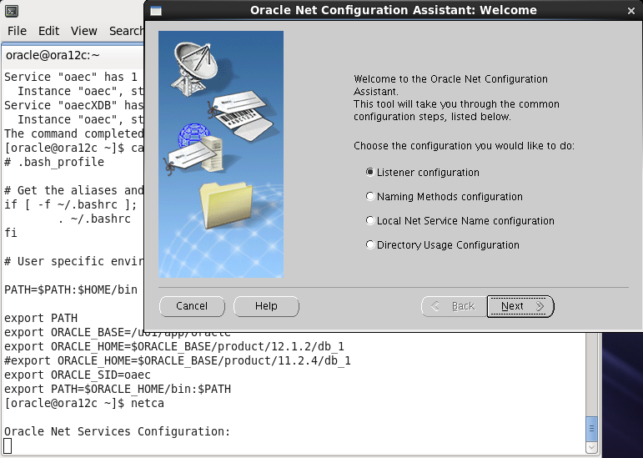

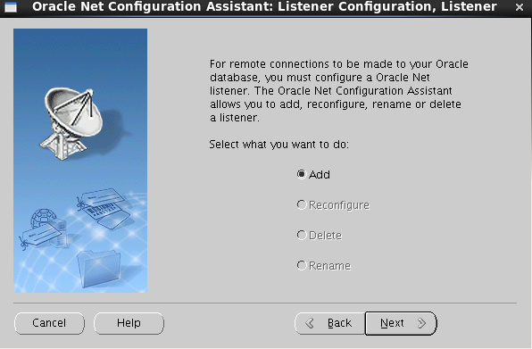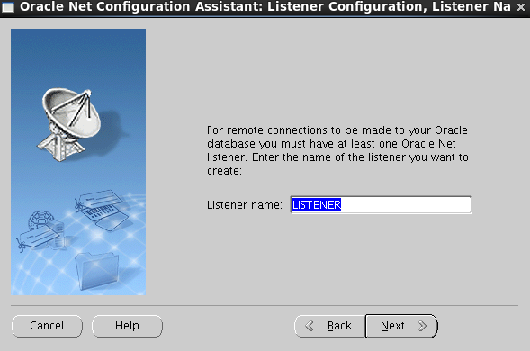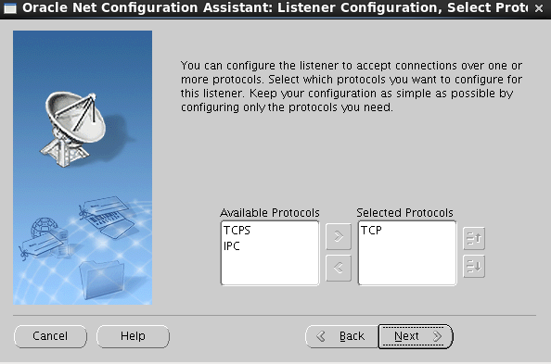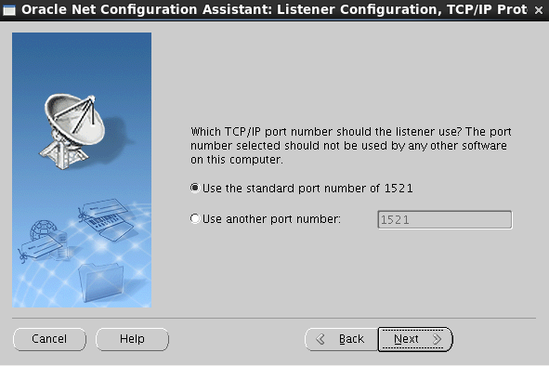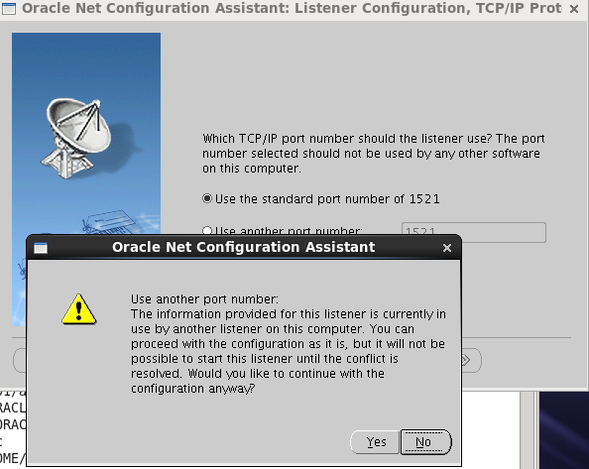

[oracle@ora12c admin]$ lsnrctl stop

LSNRCTL for Linux: Version 11.2.0.4.0 - Production on 20-OCT-2018 22:35:52

Copyright (c) 1991, 2013, Oracle. All rights reserved.

Connecting to (ADDRESS=(PROTOCOL=tcp)(HOST=)(PORT=1521))

The command completed successfully

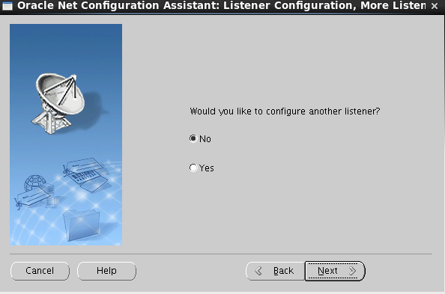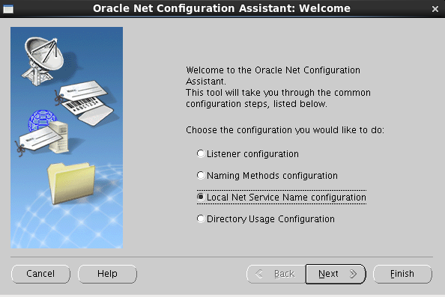

[oracle@ora12c admin]$ pwd

/u01/app/oracle/product/11.2.4/db_1/network/admin

[oracle@ora12c admin]$ ls

listener.ora samples shrept.lst

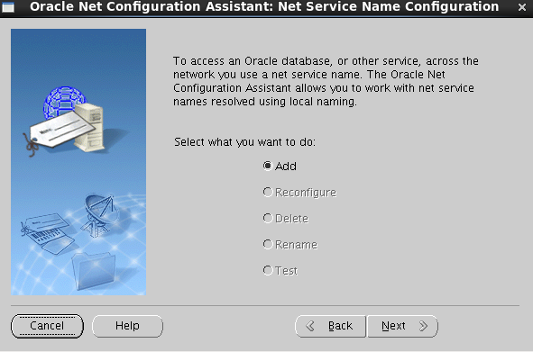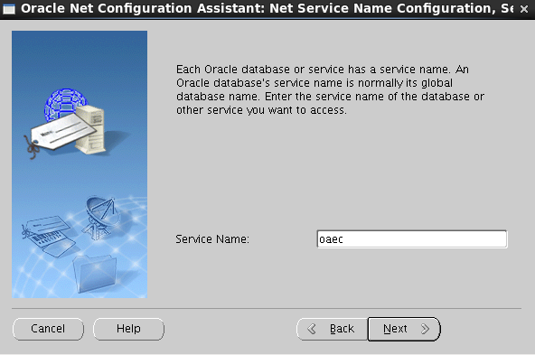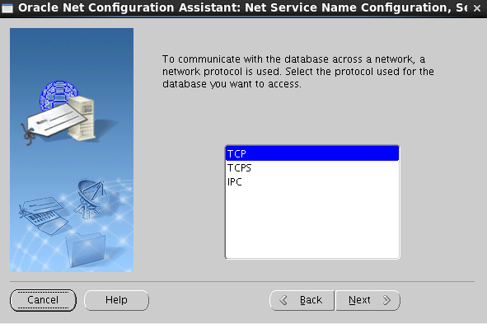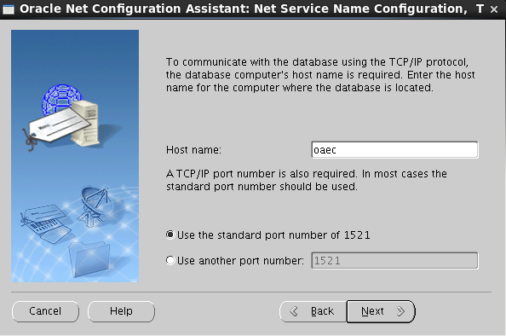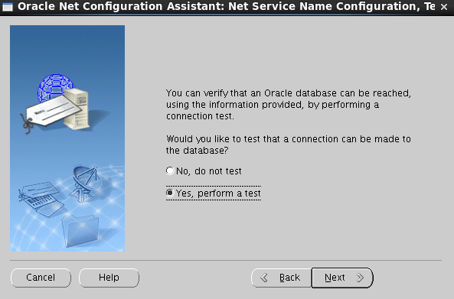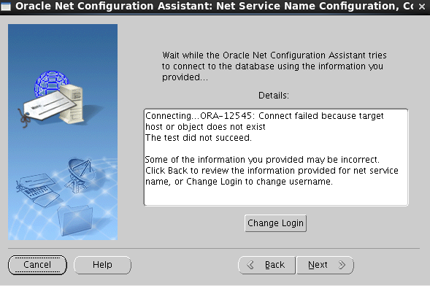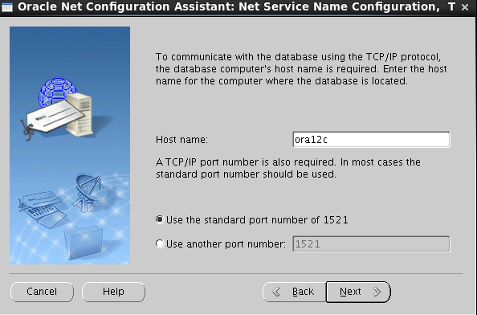

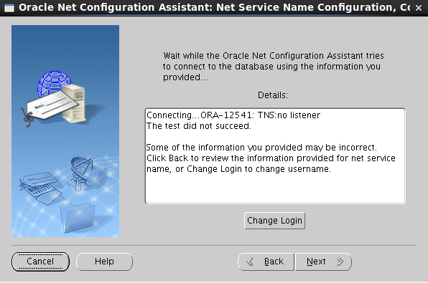

[oracle@ora12c admin]$ lsnrctl start

LSNRCTL for Linux: Version 11.2.0.4.0 - Production on 20-OCT-2018 22:41:06

Copyright (c) 1991, 2013, Oracle. All rights reserved.

Starting /u01/app/oracle/product/11.2.4/db_1/bin/tnslsnr: please wait...

TNSLSNR for Linux: Version 11.2.0.4.0 - Production

System parameter file is /u01/app/oracle/product/11.2.4/db_1/network/admin/listener.ora

Log messages written to /u01/app/oracle/diag/tnslsnr/ora12c/listener/alert/log.xml

Listening on: (DESCRIPTION=(ADDRESS=(PROTOCOL=tcp)(HOST=ora12c)(PORT=1521)))

Listening on: (DESCRIPTION=(ADDRESS=(PROTOCOL=ipc)(KEY=EXTPROC1521)))

Connecting to (DESCRIPTION=(ADDRESS=(PROTOCOL=TCP)(HOST=ora12c)(PORT=1521)))

STATUS of the LISTENER

------------------------

Alias LISTENER

Version TNSLSNR for Linux: Version 11.2.0.4.0 - Production

Start Date 20-OCT-2018 22:41:06

Uptime 0 days 0 hr. 0 min. 0 sec

Trace Level off

Security ON: Local OS Authentication

SNMP OFF

Listener Parameter File /u01/app/oracle/product/11.2.4/db_1/network/admin/listener.ora

Listener Log File /u01/app/oracle/diag/tnslsnr/ora12c/listener/alert/log.xml

Listening Endpoints Summary...

(DESCRIPTION=(ADDRESS=(PROTOCOL=tcp)(HOST=ora12c)(PORT=1521)))

(DESCRIPTION=(ADDRESS=(PROTOCOL=ipc)(KEY=EXTPROC1521)))

The listener supports no services

The command completed successfully

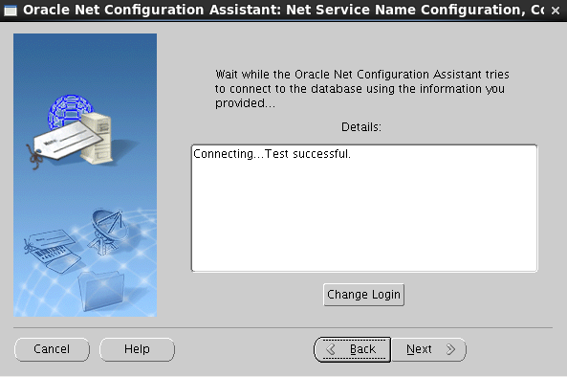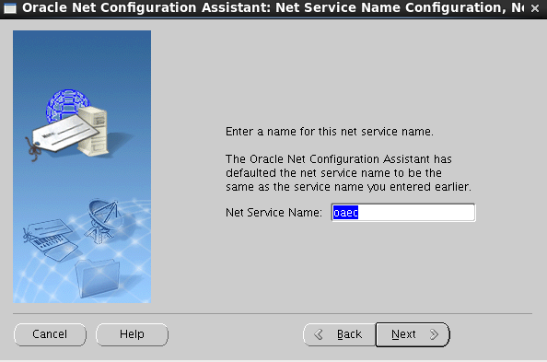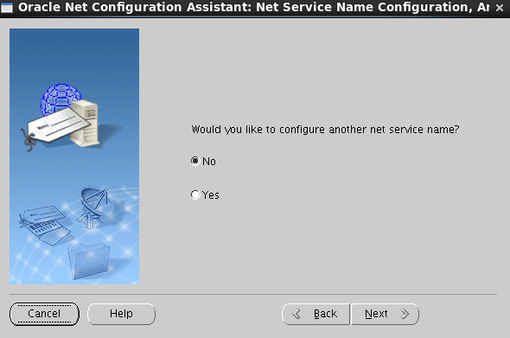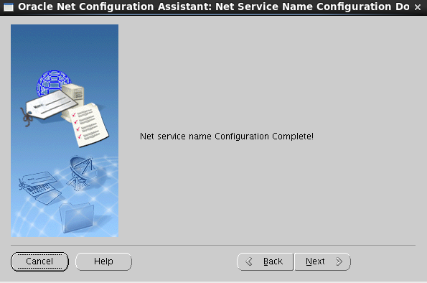

[oracle@ora12c admin]$ ls

listener.ora samples shrept.lst tnsnames.ora

[oracle@ora12c admin]$ cat tnsnames.ora

# tnsnames.ora Network Configuration File: /u01/app/oracle/product/11.2.4/db_1/network/admin/tnsnames.ora

# Generated by Oracle configuration tools.

OAEC =

(DESCRIPTION =

(ADDRESS_LIST =

(ADDRESS = (PROTOCOL = TCP)(HOST = ora12c)(PORT = 1521))

)

(CONNECT_DATA =

(SERVICE_NAME = oaec)

)

)

[oracle@ora12c admin]$ pwd

/u01/app/oracle/product/11.2.4/db_1/network/admin

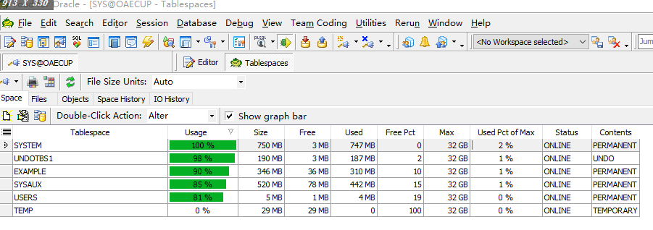

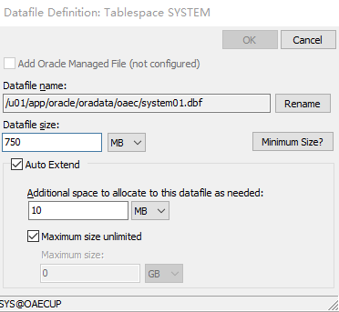

ALTER DATABASE DATAFILE '/u01/app/oracle/oradata/oaec/system01.dbf'

RESIZE 1300M;

ALTER DATABASE DATAFILE '/u01/app/oracle/oradata/oaec/system01.dbf'

AUTOEXTEND OFF;

ALTER DATABASE DATAFILE '/u01/app/oracle/oradata/oaec/undotbs01.dbf'

AUTOEXTEND OFF;

ALTER DATABASE DATAFILE '/u01/app/oracle/oradata/oaec/example01.dbf'

AUTOEXTEND OFF;

ALTER DATABASE DATAFILE '/u01/app/oracle/oradata/oaec/sysaux01.dbf'

AUTOEXTEND OFF;

ALTER DATABASE TEMPFILE '/u01/app/oracle/oradata/oaec/temp01.dbf'

RESIZE 65M;

ALTER DATABASE TEMPFILE '/u01/app/oracle/oradata/oaec/temp01.dbf'

AUTOEXTEND OFF;

--------------------------------

ALTER DATABASE DATAFILE '/u01/app/oracle/oradata/oaec/example01.dbf'

RESIZE 315M;

ALTER DATABASE DATAFILE '/u01/app/oracle/oradata/oaec/undotbs01.dbf'

RESIZE 400M;

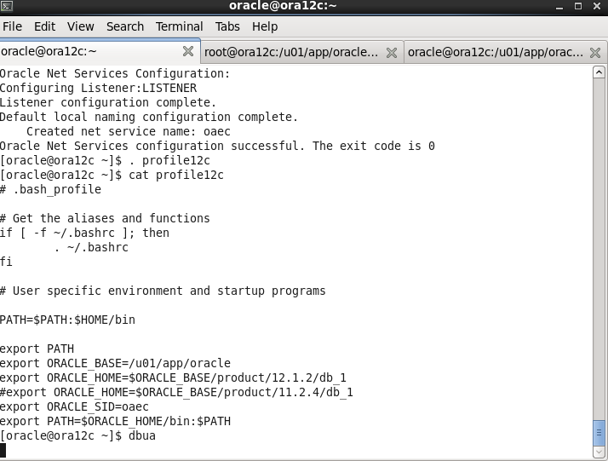

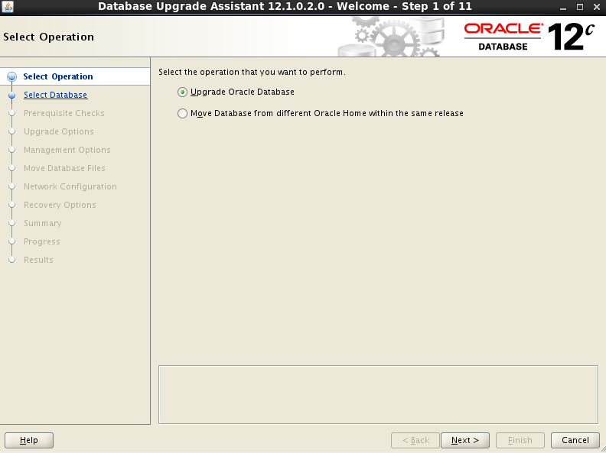

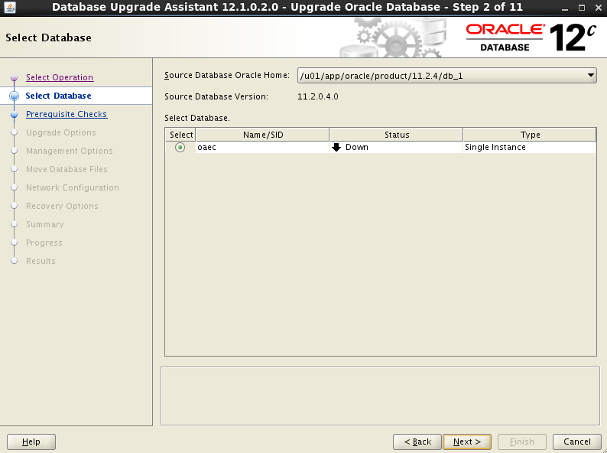

等待

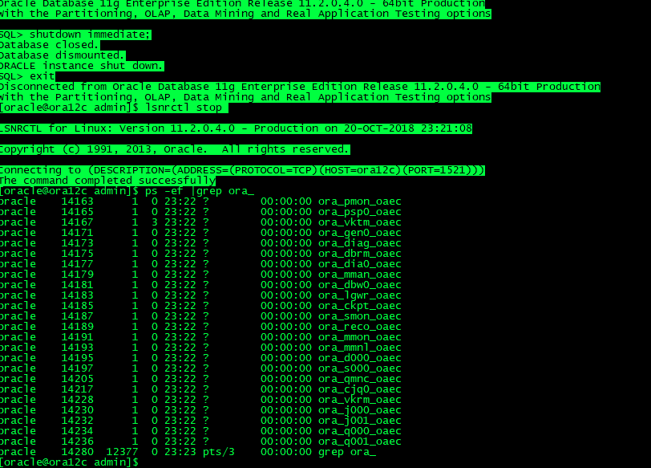

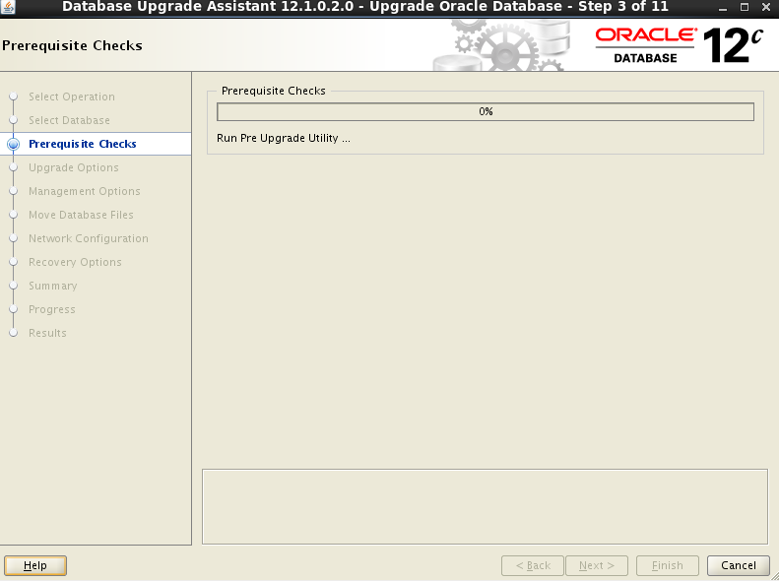

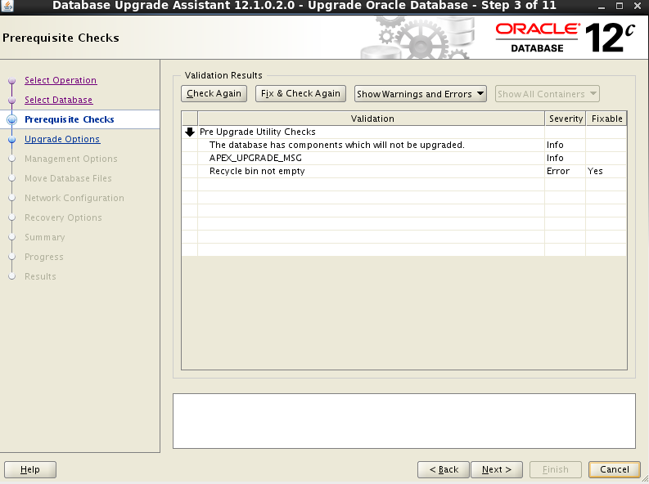 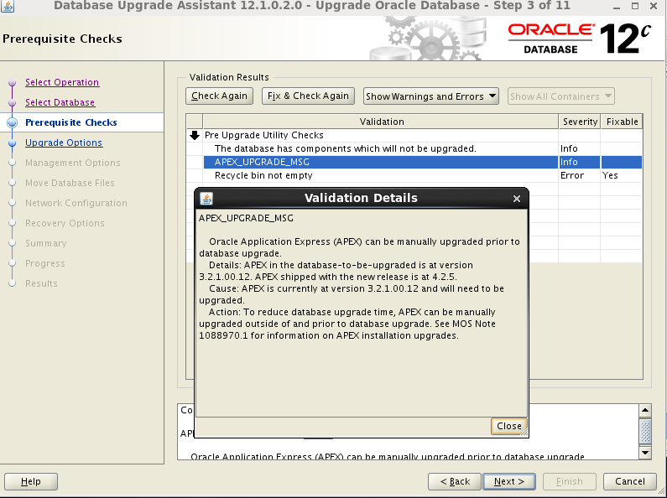

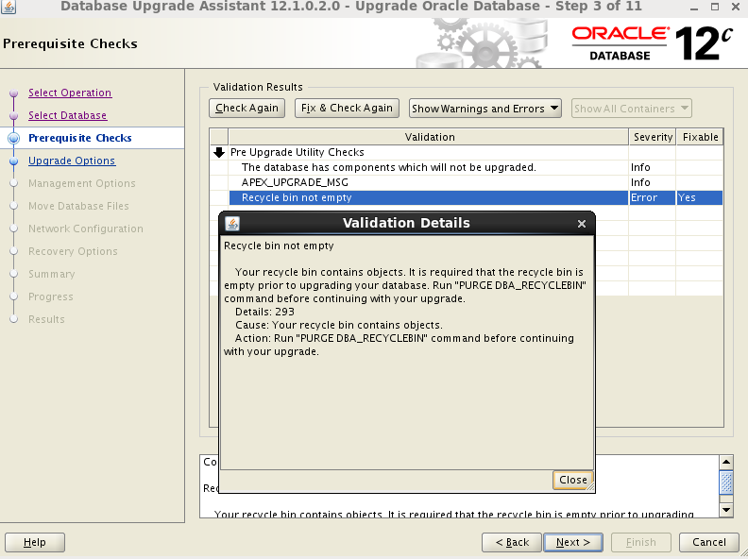

[oracle@ora12c ~]$ . .bash_profile

[oracle@ora12c ~]$ sqlplus / as sysdba

SQL*Plus: Release 11.2.0.4.0 Production on Sat Oct 20 23:27:06 2018

Copyright (c) 1982, 2013, Oracle. All rights reserved.

Connected to:

Oracle Database 11g Enterprise Edition Release 11.2.0.4.0 - 64bit Production

With the Partitioning, OLAP, Data Mining and Real Application Testing options

SQL> purge dba_recyclebin;

DBA Recyclebin purged.

 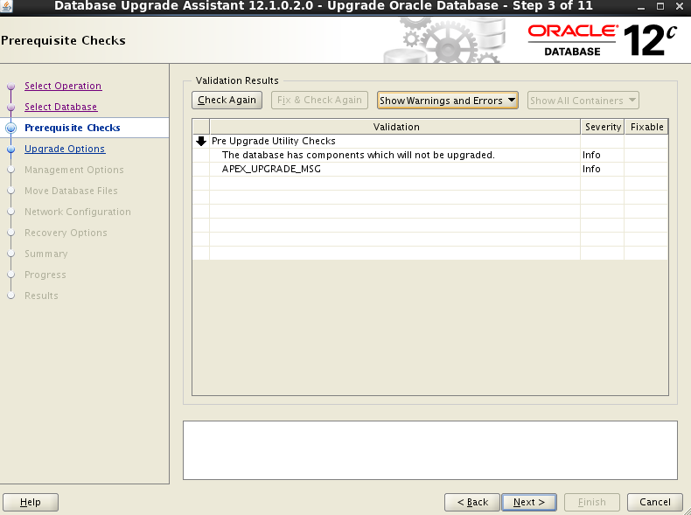 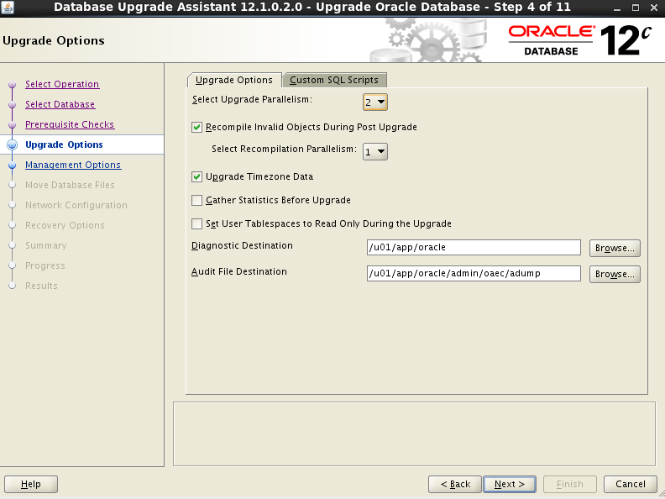 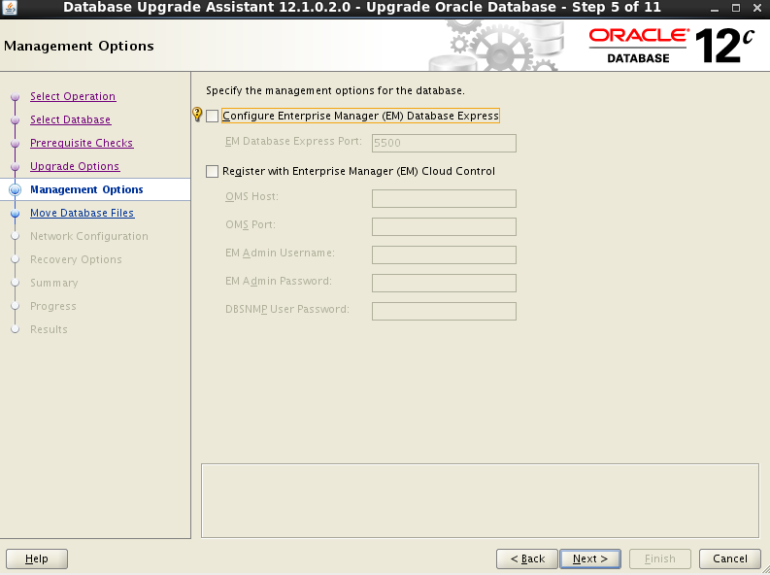 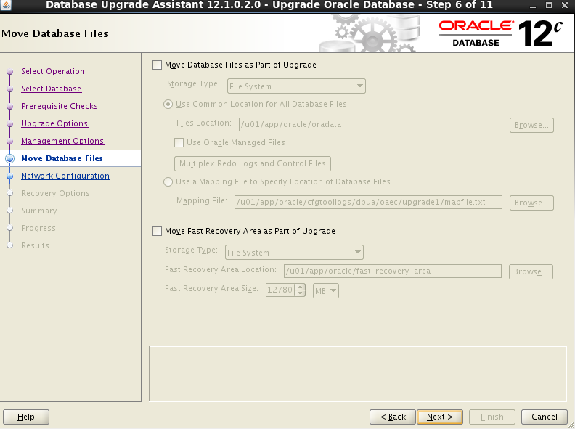 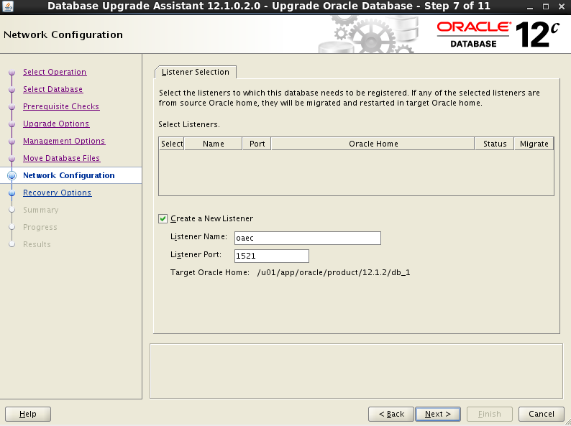 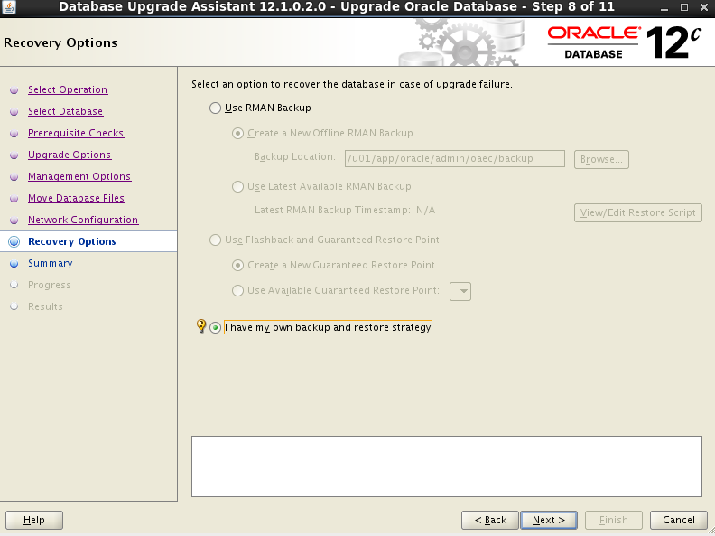 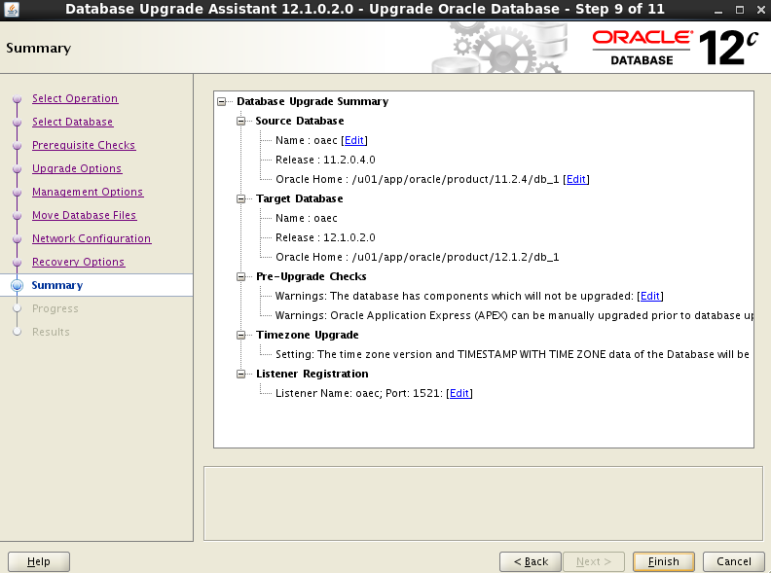 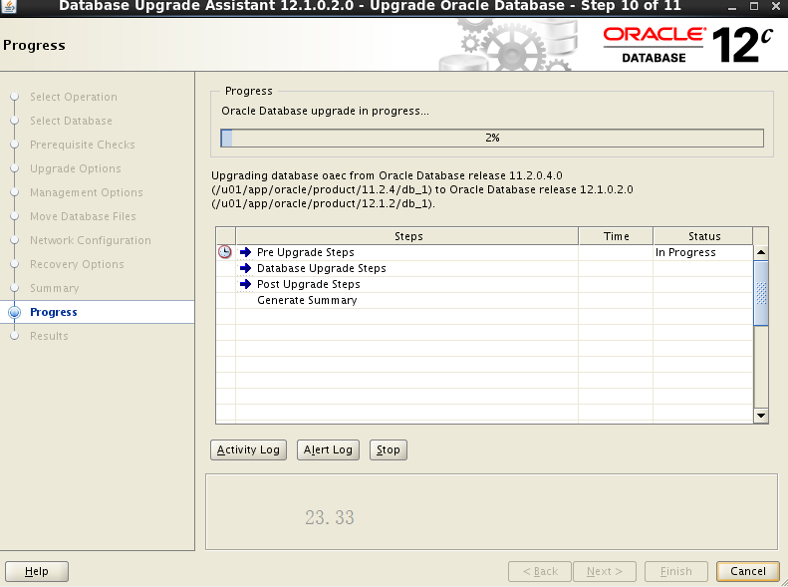

23.33---0：30

