**Exercise 1**

1.

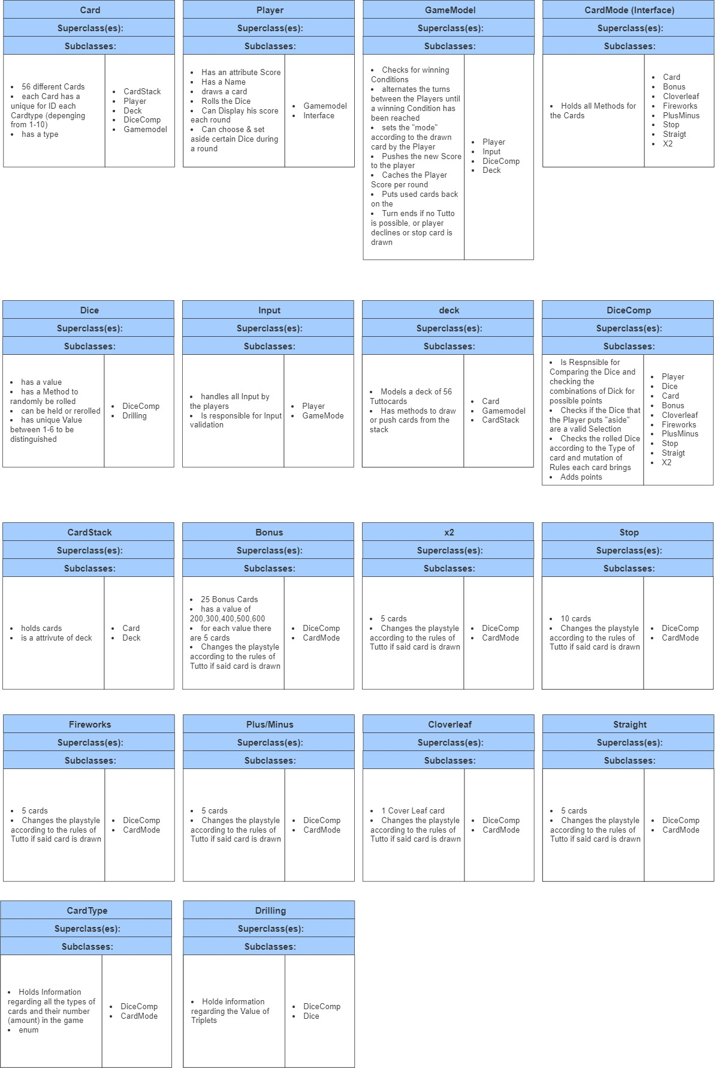

2.

The main Classes are Card, Player, GameMode and DiceComp. The cards and Dice represent the Foundation for the Cardgame and create the unique objects of said Class. The Class GameMode handles the turns and interacts with with the Input of the Player and the DiceComp which compares the rolled Dices to the rules and manages the Points. The GameMode request from the Player the required inputs. The Class Player is responsible for the Creation of Playerobjects. Therefore, we consider these Classes the main Classes for the tutto Game.