**Exercise 1**

1.

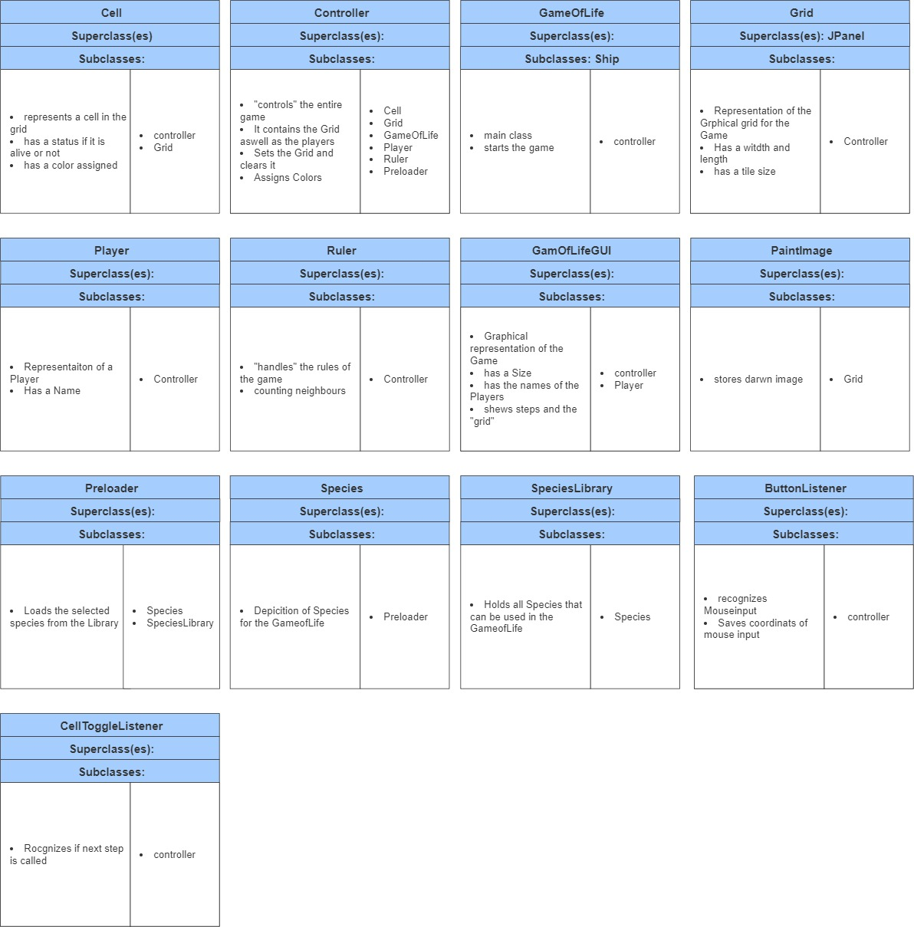

2.

The main Classes are Controller, Cell, Grid and GUI. The Controller is responsible for “handling” the game. Cell represents individual Cells that can be either alive or dead, whereas the grid Depicts the area wich is late outputted by the GUI