Structure design and data property :

designed based on the **viewpoint** that **the inherent correlation between the rain steaks within an image should be stronger than that between the rain streaks and the background (non-rain) pixels** (what kind of data the rain streak it is)

Two stage Network :

* Work : Y=X1+X2+noise 🡪 Find desired X1 or X2
* First Stage (input : origin image), : predict rain streak component
* Second Stage(input : component + origin image) : further locate the possible rain pixels while suppressing the non-rain pixels in the image
* Sequentially stacking:

* Residual dense blocks (RDB) : feature extraction

* Dual attention blocks (SDAB) : refinement

* Multi-scale feature aggregation modules (MAM) : transformation

* 對pixel做分類? 🡪 rain pixel or non-rain pixel

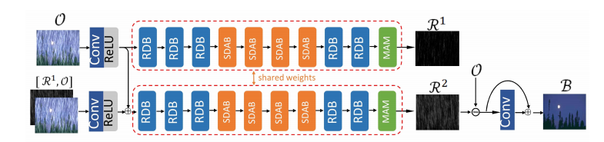

Sequential Dual Attention Network :

* Use : establish the inner dependency of the rain streak's structure
* From : [Dual Attention Network](https://arxiv.org/pdf/1809.02983.pdf)
* Component Attention : designed to learn the main components of rain streaks
* Subsidiary Attention : designed to learn the details of rain streaks

# What is dilated convolution? [空洞卷积](https://arxiv.org/abs/1511.07122)