1. Basic Pronunciation

（1）Initials

b p m f d t n l

Finals

a o e i u ü

er

（2）Initials

g k h

Finals

ai ei ao ou an en ang eng ong

Complete whole syllables yi –wu- yu=i –u – ü

（3）Initials

j q x

Finals

ia ie iao iou(iu) ian in iang ing iong üe üan ün

（4）Initials

z c s zhi chi shi r

Finals

ua uo uai uei(ui) uan uen(un) uang ueng

（5）Initials

z c s zhi chi shi r

Finals

ua uo uai uei(ui) uan uen(un) uang ueng

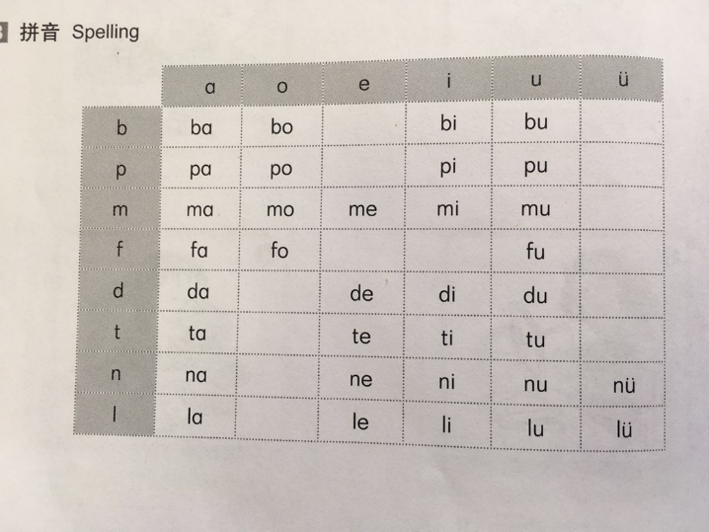 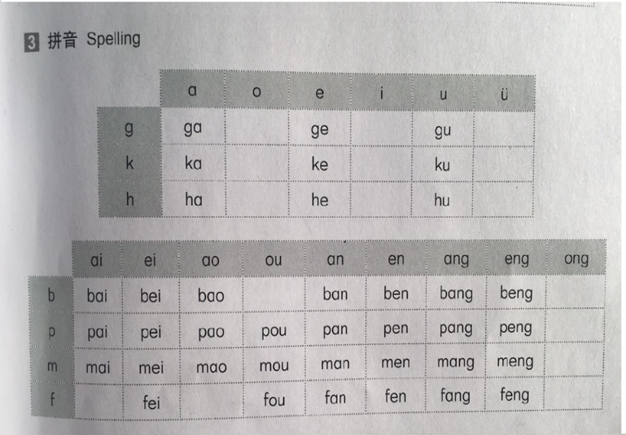

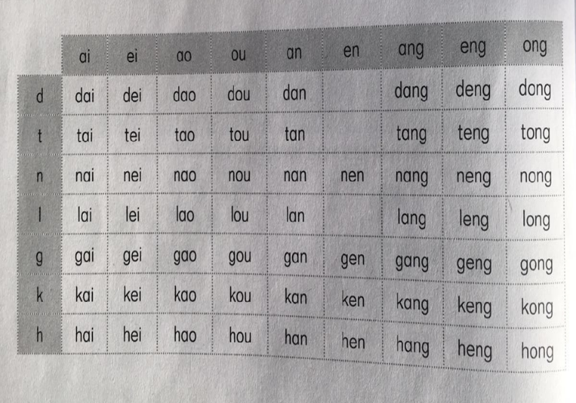 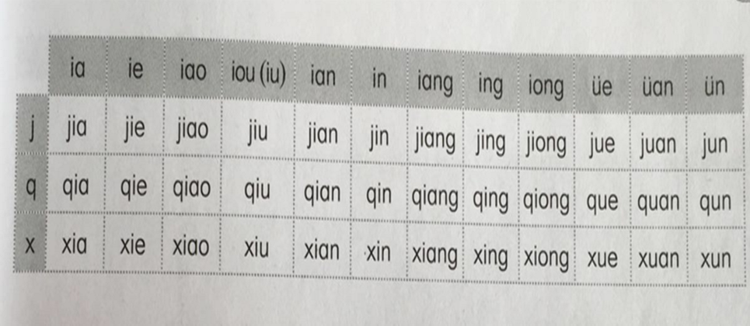

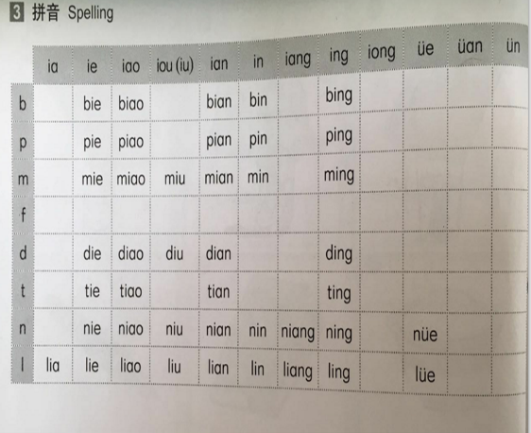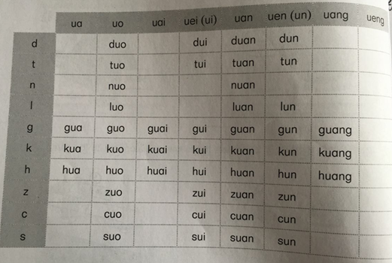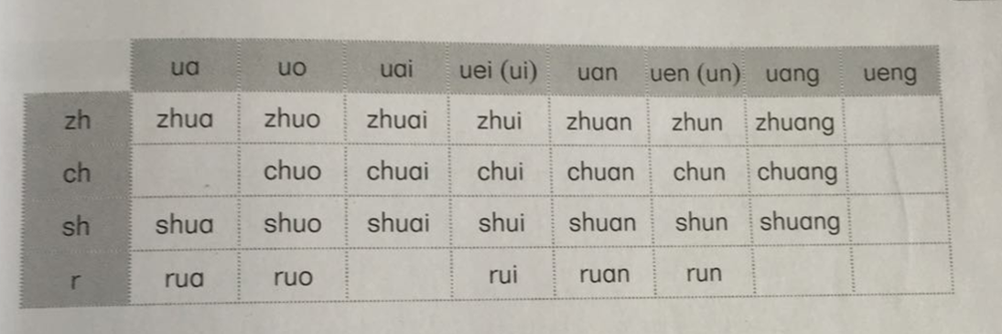

Character:

**hǎo tiān dà xiǎo rì yuè**

**好 天 大 小 日 月**

2．Words

|  |  |  |
| --- | --- | --- |
| 您 | nín(singular; honorific) | you |
| 你 | nǐ(singular) | you |
| 好 | hǎo | good; fine |
| 你好 | ní hǎo | Hello |
| 你们 | nǐmen(plural) | you |
| 老师 | lǎoshī | teacher |
| 早上 | zǎoshang | morning |
| 晚上 | wǎnshang | evening |
| 谢谢 | xièxie | to thank |
| 不 | bù | not |
| 客气 | kèqi | polite, courteous |
| 不客气 | bú kèqi | You’re welcome |
| 对不起 | duìbuqǐ | I am sorry |
| 没关系 | méi guānxi | Don’t mention it |
| 进 | jìn | to enter |
| 吗 | ma | a particle used at the end of a question |
| 我 | wǒ | I , me |
| 很 | hěn | very |
| 呢 | ne | a particle used at the end of special alternative, or rhetorical question |
| 也 | yě | too, also |
| 爸爸 | bàba | father |
| 妈妈 | māma | mother |
| 都 | dōu | both, all |
| 他们 | tāmen | they, them |
| 他 | tā | he, him |
| 她 | tā | she, her |
| 爱人 | aìren | husband or wife |
| 忙 | máng | busy |
| 累 | lèi | tired |
| 饿 | è | hungry |
| 渴 | kě | thirsty |
| 名字 | míngzi | name |
| 姓 | xìng | surname; family name |
| 中文 | zhōngwén | Chinese |
| 国家 | gúojiā | country |
| 法国 | fǎguó | France |
| 留学生 | liúxuéshēng | foreign student; overseas students |
| 天气 | tiānqì | weather |
| 今天 | jīntiān | today |
| 最近 | zuìjìn | lately；recently |
| 再见 | zài jiàn | bye |
| 晚安 | wǎn’an | Good night. |
| 明天见 | míngtīan jiàn | See you tomorrow! |
| 打电话 | dǎ diàn huà | make a telephone call |
| 打手机 | dǎ shǒu jī | make a mobile phone call |
| 知道 | zhīdào | to know |
| 的 | de | an attribute to indicate possession |
| 号码 | hào mǎ | number |
| 喂 | wèi(interjection) | hey ; telephone greeting |
| 什么 | shénme(pronoun) | what |
| 事 | shì(noun) | thing ; matter ; affair |
| 现在 | xiànzài(verb) | now; at present |
| 有 | yǒu(verb) | have; be ; exist |
| 时间 | shí jiān(verb) | time |
| 几 | jǐ | how many; several (less than ten) |
| 点 | diǎn | o’clock |
| 我们 | wǒmen | we ; us |
| 星期天 | xīngqītiān | Saturday |
| 服务员 | fúwùyuán(noun) | waiter ; waitress |
| 位 | wèi | (measure word) (a measure word for respected people) |
| 客人 | kèren (noun) | guest |
| 包间 | bāojiān(noun) | private room |
| 没(有) | méi(yǒu) | (verb, adverb) don’t have |
| 大厅 | dàtīng(noun) | hall |
| 可以 | kéyǐ(verb) | can; may; OK |
| 没问题 | méi wèntí | no problem |
| 饭店 | fàndiàn | hotel or restaurant |
| 酒店 | jiǔdiàn | hotel |
| 餐厅 | cāntīng | canteen ; dining hall |
| 餐馆 | cānguǎn | restaurant |
| 快餐店 | kuàicāndiàn | fast food restaurant |
| 麦当劳 | màidāngláo | McDonald’s |
| 肯德基 | kěndéjī | KFC |
| 咖啡馆 | kāfēiguǎn | cafe |
| 酒吧 | jiǔbā | bar |
| 点菜 | diǎn cài | order dishes |
| 好的 | hǎode | all right |
| 这 | zhè(pronoun) | this |
| 菜单 | càidān(noun) | menu |
| 吃 | chī(verb) | eat |
| (一)点儿 | (yì)diǎnr | a little |
| 鱼肉 | yúròu(noun) | fish |
| 鸡肉 | jīròu(noun) | chicken |
| 和 | hé(conjunction) | and |
| 都 | dōu(adverb) | all ; both |
| 菜 | cài | dishes |
| 热菜 | rècài | hot dishes |
| 凉菜 | liángcài | cold dishes |
| 主食 | zhǔshí | main course ; principal food |
| 点心 | diǎn xīn | dessert ; dim sum |
| 汤 | tāng | soup |
| 粥 | zhōu | porridge |
| 小吃 | xiǎo chī | snacks |
| 饮料 | yǐn liào | beverages ; drinks |
| 炒饭 | chǎofàn | fried rice |
| 饺子 | jiǎozi | dumplings |
| 米饭 | mǐfàn | rice |
| 面包 | miànbāo | bread |
| 牛肉 | niúròu | beef |
| 鸡蛋 | jīdàn | egg |
| 包子 | bāozi | steamed stuffed bun |
| 面条 | miàntiáo | noodles |
| 水 | shuǐ | water |
| 可乐 | kělè | cola |
| 茶 | chá | tea |
| 两壶茶 | liǎng hú chá | two pots of tea |
| 果汁 | guǒzhī | juice |
| 一瓶果汁 | yì píng guǒzhī | one bottle of juice |
| 啤酒 | píjiǔ | beer |
| 一杯啤酒 | yí bēi píjiǔ | one cup of beer |
| 一个碗 | yí ge wǎn | one bowl |
| 两个盘子 | liǎng ge pánzi | two plates |
| 三双筷子 | sān shuāng kuàizi | three pairs of chopsticks |
| 四把勺子 | sì bǎ sháozi | four spoons |
| 五把叉子 | wǔ bǎ chāzi | five forks |
| 六把刀 | liù bǎ dāo | six knives |
| 一包餐巾纸 | yì bāo cānjīnzhǐ | a pack of napkins |
| 一把茶壶 | yìbǎ cháhú | a tea pot |
| 三个茶杯 | sān ge chábēi | three tea cups |
| 七只酒杯 | qī zhī jiǔbēi | seven glasses |
| 盐 | yán | salt |
| 酱油 | jiàngyóu | sauce |
| 醋 | cù | vinegar |
| 辣椒油 | làjiāo yóu | hot pepper oil |
| 胡椒 | hújiāo | pepper |
| 糖 | táng | sugar |
| 买单 | mǎi dān | pay the bill; check |
| 一共 | yí gòng | altogether |
| 百 | bǎi | hundred |
| 块 | kuài | (the basic money unit in China) |
| 要 | yào | want; must |
| 打包 | dǎbāo | package; pack |
| 饭盒 | fànhé | lunch box |
| 自己 | zìjǐ | self ; oneself |
| 两 | liǎng | both; some ; two |
| 个 | ge | (usually used before nouns without a special measure word of their own) |
| 多少 | duōshao（pronoun） | how much; how many |
| 钱 | qián(noun) | money; cash |
| 超市 | chāoshì(noun) | supermarket |
| 前面 | qiánmian(noun) | front |
| 就 | jiù(adverb) | just ; only; at once |
| 大 | dà(adjective) | large ; big |
| 还 | hái(adverb) | yet; still |
| 小 | xiǎo(adjective) | small; tiny; young |
| 商店 | shāngdiàn(noun) | store; shop |
| 离 | lí(preposition) | from |
| 这儿 | zhèr(pronoun) | here |
| 近 | jìn(adjective) | near; close |
| 远 | yuǎn(adjective) | far |
| 大概 | dàgài(adverb) | about |
| 米 | mǐ(measure word) | meter |
| 便利店 | biànlìdiàn | convenience store |
| 菜市场 | càishìchǎng | market |
| 自由市场 | zìyóushìchǎng | free market |
| 批发市场 | pīfā shìchǎng | wholesale market |
| 苹果 | píngguǒ | apple |
| 怎么 | zěnme | how; why |
| 卖 | mài | to sell |
| 买 | mǎi | to buy |
| 斤 | jīn | (a weight unit in China , equal to 500g) |
| 太……了 | tài……le | too |
| 贵 | guì | expensive |
| 便宜 | piányi | cheap |
| 卖苹果的人 | mài píngguǒ de rén | the apple seller |
| 香蕉 | xiāngjiāo | banana |
| 桔子 | júzi | tangerine |
| 橙子 | chéngzi | orange |
| 梨 | lí | pear |
| 草莓 | cǎoméi | strawberry |
| 西瓜 | xīguā | watermelon |
| 水果 | shuǐguǒ | fruit |
| 饼干 | bǐnggān | biscuit |
| 薯片 | shǔpiàn | potato chips |
| 牛奶 | niúnǎi | milk |
| 酸奶 | suānnǎi | yoghurt |
| 果汁 | guǒzhī | juice |
| 矿泉水 | kuàngquánshuǐ | mineral water |
| 一支牙膏 | yì zhī yágāo | one tube of tooth paste |
| 一把牙刷 | yì bǎ yáshuā | one tooth brush |
| 一袋洗衣粉 | yí dài xǐyīfěn | one bag of laundry powder |
| 一瓶洗发水 | yì píng xǐfàshuǐ | one bottle of shampoo |
| 一瓶沐浴液 | yì píng mùyùyè | one bottle of wash |
| 两条毛巾 | liǎng tiáo máojīn | two towels |
| 一瓶洗衣液 | yì píng xǐyīyè | two bottle of washing detergent |
| 一袋卷纸 | yí dài juǎnzhǐ | one bag of toilet paper |
| 一件衣服 | yí jiàn yīfu | a shirt |
| 一条裤子 | yì tiáo kùzi | a pair of trousers |
| 一双鞋 | yì shuāng xié | one pair of shoes |
| 一双袜子 | yì shuāng wàzi | one pair of socks |
| 红色 | hóngsè | red |
| 黄色 | huángsè | yellow |
| 蓝色 | lánsè | blue |
| 绿色 | lǜsè | green |
| 黑色 | hēisè | black |
| 白色 | báisè | white |
| 紫色 | zǐsè | purple |
| 粉色 | fěnsè | pink |
| 灰色 | huīsè | grey |
| 别的 | bié de(pronoun) | other |
| 东西 | dōngxi(noun) | thing ; stuff |
| 零钱 | língqián(noun) | small change |
| 找 | zhǎo(verb) | to give change ; look for ;seek |
| 数 | shǔ (verb) | to count |
| 卖东西的人 | mài dōngxi de rén | the seller |
| 车 | chē (noun) | automobile |
| 打的 | dǎdī (verb) | take a taxi |
| 周末 | zhōumò(noun) | weekend |
| 跟……一起 | gēn……yìqǐ | to go with |
| 也 | yě(adverb) | also ; too |
| 地铁 | dìtiě (noun) | metro ; subway |
| 又 ……又 | yòu……yòu | not only…but also |
| 快 | kuài | fast ; quick |
| 故宫 | gùgōng | Forbidden City |
| 到 | dào (verb) | to arrive ; to go |
| 地铁站 | dìtiězhàn | subway station |
| 走 | zǒu (verb) | to walk |
| 小姐 | xiǎojiě(noun) | miss; young lady |
| 从 | cóng(preposition) | from |
| 一直 | yìzhí(preposition) | straight ; continuously ; always |
| 往 | wǎng(preposition) | to ; toward |
| 第 | dì(prefix) | (to use for ordinal number) |
| 路口 | lùkǒu(noun) | Intersection; cross; junction |
| 拐 | guǎi (verb) | to turn |
| 东 | dōng | east |
| 西 | xī | west |
| 南 | nán | south |
| 北 | běi | north |
| 左 | zuǒ | left |
| 右 | yòu | right |
| 上 | shàng | up |
| 下 | xià | down |
| 前 | qián | before |
| 后 | hòu | after |
| 张 | zhāng(measure word) | a piece of |
| 机票 | jīpiào(noun) | airplane ticket |
| 日期 | rìqī(noun) | date |
| 月 | yuè(noun) | mouth |
| 打折 | dǎzhé(verb) | discount |
| 今天 | jīntiān(noun) | today |
| 巴黎 | Bālí | Paris |
| 北京 | Běijīng | Peking |
| 走路去 | zǒu lù qù | go on foot |
| 开车去 | kāi chē qù | go by bus |
| 打车去 | dǎ chē qù | go by taxi |
| 骑自行车去 | qí zì xíng chē qù | go by bike |
| 骑摩托车去 | qí mó tuō chē qù | go by motorcycle |
| 坐公共汽车去 | zuò gōng gòng qì chē qù | go by bus |
| 坐地铁去 | zuò dìtiě qù | go by subway |
| 坐火车去 | zuò huǒchē qù | go by train |
| 坐飞机去 | zuò fēi jī qù | travel by airplane |
| 租 | zū(verb) | to rent |
| 房子 | fángzi(house) | house |
| 住 | zhù(to live in) | to live in |
| 正 | zhèng(just) | just |
| 中介 | zhōngjiè(noun) | agency ; agent |
| 公司 | gōngsī(noun) | company |
| 帮 | bāng (verb) | to help |
| 套 | tào(measure word) | a set of |
| 厅 | tīng (noun) | living room or dining room |
| 怎么样 | zěnmeyàng (pronoun) | how |
| 还行 | hái xíng | not bad |
| 租金 | zūjīn(noun) | rent |
| 千 | qiān(number) | thousand |
| 宿舍 | sùshè | a dormitory |
| 公寓 | gōngyù | an apartment |
| 单间 | dānjiān | a single room |
| 套房 | tàofáng | a flat |
| 三室一厅 | sān shì yìtīng | three bedrooms and one living room |
| 空调 | kōng tiáo(noun) | air condition |
| 坏 | huài(adjective) | bad; broken; out of water |
| 里 | lǐ (noun) | inside |
| 真 | zhēn(adverb/adjective) | really; very/rea ; true |
| 热 | rè(adjective) | hot |
| 房东 | fáng dōng(noun) | house owner; landlord ; land lady |
| 会 | huì(verb) | can; be able to ; understand ; likely to |
| 来 | lái(verb) | to come ; arrive |
| 修 | xiū | to repair |
| 厨房 | chú fáng | kitchen |
| 卧室 | wò shì | bedroom |
| 床 | chuáng | bed |
| 客厅 | kè tīng | living room |
| 卫生间 | wèi shēng jiān | bathroom |
| 阳台 | yáng tái | balcony |
| 窗户 | chuānghu | window |
| 门 | mén | door |
| 灯 | dēng | lamp/desk lamp |
| 电视机 | diàn shì jī | television |
| 洗衣机 | xǐ yī jī | washing machine |
| 冰箱 | bīngxiāng | refrigerator |
| 窗帘 | chuānglián | curtain |

3. Dialogue

(1) How to Rent a House?

Nǐ zhù nǎr ?

David:你住哪儿？

Where do you live?

Wǒ xiànzài zhù jiāotāngdàxué, zhèng xiǎng zū fáng zi , nǐ zhī dào zěn me zū ma ?

Anna:我现在住交通大学，正想租房子，你知道怎么租吗？

I am staying in the Jiaotong University. I want to rent a house. Can you help me?

Nǐ kěyǐ zhǎo zhōngjiè gōngsī .

David:你可以找中介公司。

You should find an estate agency.

Nǐ yǒu zhōngjiè gōng sī de diànhuà ma ?

Anna:你有中介公司的电话吗？

Do you have any agencies telephone number?

Méiyǒu. Wǒ bāng nǐ wènwen ba .

David: 没有。我帮你问问吧。

No. I will check for you.

(2) How About This Flat?

Wǒ xiǎng zū yí tào sān shì yī tīng de fáng zi .

Anna: 我想租一套三室一厅的房子。

I would like to rent an apartment with three bedrooms and one living room.

Zhè tào zěnmeyàng?

Agent:这套怎么样？

How about this one?

Hái xíng , zhè tào zū jīn shì duō shǎo ?

Anna:还行，这套租金是多少？

Not bad, How much is the rent for this one?

Yí gè yuè sānqiān yuán.

Agent: 一个月三千元。

3000 yuan per month.

(3) The Room Is Very Hot!

Nǐde fángjiān lǐ zhēn rè !

David :你的房间里真 热！

It is very hot in your room.

Fángjiān lǐ de kōngtiáo huàile.

Anna:房间里的空调坏了。

The air conditioner is not working.

Nǐ gěi fángdōng dǎ ge diànhuà ba, tā huì zhǎo rén lái xiū.

David:你给房东打个电话吧，他会找人来修.

You should give the house owner a call. He will find someone to fix it.

Hǎo，wǒ xiànzài jiù dǎ .

Anna :好，我现在就打。

Sure, I will make the call now.

(4) By Taxi

Zhège zhōumò wǒ gēn jiékè yìqǐ qù gùgōng ,nǐ xiǎng qù ma?

David :这个周末我跟杰克一起去故宫，你想去吗？

I am going to the Forbidden City with Jack the weekend. Do you want to join us?

Hǎo a, wǒ yě xiǎng gēn nǐmen yìqǐ qù. zěnme qù ne？

Anna：好啊，我也想跟你们一起去。怎么去 呢？

Yes, I would like to go with you both. How can we get there?

Wǒ men xiǎng dǎdī qù？

David:我们想打的去。

I plan to go by taxi.

Zuò dìtiě ba, yòu kuài yòu piányi.

Anna：坐地铁吧，又快又便宜。

How about going by subway? It is fast and cheap.

(5) How to get to the subway station?

Nínhǎo！Xiǎojiě，qǐngwèn dào dìtiězhàn zěnme zǒu？

Anna:您好！小姐，请问到地铁站怎么走？

Hello! Miss, could you tell me how to get to the subway station.

Cóng zhèr yízhí wǎngqián zǒu, dào dì èr ge lùkǒu wǎng yòu guǎi jiù dào le .

Lady: 从这儿一直往前走，到第二个路口往右拐就到了。

Go straight ahead and turn right at the second junction.

Xièxiè！

Anna:谢谢！

Thank you!

Búkèqi！

Lady :不客气！

You are welcome!

（6）Where Is the Supermarket？

Jiékè，nǐ zhīdao nǎr yǒu chāoshì ma？

David : 杰克，你知道哪儿有超市吗？

Jack, do you know where the supermarket is?

Qián miàn jiù yǒu ge dà chāo shì,hái yǒu jǐ gè xiǎo shāngdiàn ne.

Jack：前面就有个大超市，还有几个小商店呢。

There is a large supermarket up ahead, and there are several convenience stores as well.

lí zhèr yuǎn ma？

David :离这儿远吗？

Is it far from here?

Hěnjìn, dàgài liǎngbǎi mǐ.

Jack ：很近，大概两百米。

Very close, about two hundred meters.

Xièxie！

David：谢谢！

Thank you

（7）How Much Are These Apples？

Píngguǒ zěnme mài？

David :苹果怎么卖？

How much are these apples?

Wǔ kuài wǔ yìjīn.

Seller:五块五一斤。

5.5Yuan for half a kilo.

Tàiguì le, piányi diǎnr ba.

David :太贵了，便宜点儿吧。

Too expensive. How about a little discount.

Wǔkuài ba. Nǐ mǎi duō shǎo ？

Seller:五块吧。你买多少？

5 Yuan. How many do you need?

（8）Would You Like Anything else?

Háiyào bié de ma ？

Seller:还要别的吗？

Anything else?

Búyào le. Yígòng duōshǎo qián？

David :不要了。一共多少钱？

Not more. How much is it in total.

Shísān kuài wǔ, nǐ gěi shísān kuài ba.

Seller:十三块五，你给十三块吧。

13.5Yuan, you can just give me 13.

Gěinǐ yìbǎi kuài, wǒ méiyǒu língqián.

David :给你100块，我没有零钱。

Here is a hundred Yuan. I don’t have small change.

Zhǎonǐ bāshí qī kuài, nǐ shǔshu.

Seller:找你87块，你数数。

I will give you 87Yuan in change, please count it.

（9）Please Come In

Qǐngjìn qǐng wèn nǐmen jǐ wèi？

fú wù yuán :请进，请问你们几位？

Come in please. How many people?

Sānwèi . Yǒu bāojiān ma？

kè rén:三位。有包间吗？

Three. Do you have any private rooms?

Duìbùqǐ，méiyǒu le. Zuò dàtīng kěyǐ ma？

fú wù yuán :对不起，没有了。坐大厅可以吗？

I am sorry, we don’t. Could you sit in the hall?

Méi wèntí.

kè rén:没问题。

No problem.

(10) Order Dishes

Fúwùyuán, diǎn cài .

kè rén:服务员，点菜。

Waiter, can we order now?

Hǎo de . Zhèshì càidān. Qǐng wèn nǐmen chī diǎnr shénme？

fú wù yuán : 好的。这是菜单。请问你们吃点儿什么？

All right. Here is the menu. What would you like to eat?

Yǒu yúròu hé jīròu ma？

kè rén:有鱼肉和鸡肉吗？

Do you have fish and chicken?

Dōuyǒu.

fú wù yuán :都 有。

Yes.

(11) Pay the Bill

Fúwùyuán，mǎidān

kè rén:服务员，买单。

Waitress, check please.

Hǎode. yígòng èrbǎi yī shí wǔ kuài. Yào dǎ bāo ma？

fú wù yuán :好的。一共二百一十五块。要打包吗？

All right. 215Yuan in total. Do you want to take the leftovers?

Yào，gěi liǎngge fàn hé，wǒmen zì jǐ lái ba.

kè rén:要，给两个饭盒，我们自己来吧。

Yes. Give us two lunch boxes. We can pack by ourselves.

Hǎo.

fú wù yuán :好。

OK.