# Visitors can perform the follow actions:

### Allows to add a user

End Point: **POST** <http://localhost:7777/user>

Request:

{

"userId": 1,

"firstName": "Tomal",

"lastName": "Banerjee",

"email": "tomal@GMAIL.COM",

"mobile": "999-999-9999"

}

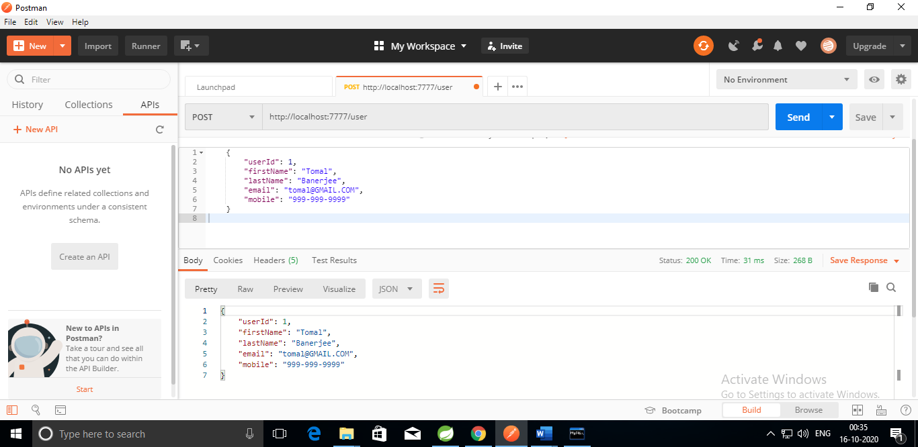

### Allows to delete an existing user

Endpoint: **DELETE** <http://localhost:7777/user/1>

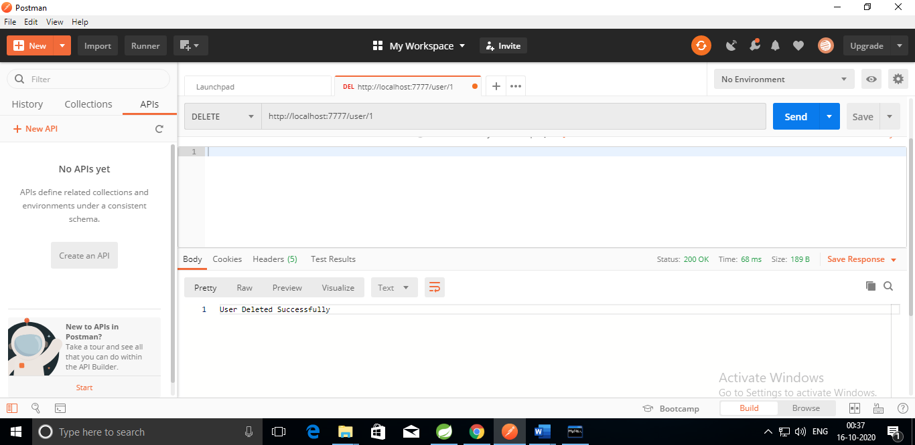

### Allows to display all the users

Endpoint: **GET** <http://localhost:7777/user>

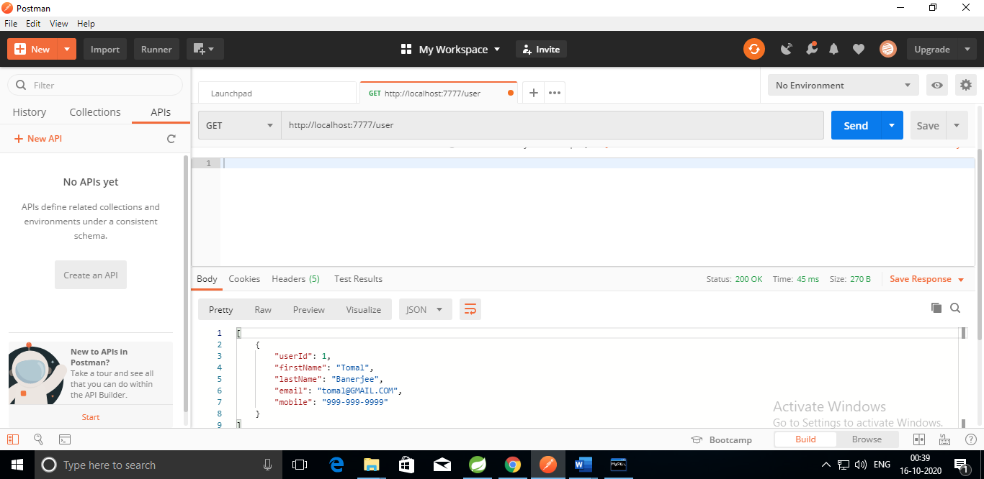

### Allow to add interview

Endpoint: **POST** <http://localhost:7777/interview>

{

"interviewId": 1,

"interviewerName": "Sam Nathan",

"interviewName": "SDET Role",

"usersSkills": "Spring,JPA, Selenium,CSS",

"time": "01:30",

"date": "2020-11-20",

"interviewStatus": "Scheduled",

"remarks": "Priority"

}

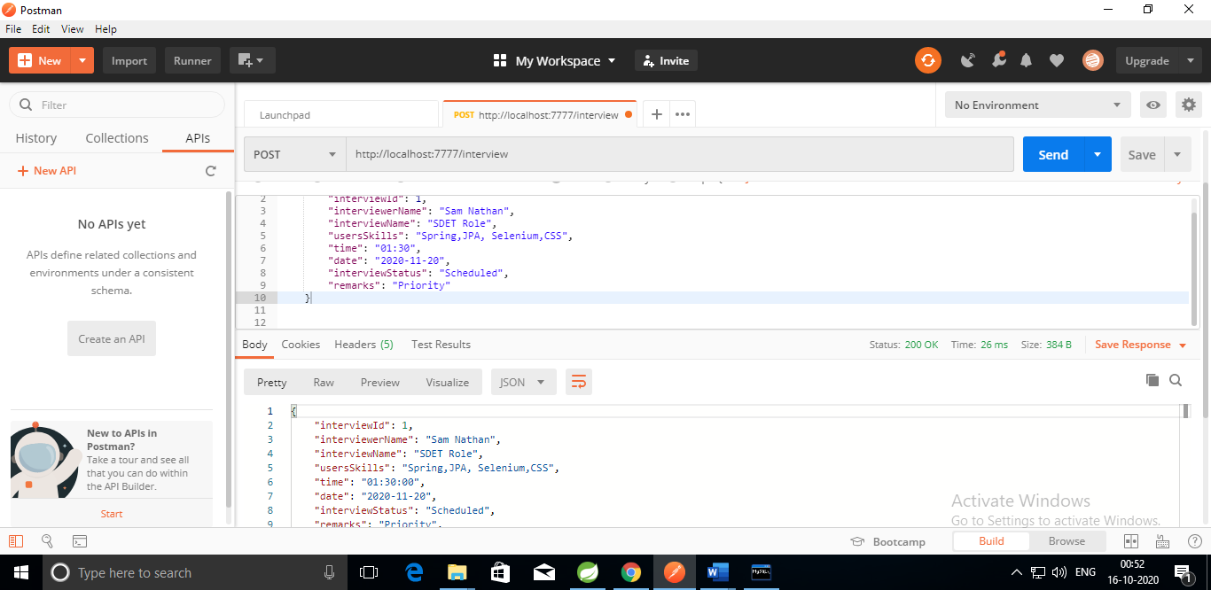

### Allow to delete an existing interview

Endpoint: **DELETE** <http://localhost:7777/interview/1>

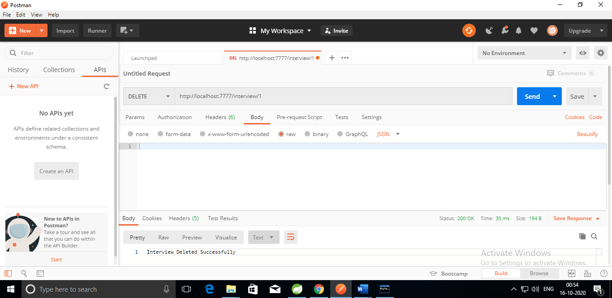

### Allow to update interview status on go

Endpoint: **PUT** http://localhost:7777/interview/updateStatus/1/In Progress

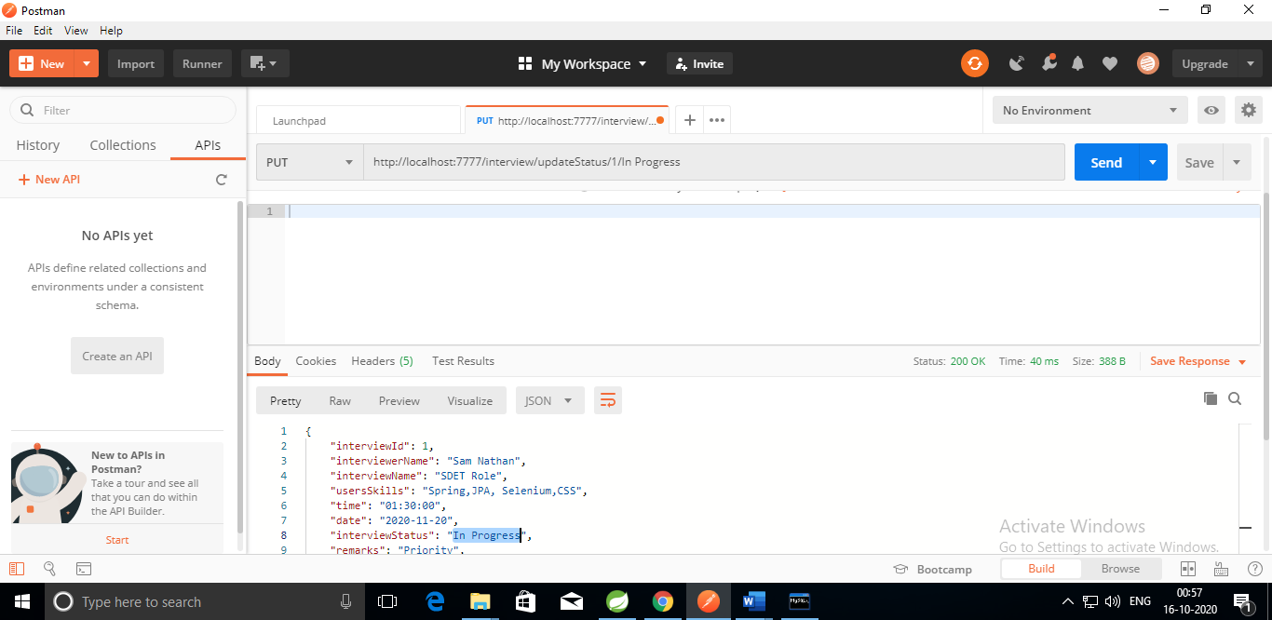

### Allows to search the interview on the basis of Interview Name and Interviewer Name

Endpoint: **GET** http://localhost:7777/interview/showInterviews/SDET Role/Sam

Note: I have used Or condition here not And in the select query, so you will receive results based on any one of the fields

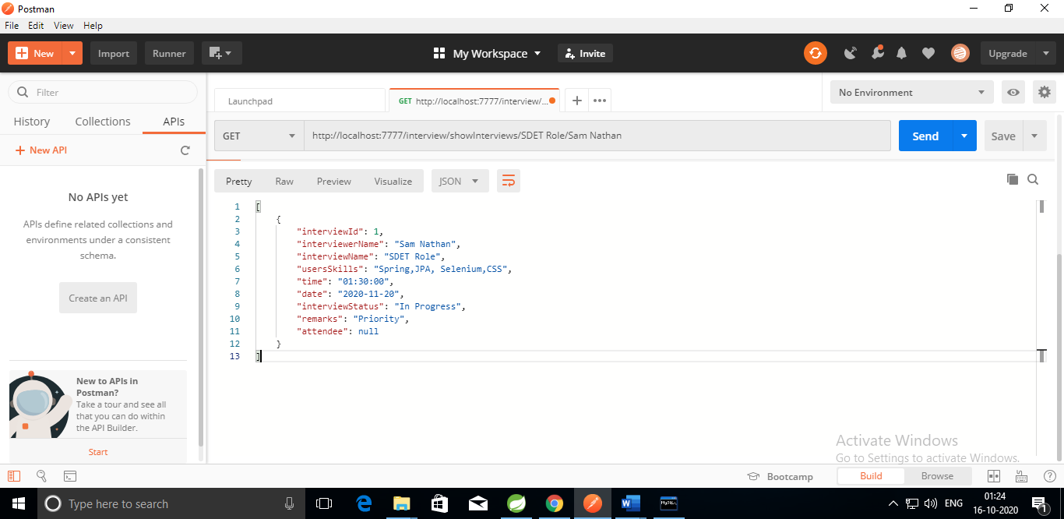

### Allows searching total no of count of interview.

End point: **GET** <http://localhost:7777/interview/count>

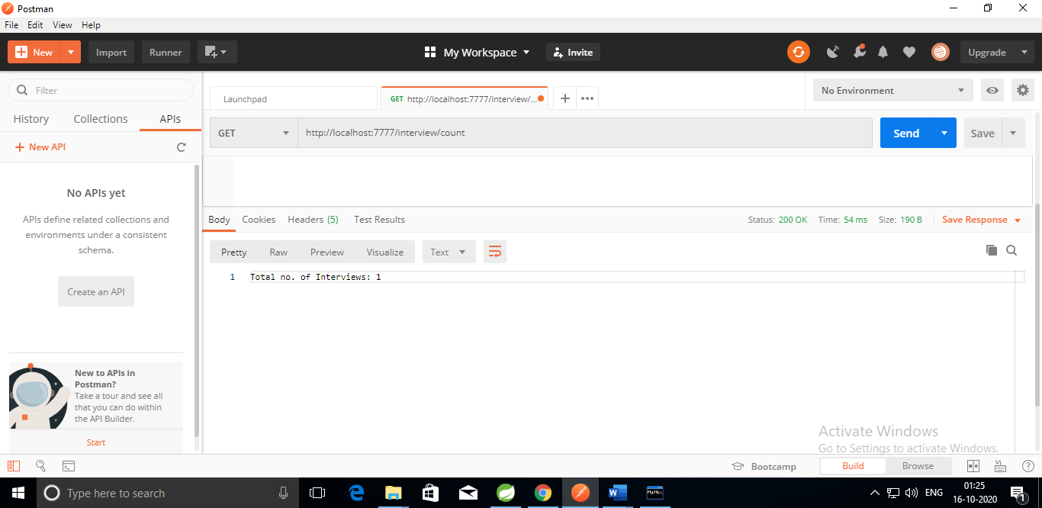

### Allows to display all the interviews

Endpoint: **GET** <http://localhost:7777/interview/showInterviews>

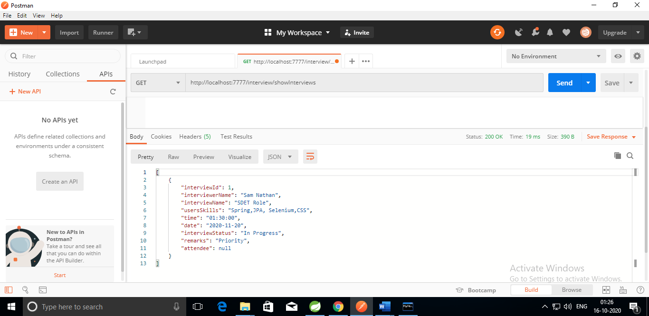

### Allow to add attendee to an interview

This can be achieved in 2 ways:

1. Add existing user as attendee to existing interview

End Point: **PUT** <http://localhost:7777/interview/addAttendee>

{

"interviewId": 1,

"userId": 2

}

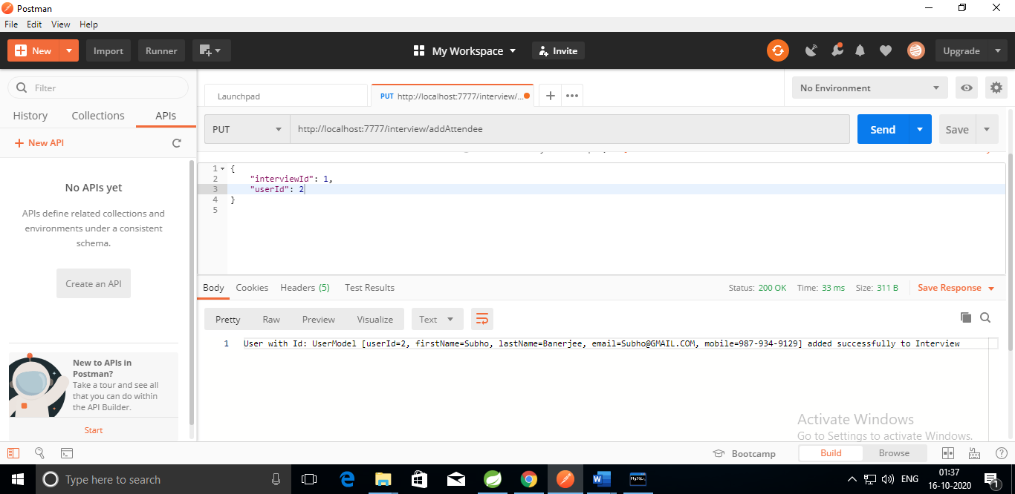

1. Add user as attendee to new interview

Endpoint: **POST** <http://localhost:7777/interview>

{

"interviewId": 2,

"interviewerName": "Sam Nathan",

"interviewName": "SDET Role",

"usersSkills": "Spring,JPA, Selenium,CSS",

"time": "01:30",

"date": "2020-11-20",

"interviewStatus": "Scheduled",

"remarks": "Priority",

"attendee": [

{

"userId":3,

"firstName": "Sabita",

"lastName": "Tata",

"email": "Sabita@GMAIL.COM",

"mobile": "125-235-2583"

}

]

}

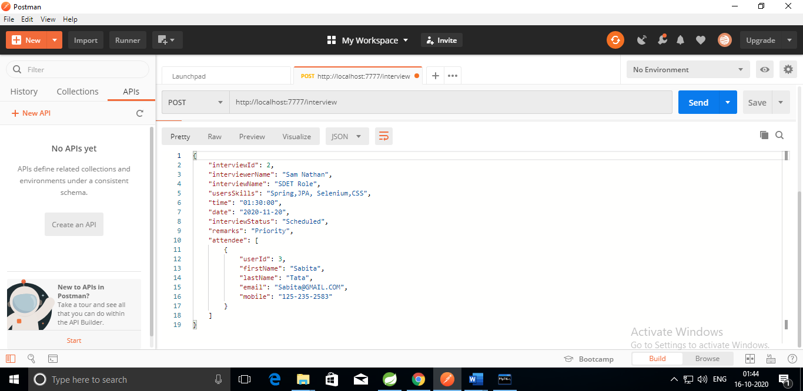

### Allow to show all attendee of an interview

Endpoint: GET <http://localhost:7777/interview/showAttendee/2>

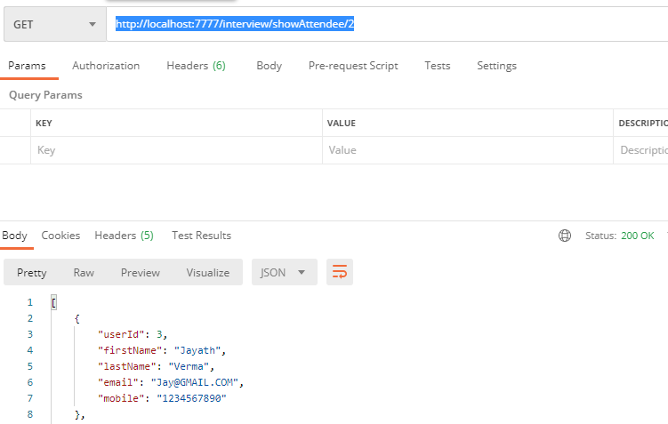

# Assumptions, Dependencies, Risks / Constraints:

### While adding a user to interview as attendee, if user id already exists, it should throw a custom exception.

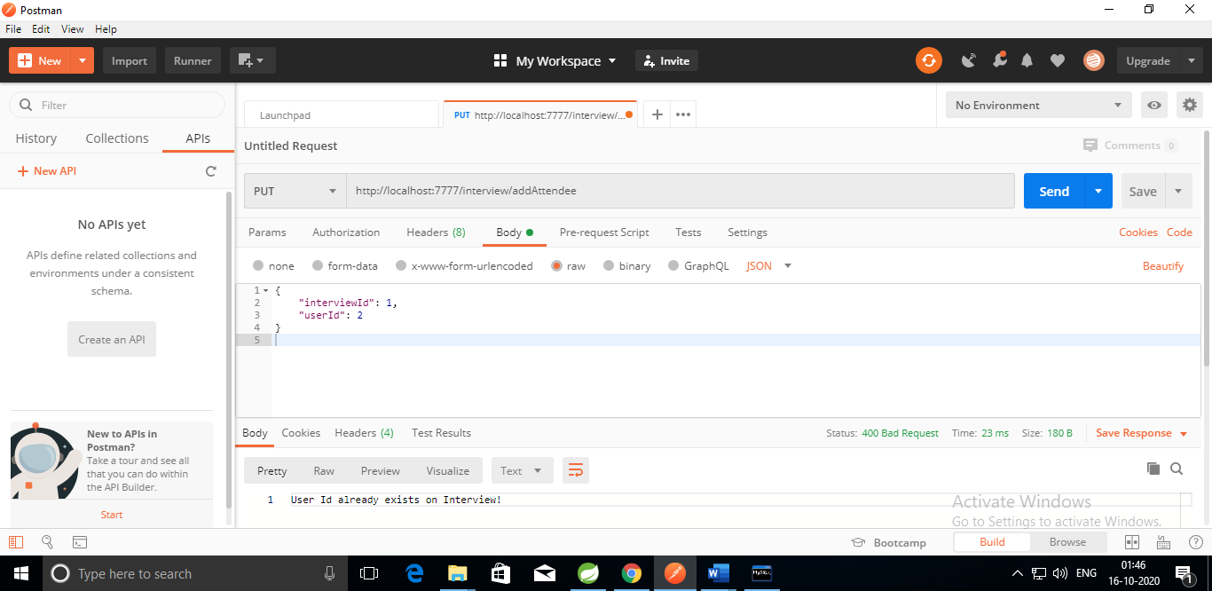

### While deleting the user and interview also, assumed that id already exists, else throw an custom exception

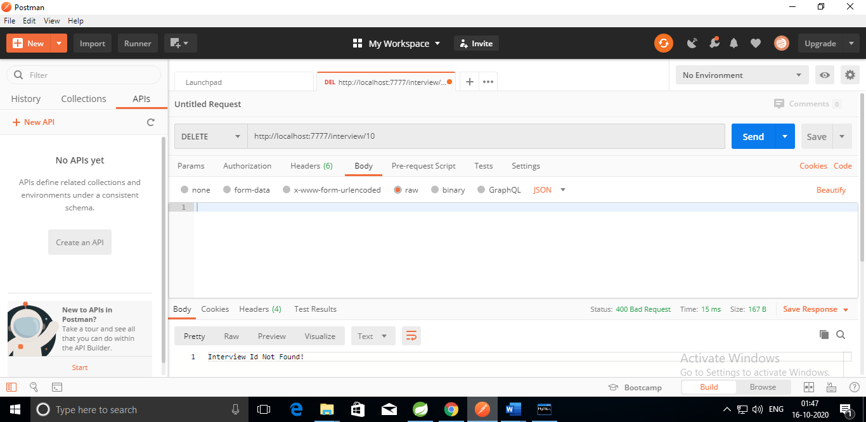

# MySQL Schema

mysql> drop database itDb;

Query OK, 3 rows affected (0.72 sec)

mysql> create database itDb;

Query OK, 1 row affected (0.09 sec)

mysql> use itDb;

Database changed

mysql> show tables;

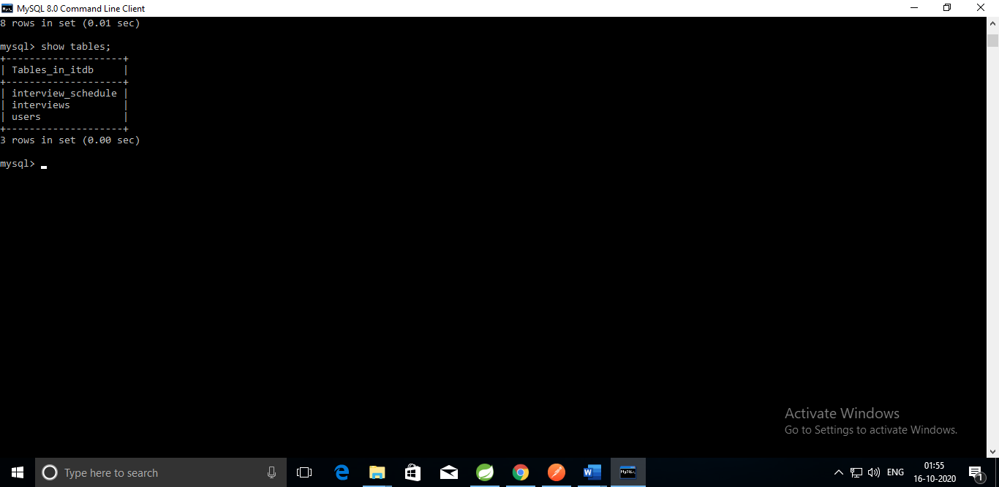

mysql> desc interviews;

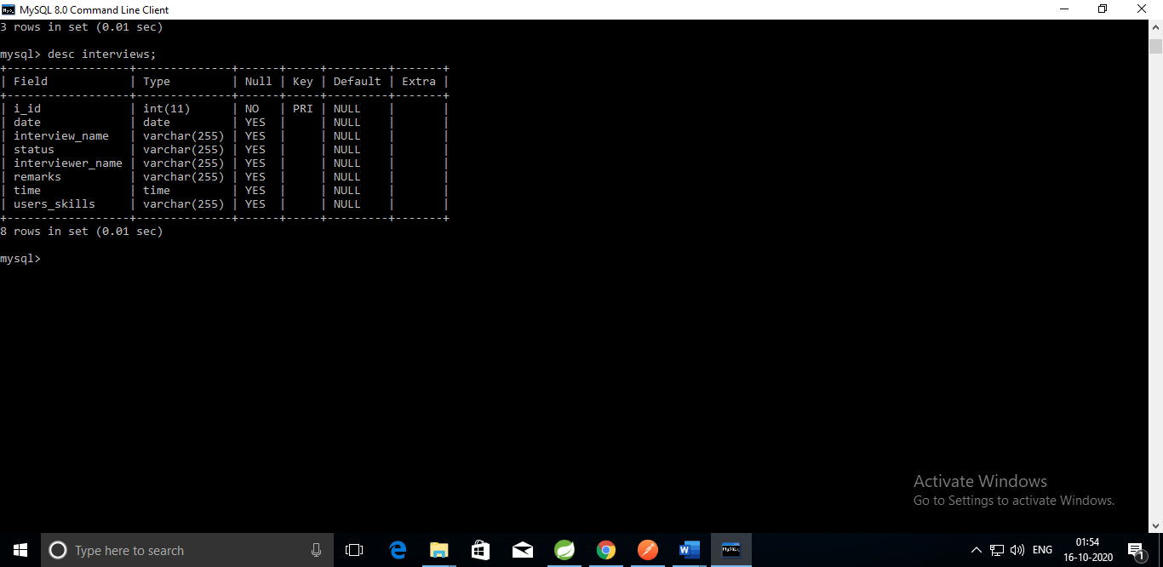

mysql> desc users;

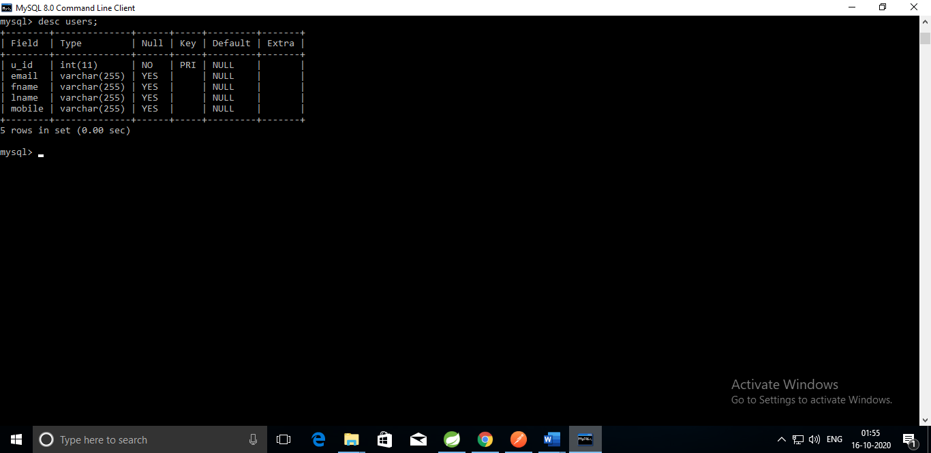

mysql> desc interview_schedule;

