**Client Server**

Create server – restful API server for adding and getting students.

* Use express package - as u can see we are using TS
* Use cors package - as u can see we are using TS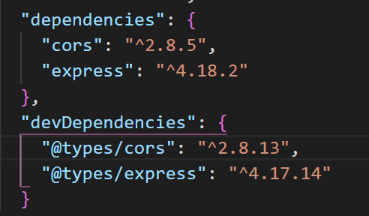
* Make sure that u are working in server side with typescript
* Database is a simple empty array.  
  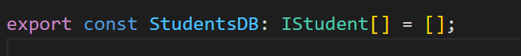
* Server folder structure:  
  Graphical user interface, text, application

  Description automatically generated

Client Side:

* Please install bootstrap (npm i bootstrap)
* For the notification toast if u like its u can read about it [(LINK)](https://fkhadra.github.io/react-toastify/introduction/#the-playground)
* Use axios package (npm i axios) to perform http request to server
* Client folder structure:  
  