GraPhlAn (Graphical Phylogenetic Analysis), a computational tool that produces high-quality, compact visualizations of microbial genomes and metagenomes.
This includes phylogenies spanning up to thousands of taxa, annotated with metadata ranging from microbial community abundances to microbial physiology or host and environmental phenotypes.
GraPhlAn plots for taxonomic profiles, functional profiles and specific features identified as biomarkers.

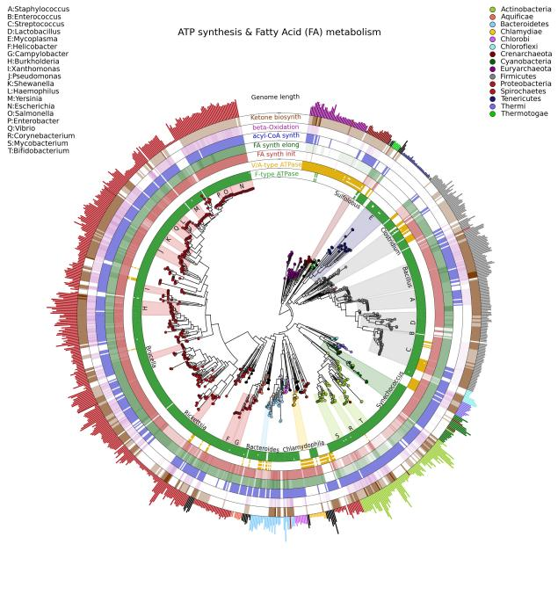

SynTView, a comparative and interactive viewer for microbial genomes, designed to run as either a web-based tool (Flash technology) or a desktop application (AIR environment).
The basis of the program is a generic genome browser with sub-maps holding information about genomic objects (annotations).
The software is characterised by the presentation of syntenic organisations of microbial genomes and the visualisation of polymorphism data. visualise information about polymorphism across a large number of bacterial strains.

AmphoraVizu
Phylogeny based phylotyping (finding phylogenetic marker genes in the shotgun sequencing data and using evolutionary trees): AMPHORA2 [8] and its web server implementation AmphoraNet ● AMPHORA2 uses 31 bacterial and 104 archaeal protein-coding phylogenetic marker genes for metagenomic phylotyping ● Most of these marker genes are single copy genes, therefore AMPHORA2 is suitable for inferring the taxonomic composition of shotgun sequencing data

Elviz (Environmental Laboratory Visualization) is an interactive web-based tool for the visual exploration of assembled metagenome data and their complex metadata.
Elviz allows scientists to navigate metagenome assemblies across multiple dimensions and scales, plotting parameters such as GC content, relative abundance, phylogenetic affiliation and length of the assembled contigs. It enables interactive exploration using real-time plot navigation, search, filters, axis selection, and the ability to drill from a profile of the entire community down to the gene annotations of an individual contig.

