AIMS IMOS ONBOARDING GUIDE

# General Information

Step by step guides to configure access to essential systems used in AIMS’ IMOS Moorings operations and data pipeline.

### Useful Links/Directories

Server where all IMOS related data etc is stored: \\pearl\imos

Server where all oceanographic information and files are stored: \\pearl\ocean

Directory where all oceanographic technical information is stored: \\pearl\ocean\OGTECH

AODN Portal (Where all of our processed data is eventually uploaded): <https://portal.aodn.org.au/>

AODN Thredds server (Useful for querying data files programmatically): <https://thredds.aodn.org.au/thredds/catalog.html>

AIMS moorings descriptions web archive (more specific details on individual deployments): <https://data.aims.gov.au/moorings/>

# GiT(Lab/hub)

Getting Git installed and setup for IMOS toolbox processing

1. Install a Git GUI program:
   1. TortoiseGit (this guide refers to TortoiseGit specifically):
      1. First download Git from <https://git-scm.com/downloads>
      2. Then download <https://tortoisegit.org/> using all defaults
   2. Github Desktop (Optional):
      1. Download from <https://desktop.github.com/>
      2. (Git is installed with Github Desktop by default)
   3. Other Git GUI by personal preference
2. Login to GitLab with your AIMS credentials: <http://gitlab.aims.gov.au/users/sign_in>
3. Install Putty in order to generate an SSH Key:
   1. <https://www.puttygen.com/download-putty>
4. Start PuttyGen
5. Select “Ed25519” as the type of key to generate
6. Click “Generate” and follow directions
7. Enter a passphrase to protect your private key in the labelled box **\*\*Remember it\*\***
8. Save the public key as “aims-gitlab.pub”, save the private key as “aims-gitlab.ppk”. Ideally put it in your /OneDrive/.ssh directory so if your machine dies you don’t have to do this again.
9. Apply your SSH Key to your Gitlab:
   1. Click your profile icon in the top right of the GitLab Page
   2. Select Preferences
   3. Select SSH Keys on the left hand menu
   4. Copy the text in the “SSH Fingerprints” box and add it as a key
10. Exit PuttyGen

# imos toolbox

Installation and setup of the IMOS Toolbox within MATLAB

1. Navigate to C:\AIMS and open a Git Bash terminal and enter the following:

git clone https://github.com/aodn/imos-toolbox.git

cd imos-toolbox

git checkout AIMS-2.6

1. Open MATLAB
2. Run ‘setup_imostoolbox_aims_Flick.m’
3. Ensure your OceanDB is properly configured
4. Run ‘imosToolbox’

OR

The IMOS toolbox is one component of the processing system. You will need to set up your Matlab area so that you have all the libraries etc that the toolbox requires. Simon Spagnol maintains an area on the Pearl server area.

1. Create a folder C:\AIMS. This will be your default Matlab area for installing all the tools used for processing. Copy the entire **matlab** directory from \\PEARL\ocean\AIMS into your C:\AIMS directory.
2. Open the toolbox project on Gitlab (<https://gitlab.aims.gov.au/imos/imos-toolbox>)
3. Click the Blue “Clone” button and click the copy icon next to the “Clone with SSH” address. It should be [git@gitlab.aims.gov.au:imos/imos-toolbox.git](mailto:git@gitlab.aims.gov.au:imos/imos-toolbox.git) or similar.
4. In your C:\AIMS directory, right click and select ‘Git Clone’.
5. Paste your copied repository Git URL into the URL input as below:

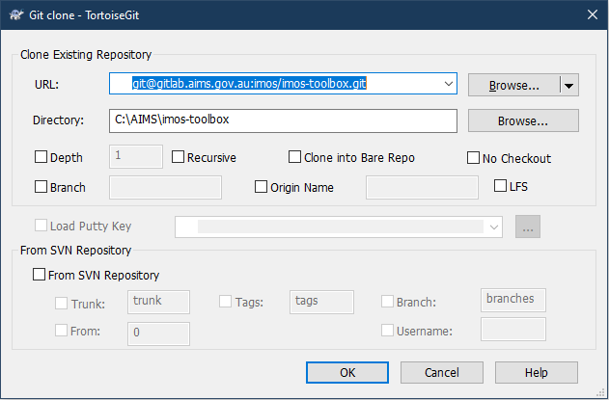

1. Select OK. This will create a cloned copy of the Master toolbox. You will need to enter your passcode (created when you set up your SSH Key).
2. Right click on the imos-toolbox directory and select TortoiseGit -> Switch/Checkout
3. Set the branch to AIMS-2.6 (Or higher) as below:

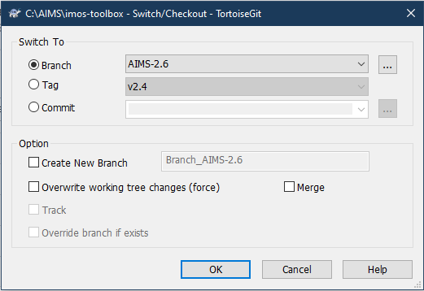

1. Select OK. You will now be using AIMS’ branched version of the toolbox. This has some AIMS specific utility which is maintained by Simon Spagnol.
2. Repeat this cloning process into your C:\AIMS directory (without switching branches for the other projects:
   1. imos/datatools: [git@gitlab.aims.gov.au:imos/datatools.git](mailto:git@gitlab.aims.gov.au:imos/datatools.git) - clone into C:\AIMS\imos-datatools
   2. imos/imos-user-code-library: [git@gitlab.aims.gov.au:imos/imos-user-code-library.git](mailto:git@gitlab.aims.gov.au:imos/imos-user-code-library.git) - clone into C:\AIMS\imos-user-code-library
   3. ogtech/easyplot: [git@gitlab.aims.gov.au:imos/imos-user-code-library.git](mailto:git@gitlab.aims.gov.au:imos/imos-user-code-library.git) clone into C:\AIMS\easyplot
3. The last step is setting up the Oceanographic Database and getting it talking to the toolbox.

For more information, including a link to the database manual see the ‘Getting Started’ section in the IMOS Toolbox Wiki: <https://github.com/aodn/imos-toolbox/wiki#getting-started>

# Oceanographic Database

Installation of the Oceanographic Database (OceanDB):

1. If you have an existing database and have any queries in your existing database that you use that aren’t part of the standard database – export these first so that you can re-import them
2. If they exist, Remove your old OceanDBXXXX.mdb and OceanDBSecurity.mdw
3. Creare C:\OceanDB directory if it doesn’t exist
4. You will need to get the file - OceanDB2016.zip – from \\PEARL\ocean\OceanographyDatabase\Distribute_Secured and unzip it to C:\OceanDB
5. Use the shortcut (OceanDBLaunch2013) to open the Database. This shortcut draws in the security file when opening.
6. Log in with your aims user name – e.g. jluetchf , and use the same for your password.
7. For users who only want to view the information use “readonly” for both the username and password.

If you are going to be out of internet range (In the field) and want to have access to the database you can create a local backend, though you will not be able to synchronise any changes made.

1. Close the Database
2. Copy \\PEARL\ocean\OceanographyDatabase\BackEnd\OceanDB2016_be.mdb to your database directory
3. Open OceanDB2016 (in the usual way using your shortcut as in step 4 above)
4. From top menu select External Data ->Linked Table Manager
5. Select All and Tick Always Prompt for New Location - OK
6. Browse to the new location of your Back End (ie c:\OceanDB\OceanDB2016_be.mdb)
7. This will refresh all your links to point at the local Back End.
8. When back in range, repeat the process but refresh your links to point at Back End on Pearl.
9. This process is a little clunky and may require you to do it a couple of times. If you’re finding you have duplicated tables or issues opening the switchboard, simply reopen the Linked Table Manager, remove the linked database backend and readd it.

Your AIMS\imos-toolbox\toolboxProperties.txt file will need to be edited so that is looks for the Back End of the database:

e.g. toolbox.ddb = "\\pearl\ocean\OceanographyDatabase\BackEnd\OceanDB2016_be.mdb"

# IMOS Data Upload to aodn

FTP registration and data upload

1. Go to the registration page: <https://ftp-uploader-registration.aodn.org.au/register.php>
2. Fill out your details and click “Register”. For the username, please use your first initial followed by your last name, all in lower case (e.g. 'jsmith' for John Smith). Please set a password you will remember.
3. Setting up your account is a manual process and may take a couple of days. You can speed up the process by letting AODN (previously eMII) know why you have registered (i.e. what data you will be uploading) – Contact your supervisor for the appropriate contact for this.
4. You will receive an email from AODN when your account has been set up.

To upload IMOS files to the AODN, use any FTP client software (e.g. FileZilla) to connect via FTP. In most cases you will be connected directly to the incoming folder for the ANMN facility (unless you also upload data for other IMOS facilities). For all National Reference Stations data, please upload into the NRS sub-folder.

1. Open FileZilla
2. Add your processed data to a .zip file to keep it packaged and reduce the amount of ‘Successfully Uploaded’ emails.
3. Set the Host as: **incoming.aodn.org.au**
4. Set the Username as the username you used for your AODN account (e.g. ‘jsmith’)
5. Set the Password as the password you used for your AODN account
6. Leave the Port blank
7. Click Quickconnect
8. For uploading mooring data, make sure you are in the correct folder – ie AIMS_MOORING (Remote Site)
9. Then go to your local site, get your zipped folder (.zip), right click and select upload.

# Placeholder

.

# Placeholder

.