Course-End Project
Implementing microservices with AWS ECR and ECS

Steps to be followed:
- Set Up Docker and GitHub Repositories
- Deploy Services on Amazon ECS using ECR

Step 1: Set Up Docker and GitHub Repositories
- Navigate to GitHub to access the GitHub repositories for both Backend (NodeJS) and Frontend (React) applications
https://github.com/hkshitesh/ReactFrontend.git

https://github.com/hkshitesh/NodeBackend.git

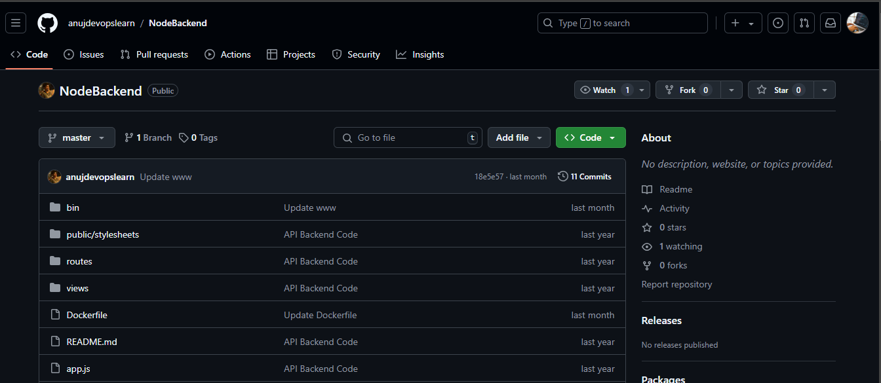

- Create Dockerfiles for both services with the following configurations and push them to the respective repositories:

Backend Dockerfile:

FROM node:16
ENV HOME=/home/app
COPY package.json $HOME/node_docker/
WORKDIR $HOME/node_docker
RUN npm install --silent --progress=false
COPY . $HOME/node_docker
EXPOSE 3000
CMD ["npm", "start"]

Frontend Dockerfile:

FROM node:16
ENV HOME=/home/app
COPY package.json $HOME/node_docker/
WORKDIR $HOME/node_docker
RUN npm install --silent --progress=false
COPY . $HOME/node_docker
EXPOSE 3000
CMD ["npm", "start"]

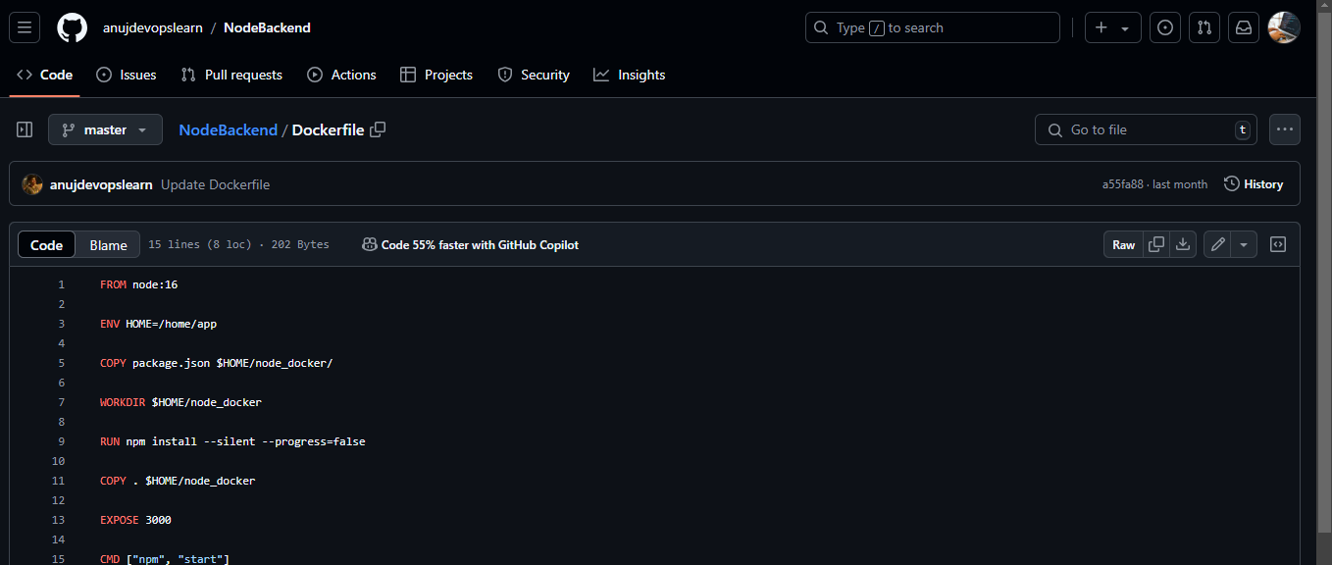

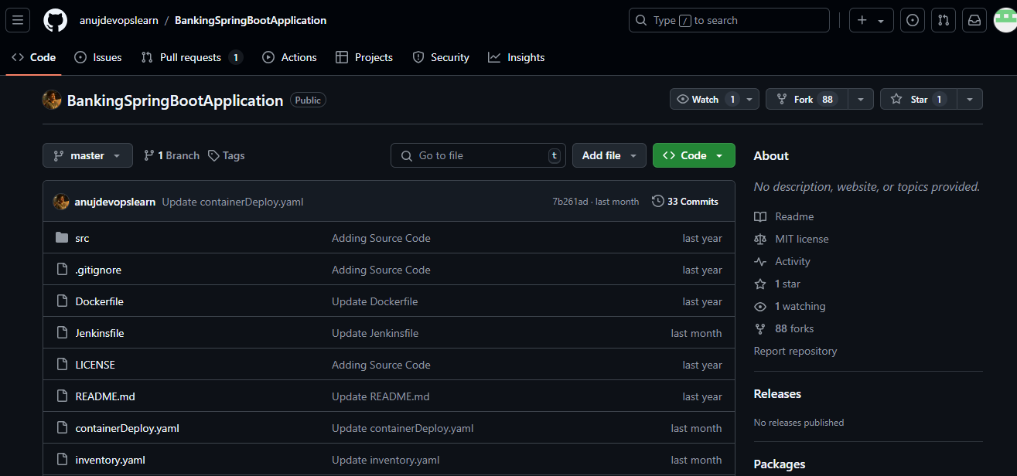

Step 2: Deploy Services on Amazon ECS
  - Navigate to the AWS Console, open the Containers menu, and select Elastic Container Service (ECS) to proceed with setting up your new ECS cluster for deploying Frontend and Backend Docker containers

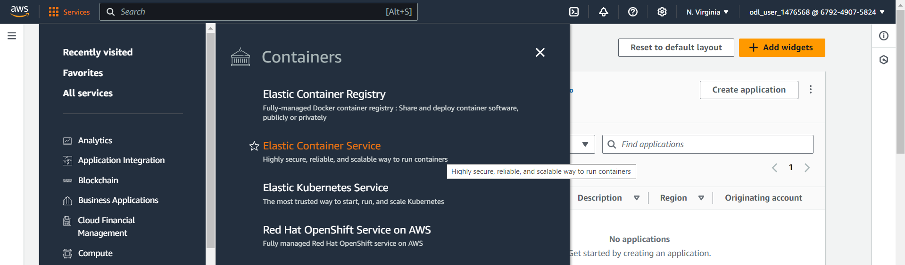

  - Click on Create cluster in the Amazon Elastic Container Service (ECS) dashboard to start the process of setting up a new cluster for deploying your Frontend and Backend Docker containers.

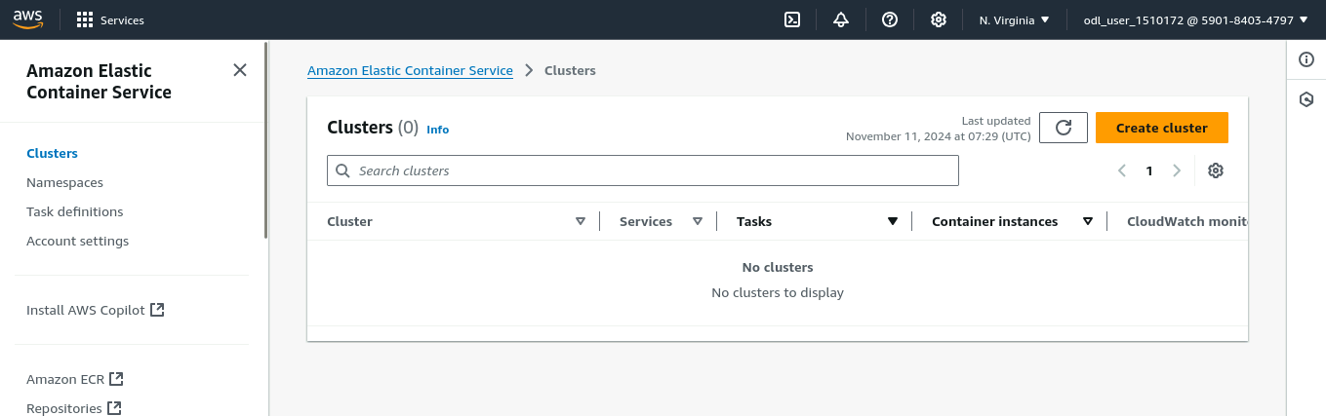

  - Enter the cluster name as DevCluster, select the default namespace, and choose AWS Fargate (serverless) as the infrastructure type to set up a serverless environment for your container deployment

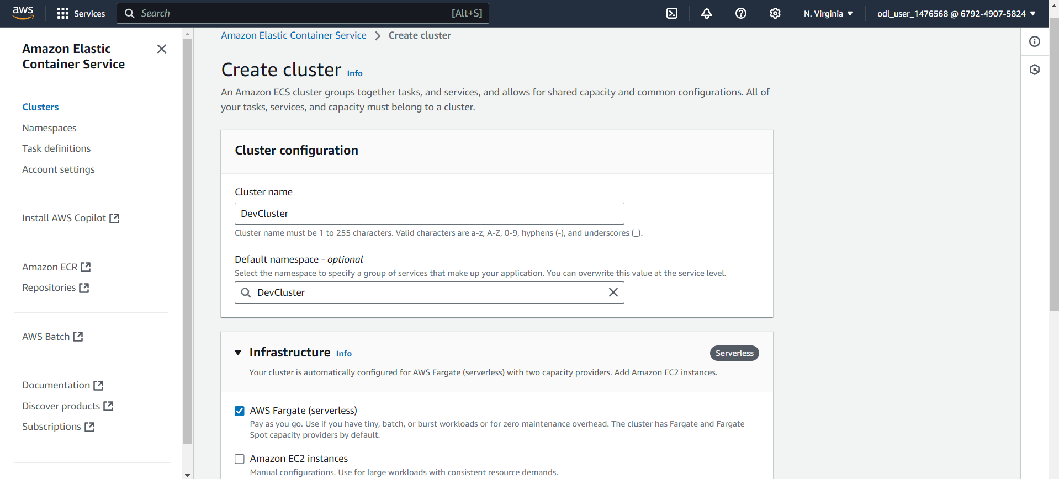

  - Confirm that the new cluster DevCluster has been successfully created and is visible in the list of clusters in the Amazon ECS dashboard.

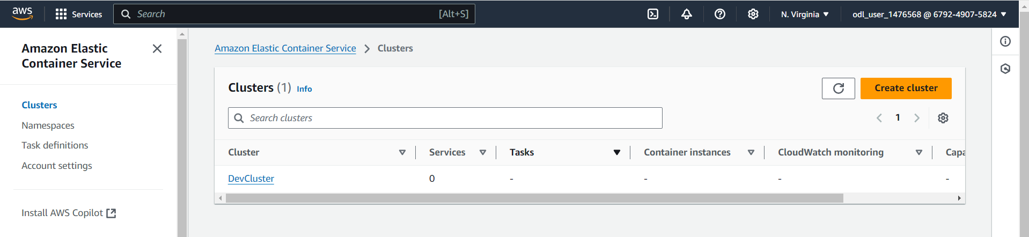

  - Verify that the cluster DevCluster is in an Active state in the cluster overview section of Amazon ECS. Check the details such as ARN, CloudWatch monitoring status, and the registered container instances before proceeding with service and task definitions

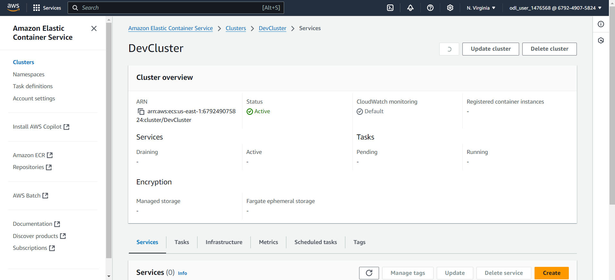
Note: We need to create task definition and basic service to start with container deployment

  - Click on Create new task definition in the Task Definitions section of Amazon ECS to start configuring a new task definition for your Docker containers, specifying details such as launch type, container definitions, and resource requirements

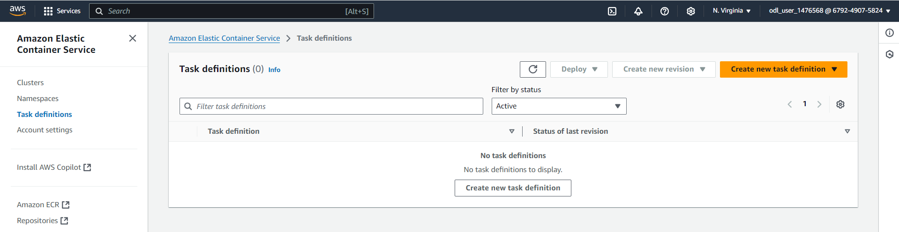

Note: Provide information regarding docker container to be deployed. We need to create two task definition one for backend and another one for frontend

  - Enter backendcontainer as the task definition family name, select AWS Fargate as the launch type, and choose the operating system as Linux/X86_64 with the network mode set to awsvpc for a serverless and secure container deployment

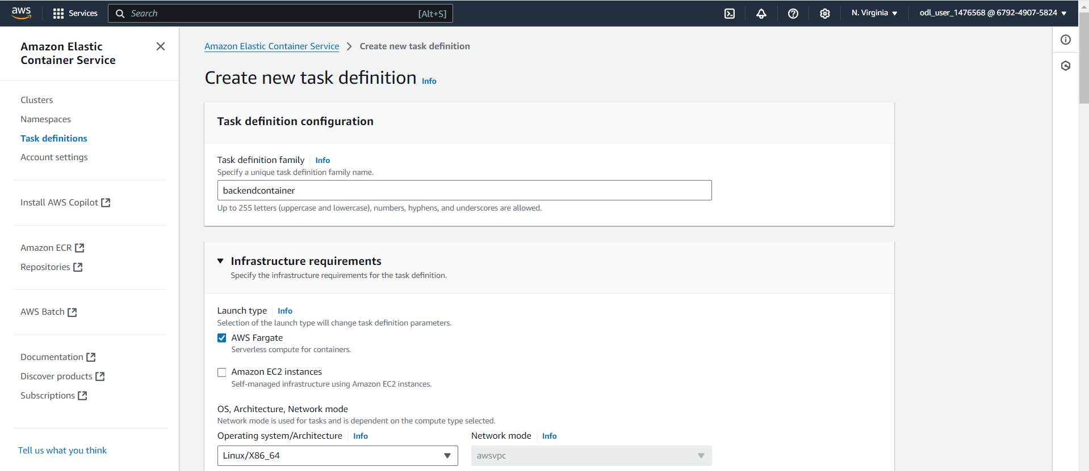

  - Set the container name to backend, use the image URI docker.io/anujsharma1990/backend:latest, mark it as Yes in Essential container, and enable port mapping with container port 3000, protocol TCP, and application protocol HTTP. Ensure that resource limits are defined as required for CPU and memory allocation.

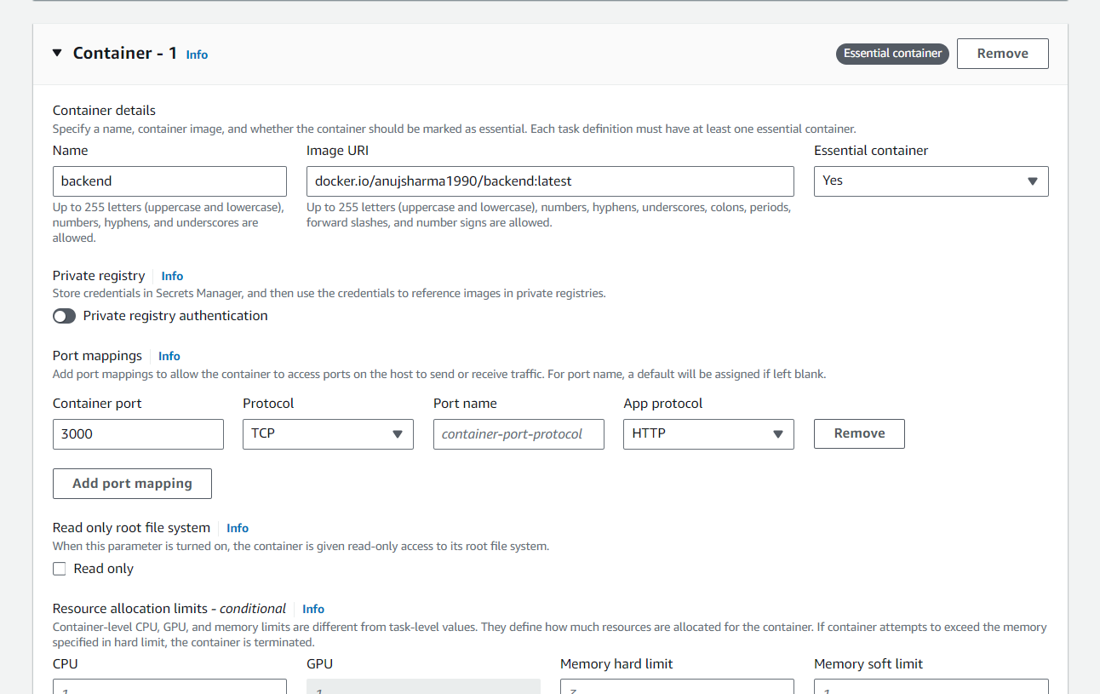

  - Click on Create to create task definition

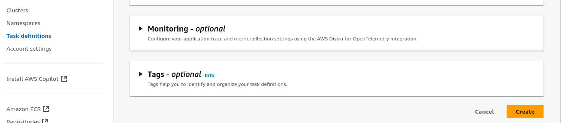

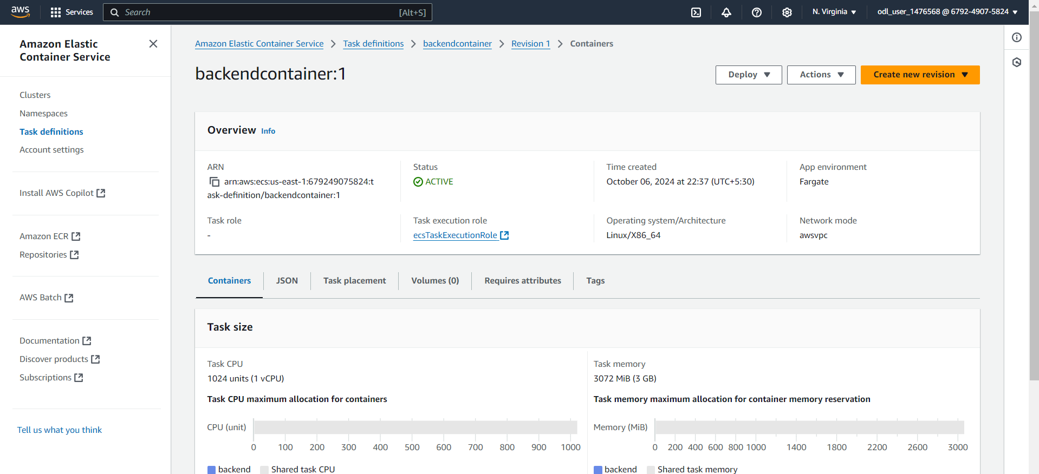

Note: Once task definition is created, we need to deploy the service.

  - Select the existing cluster DevCluster, choose Capacity provider strategy for compute configuration, and set the capacity provider to FARGATE with a weight of 1 to ensure tasks are deployed using AWS Fargate

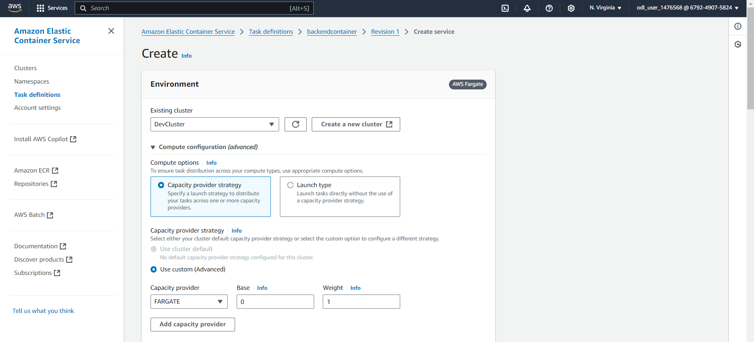

  - For the deployment configuration, select Service as the application type, choose the task definition backendcontainer with revision 1, set the service name as backend-service, and select Replica as the service type. Define the desired number of tasks as required for the deployment.

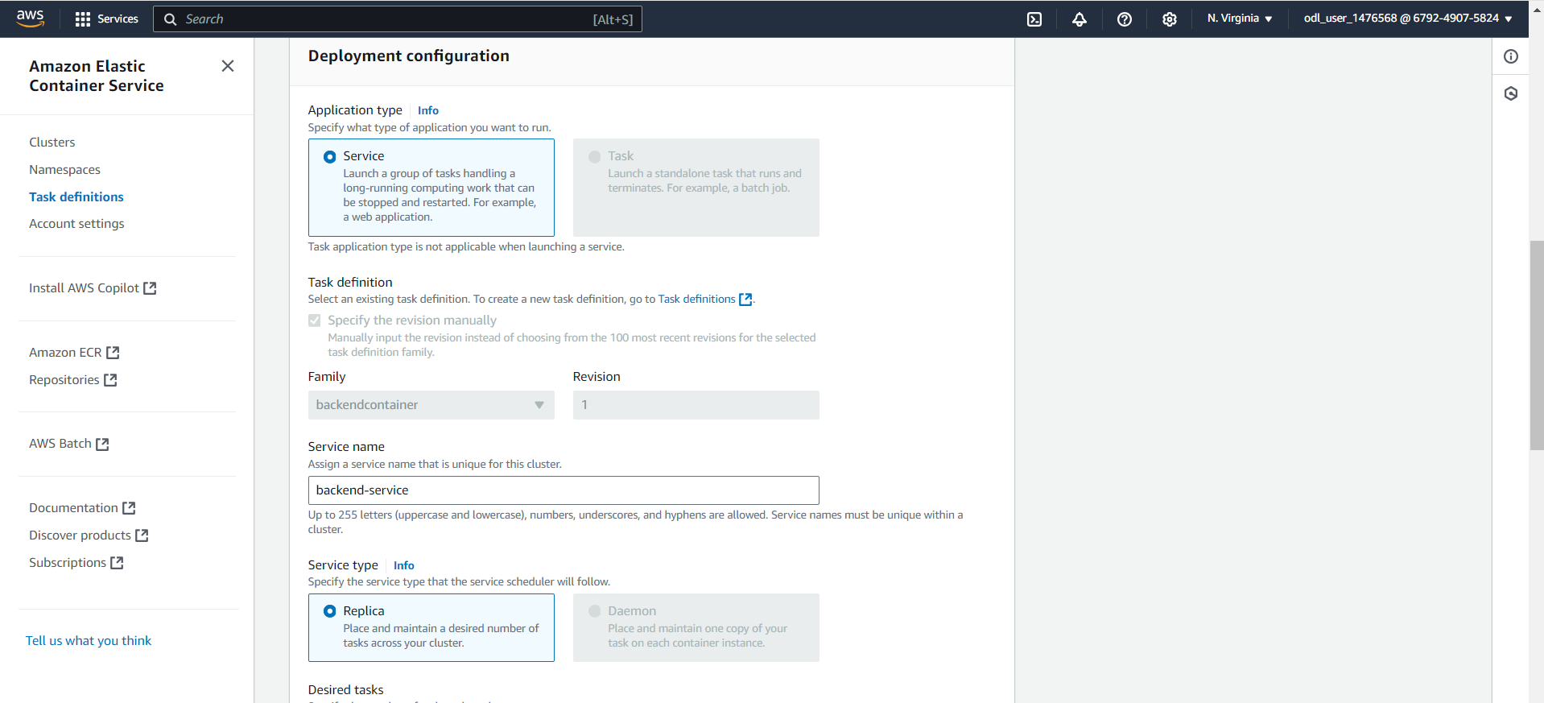

  - Choose the default VPC, select multiple subnets for high availability, and create a new security group named sg_backend_service with a description Created in ECS Console. This setup ensures secure networking and resource placement within the specified subnets

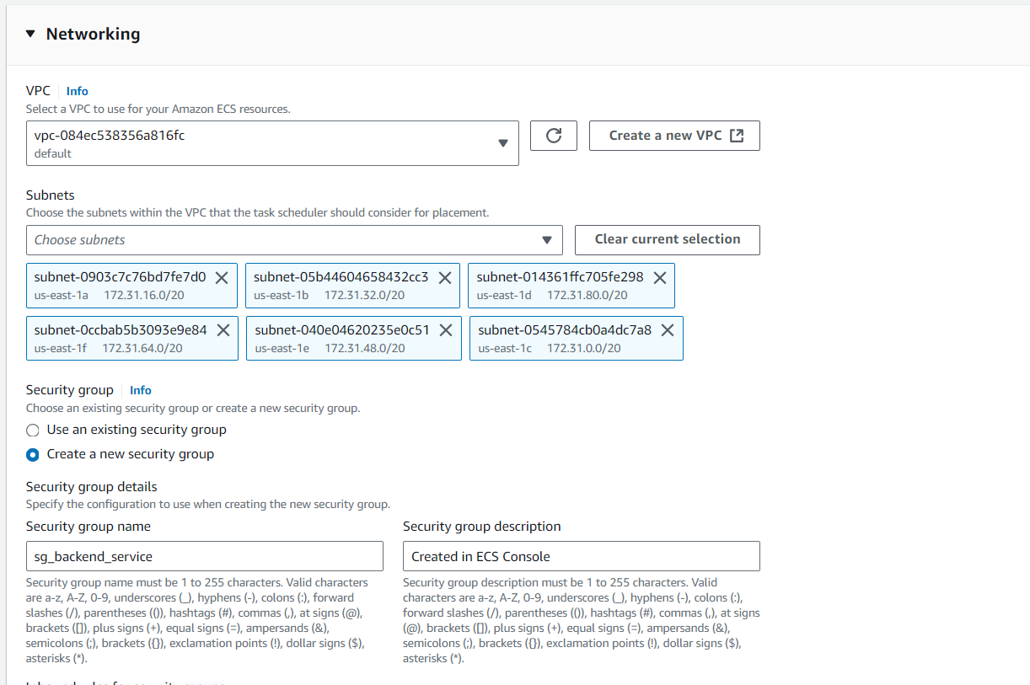

  - Set up an inbound rule in the security group sg_backend_service to allow TCP traffic on port 3000 from any source (0.0.0.0/0, ::/0) and ensure that the option for assigning a Public IP is turned on to enable external access to the backend service

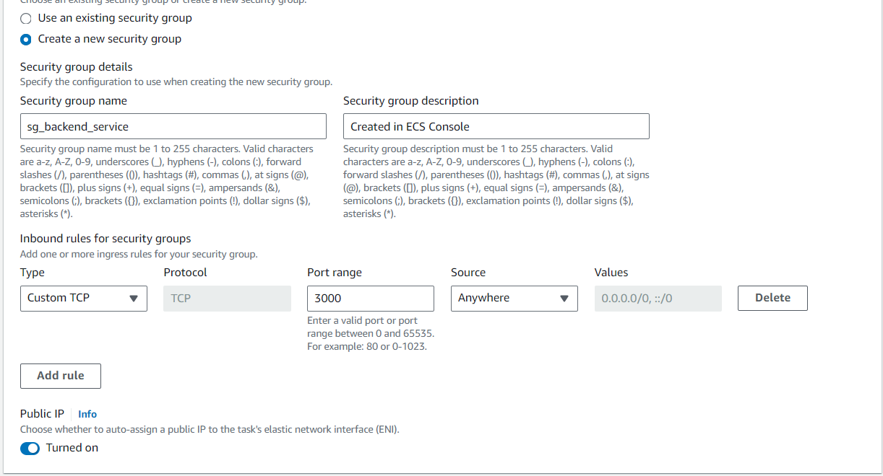

  - Confirm that the deployment of backend-service is in progress and that the cluster DevCluster is in an Active state, as indicated in the cluster overview. Monitor the status of tasks and services to ensure successful deployment and proper operation

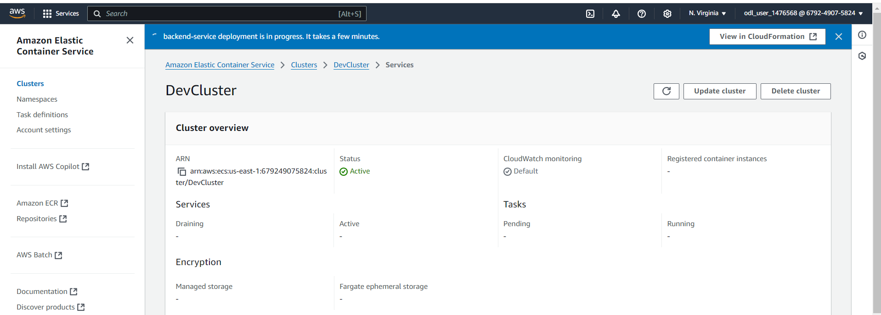

Note: We need to repeat same steps for frontend application
  - Create a new task definition named frontend, select AWS Fargate as the launch type, and set the operating system architecture to Linux/X86_64 with the network mode configured as awsvpc for a serverless and secure container environment

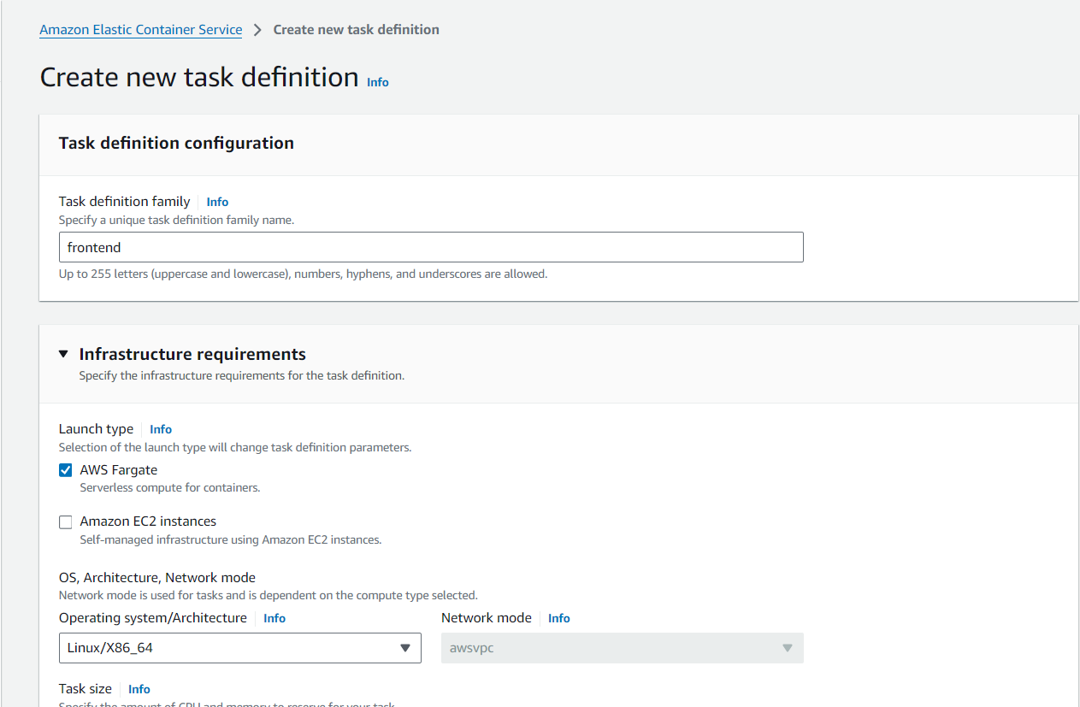

  - Set up frontend-container with image URI docker.io/anujsharma1990/frontend:latest, mark it as essential, configure port 80 with TCP and HTTP protocols, and allocate resources with 1 CPU, 1 GPU, a hard memory limit of 3 GB, and a soft limit of 1 GB

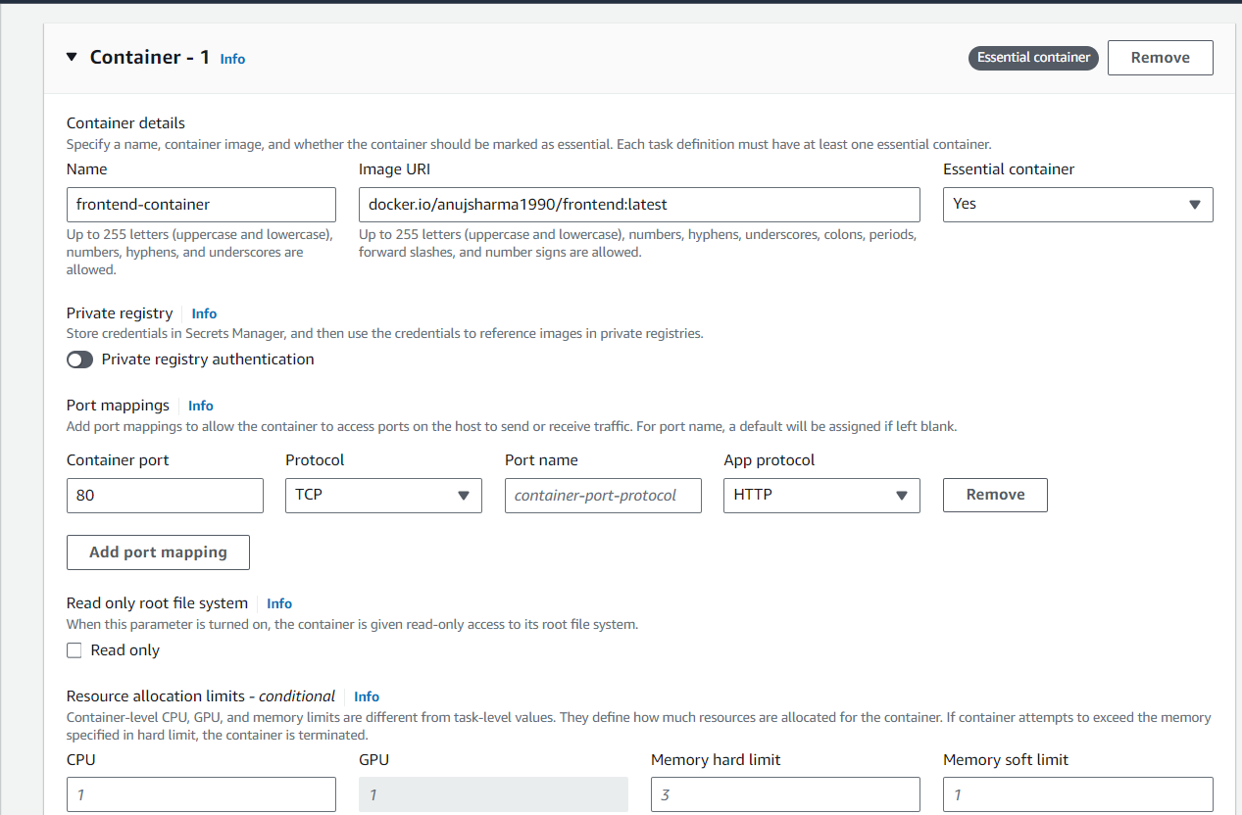
Confirm that the task definition frontendfro:1 has been successfully created and is in an Active state, with 1 vCPU, 3 GB memory, using Fargate launch type, Linux/X86_64 architecture, and awsvpc network mode, ready for deployment

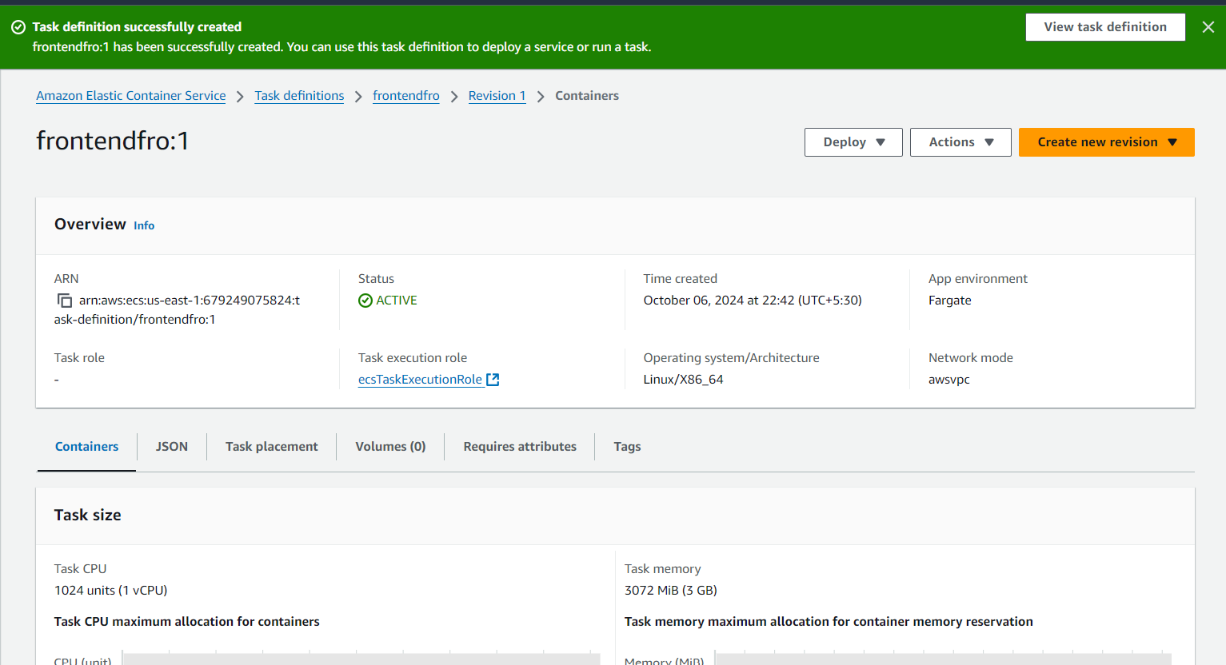

  - Choose Service as the application type, select the task definition frontendfro with revision 1, set the service name to frontend-service, and choose Replica as the service type to maintain the desired number of tasks in the cluster.

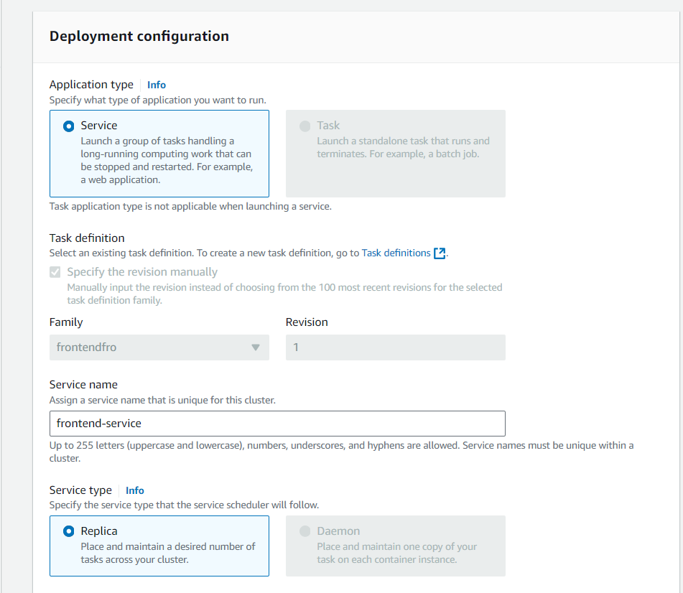

  - Create a new security group named sg_frontend_security with a description Created in ECS Console, add an inbound rule to allow TCP traffic on port 3000 from any source (0.0.0.0/0, ::/0), and ensure that the option for assigning a Public IP is turned on.

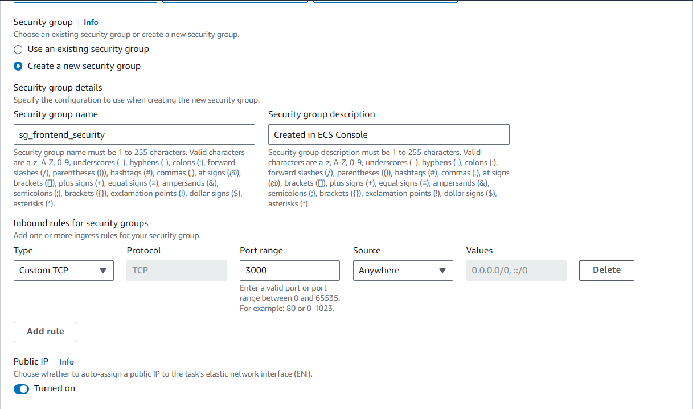

Once both backend and frontend services are created you can see them created as per below screenshot.

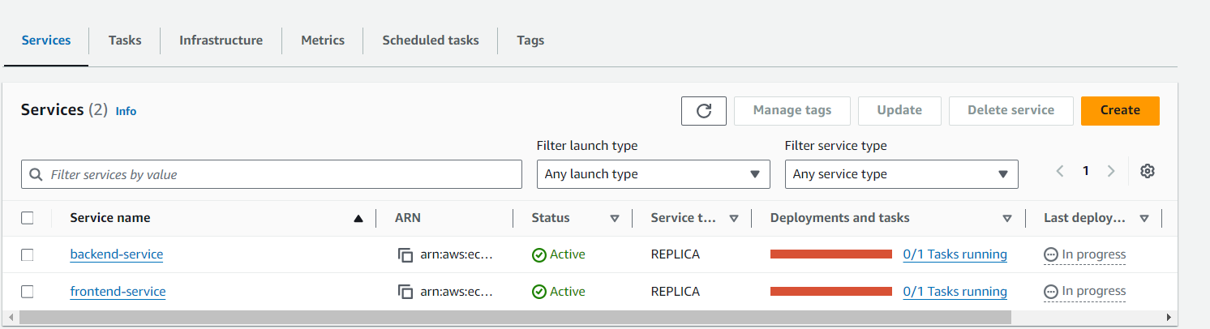

  - Use system default browser to access application deployed on Docker container frontend application
http://<public-ip>:3000

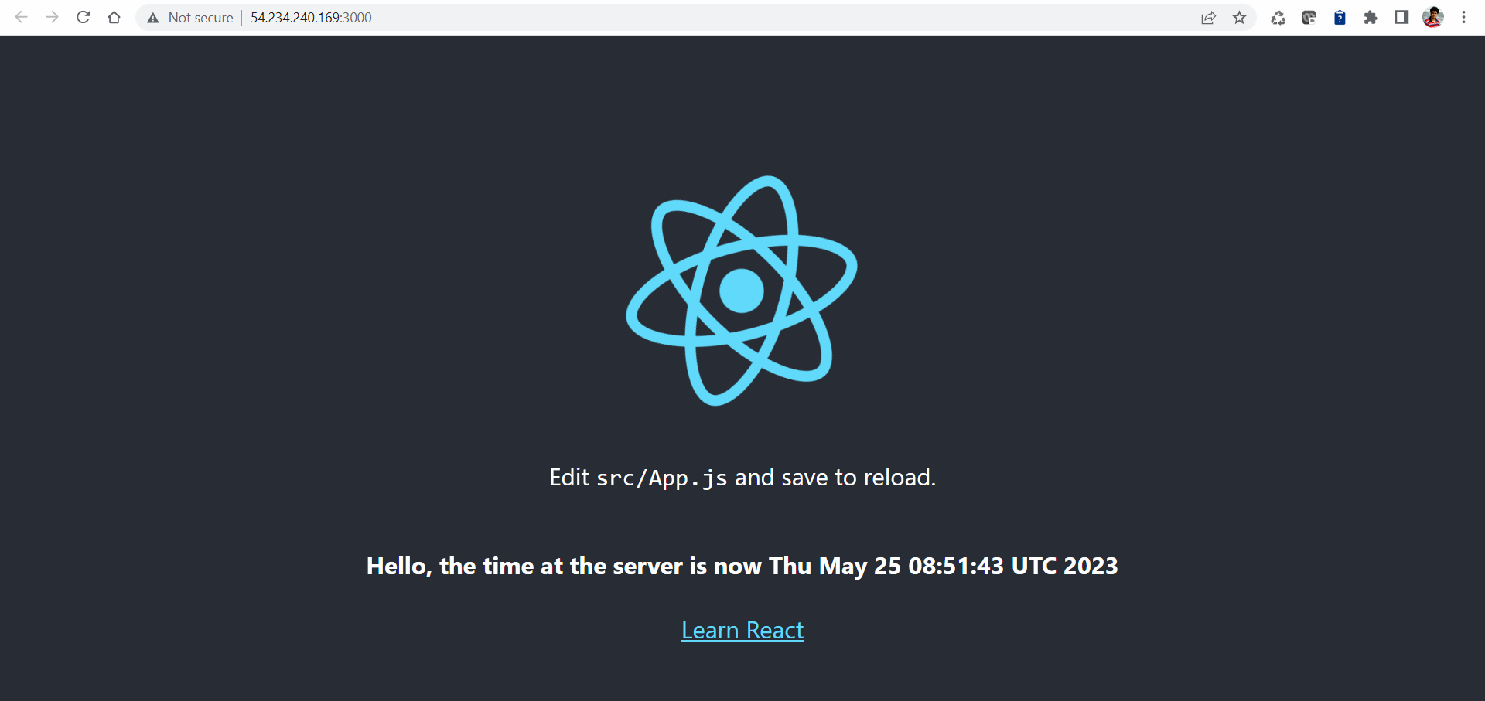

By following the above steps, you have successfully implemented microservices architecture using AWS CodePipeline and ECS, enabling automated CI/CD for seamless deployment of both backend and frontend applications, ensuring they are up and running on the ECS cluster with full integration and public accessibility.

