Lesson 3 Demo 1
Azure Key Vault

Objective: To create an Azure Key Vault

Tools required: Azure account with administrator access

Prerequisites:None

Steps to be followed:
- Creating an Azure Key Vault

Step 1: Creating an Azure Key Vault
1.1 Login to the azure portal
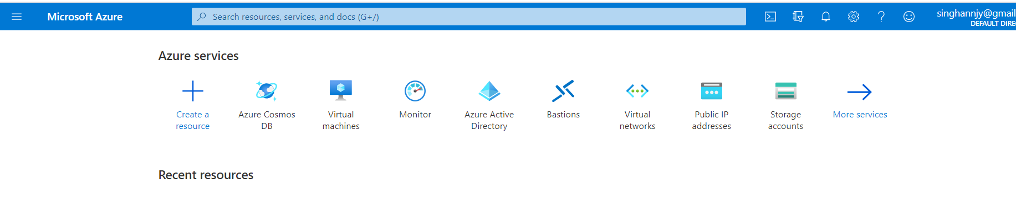

1.2 Click on Create a resource and then search for key vault
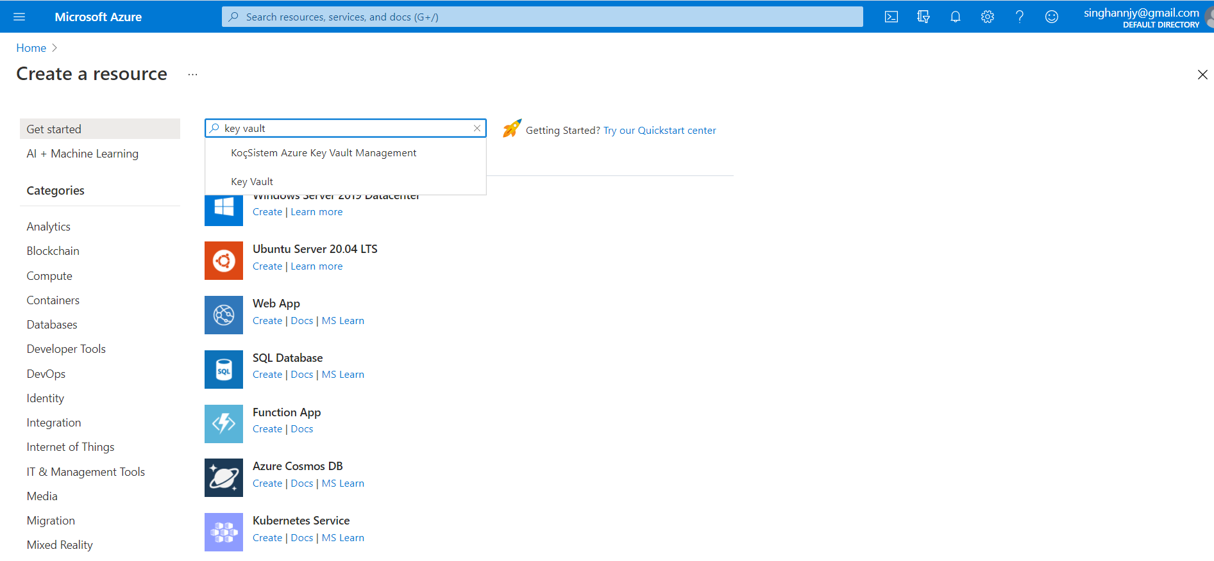

1.3 On the Key Vault section, choose Create
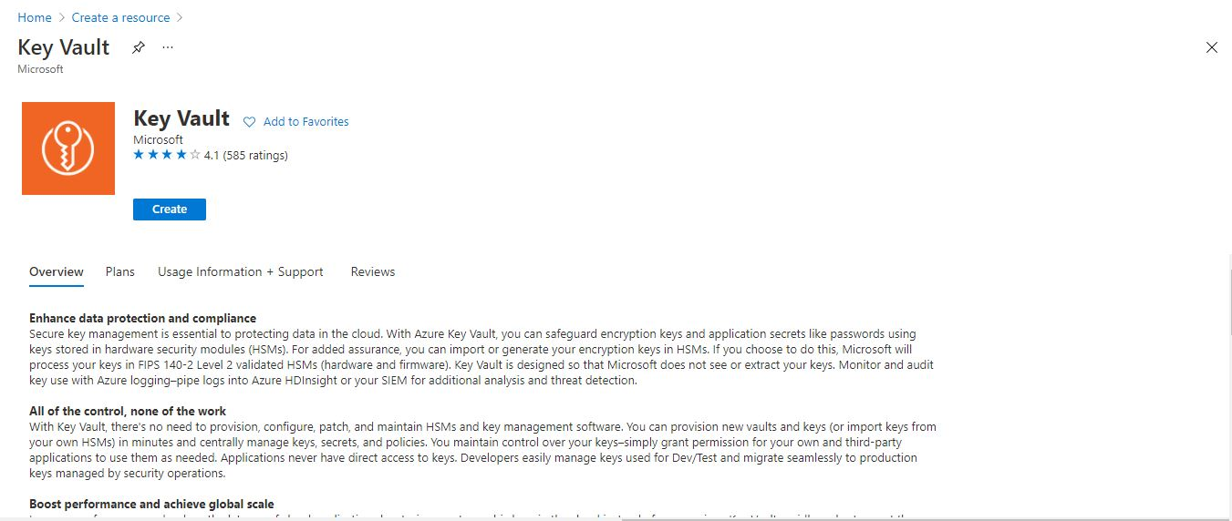
1.4 In the Azure key vault creation pane, enter the necessary details

1.5 Select Review + create leaving others to default
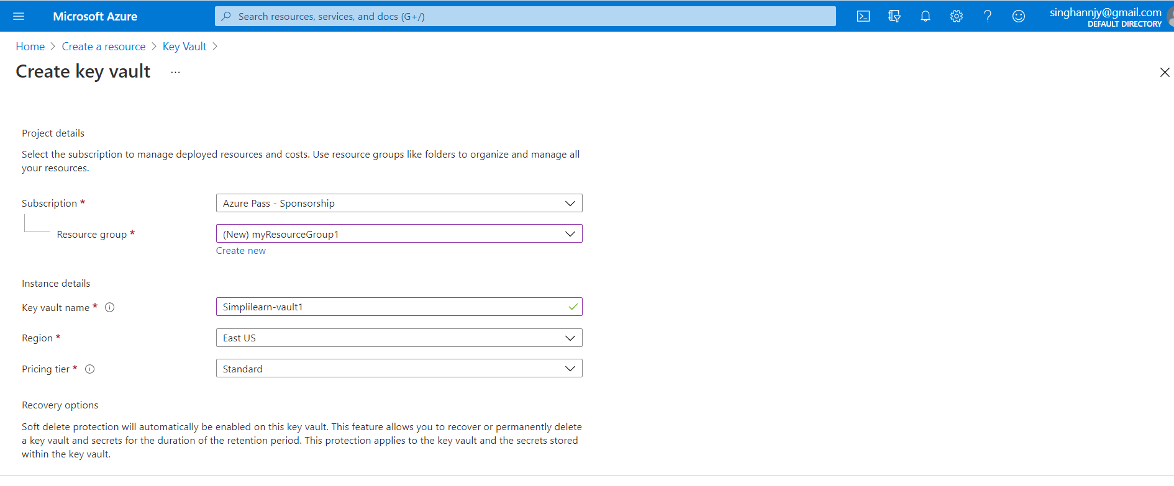
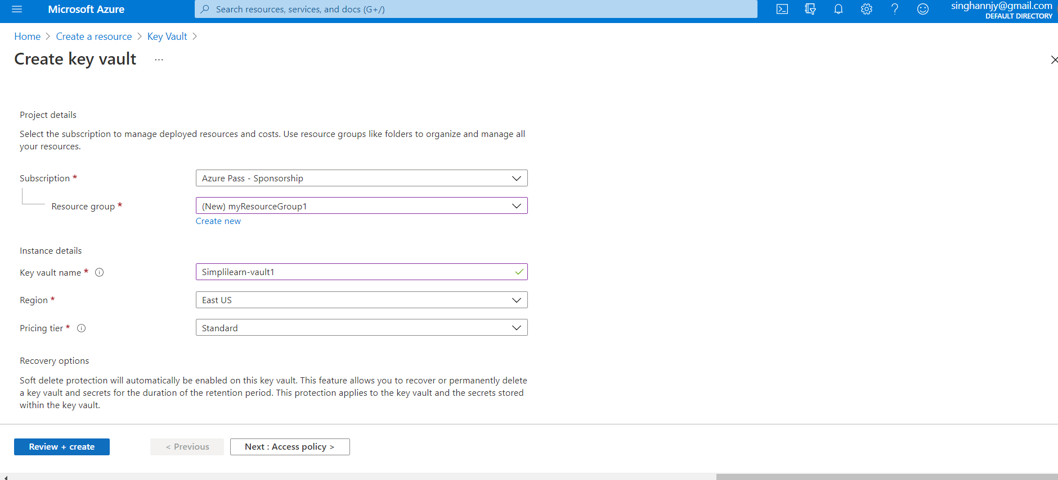

1.6 Select Create after reviewing the account settings
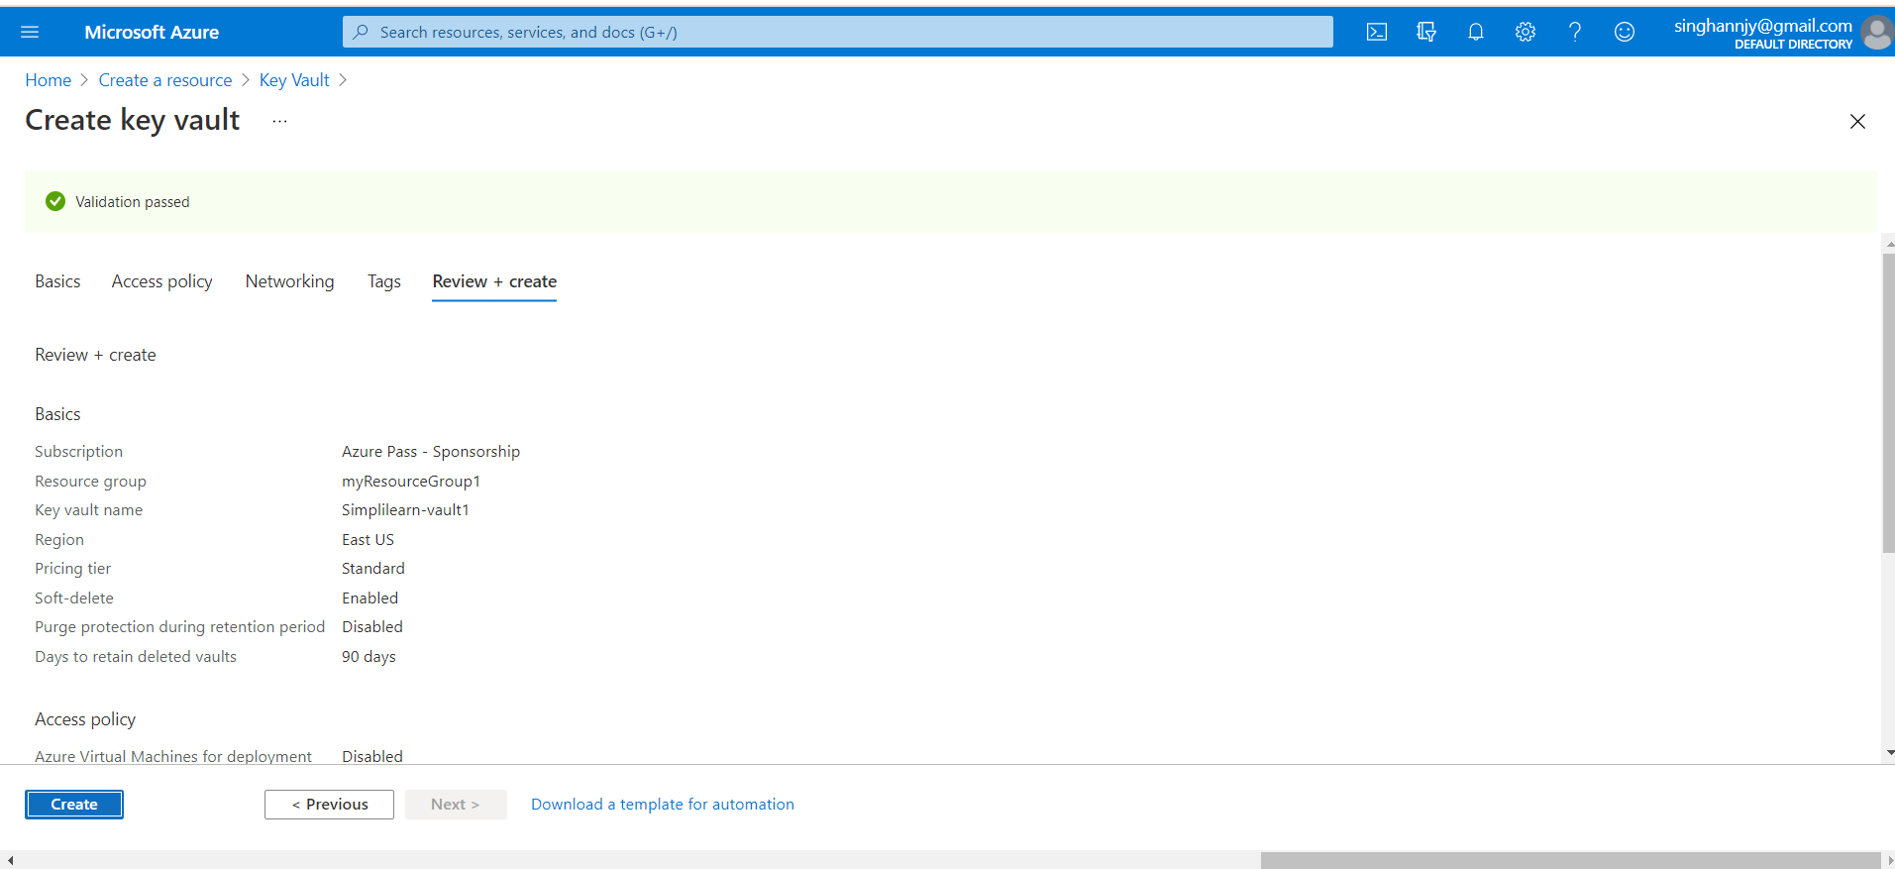

Wait for a few minutes, your Azure key vault will be created
