Lesson 2 Demo 1
Azure Policy Creation
Objective: You have been asked to create an azure policy.

Tools required: Azure account with administrator access.

Prerequisites: None

Steps to be followed:
- Log into the Azure portal
- Define a Policy

Step 1: Log into the Azure portal

  - Log into the Azure portal at https://portal.azure.com

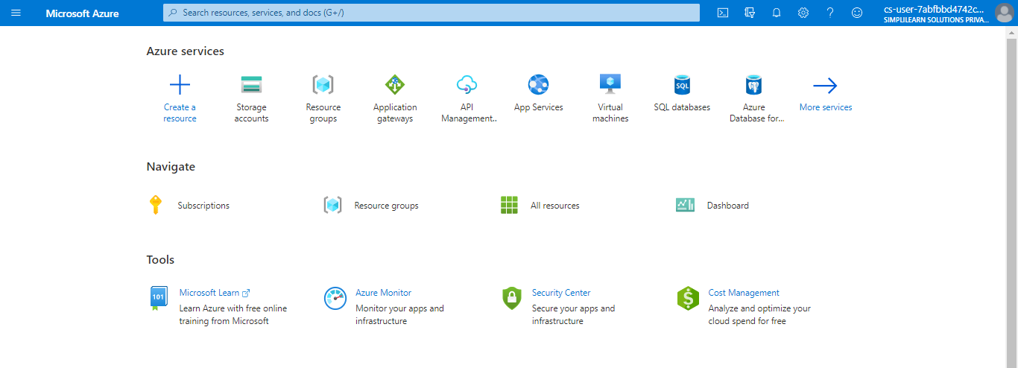

Step 2: Define a Policy

2.1 Search for and select Policy

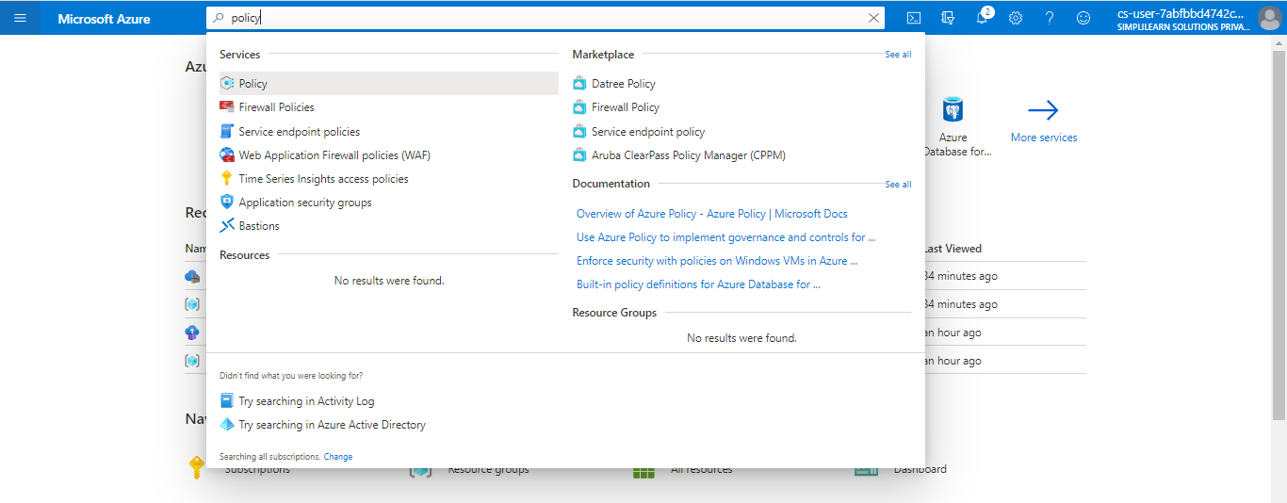

2.2 Select Definitions under Authoring in the left side of the Azure Policy page
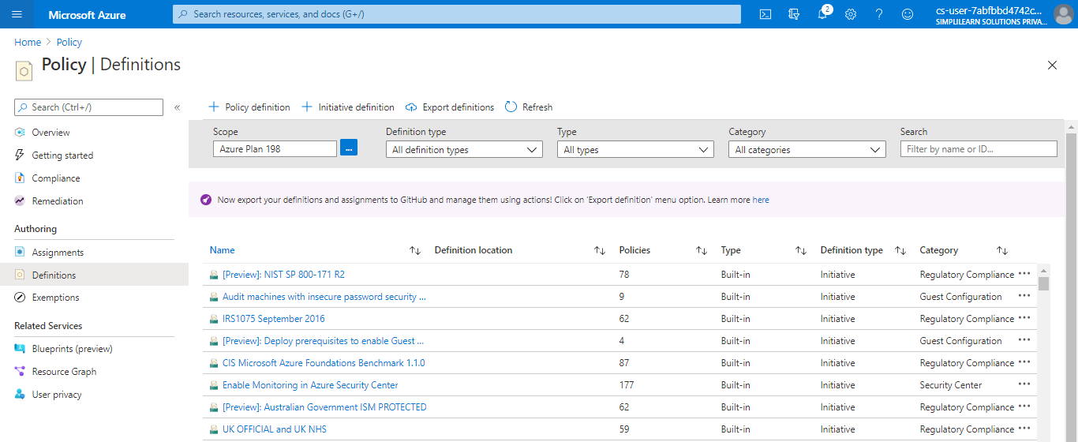

2.3 Select + Policy definition at the top of the page. This button opens to the Policy definition page
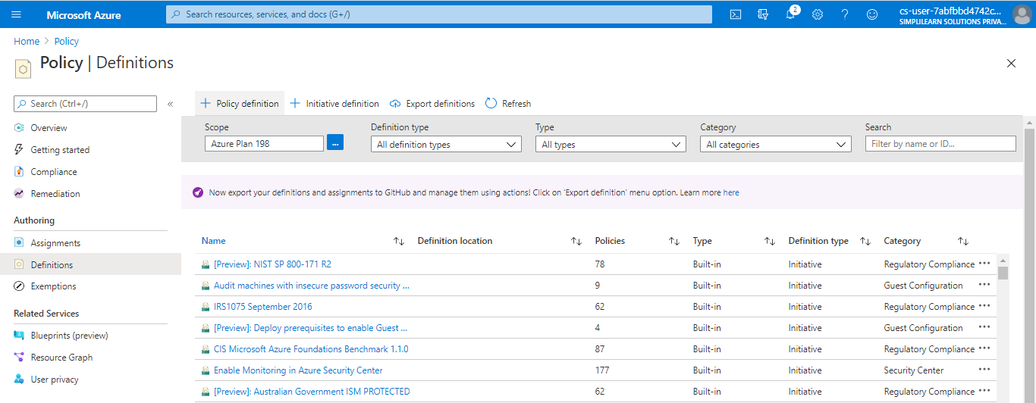

2.4 Enter the following information:
a. The management group or subscription in which the policy definition is saved. Select by using the ellipsis on Definition location
b. The name of the policy definition - _*Require VM SKUs smaller than the G series
c. The description of what the policy definition is intended to do: This policy definition enforces that all VMs created in this scope have SKUs smaller than the G series to reduce cost
d. Choose from existing options (such as Compute) or create a new category for this policy definition
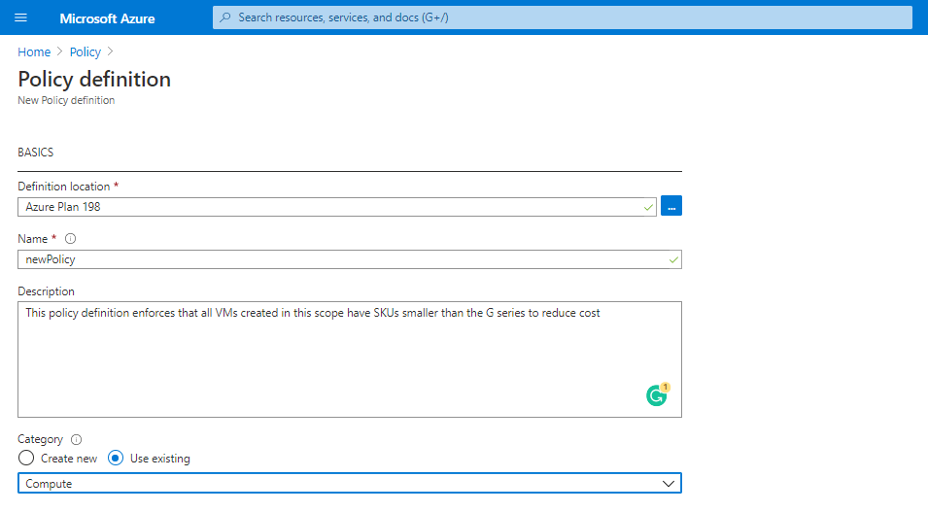
e. Copy the following JSON code and then update it for your needs with:
i. The policy parameters
ii. The policy rules/conditions, in this case – VM SKU size equal to G series
iii. The policy effect, in this case: Deny
JSON that you need to copy:

{ "policyRule": { "if": { "allOf": [{ "field": "type", "equals": "Microsoft.Compute/virtualMachines" }, { "field": "Microsoft.Compute/virtualMachines/sku.name", "like": "Standard_G*" } ] }, "then": { "effect": "deny" } } }
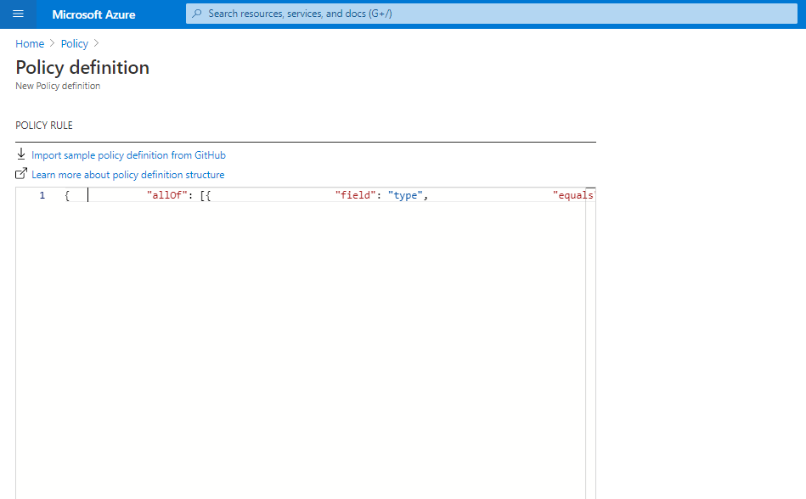

2.5 Click on Save
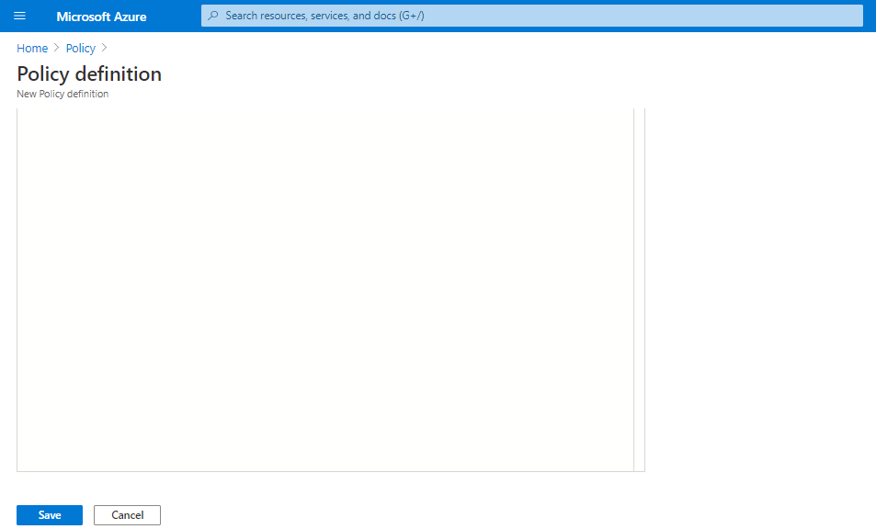

Your new policy will get created
