Lesson 2 Demo 2
Assign a Built-in Azure Policy to an Azure Resource Group
Objective: You have been asked to assign a built-in azure policy to an azure resource group.

Tools required: Azure account with administrator access.

Prerequisites: A resource group should be already available in your azure account to proceed with this demo.

Steps to be followed:
- Log into the Azure portal
- Assign a Policy

Step 1: Log into the Azure portal

1.1 Log into the Azure portal at https://portal.azure.com

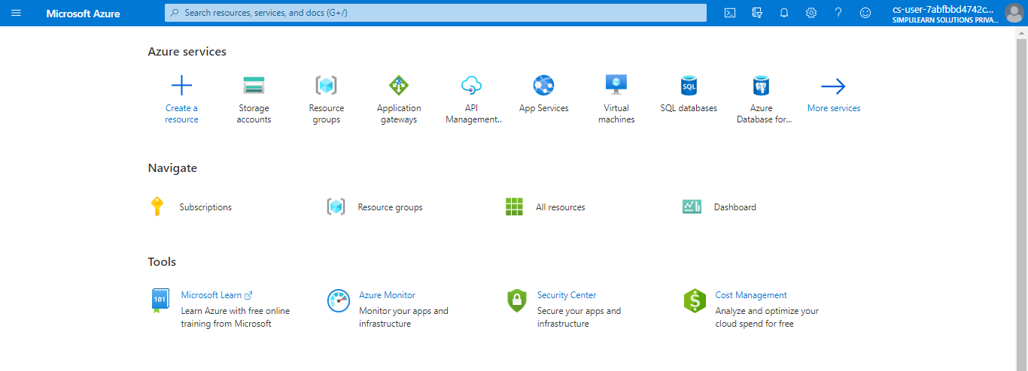

Step 2: Assign a Policy

2.1 Click on All services, search for and select Policy
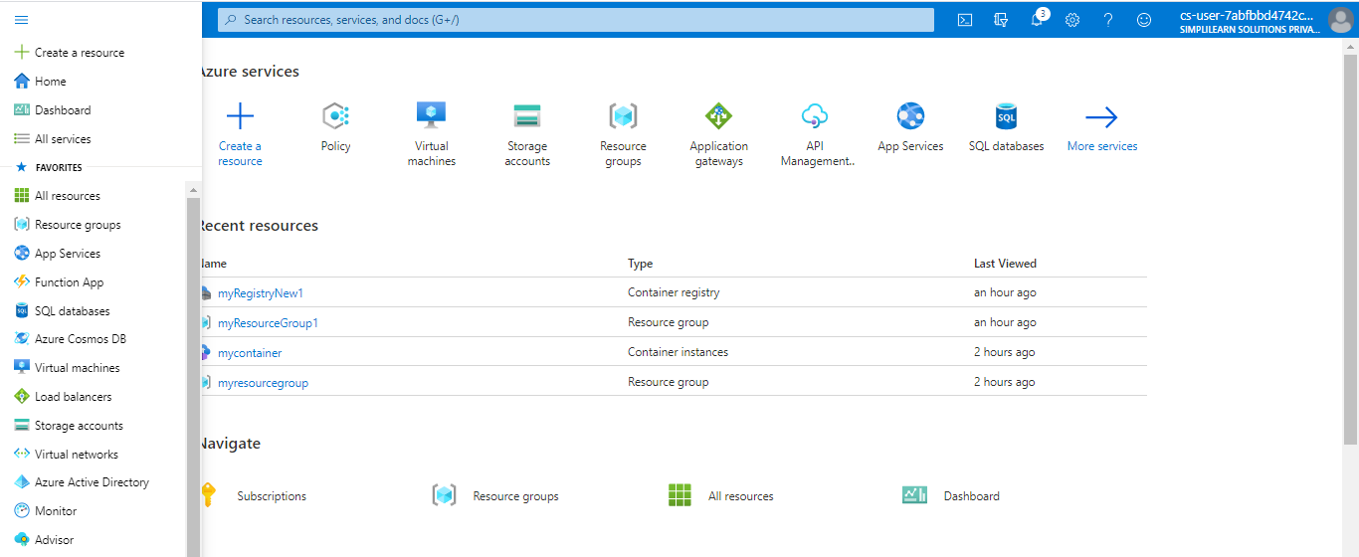

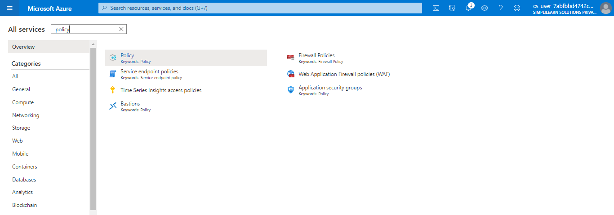
2.2 Select Assignments on the left side of the Azure Policy page. An assignment is a policy that has been assigned to take place within a specific scope
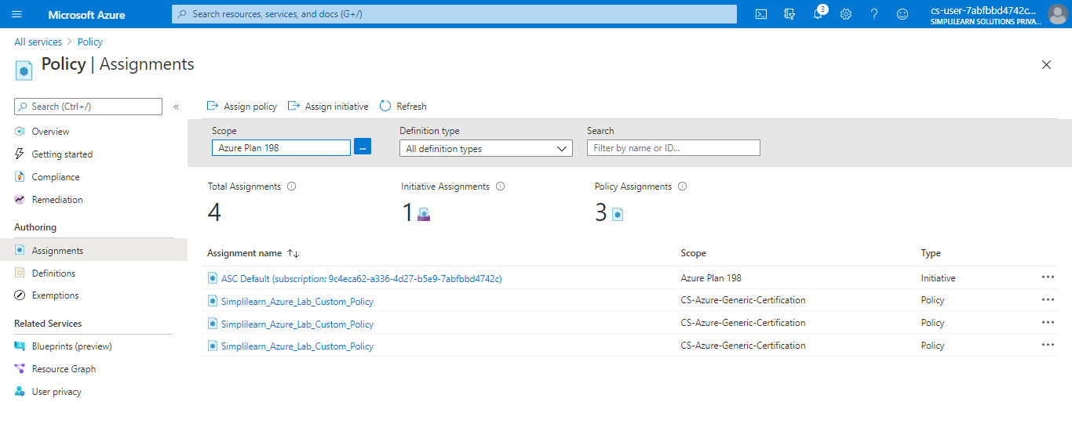
2.3 Click on Assign policy
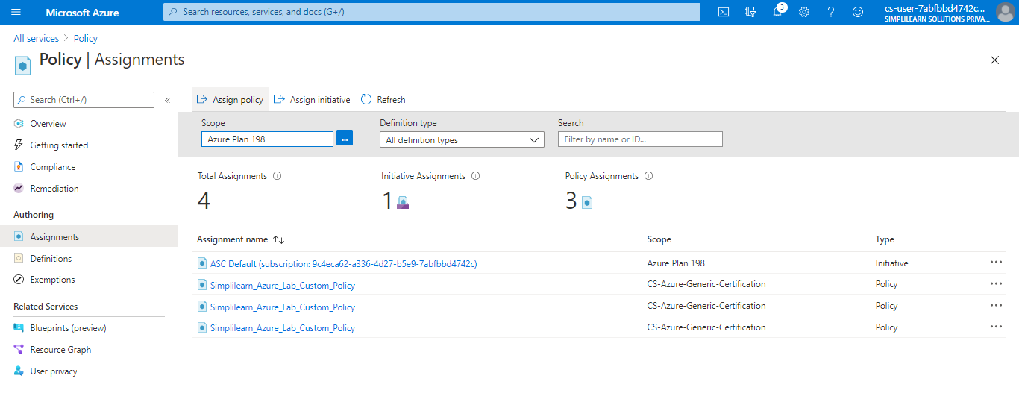

2.4 On the Assign Policy page, select the Scope by clicking the ellipsis and selecting either a management group or subscription. In this case, we will select a resource group. A scope determines what resources or grouping of resources the policy assignment gets enforced on. Then click Select at the bottom of the Scope page

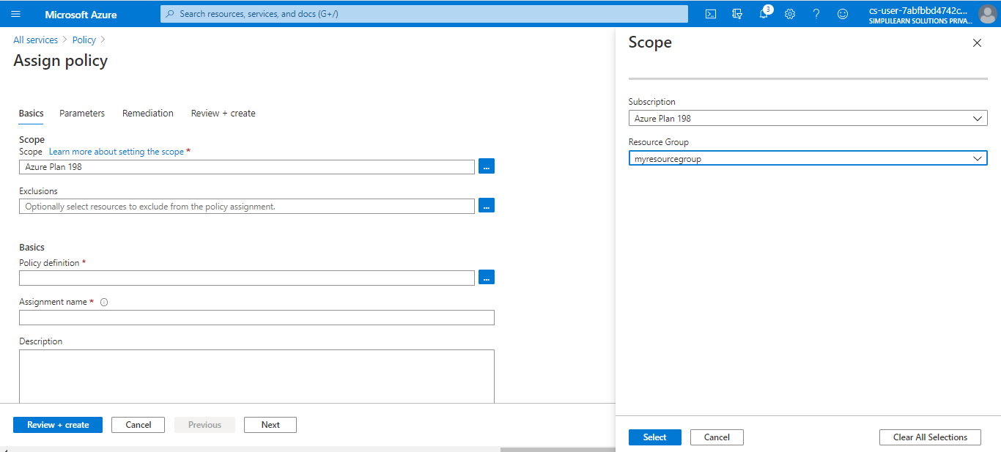

2.5 Resources can be excluded based on the Scope. Exclusions start at one level lower than the level of the Scope. Exclusions are optional, so leave it blank for now
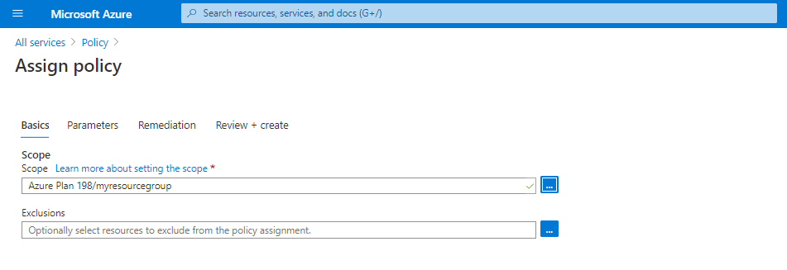

2.6 Select the Policy definition ellipsis to open the list of available definitions. Azure Policy comes with built-in policy definitions you can use. Many are available, such as: a. Enforce tag and its value b. Apply tag and its value c. Inherit a tag from the resource group if missing
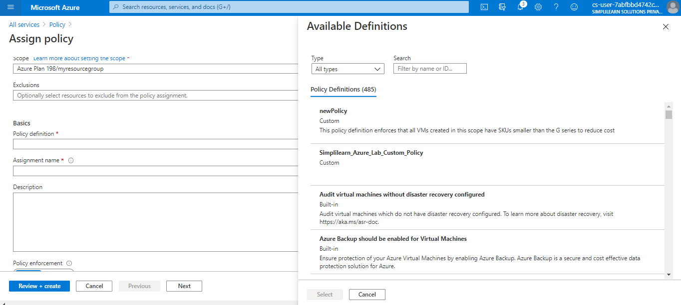

2.7 Search through the policy definitions list to find the Audit VMs that do not use managed disks definition. Click on that policy and click on Select
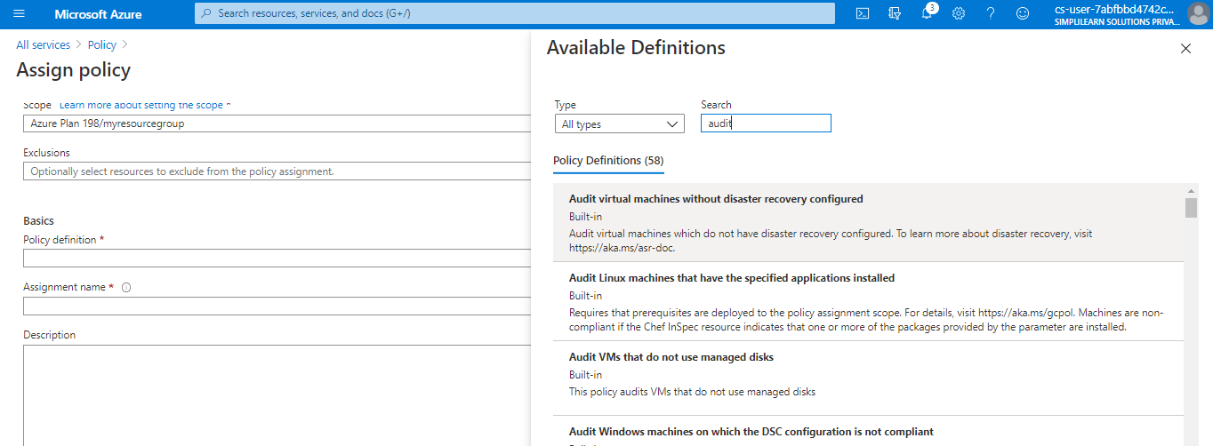

2.8 The Assignment name is automatically populated with the policy name you selected, but you can change it. For this example, leave Audit VMs that do not use managed disks. You can also add an optional Description. The description provides details about this policy assignment. Assigned by will automatically fill based on who is logged in. This field is optional, so custom values can be entered
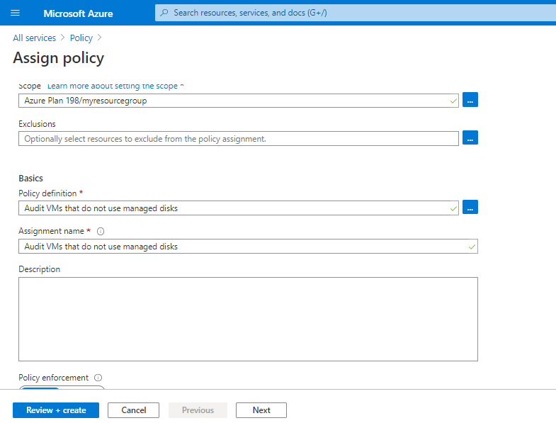

2.9 Leave Create a Managed Identity unchecked
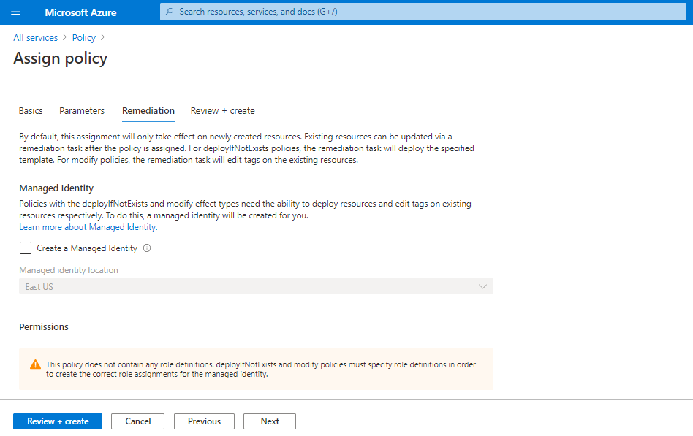

2.10 Click on Review + create


2.11 Click on Create

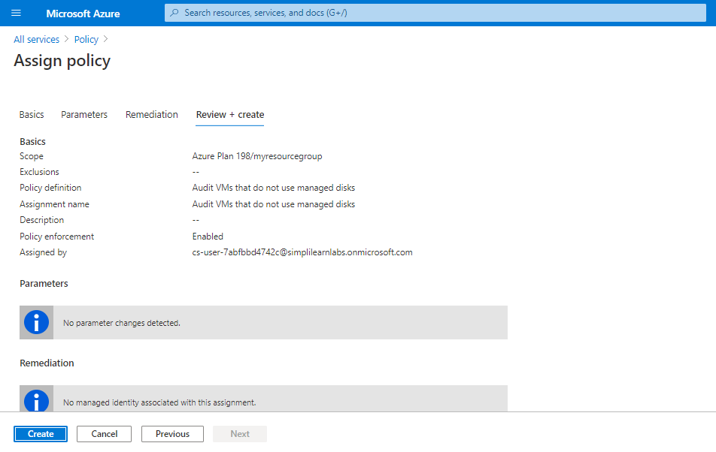

Azure policy will get assigned

