Lesson 3 Demo 2
Azure AD Join

Objective: To create Azure AD Join

Tools required: Azure account with administrator access

Prerequisites: None

Steps to be followed:
- Creating an Azure AD Join
- Creating a virtual machine
- RDP to the virtual machine to join the machine to Azure AD domain

Step 1: Creating Azure AD Join

  - Sign into the Azure portal as an administrator
  - Under Azure services, select Azure Active Directory

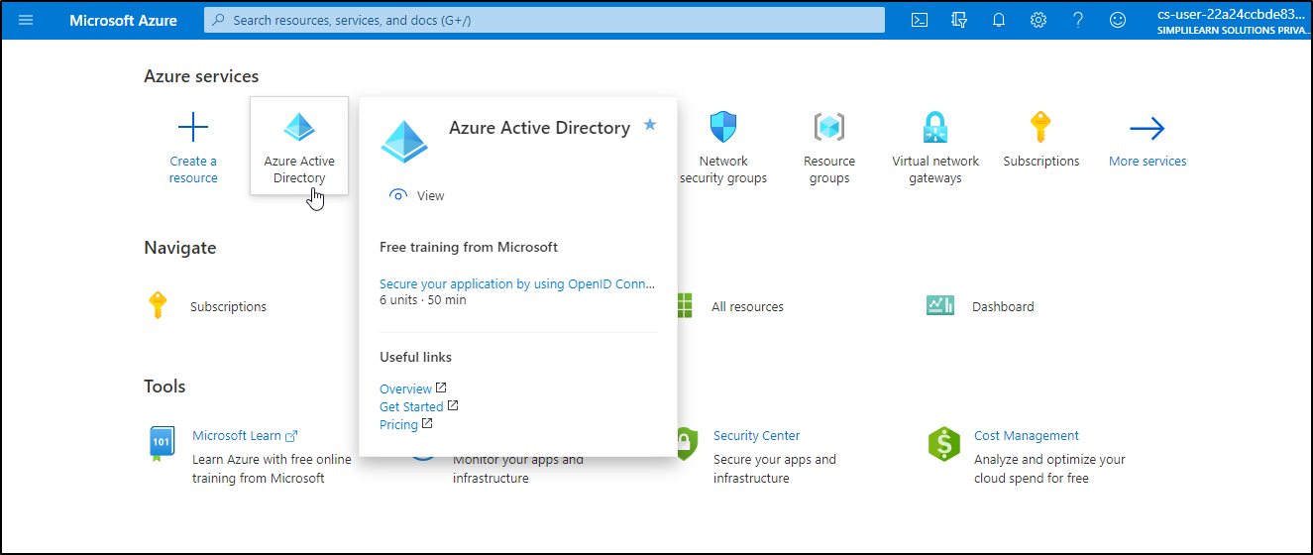

1.3 Select Devices present on the left of the Azure AD page

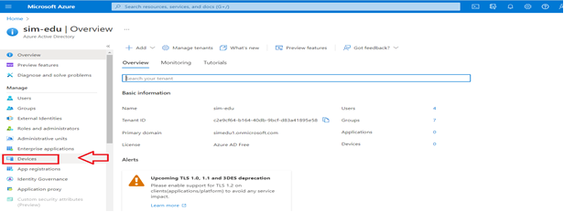

1.4 Click on Device Settings

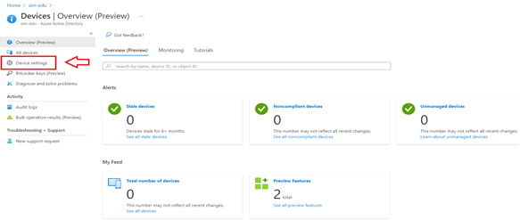

1.5 Users may join devices to Azure AD:
Set this option to All or Selected based on the scope of deployment and whom you want to allow setting up an Azure AD joined device
1.6 Additional local administrators on Azure AD joined devices:
Choose Selected and select the users you want to add to the local administrators’ group on all Azure AD joined devices
1.7 Require multi-factor Auth to join devices:
Select Yes if you require users to perform MFA while joining devices to Azure AD. For the users joining devices to Azure AD using MFA, the device becomes a 2nd factor

1.8 Click on Save to save the changes

Step 2: Creating a virtual machine

2.1 Now, let’s create Windows 10 VM on Azure (we can treat this machine as one of the user desktop/laptops, which wants to join his machine with Azure AD domain

2.2 Click on Create and select all parameters as below:

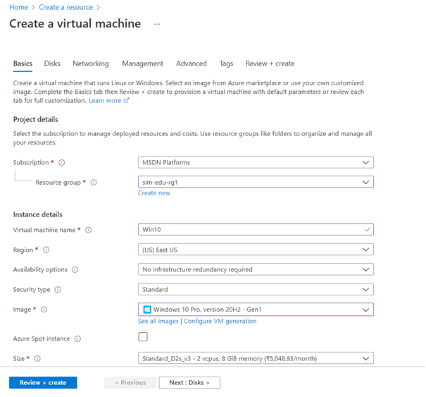

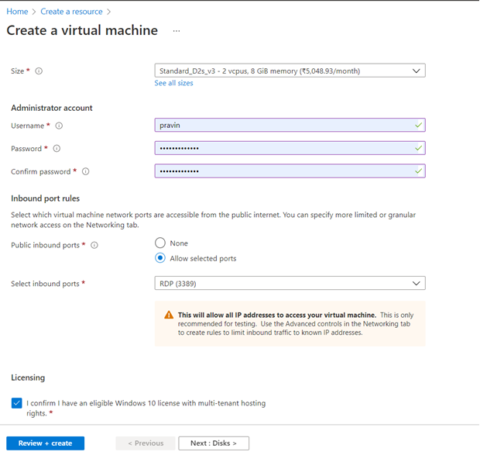

2.3 Click Review + create and create virtual machine

Step 3: RDP to the virtual machine to join the machine to Azure AD domain

3.1 Now, RDP to the VM so we can join this machine to the Azure AD domain

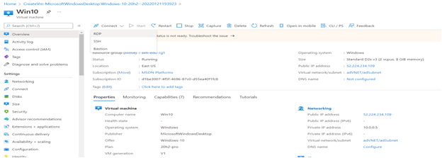

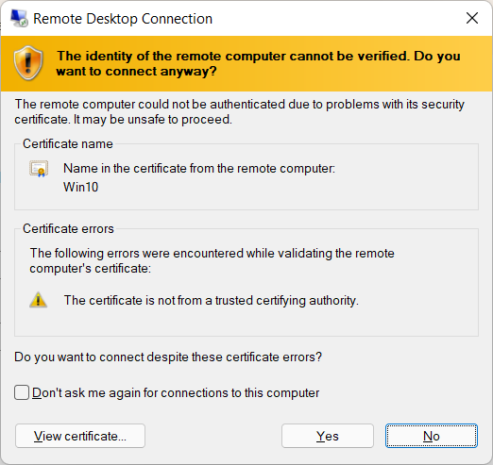

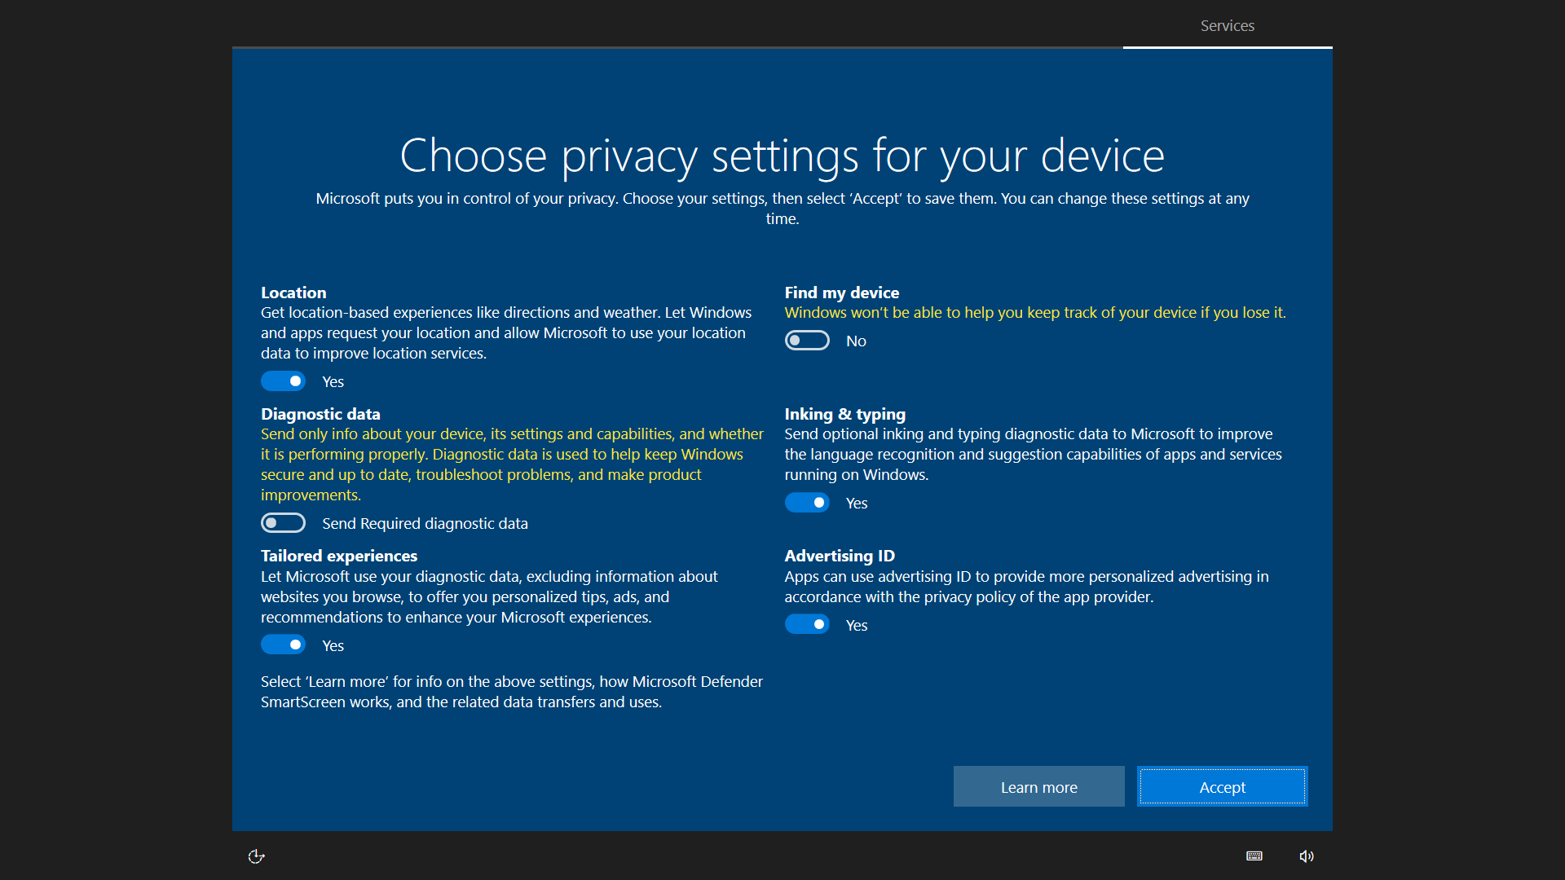

3.2 Open settings option inside Windows 10 machine

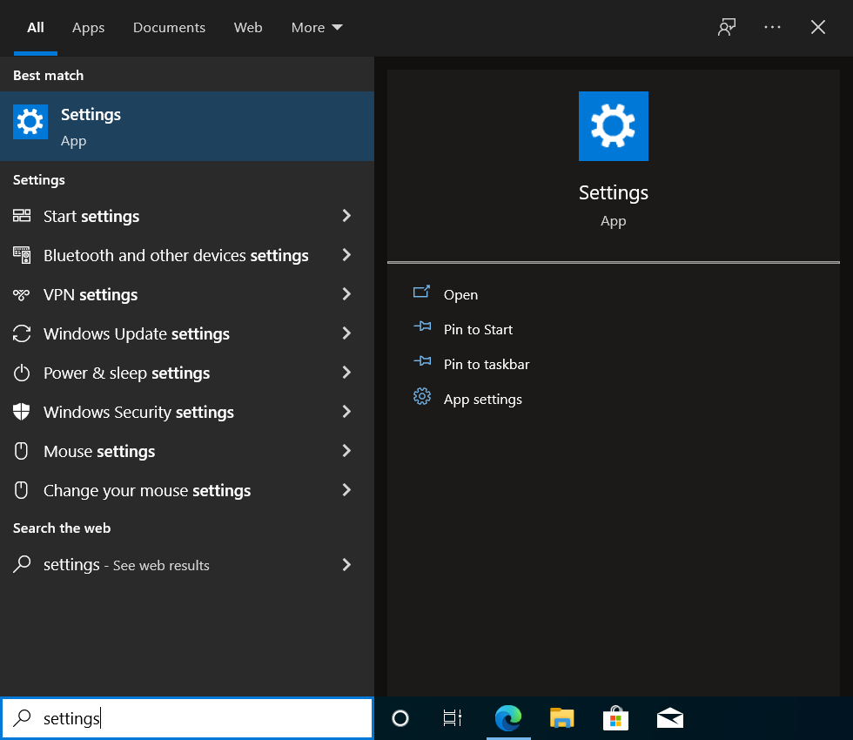

3.3 Now click Accounts

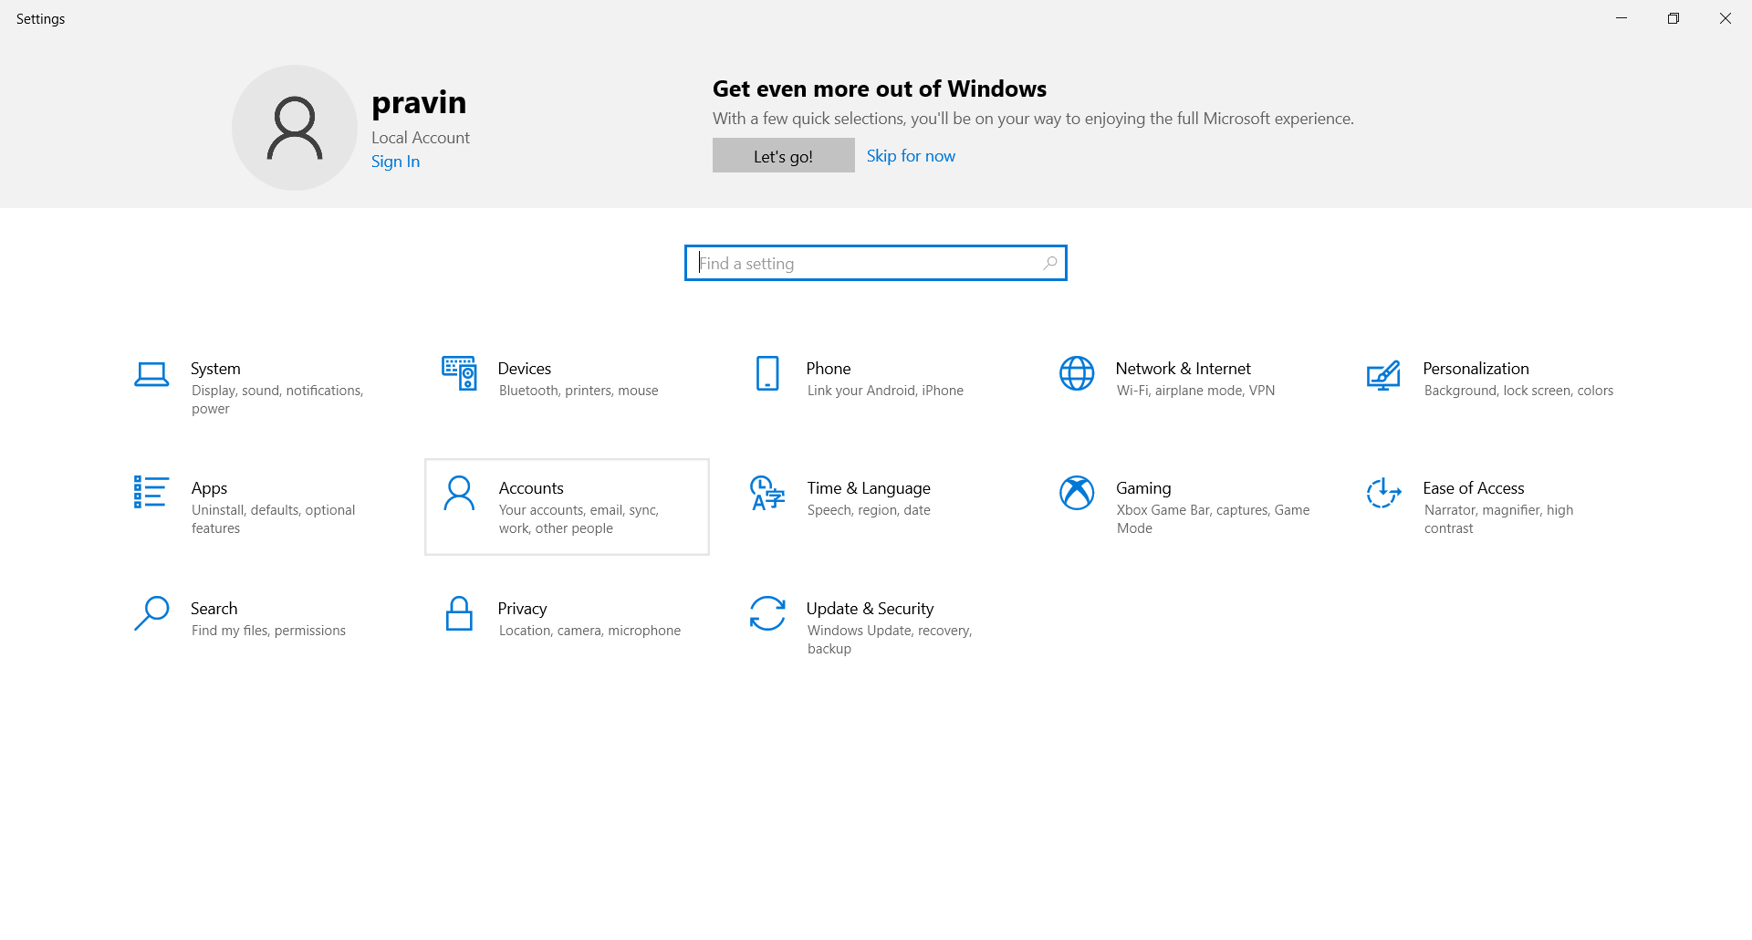

3.4 Click Access work or school account and click Connect

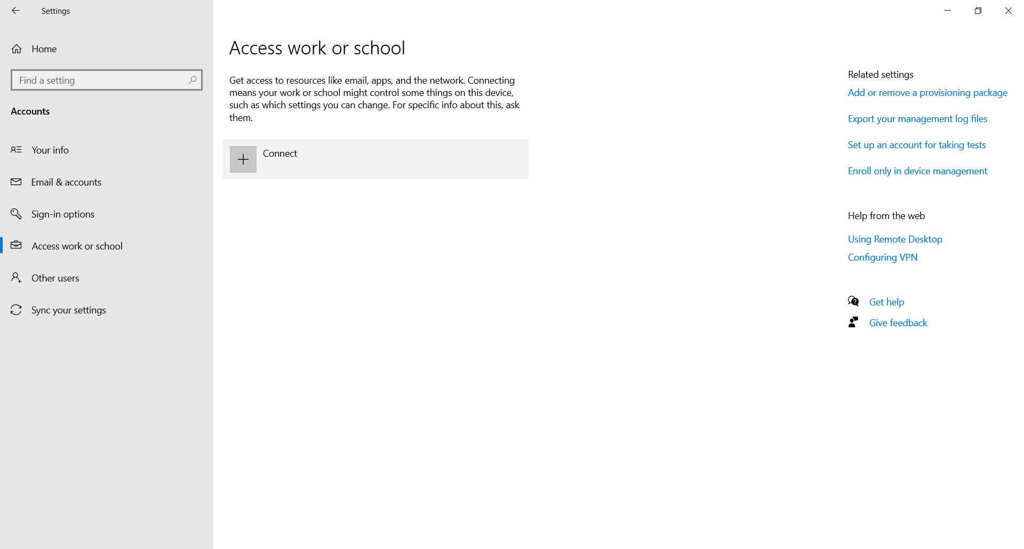

3.5 On the window that opens, click Join this device to Azure Active directory

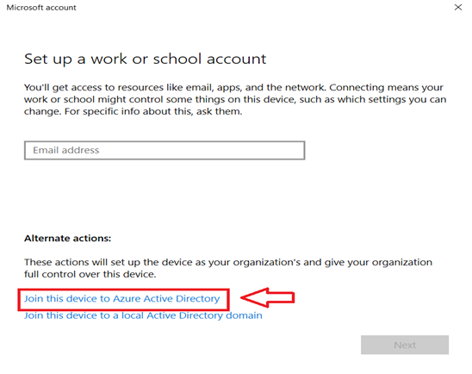

3.6 Provide credentials of any user, in this case we will provide on-prem AD synced user’s credentials

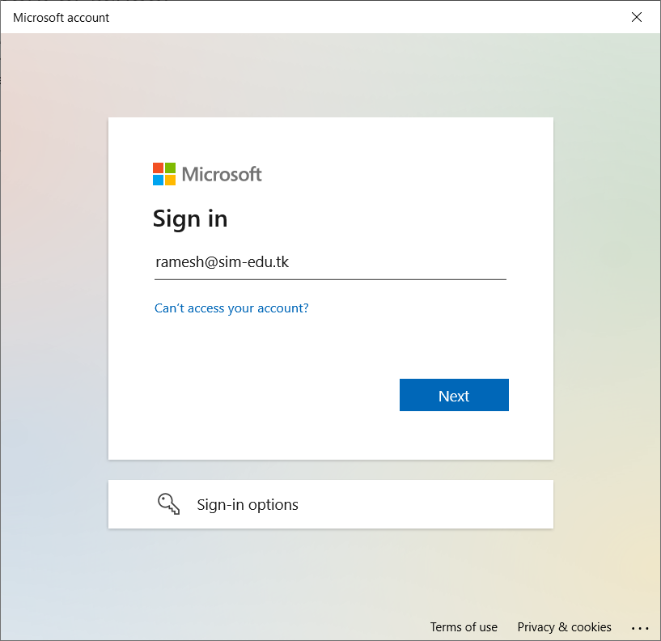

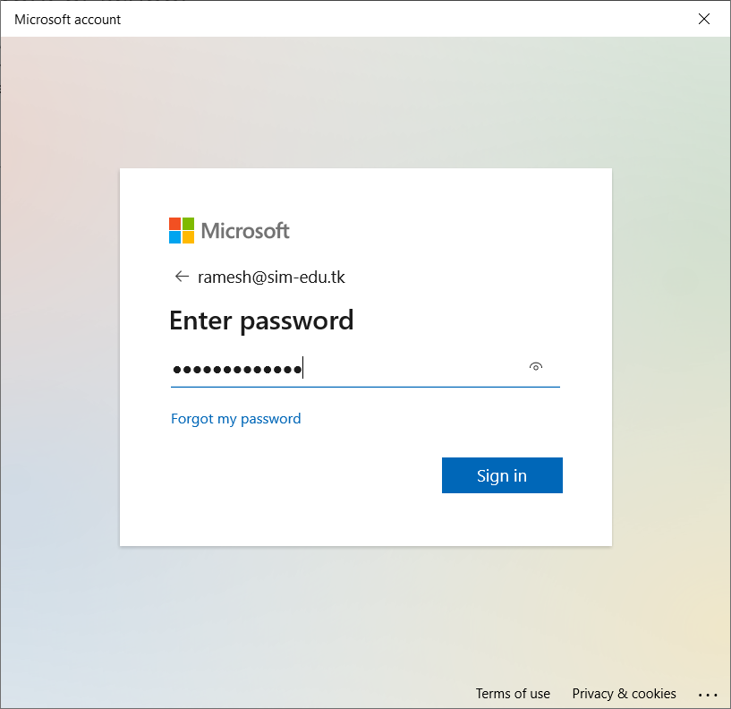
3.7 Click Join when prompted
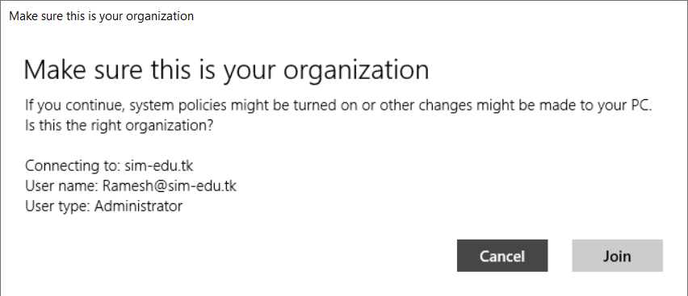
3.8 Now click Done

