Lesson 3 Demo 3
Azure AD: User Creation

Objective: To create a user in Azure AD

Tools required: Azure account with administrator access

Prerequisites: None

Steps to be followed:
- Creating a user in Azure AD

Step 1: Creating a user in Azure AD

- Sign in to the Azure portal as an administrator
- Under Azure services, select Azure Active Directory
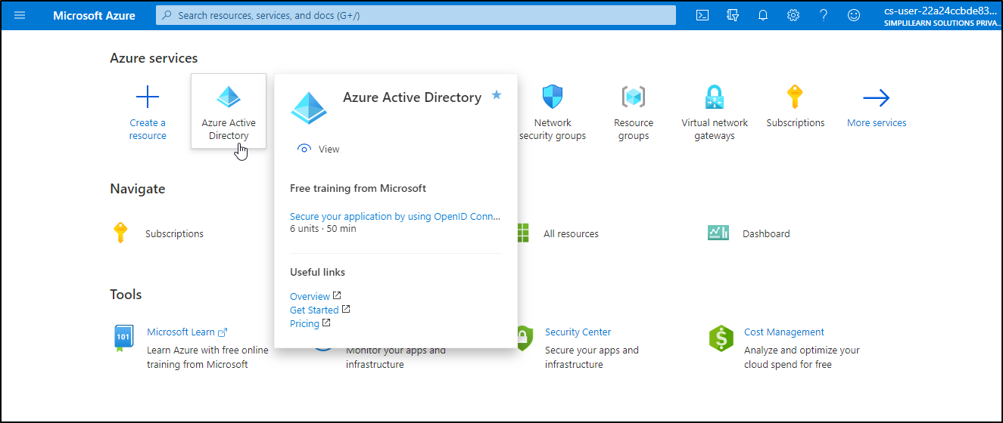

- Under Manage, select Users
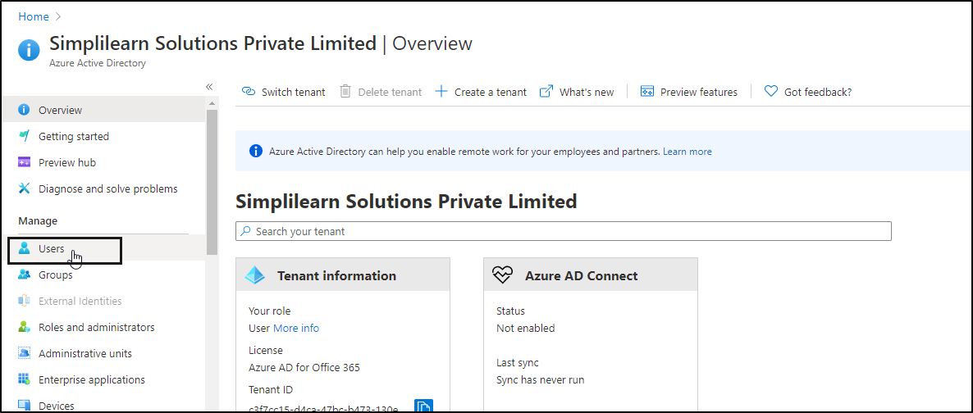

- Select New user
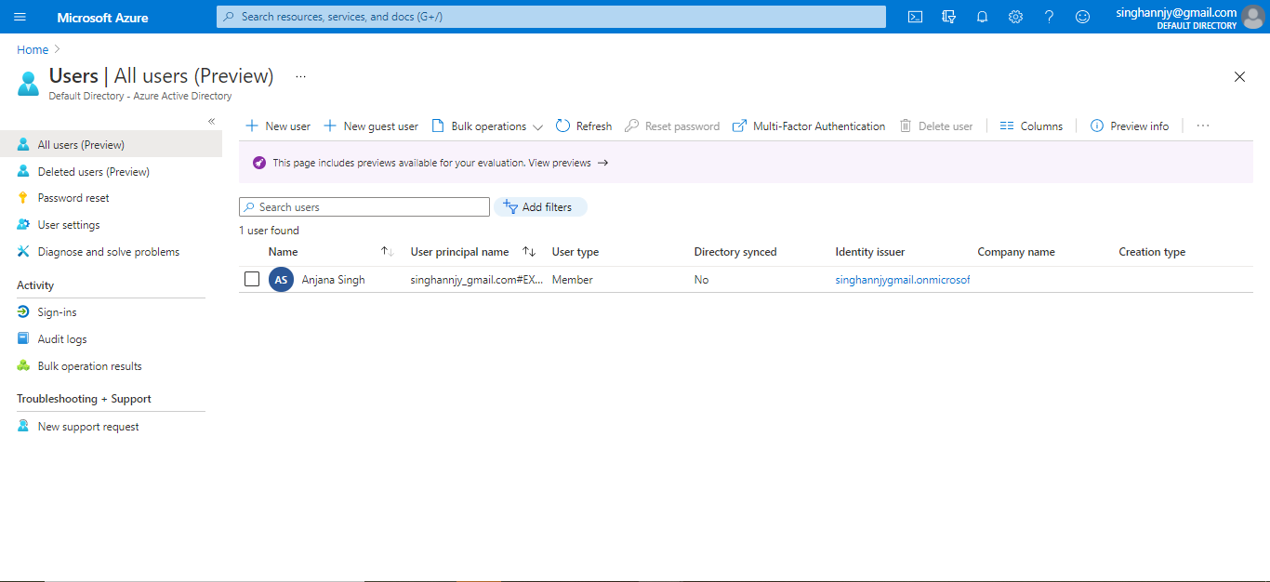

- On the User page, enter the below information for this user:
Name
Username
Groups
Directory Role
Job Info
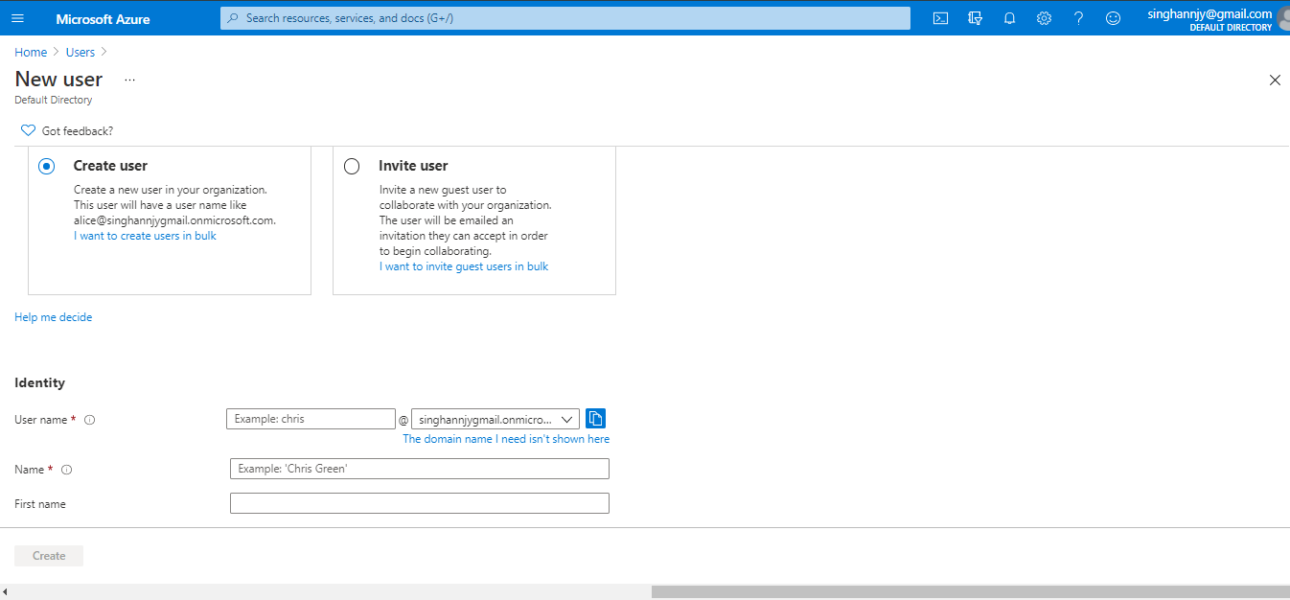

Note: Copy the auto-generated password provided in the Password box. You'll need to give this password to the user to sign in for the first time.

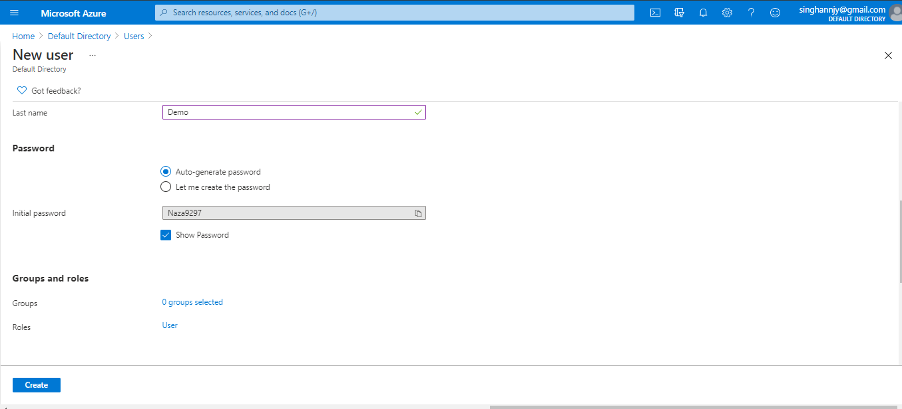

1.6 Once the details are entered, select Create
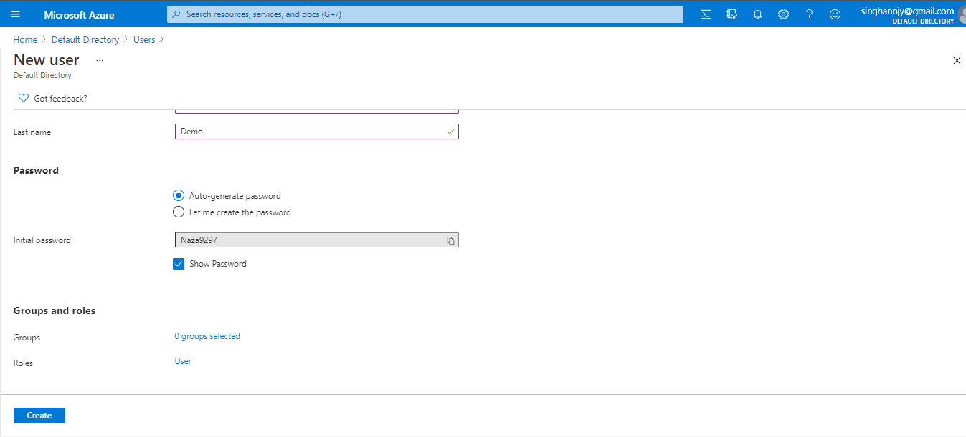

1.7 The user is created and added to your Azure AD organization.
