Lesson 3 Demo 4
Azure AD Guest User Creation

Objective: To create guest user in Azure AD

Tools required: Azure account with administrator access

Prerequisites: None

Steps to be followed:
- Creating a guest user in Azure AD

Step 1: Creating a guest user in Azure AD

- Sign in to the Azure portal as an administrator
- Under Azure services, select Azure Active Directory

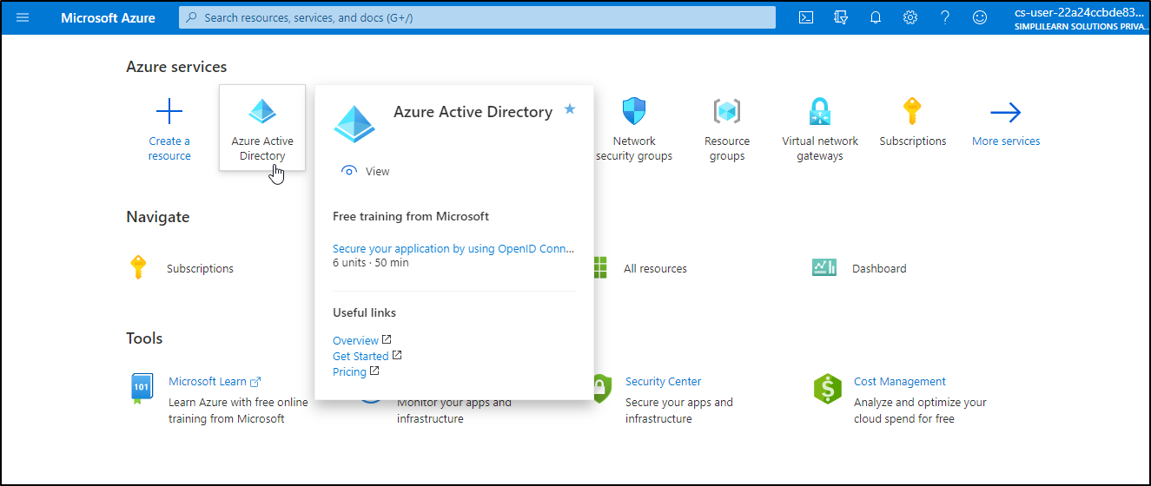

- Under Manage, select Users

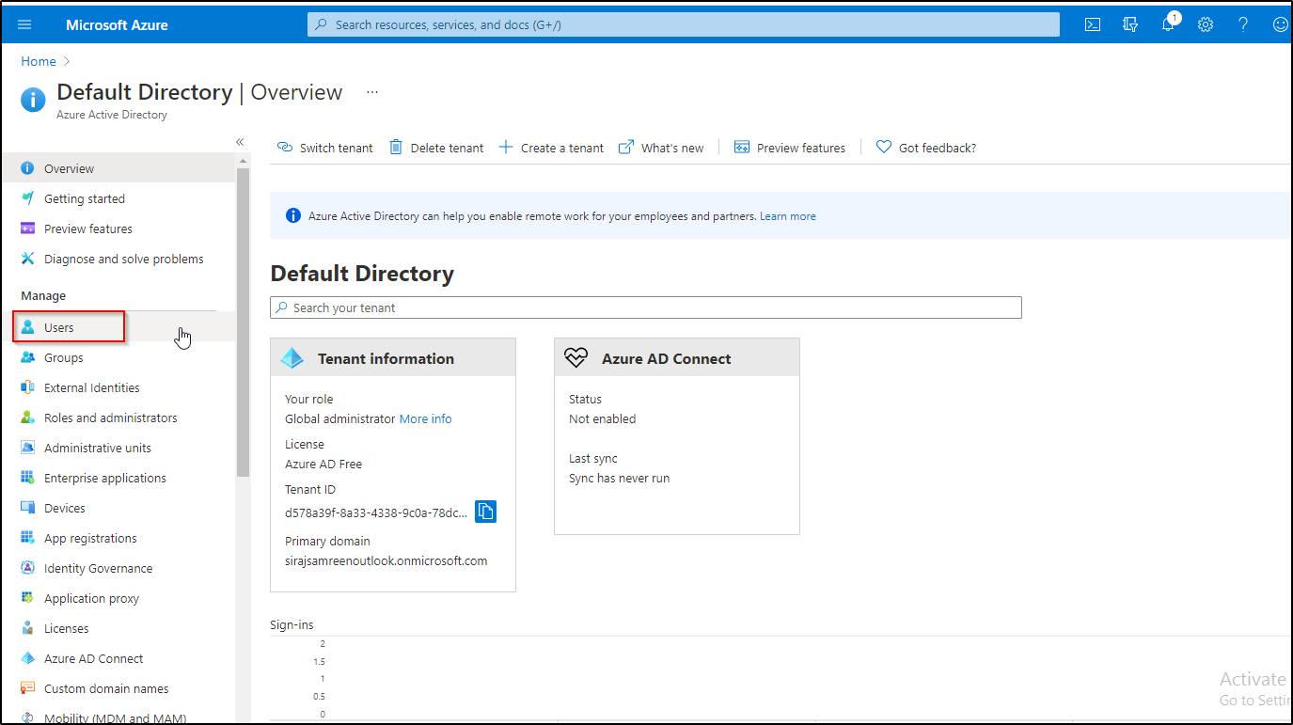

- Select New guest user

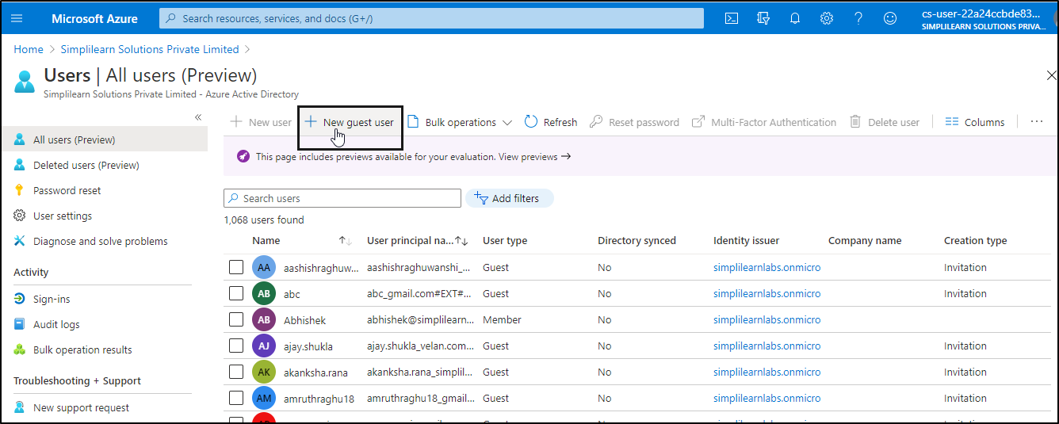

- On the New user page, select Invite user and then add the guest user's information and then click on the Invite button

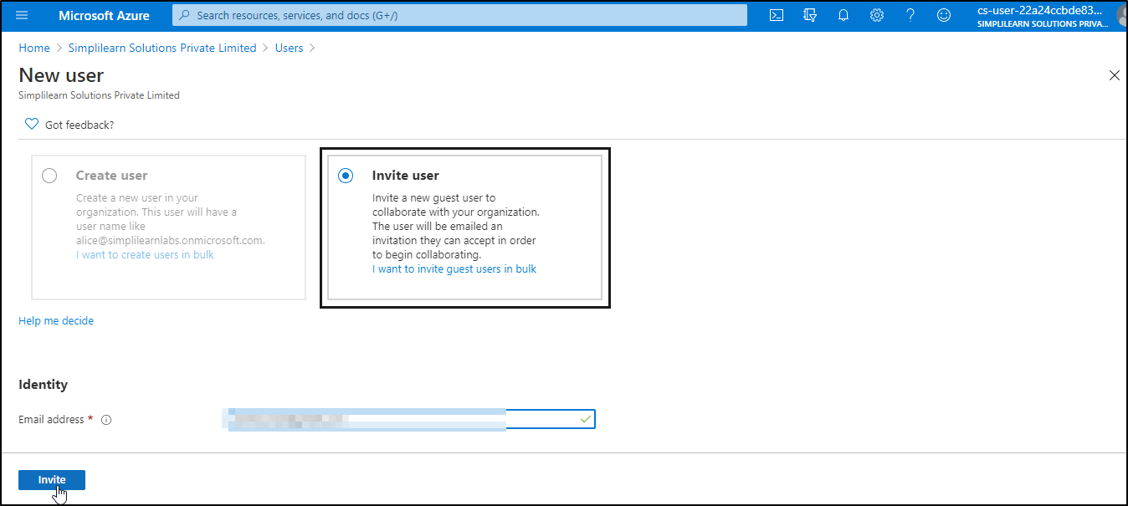

- After you send the invitation, the user account is automatically added to the directory as a guest.

