
Lesson 3 Demo 5
Azure AD: Group Creation

Objective: To create a user group

Tools required: Azure account with administrator access

Prerequisites: None

Steps to be followed:
- Creating a user group in Azure AD

Step 1: Creating a user group in Azure AD

1.1 Sign in to the Azure portal as an Azure AD
1.2 Under Azure services, select Azure Active Directory

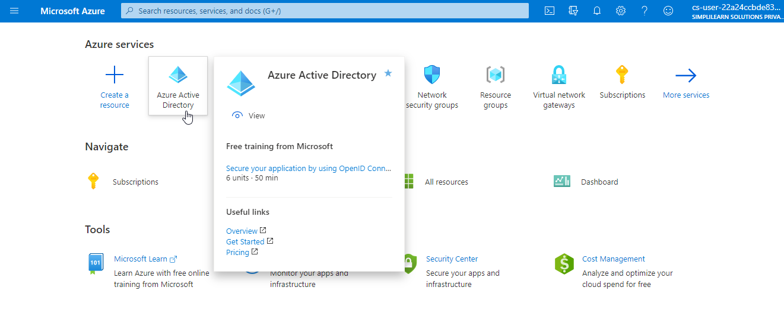
1.3 On the Active Directory page, select Groups and then select New group
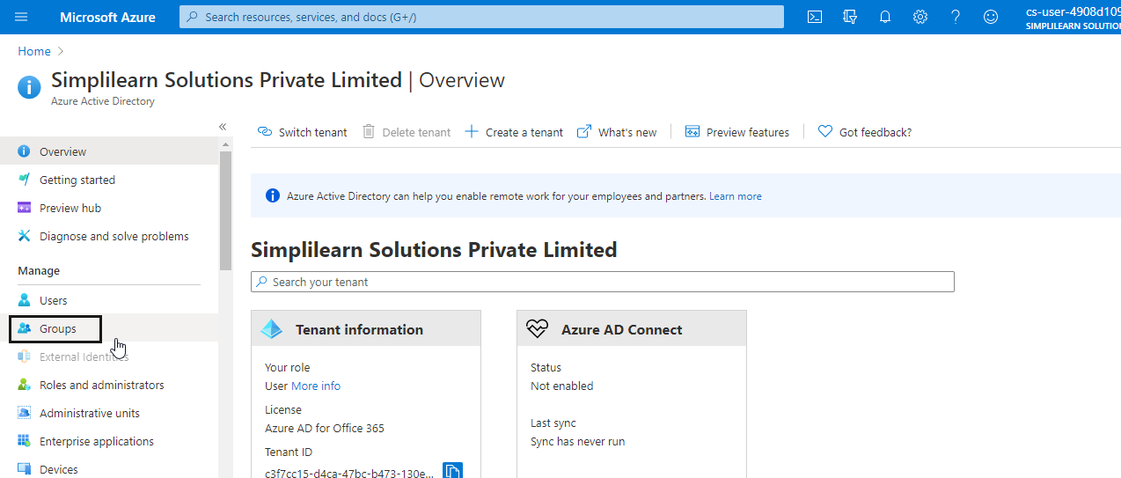
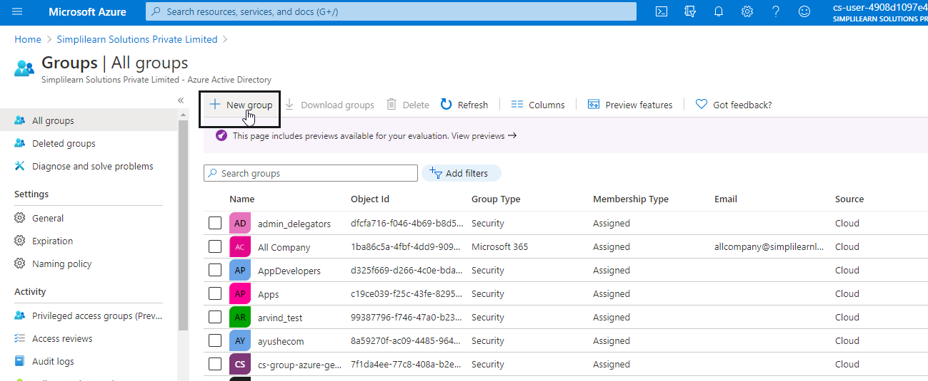
1.4 Select a pre-defined Group type
1.5 Create and add a Group name. Choose a name that you'll remember and that makes
sense for the group. A check will be performed to determine if the name is already in
use by another group. If the name is already in use, to avoid duplicate naming, you'll be
asked to change the name of your group
1.6 Add an optional Group email address for the group under Owners, or keep the email
address that is filled
1.7 Add an optional description to your group

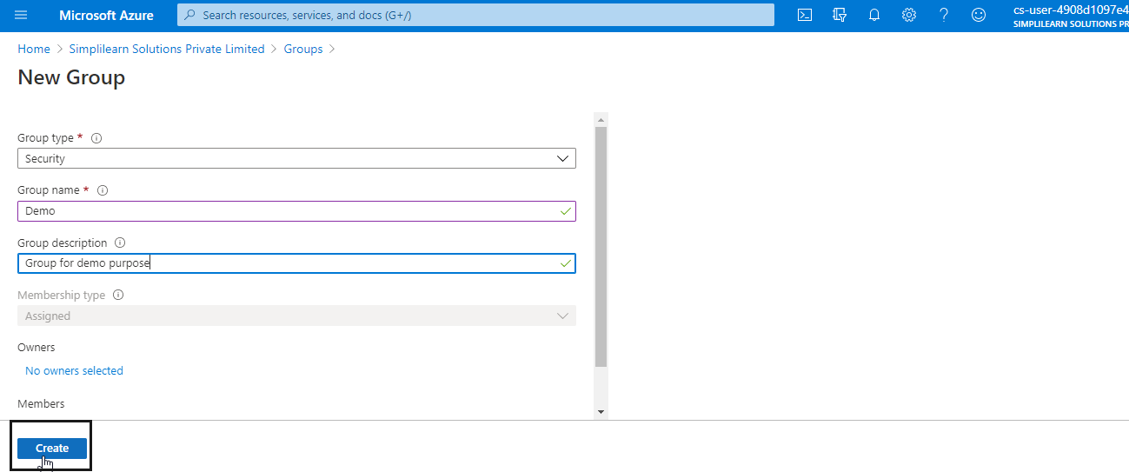
1.8 Click on the Create button
1.9 Your group will be created and ready for you to add members.

