**Report (Exercise 12)**

In this last exercise of the semester, we would attempt one nonlinear classification problem with Neural networks, which further shows the versatility of such tools. Consider the given dataset of two types of data points in a plane (dataset and figure given in the folder). For this dataset, can you create a Neural network that performs the binary classification? As usual, take a 80:20 split for training and testing data to complete the exercise. Also, remember the loss functions that you used for the earlier classification example. Consider the following questions for your report:

• How many minimum hidden layers and neurons are needed to perform a satisfactory classification?

• Would the above depend on the choice of the activation function?

• Include the classification boundaries and all red and blue data points in one single figure for your final report. For your reference, the dataset (with blue and red points) is shown in the figure below. In an actual problem, there will be multiple classes of data as well as multiple dimensions.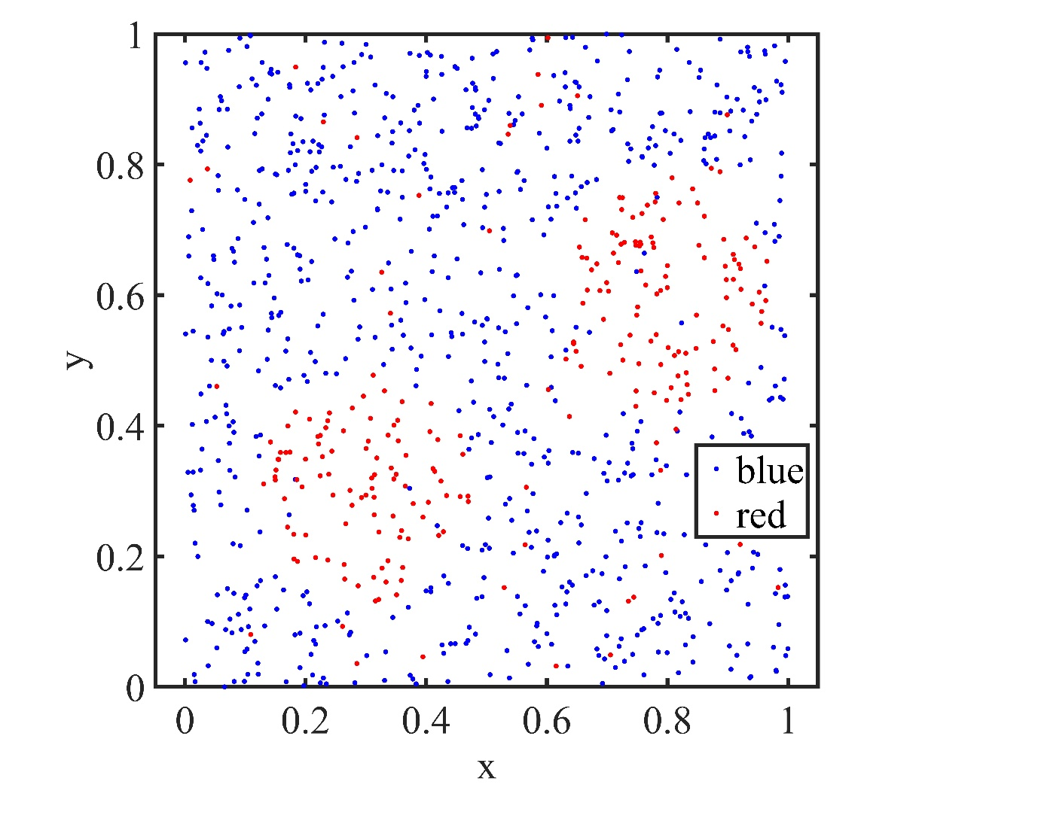

**Solution**

1. We require **2 hidden layers with 64 and 32 neurons** respectively.
2. **Yes**,the above problem depends upon the activation function ,in this problem we use the **Relu** activation function.

