Date | April 26th, 2026
Group | 322
Member | Tomas Chavarria
Member
Homework | Project
Due | April 28th, 2026

- Project Description:
This project is meant to implement a database management system which houses information on a rental service. More specifically, it covers the current rentals, items, customers, and returns. It allows for filtering of any given category and for various checks on different data, such as (but not limited to): filtering items or customers, waitlists for items, rental extensions, etc. We are supposed to implement the underlying SQL functionality, with the database creation and main loop for actually inserting being provided to us.
- What works:
- add_customer
- add_item
- edit_customer
- rent_item
- waitlist_customer
- update_waitlist
- return_item
- grant_extension
- get_filtered_items
- get_filtered_customers
- get_filtered_rentals
- get_filtered_rental_histories
- get_filtered_waitlist
- number_in_stock
- place_in_line
- line_length
- save_changes
- close_connection
- What does not work:
- N/A
- Known Bugs:
- When running the tests from public_tests.py as batch in Visual Studio Code, many of the tests will fail or pass sporadically. When checking the tests individually, the only test that fails about 30% of the time is close_connection. The reason for this is unknown. Tests were not run in PyCharm. When manually testing the program, no notable bugs were found.
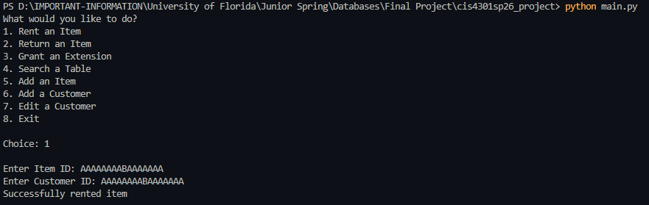
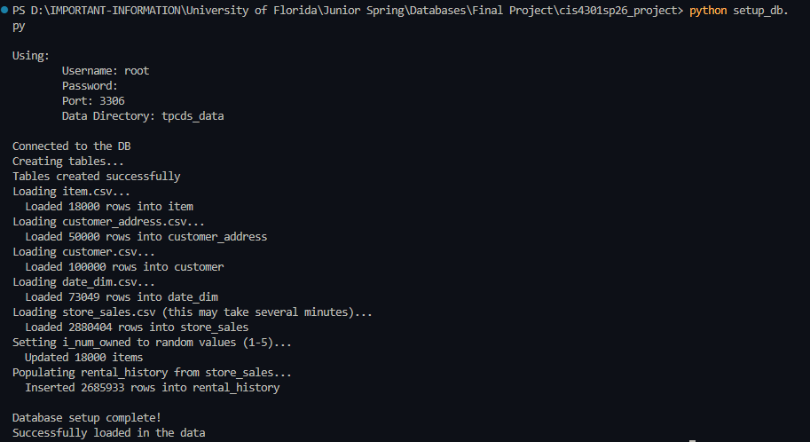
- Required Screenshots:
1. Load
setup_db.py
2. Rent an item

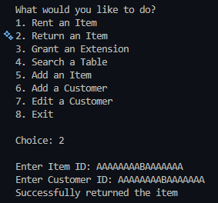
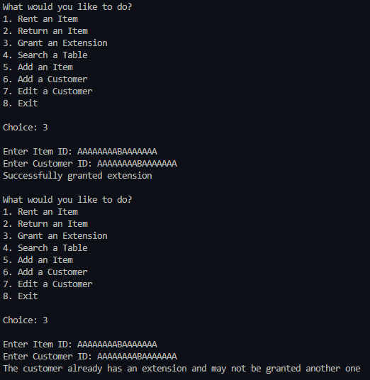

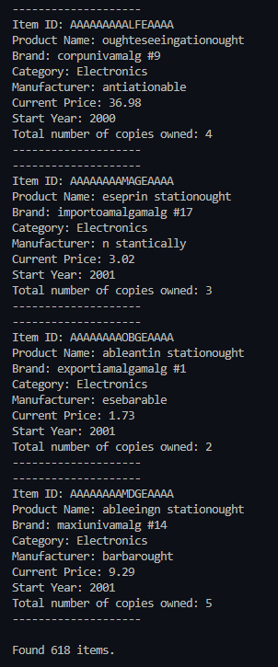
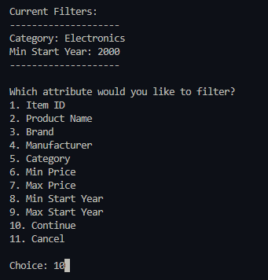
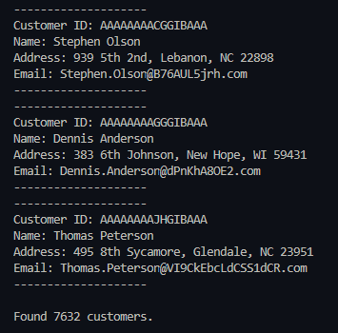
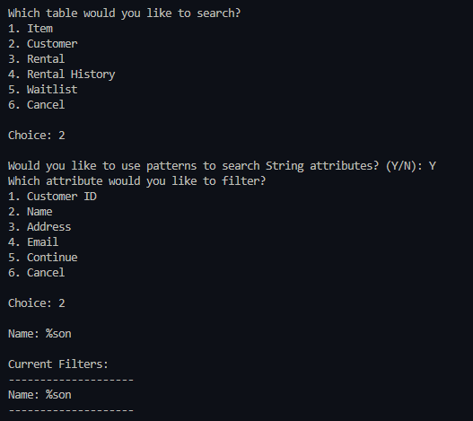
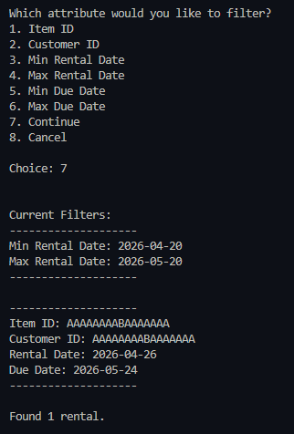
3. Return an item 4. Grant an
extension
5. Filtered item search using
at least two filters
6. Customer search using
pattern
7. Rental search filtered by date range
8. Rental history search showing
results populated from store_sales

