worksheet 1-Introduction to xml

*Submit a pdf with the answers of this worksheet

Exercise #1 – Information Structure
For the sample document provided below:

- Create an XML document that represents the following student data: name, address and a student id, one or more subjects (computer science, law, chemistry, sociology etc)
Draw a tree representation of the structure.

Exercise #2 – Well-Formedness
Are the following document instances well-formed? Explain any NO answers.
<list><title>The first list</title><item>An item</list>

- No because XML elements must have a closing tag (<item> does not have a closing tag).

<item>An item</item><item>Another item</item>
- Yes.
<para>Bathing a cat is a <emph>relatively</emph> easy task as long as the cat is willing.</para>
- Yes.
<bibl><title>How to Bathe a Cat<author></title>Merlin Bauer<author></bibl>
- No because XML elements must be properly nested (<author> is opened after the titled but it is not closed before this tag). In addition the <author> tag is not closed properly (the / is missing).

Exercise #3 – Well Formedness
Here is a fragment of an XML document instance. Identify all the places where it fails to match the constraints for well-formedness.

<PROCEDURE><TITLEHow to Bathe a Cat</TITLE><OVERVIEW>This procedure
tells you how to bathe a cat. <WARNING></OVERVIEW>Cats don't like to take baths. You could get hurt doing this. Be sure to obtain all the required protective gear before you start. </WARNING><EQUIPEMENT><ITEM>Hockey Mask <ITEM>Padded Full-body Kevlar Armor</ITEM><ITEM>Tub full of warm water</ITEM><ITEM>Towels </ITEM><ITEM>First Aid kit</ITEM><ITEM>Cat Shampoo</ITEM> <EQUIPMENT><INSTRUCTIONS> <STEP> Locate the cat, who by now is hiding under the bed.</STEP><STEP>Place the cat in the tub of water.</STEP> <ITEM>Using the First Aid kit, repair the damage to your head and arms.</STEP> <STEP>Place the cat back in the tub and hold it down.</STEP> <STEP>Wash it really fast, then make an effort to dry it with the towels.</STEP> <STEP>Decide not to do this again. </STEP> </INSTRUCTIONS>

Solution:

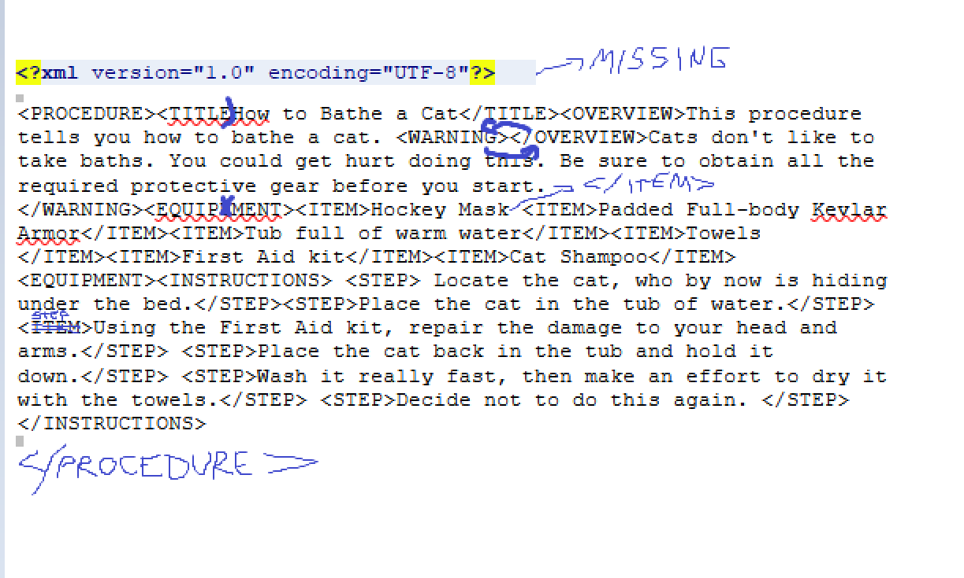
Exercise #4 – Well Formedness
Examine the following file. Circle all of it's syntactical errors, and write in the corrections.

<name>Oyster Soup</name>
<author>Eric Lease Morgan</author>
<copyright holder=Eric Lease Morgan>&copy; 2003</copyright>
<ingredients>
<list>
<item>1 stalk of celery
<item>1 onion
<item>2 tablespoons of butter
<item>2 cups of oysters and their liquor
<item>2 cups of half & half
</list>
</ingredients>
<process>
<P>Begin by sauteing the celery and onions in butter until soft.
Add oysters, oyster liquor, and cream. Heat until the oysters float.
Serve in warm bowls.</p>
<p><i>Yummy!</p></i>
</process>
-
- the &copy; should be replaced with an © .
- the item tags are not closed
the
Exercise #5 – Attributes
Here is an example of the bibliography with no attributes. Convert this document into one with the same information, but including attributes wherever it is convenient. Explain the reason why you have decided to use an element or an attribute to represent the information.

<Bibliography>
<Book>
<Author>Tim Berners-Lee</Author>
<Title>Weaving the Web</Title>
<Publisher>Orion business</Publisher>
<Year>1999</Year>
</Book>
<Standard>
<Title>Extensible Markup Language (XML) 1.0</Title>
<Organisation>World-Wide Web Consortium</Organisation>
<Year>1998</Year>
</Standard>
</Bibliography>

