**QuaSAR Tutorial**

This tutorial will walk you through how to use QuaSAR. You are provided an existing data set to explore the module or may follow the tutorial to create your own data sets to use with QuaSAR. The expected results from the preexisting data sets are provided so you may verify what you have obtained.

QuaSAR is a program that aids in the Quantitative Statistical Analysis of Reaction Monitoring Experiments. It was designed to quickly and easily convert processed SRM/MRM-MS data into calibration curves, determine limits of detection and quantification, calculate mean and coefficient of variation for all transitions of each peptide in a set of samples, as well as determine the peptide analyte concentration in unknown samples. The resulting output files, consisting of *.csv tables and *.pdf figures, can readily be used for further statistical analyses or reported as output for reports or publications.

In order to use QuaSAR, two files must be provided; a **Skyline Export file** and a **Concentration and Sample Grouping Map file.** These files are already available to use for the tutorial; however the tutorial will also cover how to create and format these documents.

**Getting Started:**

To start this tutorial, download the following ZIP file:

https://skyline.gs.washington.edu/tutorials/QuaSAR

Extract the files in it to a folder on your computer, like:

C:\Users\brendanx\Documents

This will create a new folder:

C:\Users\brendanx\Documents\QuaSAR

The zip file contains the following files:

QuaSAR_Report Template.skyr: A template used for exporting data in the proper format out of Skyline to create the Skyline Export File

Skyline Data-Tutorial.csv: Properly formatted data exported from Skyline

Concentration and Sample Grouping Map Template.csv: A properly formatted template used to create the Concentration Map file

Concentration and Sample Grouping Map-Tutorial.csv: A properly formatted Concentration and Sample Grouping Map example

If you have downloaded the provided files and wish to move on to the usage of QuaSAR with the example Skyline data export and associated concentration and sample grouping map, skip to the section labeled "**Using QuaSAR**".

**Generating the Skyline Export File:**

The Skyline Export File can be generated in two ways, using a template or from scratch:

**With template:**

Navigate to the Library subfolder where the QuaSAR zip file was saved.

* Open Skyline document containing data and click **Export** on the **File** menu and select **Report**.

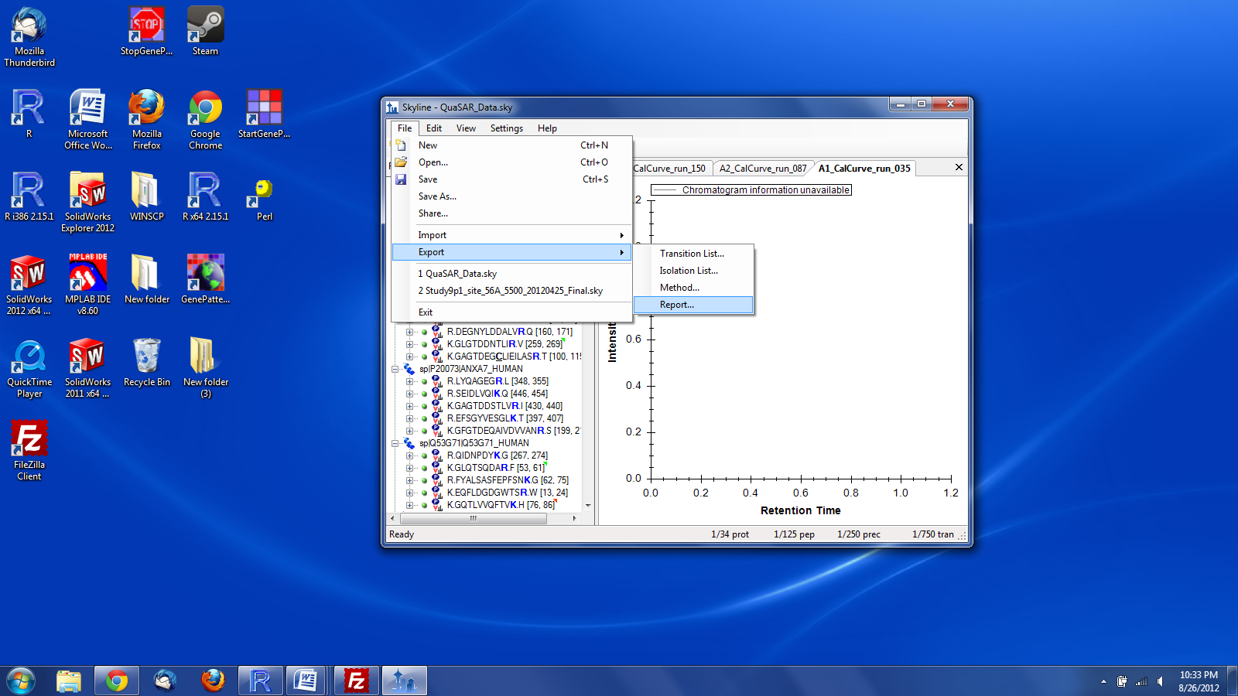

* Next click **Import**

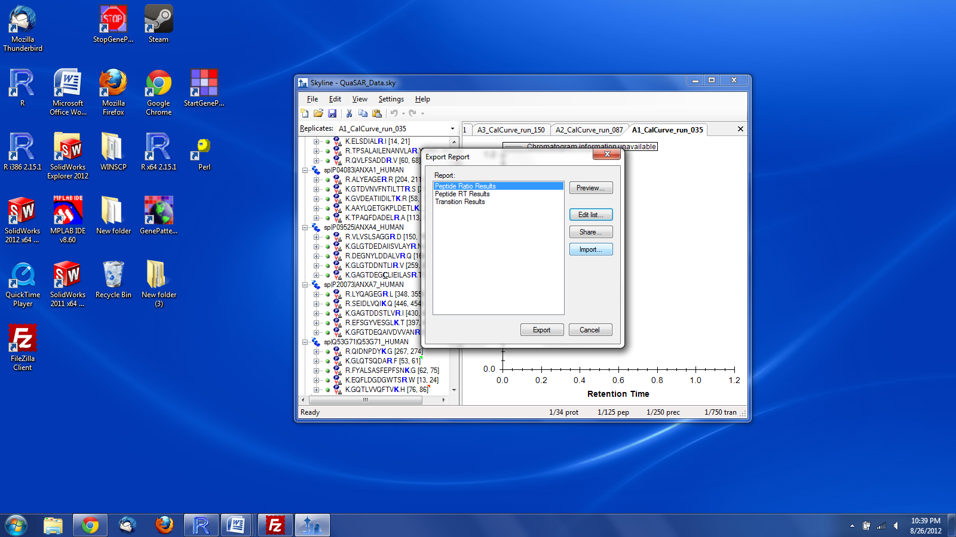

* Navigate to the directory where the QuaSAR_Tutorial.zip file was unzipped
* Select QuaSAR_Report_Template.skyr and click **Open**
* Back in the Skyline "Export Report" select the QuaSAR_Report_Template and click **Export**

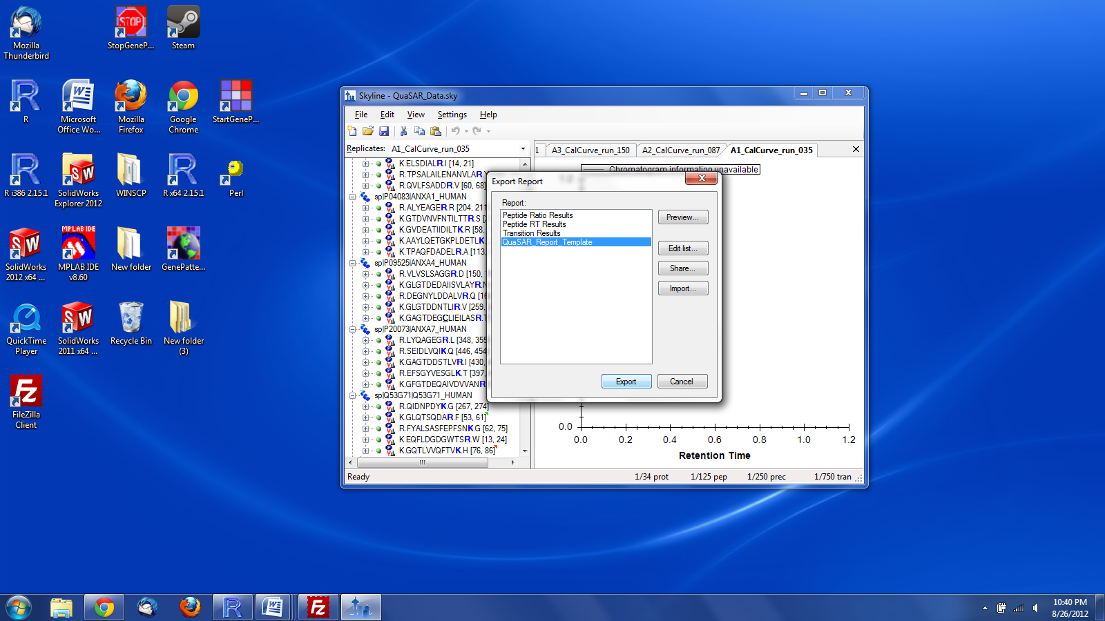

* Skyline will give the option to name the file, name the file, then click **Save**

**Without template**:

* Open Skyline and click **Export** on the **File** menu and then select **Report**.



* Click **Edit List**, then click **Add**

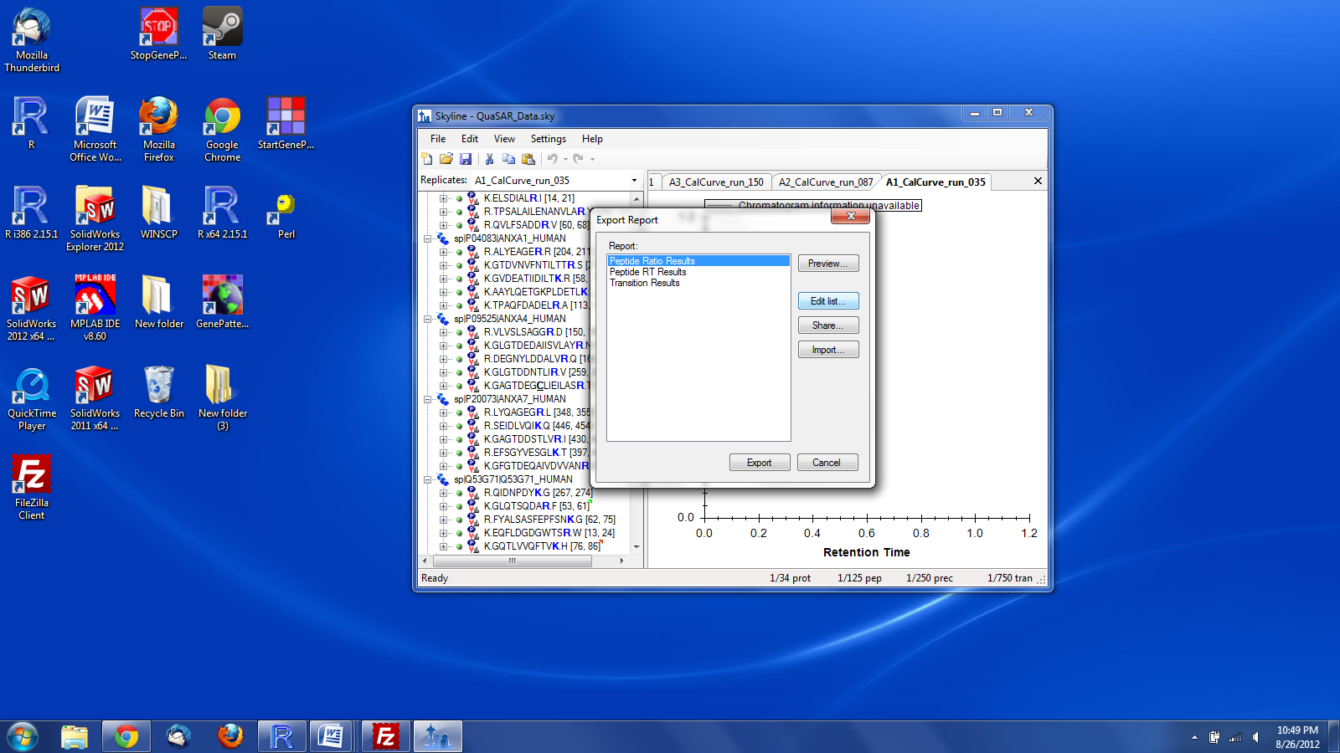

* Select the following 10 parameters for the report making sure they are listed in the correct order:
  + 1. FileName
    2. SampleName
    3. PeptideSequence
    4. ProteinName
    5. ReplicateName
    6. PrecursorCharge
    7. ProductCharge
    8. FragmentIon
    9. AverageMeasuredRetentionTime
    10. Area
* Select the **Pivot isotope label box** and fill in the "Report Template" field with the name "QuaSAR_Report_Template"

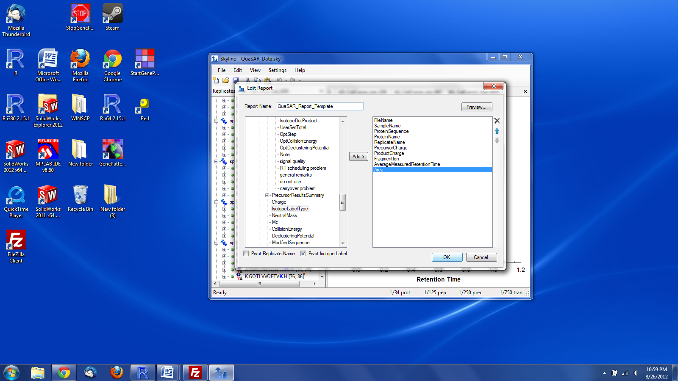

* Click **OK**, then **OK** again to get back to “Export Report” window.
* Back in the Skyline "Export Report" select the QuaSAR_Report_Template and click **Export**



* Skyline will give the option to name the file, name the file, then click **Save**

If properly exported, the final .csv Skyline Report file will already be correctly formatted and contain columns with the following headers (with **exact** spelling, capitalization and spaces)

**FileName**

**SampleName**

**PeptideSequence**

**ProteinName**

**ReplicateName**

**PrecursorCharge**

**ProductCharge**

**FragmentIon**

**AverageMeasuredRetentionTime**

**light Area**

**heavy Area**

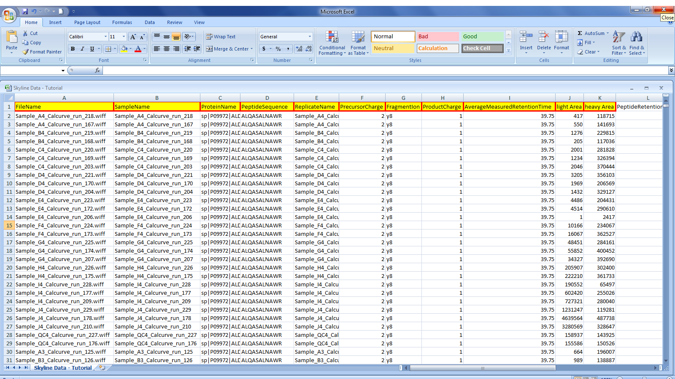Extra columns can be included but they will not be used by QuaSAR. The Skyline Data - Tutorial.csv file you will use in the tutorial comes properly configured **(Fig. 1).** The required columns can be provided in any order.

**Fig. 1.** A properly formatted Skyline Export File

**Creating the Concentration and Sample Grouping Map File:**

The Concentration and Sample Grouping Map Template.csv file comes formatted with the proper column headers. If you wish to start with the provided Concentration and Sample Grouping Map Template file, please open the file and proceed to the next section, “Populating the Concentration and Sample Grouping Map File”.

Create a new excel file Populate the first 5 columns with the following headers (with **exact** spelling, capitalization and spaces). It is recommended to copy/paste the following headers directly into Excel .

|  |  |
| --- | --- |
| **Excel Column** | **Header** |
| **A** | **SampleName** |
| **B** | **SampleID** |
| **C** | **Analyte Concentration** |
| **D** | **IS Conc** |
| **E** | **Concentration Ratio** |

**Populating the Concentration and Sample Grouping Map File:**

* Open the Skyline Export file. Go to the SampleName column and select the first instance of every sample name. Copy these names and paste them into your new excel document in the **SampleName** column. Each sample name should appear only once.
* Samples may have multiple replicates. The **SampleID** column is used to group these replicates together. For any sample, put the same symbol or letter to represent all replicates of that sample. Do this until all the samples and replicates have been appropriately grouped.
* If the analyte concentration is known (for example, as in a calibration curve), populate the **Analyte Concentration** column with the concentration for each sample in fmol/uL values.
* For the **IS Conc** column, list the concentration of your internal standard in fmol/uL.
* The last column, **Concentration Ratio**, is used if actual concentrations are not known. In this case you would input peak area ratio or concentration ratio.

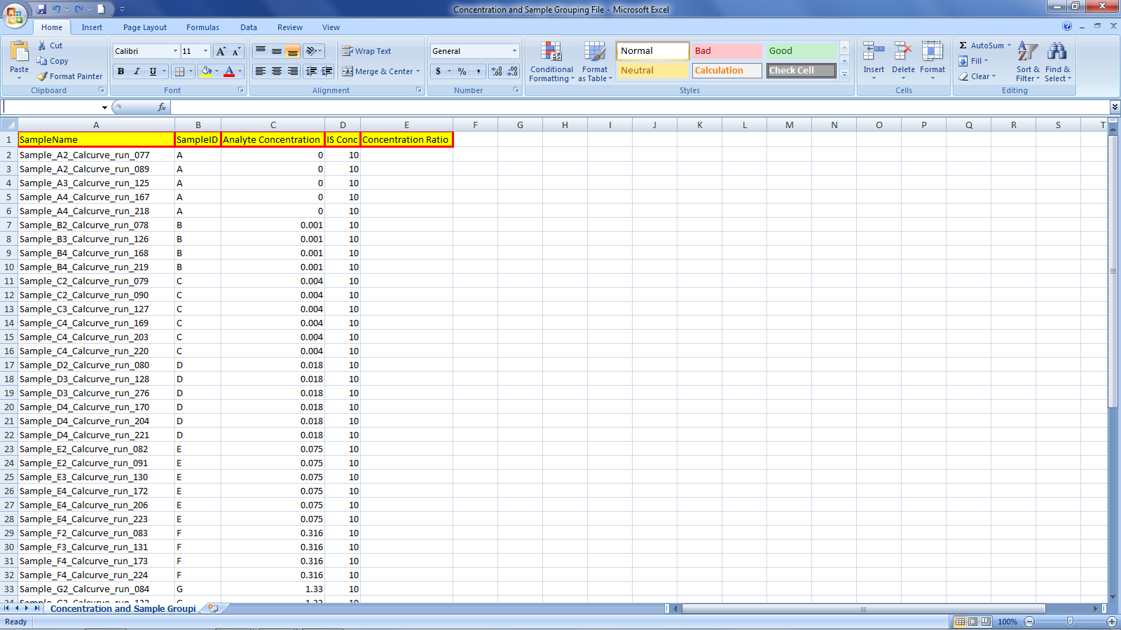The Concentration and Sample Grouping Map - Tutorial.csv file comes properly formatted **(Fig. 2).**

**Fig. 2.** A properly formatted Concentration and Sample Grouping Map File

**Using QuaSAR:**

* Navigate to the GenePattern website ([http://genepattern.broadinstitute.org](http://genepattern.broadinstitute.org/gp/pages/login.jsf)).
* Log on to the server. If you do not have a GenePattern ID then register before logging in.
* Locate the QuaSAR module under the Proteomics category on the left hand panel by scrolling down the page **(Fig 3).** Clicking on the QuaSAR module will display the module **(Fig. 4).**

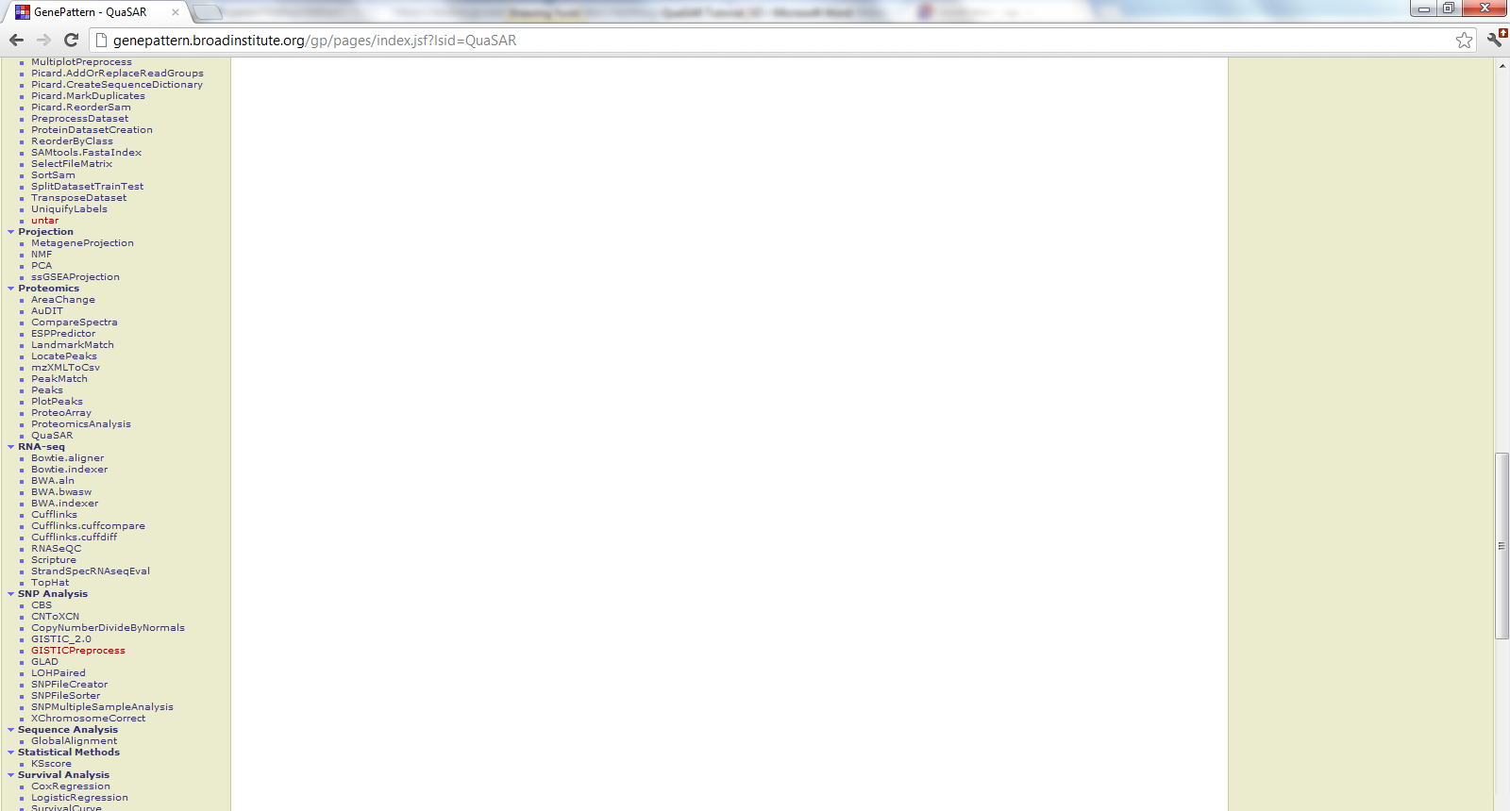

* You will now be on the QuaSAR module page. You will need to input the **Skyline Export file** and **Concentration and Sample Grouping Map file** into QuaSAR.

**Fig. 3.** The QuaSAR module located on the GenePattern page

* To specify the **skyline file** click oZn the Choose File button to invoke the file navigator. Locate and select the Skyline Data - Tutorial.csv file. Click OK to close the file navigator and proceed back to the QuaSAR module page.
* To specify the **concentration file** click on the Choose File button to invoke the file navigator. Locate and select the Concentration and Sample Grouping Map - Tutorial.csv file. Click OK to close the file navigator and proceed back to the QuaSAR module page.
* Enter "Tutorial" in the **title** field.
* For this tutorial you will leave the rest of the options in their default settings. If you wish to find out more information about the many options provided click the **help** button in the top right of the module page.

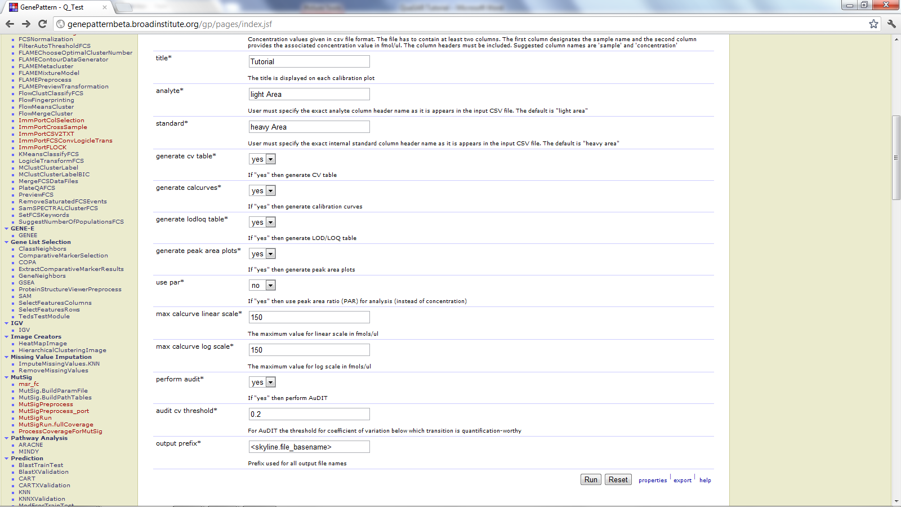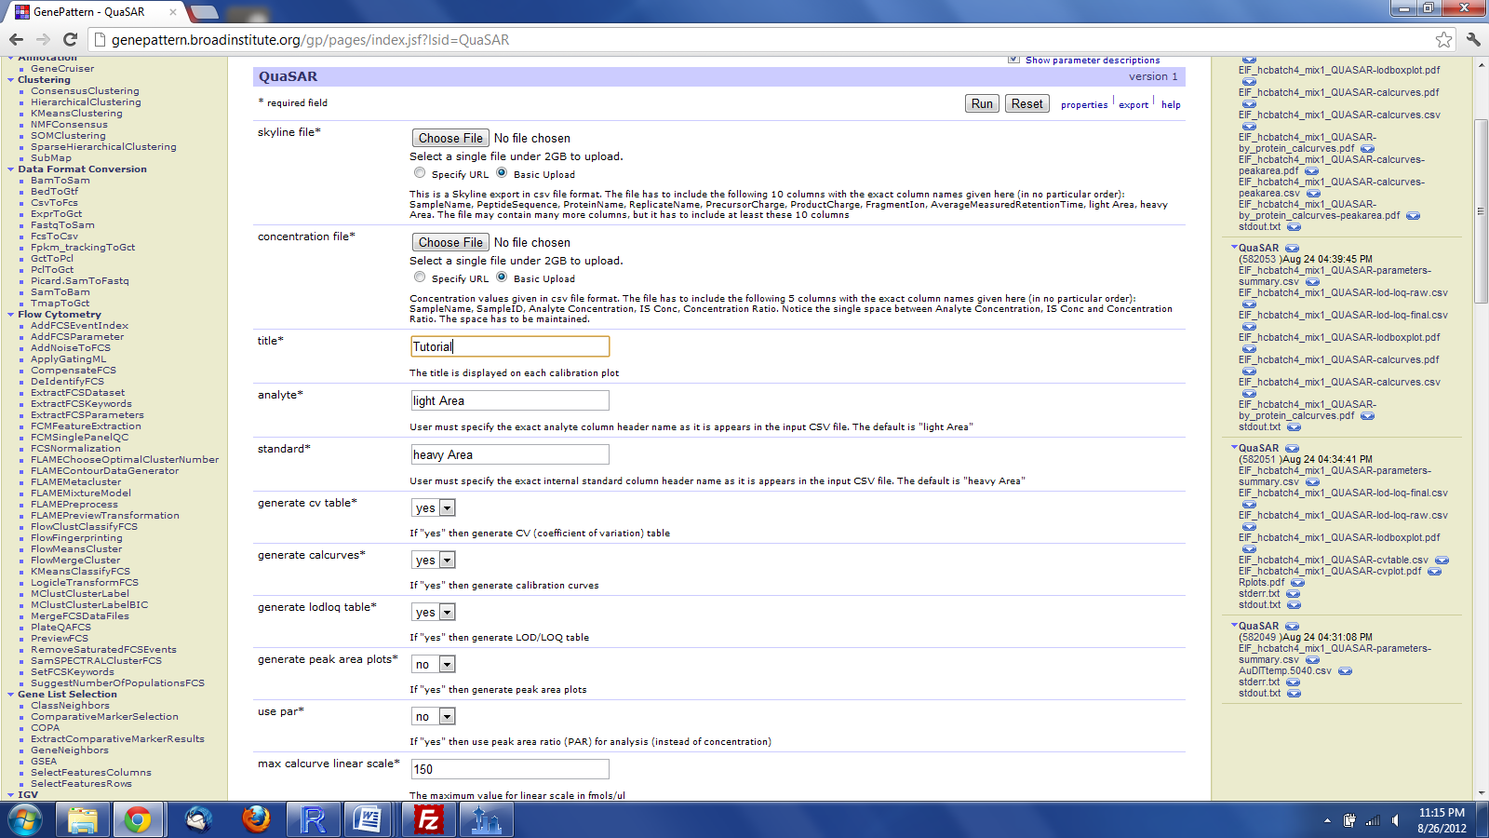

**Fig. 4.** The QuaSAR Module. Setup is finished and QuaSAR is ready to run. The **help** button is circled in the top right.

**Fig. 4.** The QuaSAR Module. Setup is finished and QuaSAR is ready to run. The **help** button is circled in the top right.

* Click the **Run** button. This will take you to a new page where it should indicate that your QuaSAR request has been submitted. If you wish to be notified by email when QuaSAR is finished select the email notification box in the right corner of the QuaSAR bar. It will take approximately 5 minutes for QuaSAR to finish.
* Once QuaSAR has finished you will see a list of files on the same page **(Fig. 5).** These files represent the output from QuaSAR. You can view these files by clicking on them. If run correctly these QuaSAR output files should exactly match the QuaSAR_Results.zip files provided in the .zip file both title and content. A description of what each file contains can be found by clicking the help button in the top right of the module page.
* To download the output files from the QuaSAR module, click the small blue arrow next to "QuaSAR" on the module title. This will reveal a drop box. In the drop box there will be an option to download. Click on **download** and all the QuaSAR output files will be automatically zipped up into one single file and downloaded onto your computer.

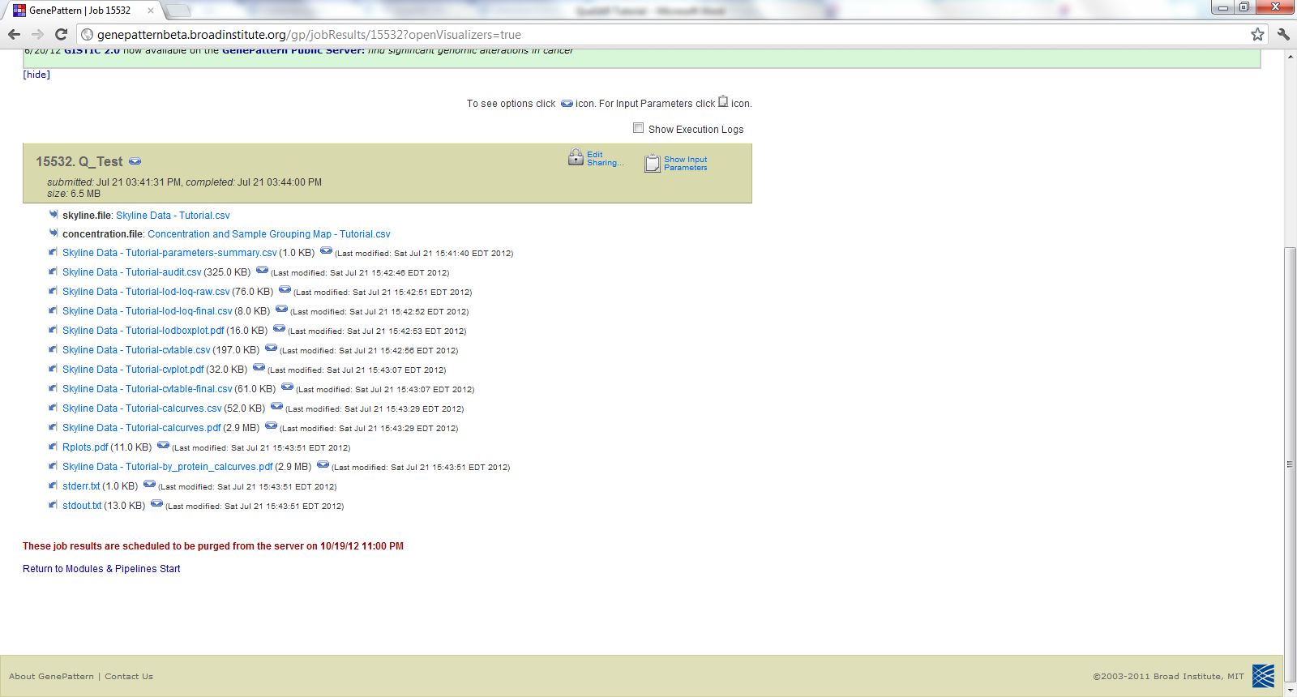

**Fig. 5.** The QuaSAR output screen after finishing the tutorial. The button for the dropbox menu that contain the **download** option is indicated.

Button for **download** dropbox