User Documentation

ChroMo

Contents

Input Data 2

Excel File 2

Excel Settings Requirements 2

Program Execution 2

Results 2

# Input Data

Input data needs to be in one folder which contains any amount of .xlsx files.

## Excel File

MS Excel files (.xlsx) needs to be in the form of template contained in the program folder.

### Excel Settings Requirements

Thousand separator needs to be set as empty input. Otherwise, it can cause problems with values reading.

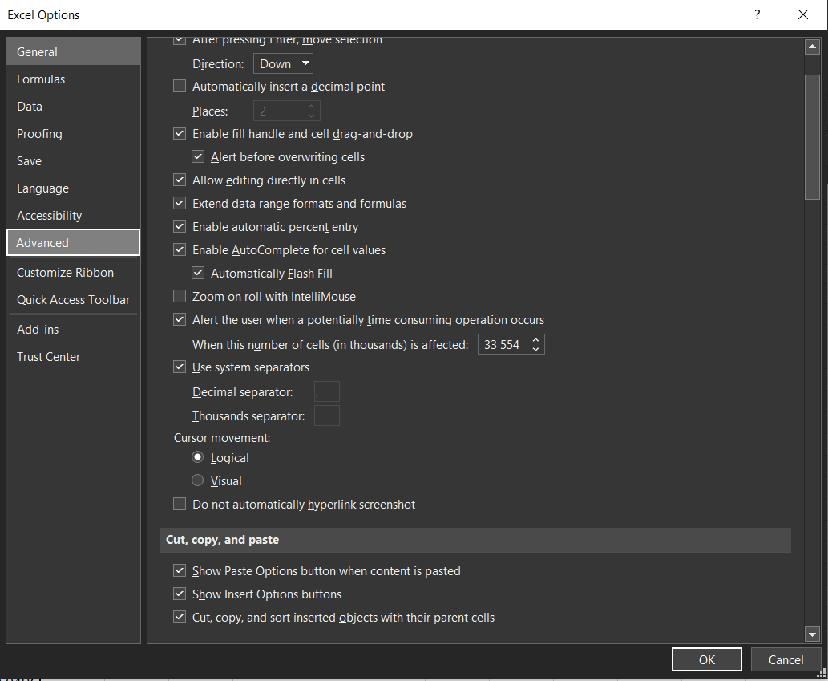

# Program Execution

# Results