**Python**

**期末報告**

班級：商三A

學號：10733114

姓名：賴俊諺

程式碼說明

程式碼&畫面

import requests

from bs4 import BeautifulSoup

gasgrow_lst=[]

evgrow_lst=[]

tslagrow_lst=[]

month_lst=[]

def main():

url_gas = 'https://stat.thb.gov.tw/hb01/webMain.aspx?sys=220&ym=10811&ymt=10911&kind=21&type=1&funid=1120009&cycle=1&outmode=0&compmode=1&outkind=1&fld9=1&cod00=1&cod11=1&rdm=R179112'

resp_gas = requests.get(url_gas)

soup_gas = BeautifulSoup(resp_gas.text, 'html.parser')

resp_gas.encoding = 'utf-8'

url_ev = 'https://stat.thb.gov.tw/hb01/webMain.aspx?sys=220&ym=10811&ymt=10911&kind=21&type=1&funid=1120009&cycle=1&outmode=0&compmode=1&outkind=1&fld9=1&cod00=1&cod13=1&rdm=R151567'

resp_ev = requests.get(url_ev)

soup_ev = BeautifulSoup(resp_ev.text, 'html.parser')

resp_ev.encoding = 'uft-8'

url_tsla = 'https://stat.thb.gov.tw/hb01/webMain.aspx?sys=220&ym=10811&ymt=10911&kind=21&type=1&funid=1120009&cycle=1&outmode=0&compmode=1&outkind=1&fld9=1&cod051=1&rdm=R102891'

resp_tsla = requests.get(url_tsla)

soup_tsla = BeautifulSoup(resp_tsla.text, 'html.parser')

resp_tsla.encoding = 'uft-8'

#table_gas=soup_gas.find('table','tblcls')

#table_ev=soup_ev.fing('table','tblcls')

#table_tsla=soup_tsla.fing('table','tblcls')

#trs_gas = table_gas.find('tr')

#trs_ev = table_ev.find('tr')

#trs_tsla = table_tsla.find('tr')

gas_data = soup_gas.find_all('td', class_='styrate stydata')

ev_data = soup_ev.find_all('td',class_='styrate stydata')

tsla_data = soup_tsla.find_all('td',class_='styrate stydata')

month_data = soup_gas.find_all('th', class_='stycode')

for gas in gas_data:

gasgrow_lst.append(float(gas.text.replace(',','')))

print(gas.text)

print("--------End Gas--------")

for ev in ev_data:

evgrow_lst.append(float(ev.text.replace(',','')))

print(ev.text)

print("--------End EV--------")

for tsla in tsla_data:

tslagrow_lst.append(float(tsla.text.replace(',','')))

print(tsla.text)

print("--------End TSLA--------")

for month in month_data:

month_lst.append(month.text)

print(month.text)

if __name__ == '__main__':

main()

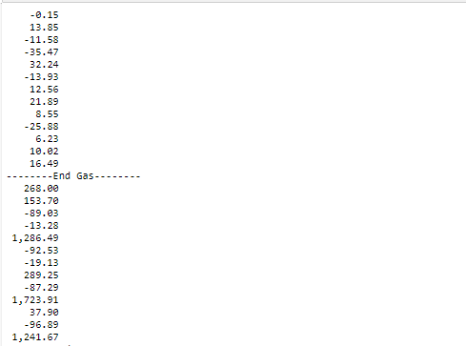

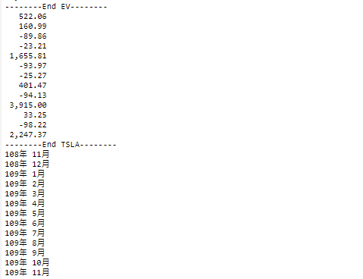

import matplotlib

import matplotlib.pyplot as plt

from matplotlib.font_manager import FontProperties

plt.rcParams['font.sans-serif'] = ['Microsoft JhengHei'] #設定字體

plt.rcParams['axes.unicode_minus'] = False

plt.figure(figsize = (15,5)) #調整大小，避免x軸字重疊

plt.title("燃油車、電動車月成長比率") #標題

plt.xlabel("年月份") #x軸名稱

plt.ylabel("成長率") #y軸名稱

plt.ylim(-300,4000)

gas,=plt.plot(month_lst, gasgrow_lst,'o-',c = "r",)

ev,=plt.plot(month_lst, evgrow_lst,'o-')

tsla,=plt.plot(month_lst,tslagrow_lst,'o-',alpha=0.3)

plt.legend(handles=[gas,ev,tsla],labels=['Gas','EV','TSLA'],loc='best')

plt.show()

