Títle: Analysis of an Internet Service

Author: 89296 Tomás Batista
89997 Flávia Figueiredo

Date: 18/04/20

Index

1. Summary / Abstract 2
2. Framework 2
3. Technical 3
3.1 What is Slack and how does it work 3
4. Social, Economic and Ethical 5
4.1 Market Target 5
4.2 Impact on people’s way of living 7
5. Conclusions 7
6. References 7
Apendix 1. A Simple Proof for 2+ 2=4 7

Summary / Abstract
??????????????????????
TODO TOMAS

Framework
???????????????????????
TODO TOMAS

Technical

What is Slack and how does it work
Slack is a space of collaboration that can replace email. It helps teams working together. It has a team-first approach. It is a place to communicate and get work done, taking advantage of the cons of email.

It works with workspaces, shared spaces that are formed by channels, where team members can communicate and work together. You can have multiple workspaces, each one assigned to an email (same email can go for multiple workspaces).

Inside workspaces there are channels, where team members can send messages and share archives. Channels can be created for teams, projects, or any other thing that is of your interest. They can be public, private, shared and channels that belong to multiple workspaces.

Public channels can be accessed by anyone inside the workspace. In private only invited people can get in. Shared channels allow two organizations to work on the same channel, each one inside their own workspace. Last, channels that belong to multiple workspaces connect different workspaces inside an organization of Enterprise Grid (Paid plan).

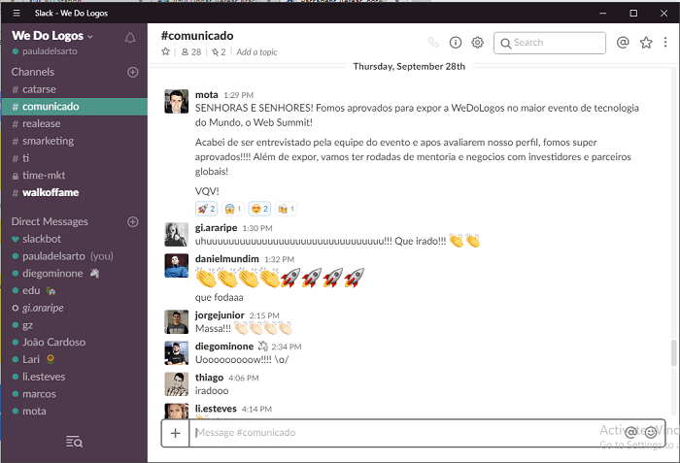
Each channel must have a topic, a description, and a nomenclature. Conversations can have sub-conversations, threads, you can reply to a message and it groups the replies, so that the channel keeps organized and with a clean look.
Figure 1 - Workspace

Slack has 4 different plans and resources: free, standard, plus and enterprise grid. Each one offers different things, from unlimited messages, files, and apps to calls with multiple participants

Members inside a workspace can have different permissions, there are 2 types of functions: administrative and non-administrative functions.
Administrative functions are main owner, owner, and admin. There is only one main owner, he has the max level of permissions, he is the only one that can delete or transfer the workspace to another person. There can be many owners of the workspace; they have the same permission levels of main owners but cannot exclude or transfer the workspace. Same happens with admins, a workspace can have multiple; they can manage members, channels, and other administrative functions.
Non-administrative functions are member and guest.
Members are persons that participate in a workspace; they can use Slack to communicate and work with their team. Guests participate in the workspace but have limited access; they can only join one channel and interact only with the people that are in that same channel.

Slack have an awesome feature: apps. Apps are software that connects a service or a tool to slack. They centralize and simplify the work. With all the apps on the workspace it is easier to manage your work. There are a lot of integrated apps: Google Drive, Google Calendar, Polls, Zoom Meetings, GitHub and so on. They all have unique features, Calendar can notify you for events, with Zoom you can start a meeting in seconds, and so on.
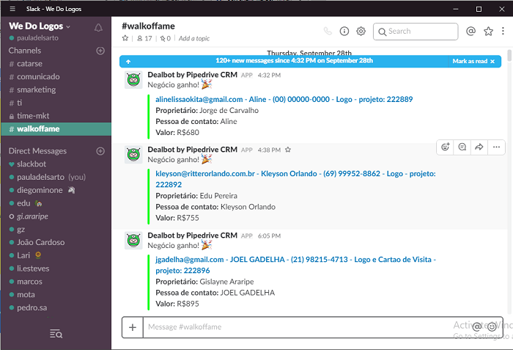
Figure 2 - Apps Integration

Social, Economic and Ethical

Market Target
Slack it is targeted to companies, group projects, literally any team that wants to promote the efficient teamwork, economize time working smarter and work in any place via phone, tablet, or PC. They offer solutions to low and enormous groups, from free tier to enterprise grid.

We have multiple examples of companies that integrated slack. We have the example of IBM that implemented Slack throughout the development lifecycle. On a single day, any worker will have to work with other 40 or 50 different people, all on different teams. So, they decided to implement slack, dividing each team on channels (#development-team, example) and implemented help channels. Each channel works as a “kind of audit trail”, all analysis for their post-mortems have a history on slack channels.

Fox, the television channel, with more than 22 thousand employees, uses slack to collaborate on live events, where the team members (producers, designers, casters, and so on) need to work on real time. CTO of Fox said “Before, it took us hours to create, approve and transmit the best moments of a sport event. Now, with slack, it takes minutes, it’s almost on real time”. They used Slack on the Fifa World Cup 2018. The collaborators that were on the local took photos and videos and shared on #worldcup-digital channel. The production team shared that material on other channels so that the other teams could use them. To synchronize the work, they had quick meetings with the Zoom integration on Slack.

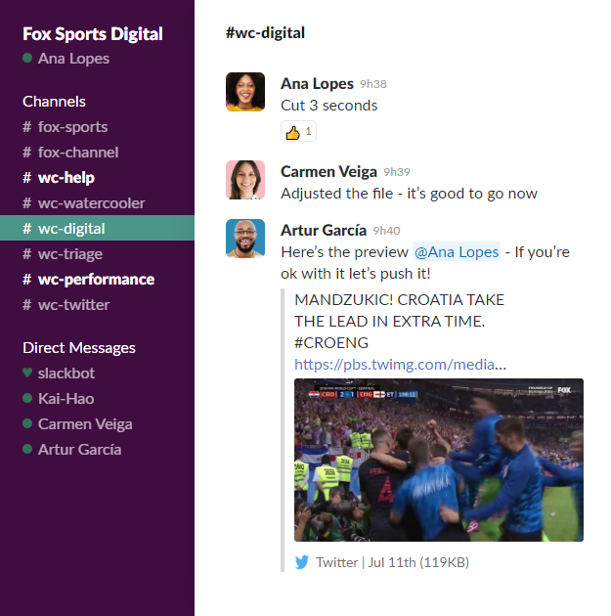
Figure 3 - Fox World Cup Channel

They also implemented multiple bots to control access request of new freelancers to join the team, to show the stats of games highlights, and many more.

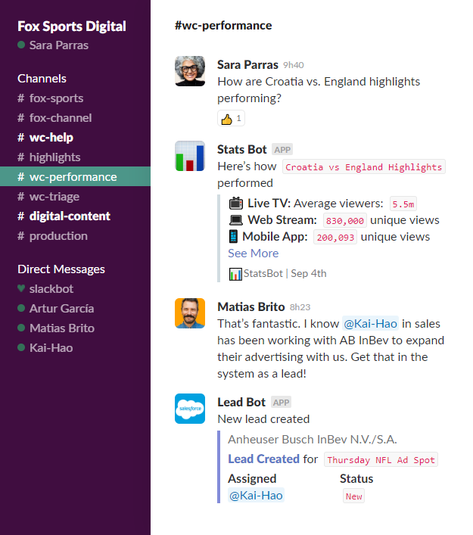
Figure 4 - Fox Slack Bots

One relatable example is the use of Slack on DETI, Departamento de Eletrónica, Telecomunicações e Informática. We have a common use of Slack; channels divided by associations (GLUA, AETTUA, ...), course units and topics.
Other examples are Oracle, ETrade, The New York Times, Deliveroo, Vodafone, BBC, Trivago, Shopify, and so on.

Impact on people’s way of living
As can be seen in other communication apps like Slack, it provides several benefits such as saving time, strengthen and facilitate team interactions and promote organized team and user environments.
Since slack provides numerous applications within itself, making it possible for the user to complete tasks in fewer steps, it also makes the communication between team members faster and simpler, eliminating the need of back-and-forth emailing. This application can eliminate the need for the team to use multiple other technologies to organize their works or keep information up to date (etc.).
Slack can be the perfect fit for large teams where people perform multiple and diverse functionalities due to the pervasiveness of its communication tools.

TODO – FLÁVIA
Rever texto acima porque:
AFINAL Ñ É ASSIM TAO PRODUTIVO QTO ISSO
https://www.vox.com/recode/2019/5/1/18511575/productivity-slack-google-microsoft-facebook

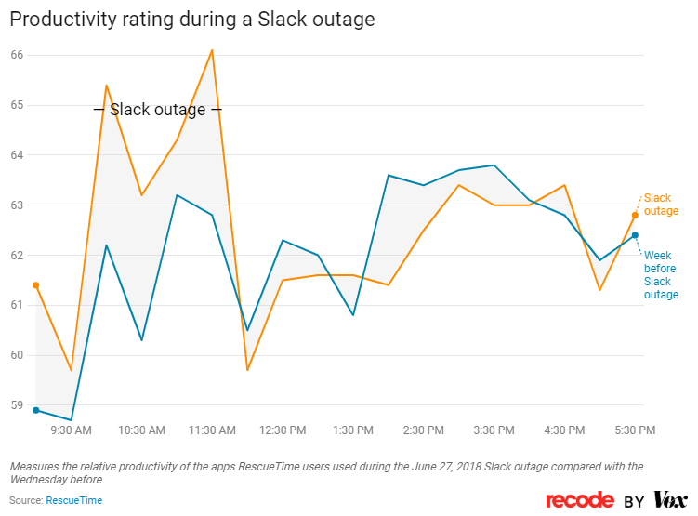
Figure 5 – Increment of productivity during a Slack outage

Economic Implications
Slack is a “freemium” software. For small teams it can work fine. But when your team starts expanding or you belong to a large team the free tier it is not that great. You need to take in consideration the features you really need in order to choose a plan. The price of each paid option is per person/month or per person/year. You may need to do a study of features vs number of team members.

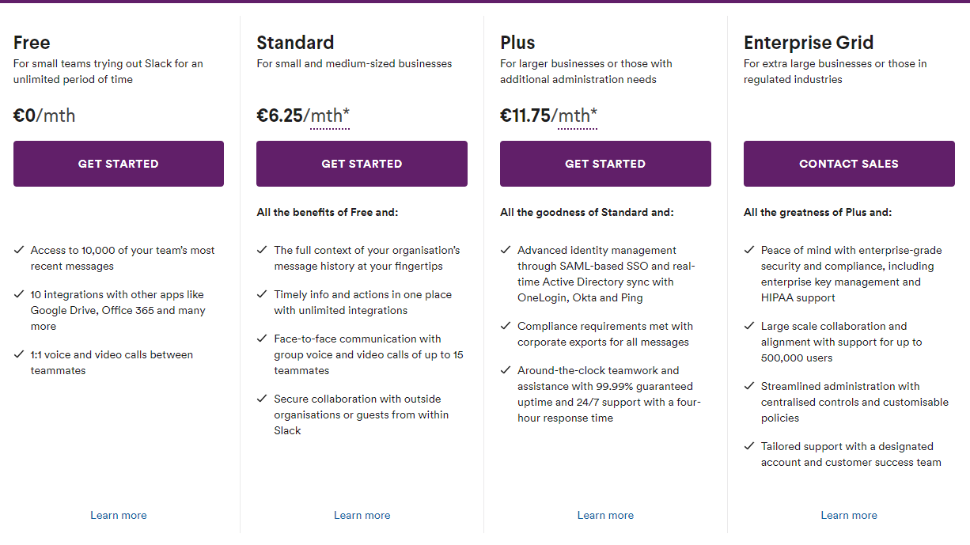
Figure 6 - Slack plans

Business Model
The business model associated with Slack would be Freemium Base Membership or Recurring Model. The Freemium is a type of business model that offers users simple and basic services free to try, hoping that the user needs will increase and eventually move into premium membership with more advanced services or additional features.
This model, by giving away a free of charge service, is trying to establish a foundation for future deals with the costumer.
As it can be seen in the website, Slack charges monthly fees of $6.67 per user for the standard subscription, $12.50 for the Plus subscription and it also has launched Enterprise Grid for larger organizations that have tens of thousands of users.
Unlike other softwares such as this one, Slack charges organizations only for active users.

TODO – FLÁVIA

Falar q sao startup
Unicorn (aka avaliada over bilio or milion)
Uma das maiores startups ever etc etc
Resumir texto final do doc

O business plan tem muita coisa para se falar (procurer graficos, fotos, relatorios, etc)

Ethical Issues
Despite the phrase “Slack – where work happens” some companies reported that the software has been blurring the boundaries between work and play. An employee says that “It is totally addictive. You post and you are just waiting for the emoji reaction.”
A manager from a London startup says that when they were 20-30 workers it was truly helpful but, by the time they were 50 it was causing a lot of problems. The fact that slacks is an app is disturbing, you can always see if you have notifications or not, leading to stress and anxiety for teams. You are always on, you can never disconnect, and if you do and you do not reply, coworkers will think that you are ignoring them.
People are much meaner on Slack than face to face was another point added by Slack users, there is no way of expressing emotions without smiley faces and emojis, because it does not have that serious spirit of email.

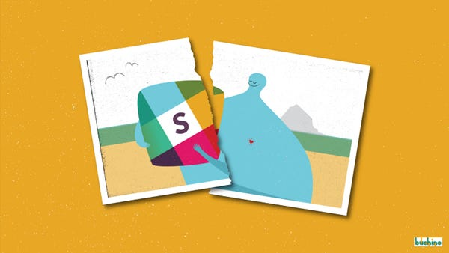
Figure 7 - Slack disconnecting - Medium

To fight people hating Slack and destroying their work rate they implemented Artificial Intelligence. An example of that is, with machine-learning algorithms, highlight most important messages that the user missed.

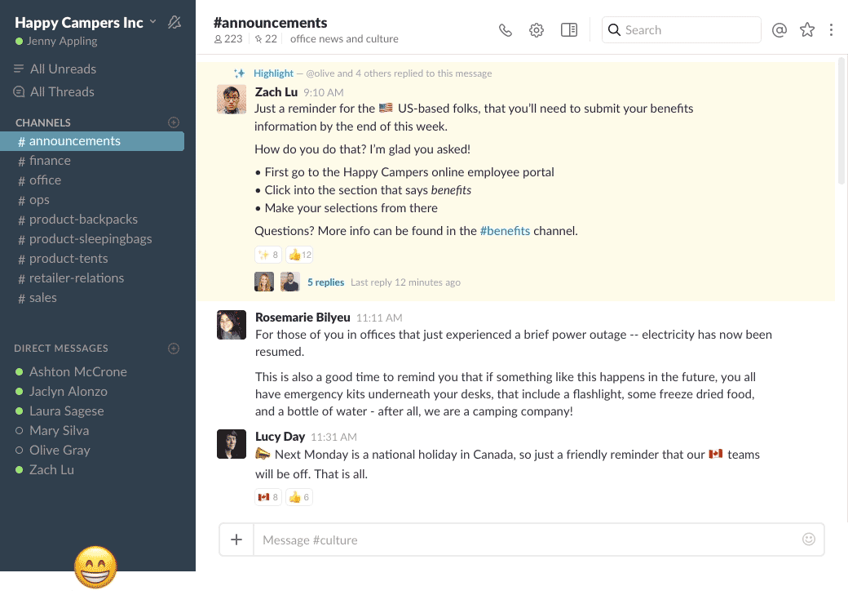
Figure 8 - ML Highlighting messages

Fair usage of the involved resources
There are reports of some security concerns regarding the exchanges of messages between team members on the software, but Slack assures that it provides security practices at many levels such as data encryption, security features for team members & administrators (access logging, data retention, deletion of customer data, return of customer data, team-wide two-factor authentication, single sign-on), availability, disaster recovery, network protection, host management and product security practices.

TODO FLAVIA????

Conclusions
TODO TOMAS

References
TODO TOMAS

ALGUMA FOTO TALVEZ SE NECESSÁRIO

