Title: Anatomy of a Web Connection: A Brief Analysis

Author: Tomás dos Santos Batista

Date: 02/03/2020

**Index**

1. Summary / Abstract 2

2. Framework 2

3. Traceroute 2

4. ISO OSI Model 3

4.1 Layer 1: Physical Layer 3

4.2 Layer 2: Data Link Layer 4

4.3 Layer 3: Network Layer 4

4.4 Layer 4: Transport Layer 4

4.5 Layer 5: Session Layer 4

4.6 Layer 6: Presentation Layer 5

4.7 Layer 7: Application Layer 5

5. Traceroute Analyzing 6

5.1 Aveiro University network 6

5.2 General Comparison 6

6. Conclusions 8

7. References 8

Apendix 1. Traceroute from home at Aveiro 9

Apendix 2. Traceroute from Aveiro University 9

Apendix 3. Traceroute from home at Viseu 9

# Summary / Abstract

This document describes the problem “Anatomy of a Web Connection”, focusing on the operations, processes, techniques and technologies involved in network communication and, also, the possible social and economic impacts of this ones referred before.

# Framework

For the most common humans the Internet works like as “magic” but, for us computer science students it’s not like that. When we access a web page, the request will traverse from our computer to the destination. To study that path, we will use tracert, a Windows command that will show the path that our packets will follow. With this report, we will be able to understand the underlying the simple act of opening and web page.

# Traceroute

Traceroute is a “computer network diagnostic commands for displaying the route (path) and measuring transit delays of packets across an Internet Protocol (IP) network.”, in [Wikipedia](https://en.wikipedia.org/wiki/Traceroute). It traverses each host (node) in the route to the destination, calculating the times (RTT – round-trip time) that each packet takes to reach and return to your computer. In each hop it will show the time taken (in milliseconds) of each three IPV4 packets sent, the domain name and the respective IP address.

Figure 1 - Traceroute Operation

The domain name can give some aspects on the:

* Location Identifiers
* Interface Types and Capacities
* Router Type and Roles
* Network Boundaries and Relationships

The network diagnostic tool relies on ICMP (Internet Control Message Protocol) echo packets with TTL (Time to Live) values. It’s useful to troubleshoot Network problems such as packet loss or high latency. It can locate points of failure in route to the destination.

Although, traceroute has down points. For example, some messages are often blocked by routers, the node might be very busy, or they are programmed not to respond; also, the domain name it’s hard to decode.

# ISO OSI Model

ISO Open System Interconnection (OSI) model is “a conceptual model that characterizes and standardizes the communication functions of a telecommunication or computing system without regard to its underlying internal structure and technology.”, in [Wikipedia](https://en.wikipedia.org/wiki/OSI_model). They aim to standardize the interoperability of diverse communication protocols.

The model is divided in 7 layers, as can be seen in Figure 2. The n-layer serves the layer n+1 (above) and is served by the layer n-1 (below). Each layer has a specific function and they all work in collaboration to transmit data.

For the information be transferred over a network, on the sending device, the data must travel down the seven layers of the OSI model and then travel up the seven layers on the receiving end.

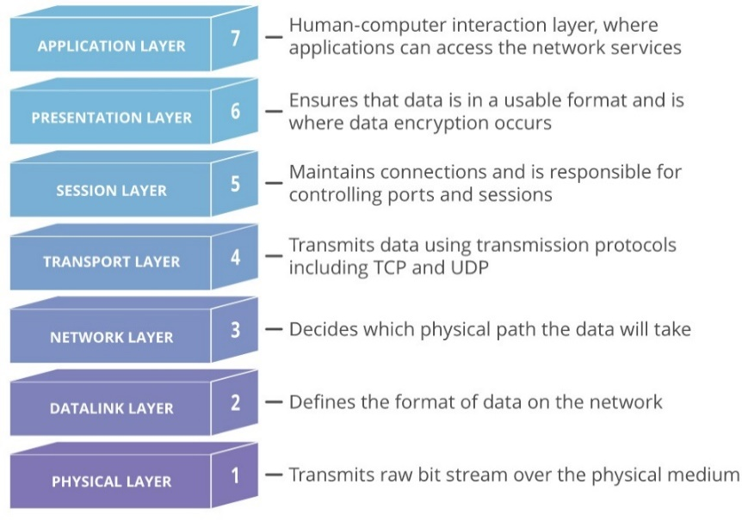

Figure 2 - Seven layers of the OSI Model

## Layer 1: Physical Layer

Responsible for physical connection between devices. The information it’s in the form of bits (unstructured raw data). The electrical and physical representation of the system (cables and switches).

The functions of the physical layer are: **Bit Synchronization**, **Bit rate control**, **Physical topologies** and **Transmission node**.

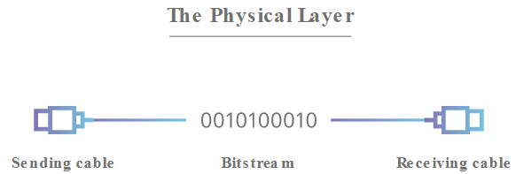

Figure 3 - Physical Layer

## Layer 2: Data Link Layer

Provides node-to-node data transfer, between two devices on the same network. Its function is to ensure that data transfer has no errors from one node to another (over the physical layer). The packets are broken into smaller pieces (frames). There are two sublayers: Medium Access Control (MAC) and Logical Link Control (LLC).

The functions of the Data Link Layer are: **Framing**, **Physical addressing**, **Error control**, **Flow control** and **Access control.**

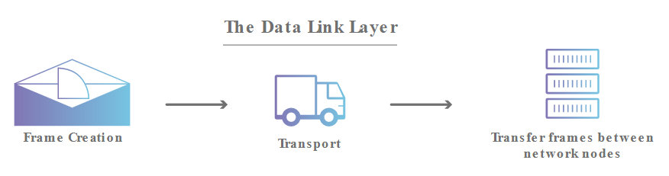

Figure 4 - Data Link Layer

## Layer 3: Network Layer

This layer it’s responsible for data transfer between two host in different networks. It takes care of packet routing. The segments (from the transport layer) are broken into smaller units (packets) and reassembled again. It also finds the best physical path to reach the destination.

The functions of the Network Layer are: **Routing** and **Logical Addressing**.



Figure 5 - Network Layer

## Layer 4: Transport Layer

The Hearth of OSI. It provides services to application layer and takes services from network layer. Responsible for the End to End Delivery of the complete messages; the data on this layer is referred as Segments. One example of this Layer is the Transmission Control Protocol (TCP), built on top of the Internet Protocol (IP, Layer 3). It’s responsible for flow and error control.

The functions of the Transport Layer are: **Segmentation and Reassembly** and **Service Point Addressing**.

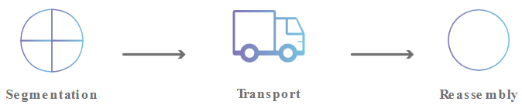

Figure 6 - Transport Layer

## Layer 5: Session Layer

This layer is responsible for creating and closing a session for two devices to communicate. It also ensures maintenance, authentication and security.

The functions of the Session Layer are: **Session establishment, maintenance and termination**, **Synchronization** and **Dialog Controller**.

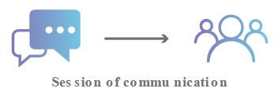

Figure 7 - Session Layer

## Layer 6: Presentation Layer

The primary function it’s to prepare/translate data (extracted from the Application layer) to network format, and vice versa. Also known as Translation Layer.

The functions of the Session Layer are: **Translation**, **Encryption/ Decryption** and **Compression**.

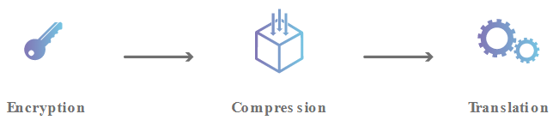

Figure 8 - Presentation Layer

## Layer 7: Application Layer

The layer that directly interacts with data from the user, it’s what most users see. It can be a web browser or other app. This layer produces de data, which must be transferred over the network.

The functions of the Session Layer are: **Network Virtual Terminal**, **File transfer access and management (FTAM)**, **Mail Services** and **Directory Services**.

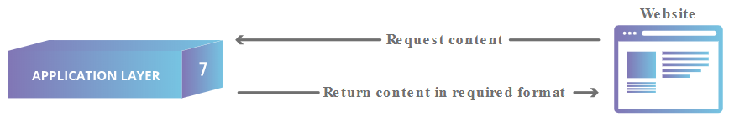

Figure 9 - Application Layer

# Traceroute Analyzing

## Aveiro University network

As seen on Figure 13, we can convert the image into the next table:

|  |  |  |  |  |
| --- | --- | --- | --- | --- |
| **Hop** | **Device or Media** | **Local** | **Network/Operator/Owner** | **OSI Layer** |
| 0 | Personal Computer  (192.168.45.12) | GSBL UA | UA Ethernet Network / STIC / Aveiro University | From 7 to 1 |
| 1 | Router (192.168.63.252) | DETI UA | UA Ethernet Network / STIC / Aveiro University | From 3 to 1 |
| 2 | Router (193.137.173.244) | STIC UA | UA Ethernet Network / STIC / Aveiro University | From 3 to 1 |
| 3 | 10.0.34.1 | UA | UA Ethernet Network / STIC / Aveiro University | From 3 to 1 |
| 4 | Router (193.136.4.26) | Porto | FCCN | From 3 to 1 |
| 5 | Router (193.136.4.21) | Porto | FCCN | From 3 to 1 |
| 6 | Router (193.136.1.1) | Lisbon | FCCN | From 3 to 1 |
| 7 | Router (193.137.0.17) | Lisbon | FCCN | From 3 to 1 |
| 8 | Router (83.97.88.209) | Lisbon | FCCN | From 3 to 1 |
| 9 | Router (62.40.98.107) | Spain | GÉANT | From 3 to 1 |
| 10 | Router (62.40.98.67) | Switzerland | GÉANT | From 3 to 1 |
| 11 | Router (62.40.98.190) | United Kingdom | GÉANT | From 3 to 1 |
| 12 | Router (80.239.13.136) | Norway | Telia | From 3 to 1 |
| 13 | Router (62.115.135.136) | Sweden | Telia | From 3 to 1 |
| 11 | Router (62.115.142.46) | German | Telia | From 3 to 1 |
| 11 | Router (62.115.189.7) | Switzerland | Telia | From 3 to 1 |
| 11 | Router (182.75.246.90) | India | Airtel | From 7 to 1 |

## General Comparison

**Different routes**

When analyzing each traceroute from each location, they have some slightly differences. Different domain names and IP’s. This could be due the fact that some nodes might be very busy (or even down) at some certain times and so the packets need to follow a different path.

**Advertising**

One domain name (nsg-static-90.246.75.182-airtel.com) gave me an advertising to a [fake Publico’s journal page](https://associated-press.org/publico/?lpkey=158982258183572580&uclick=b7a7sca4).

**Social and Economic Implications**

Some of the actors in the path of traceroute make their revenue from network, such as FCCN, GÉANT, Telia and Airtel. On the other hand, STIC don’t have the propose of making money, they work for the Aveiro University and aim to control all the network of the Campus and the ingoing and outgoing connections.

# Conclusions

With this work I was able to discover and dig in the tracert command, will add this tool to my list when in need of knowing the path to a website, why I can’t connect, why I’m lagging, etc. I could also see how a web page request is sent through the worldwide network, to which countries it goes, the companies who works with telecommunications network, and so on.

In the end, the balance it’s positive.

# References

1. [Traceroute](https://pt.wikipedia.org/wiki/Traceroute), Wikipedia.
2. [ISO OSI Model](https://pt.wikipedia.org/wiki/Modelo_OSI), Wikipedia.
3. [whatismyipaddress](https://whatismyipaddress.com/).
4. Traceroute from home at Aveiro

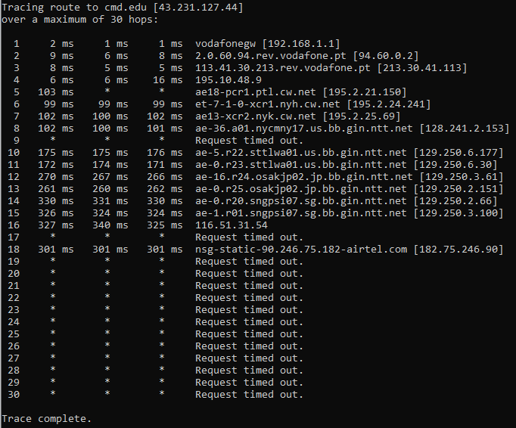

Figure 11 - Try 01: 26/02/2020 – 19h00

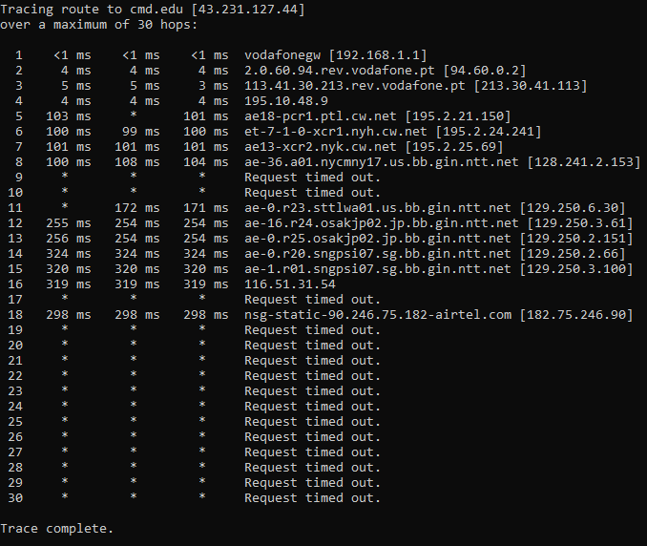

Figure 11 - Try 02: 28/02/2020 – 14h00

1. Traceroute from Aveiro University

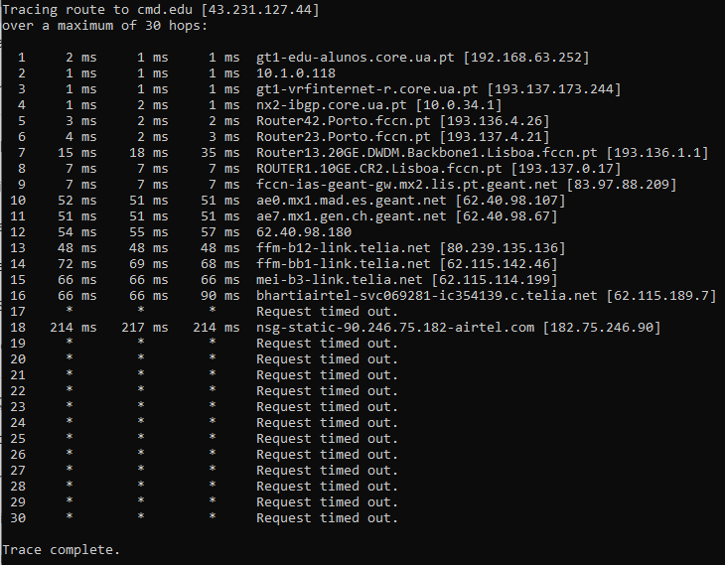

Figure 13 - Try 01: 27/02/2020 – 13h00

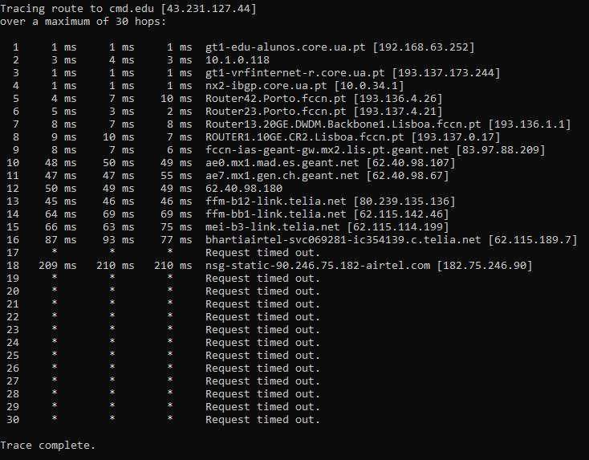

Figure 13 - Try 02: 28/02/2020 – 17h00

1. Traceroute from home at Viseu

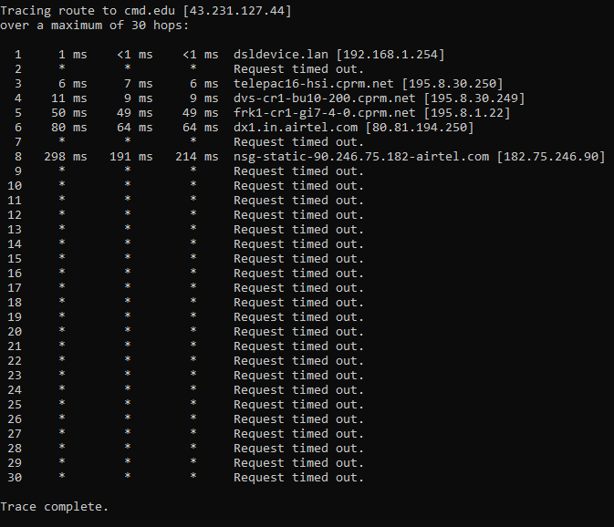

Figure 14 - Try 01: 01/03/2020 – 14h00