Title: Slack – Business Model

Author: Tomás dos Santos Batista - 89296

Date: 10/06/2020

**Index**

1. Summary / Abstract 2

2. Framework 2

3. What is Slack? 3

4. Business Model 4

4.1 Value Proposition 4

4.2 Key Activities 4

4.3 Key Resources 4

4.4 Key Partners 4

4.5 Customer Relationships 5

4.6 Channels 5

4.7 Customer Segments 6

4.8 Cost Structure 6

4.9 Revenue Streams 7

5. Conclusions 8

6. References 9

# Summary / Abstract

On the last assignment of the course Aspetos Profissionais e Sociais da Engenharia Informática I chose to keep the work of my last project. So, I am going to talk about Slack. But, this time, I will talk about, mostly, of their business model. First, I am going to explain what Slack is, how they earn money, the investments they received, their current financial position/status, and so on.

# Framework

The application Slack will be analyzed on this document, which is a communication platform focused on teamwork. “It is a service that helps us ease and organize work, providing a broad spectrum of tools that can be used and reused to achieve a more concise work process. It was chosen because it is a very appreciated tool in our workplace, and it has become essential in terms of simplifying our way of working and communicating with colleagues and team members.”, in Assing02, made by me in collaboration with a colleague.

The last document was analyzed from 2 points of view, technical and Social/Economical/Ethical. But, this time, it will be mainly focused on the Business/Economical part of the company

# What is Slack?

Slack is a communication platform focused on teamwork and improving productivity. It came to end with email within an organization and focused on the negative points of emails and those became his strengths.

It works with workspaces, shared spaces that are formed by channels, where team members can communicate and work together. You can have multiple workspaces, each one assigned to an email (same email can go for multiple workspaces).

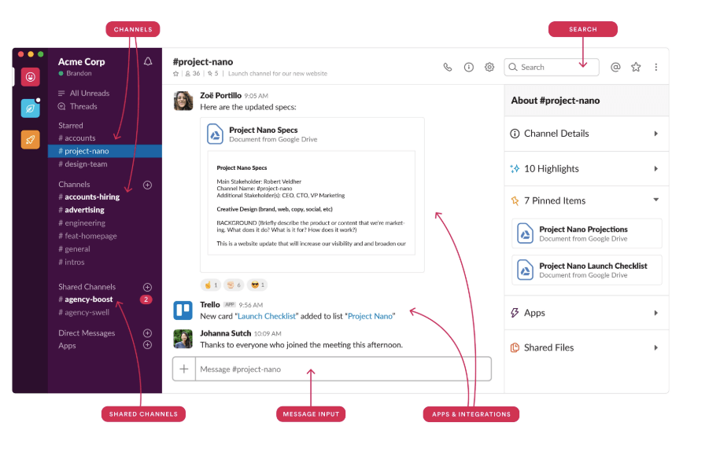

Figure 1 - Slack Workspace example

It was created by Stewart Butterfield, the co-founder of the website Flickr, when he was on a company, Tiny Speak, they felt the need of a communication system to control the teams within his organization. In 2013 Slack was launched and a lot of companies started using it, it grew fast.

Their **vision** is a world where organizational agility is easy to achieve, regardless of an organization’s size. The **mission** of Slack is to make people’s working lives simpler, more pleasant, and more productive. They aim to reduce fragmentation within tools used by companies because one of their critical points is the integration with other apps and tools.

Slack is, by the time of this report, is the fastest-growing enterprise software company. With 1.2 billion $ in investment, 8 million active users and 3 million paid users.

I have already talked more in detail about the technical part of Slack on my past report. For more information it can be seen on [GitHub](https://github.com/tomas99batista/Analysis-of-an-Internet-Service). Given this context, now I am going to present the business model of the company.

# Business Model

## Value Proposition

Value Proposition describes the bundle of products and services that create value (benefits) for a specific Customer Segment. The Value Proposition is the reason why customers turn to one company over another. It solves a customer problem or satisfies a customer need. Some Value Propositions may be innovative and represent a new or disruptive offer. Others may be like existing market offers, but with added features and attributes.

Slack offers **Newess** (Slack Value Proposition satisfy an entirely new set of needs that customers previously didn’t perceive because there was no similar offering), **Design**, **Convenience and Usability** (it makes easier to communicate) and **Accessibility** (because Slack can be accessed through computer and smartphone).

Slack has a “cool” part, it’s freemium, lets you be more productive at work with less effort, has increased productivity gains (saving you time), it’s simple, removes the frustration of unnecessary CC emails and has a lot of integrations.

## Key Activities

Describes the most important things a company must do to make its business model work. Every business model calls for a few Key Activities. These are the most important actions a company must take to operate successfully. Like Key Resources, they are required to create and offer a Value Proposition, reach markets, maintain Customer Relationships, and earn revenues. And like Key Resources, Key Activities differ depending on business model type.

Slack key activities are **Problem Solving** because they came up with new solutions to the problem of communication inside companies/teams and **Platform/Network** due to their product being a (communication) platform. Plus, they develop software, do app maintenance, operations, integration marketing and customer support.

## Key Resources

Describes the most important assets required to make a business model work. These resources allow an enterprise to create and offer a Value Proposition, reach markets, maintain relationships

with Customer Segments and earn revenues. Different Key Resources are needed depending on the type of business model.

The most important resource of Slack is **Intellectual** because they depend on people qualified, from programmers to human resources, they are dependent on the intellectual of their workers, they are the most important components of a strong business model.

Their key resources are talent, datacenter, cloud, platform, developers and chatbots.

## Key Partners

Describes the network of suppliers and partners that make the business model work. Companies forge partnerships for many reasons, and partnerships are becoming a cornerstone of many business models. Companies create alliances to optimize their business models, reduce risk, or acquire resources.

We can distinguish between four different types of partnerships:

**1. Strategic alliances** between non-competitors

**2. Coopetition:** strategic partnerships between competitors

**3. Joint ventures** to develop new businesses

**4. Buyer-supplier relationships** to assure reliable supplies

Their key partners are third-party integrators, business angels, developers and [The Last Mile prison program](https://slackhq.com/the-next-chapter-program-a-collaboration-for-impact).

## Customer Relationships

Describes the types of relationships a company establishes with specific Customer Segments. Relationships can range from personal to automated. Customer relationships may be driven by the following motivations:

- Customer acquisition

- Customer retention

- Boosting sales (upselling)

Slack offers **Personal Assistance** (through their customer service with online assistants) because the customer can communicate with a real customer representative to get help, on the top paid plan (Enterprise Grid) they offer **Dedicated Personal Assistance** (because the relationship involves dedicating a customer representative specifically to and individual client). But, on the other hand, if you only want to use the free plan or the lowest paid plan (not the top plan) they also have to offer **Self-Service** because you can set-up everything by yourself, from buying to start using Slack (because Slack does not maintain a direct relationship with the customer).

## Channels

Describes how a company communicates with and reaches its Customer Segments to deliver a Value Proposition. Channels are customer touch points that play an important role in the customer experience. Channels serve several functions, including:

- Raising awareness among customers about a company’s products and services.

- Helping customers evaluate a company’s Value Proposition.

- Allowing customers to purchase specific products and services.

- Delivering a Value Proposition to customers.

- Providing post-purchase customer support.

Slack uses their **Own Channels** through **Indirect Channels** because Slack promotes their product through their own Website.

There are 5 distinct channel phases:

**1. Awareness:** How do we raise awareness about our company’s products and services?

**2. Evaluation:** How do we help customers evaluate our organization’s Value Proposition?

**3. Purchase:** How do we allow customers to purchase specific products and services?

**4. Delivery:** How do we deliver a Value Proposition to customers?

**5. After sales:** How do we provide post-purchase customer support?

Taking in consideration Slack:

**1. Awareness:** Through their website, ads, participating on conferences and tech events.

**2. Evaluation:** With the help of the marketing team that has done an amazing job on their website and makes great videos explaining the Value Proposition of Slack.

**3. Purchase:** On their website you can find all the pricing and buy the paid plan you want. They also offer customer service to help you decide on which one is the best to buy.

**4. Delivery:** Through their product itself and through propaganda.

**5. After sales:** Depending on the plan the client has chosen: it may vary from 24/7 customer service or working-hours customer service.

Their channels are: Website, Social Network, Blogs, Third-party integrators and Slackshop (merchandising).

## Customer Segments

The needs of the Customer segment are different when compared to other customers segments, therefore the product or service needs to be different too. They are contacted through different channels and demand different types of relationship (engagement, communication). They are able to pay more or differently (because they value different benefits) when compared with other customer segments.

Our Customer Segment is from the type **Mass Market** because Slack don’t distinguish between different Customer Segments. The Value Propositions, Distribution Channels and Customer Relationships focus on one large group of costumers with similar needs and problems.

Our costumer segment is mostly focused on small teams, large companies and institutions that want to communicate efficiently and promote efficient teamwork, economize time working smarter, and so on.

## Cost Structure

Describes all costs incurred to operate a business model. This building block describes the most important costs incurred while operating under a business model. Creating and delivering value, maintaining Customer Relationships, and generating revenue all incur costs. Such costs can be calculated relatively easily after defining Key Resources, Key Activities, and Key Partnerships.

Slack is a company that is **Value-driven** because they offer premium Value Proposition and high degree of personalized service.

Their principal costs are: Product features, Development, IT Infrastructure, Hosting, Operations, Staff, Help desk and Marketing.

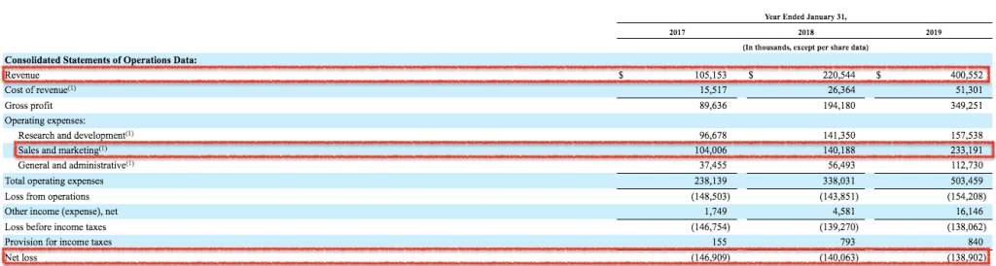

Figure 2 - Slack Accounts Report

## Revenue Streams

Represents the cash a company generates from each Customer Segment (costs must be subtracted from revenues to create earnings). A company must ask itself, for what value is each Customer Segment truly willing to pay? Successfully answering that question allows the firm to generate one or more Revenue Streams from each Customer Segment.

Slack, to generate Revenue Streams, they use **Subscription Fee** (because they continuous sell access to the service)

They are a freemium product available for an unlimited number of users. Users can upgrade to various paid versions to gain access to larger channels and additional features.

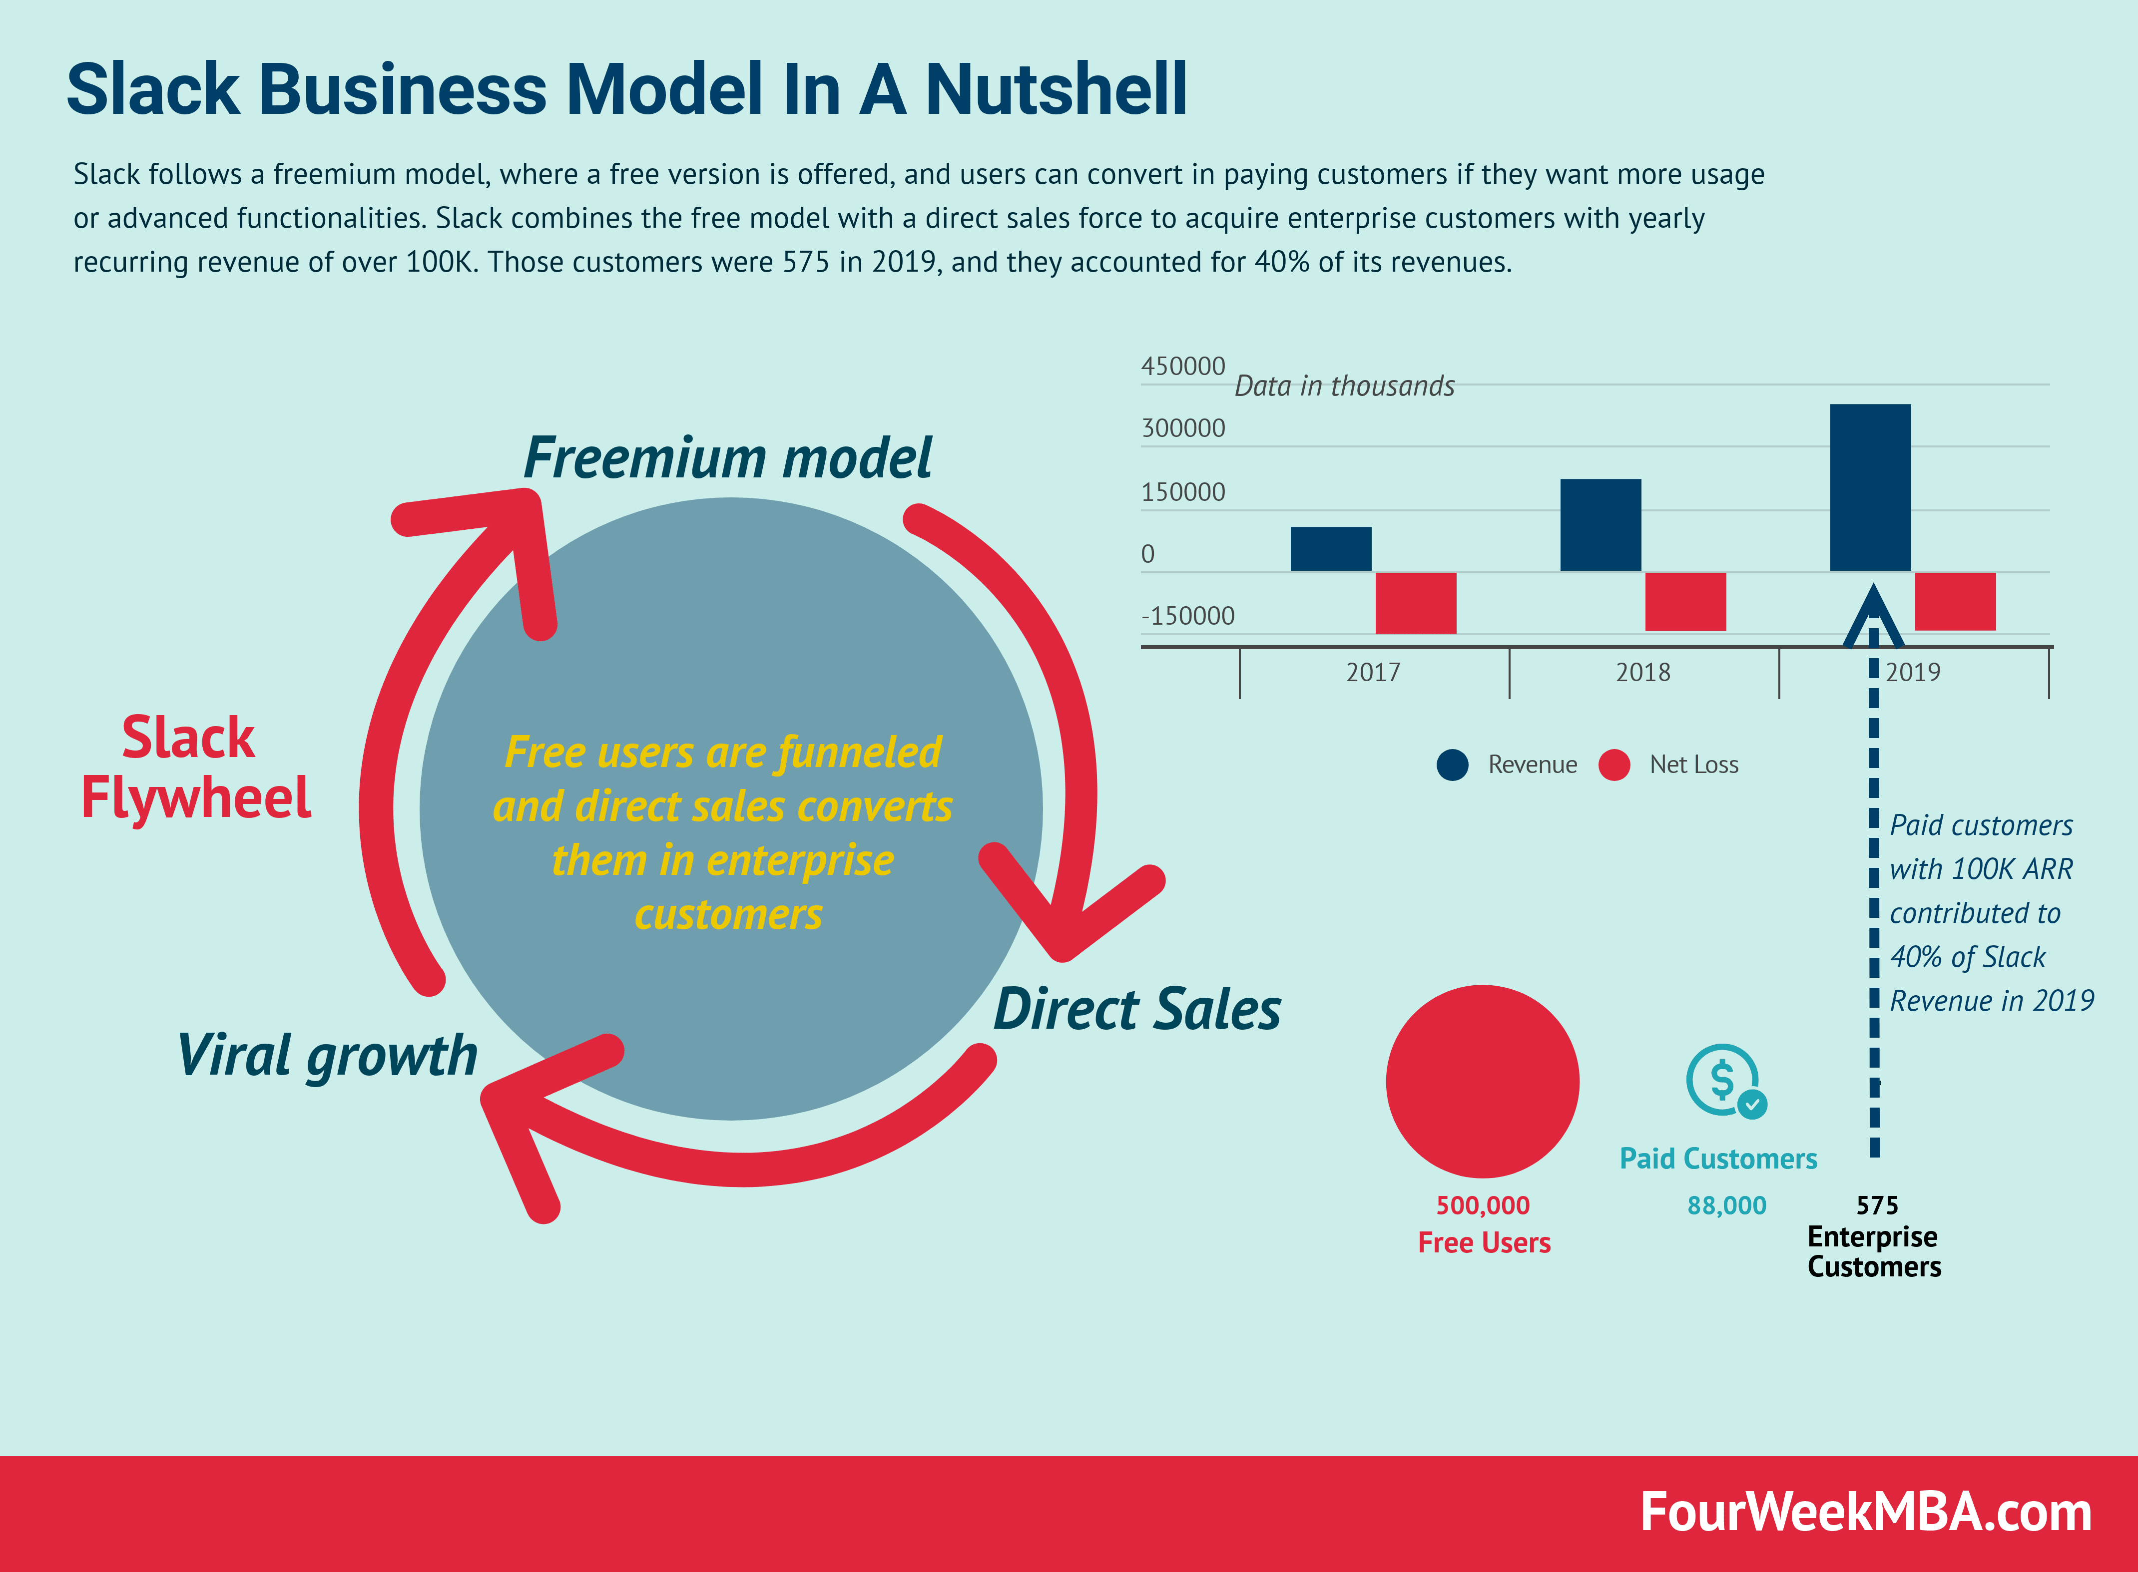

Figure 3 - Slack Business Model

# The reason of the success of Slack

Slack has become so popular and successful because of its addiction and pressure; the workspace is online 24/7 and you are always connected. You have everything you need on Slack due to the enormous number of app integrations.

There are alternatives but most of them fail because, unlikely Slack, you do not need to check the conversations all the time because there are no threaded conversations. On Slack you lose messages if you do not keep updated regularly, feeling social isolated. Another reason is that they did not implement message limits so the historical is always there; on Slack, if you do not pay you start losing conversations.

The reason of success is that people feel emotionally locked because of social pressure.

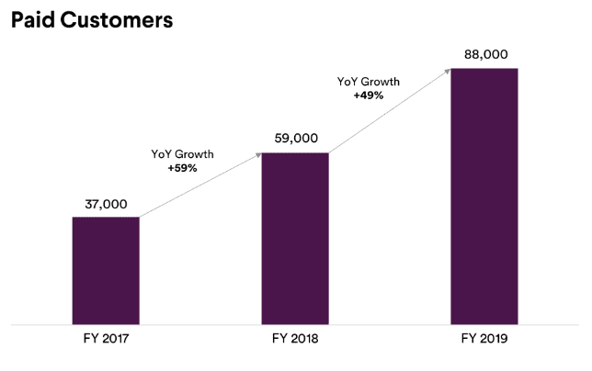

Figure 4 - Paid Customers

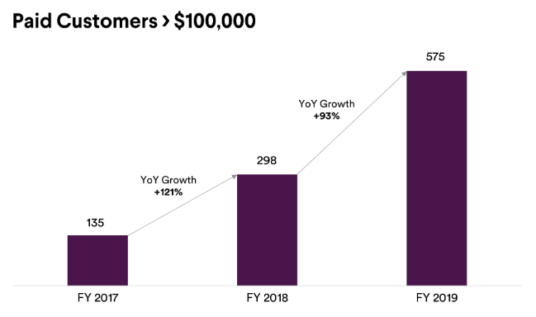

Figure 5 - Slack Paid Customers > $100,000

# Conclusions

With this report I gained a deeper knowledge about business models and understood how Slack has become so popular and gained so many money from investors and has increased his numbers of users every year.

Also, understood what are the costs, the revenues, and so on from the company.

# References

* [1] [Slack - Help Center](https://slack.com/intl/pt-pt/help)
* [2] [Unicornomy - Slack Business Model](https://unicornomy.com/slack-business-model-makes-money-revenue-working/)
* [3] [Wikipedia](https://en.wikipedia.org/wiki/Slack_(software))