***Tomas H. Seged***

**Bank Transactions Simulator**

This project will be able to:

* Withdraw and deposit money from an existing account
* Create a new account
* Exchange currencies (USD, €, £)
* Calculate Loan Amount and Monthly Payment with a given interest rate and number of years
* Provide information about the bank.

1. Home Page

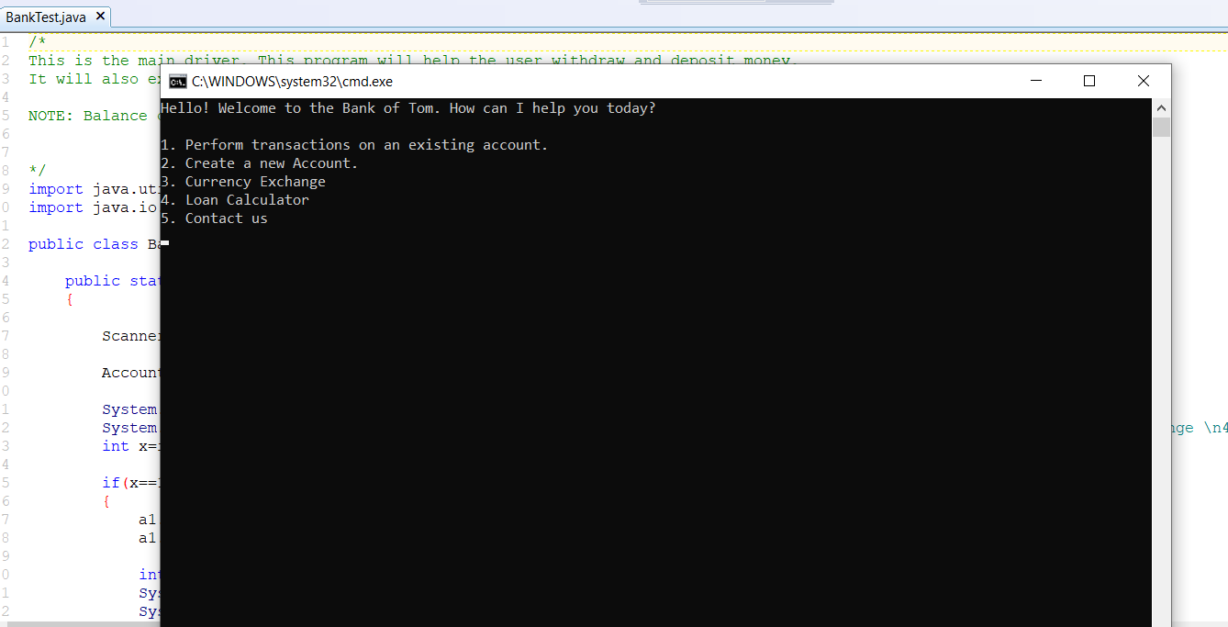

1. Withdrawal

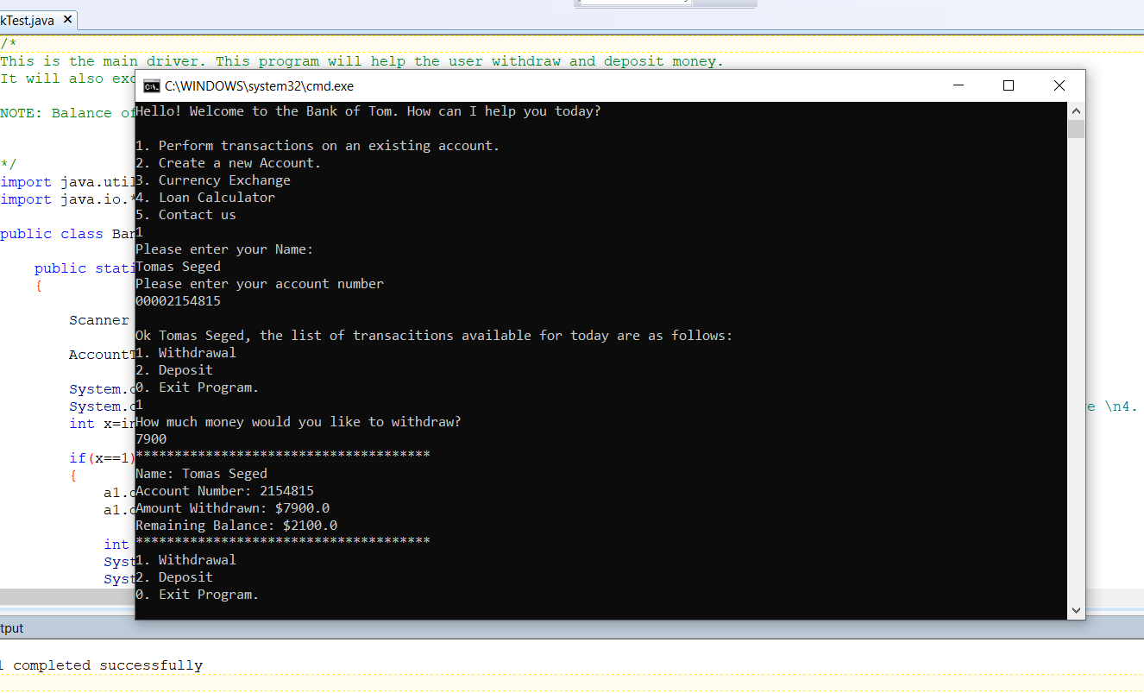

1. Deposit

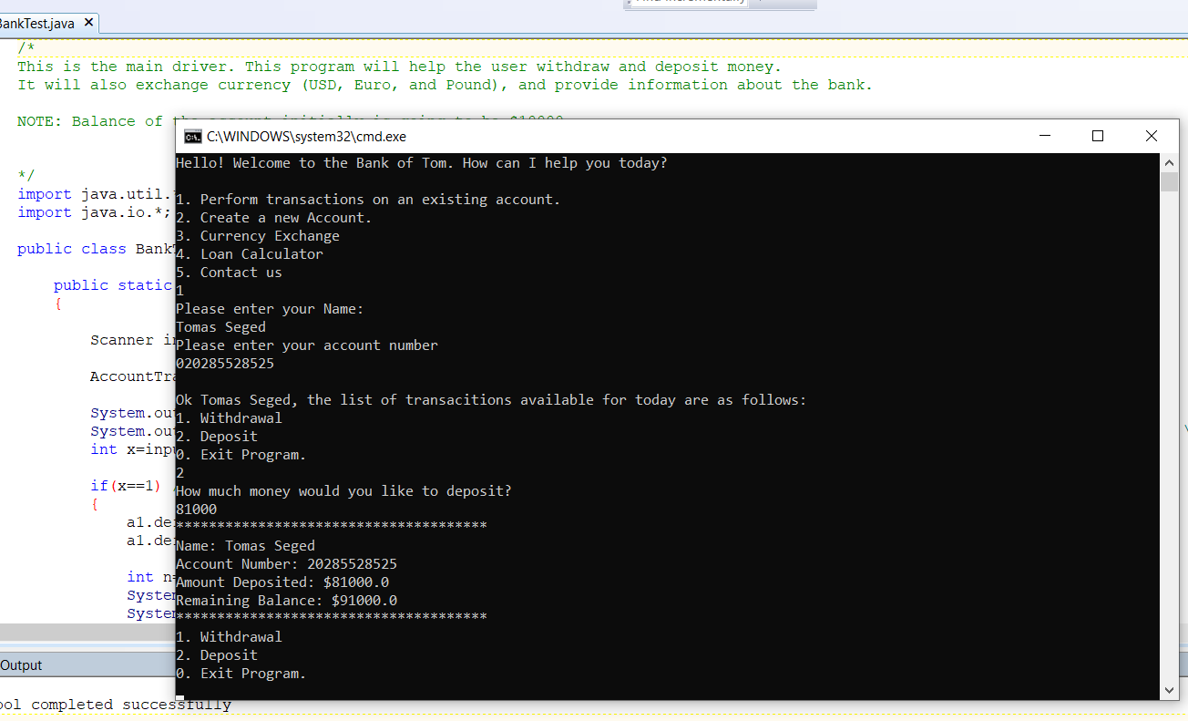

1. Currency Exchange

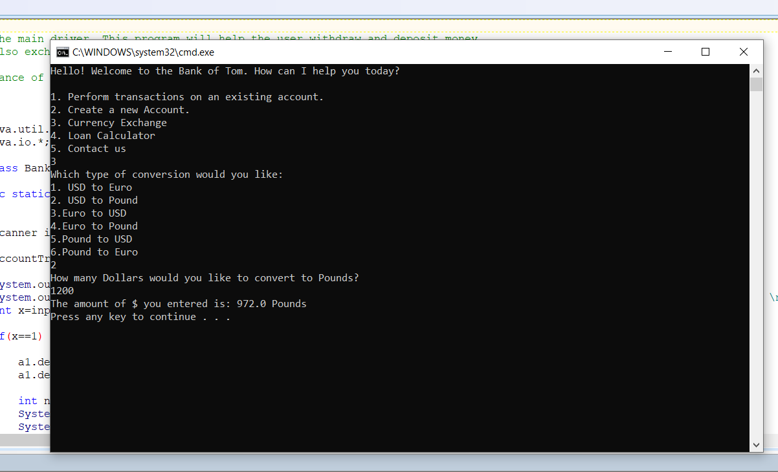

1. Loan Amount

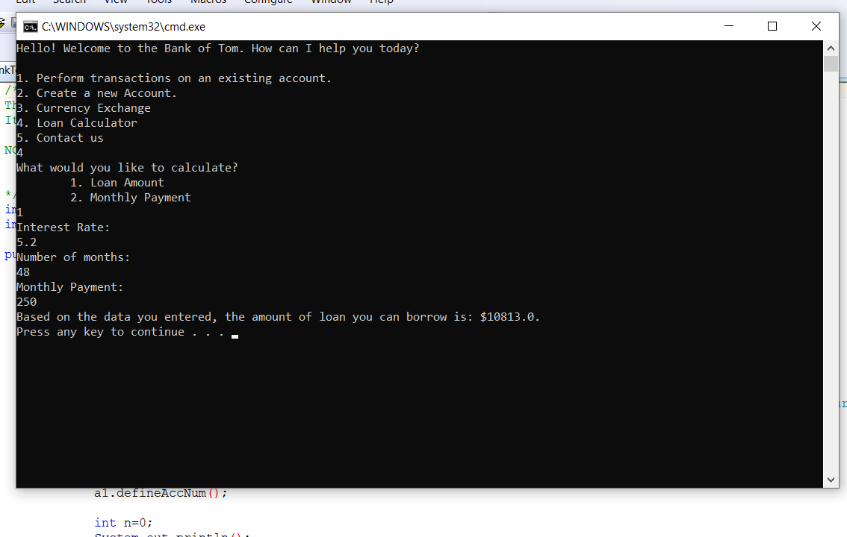

1. Monthly Payment

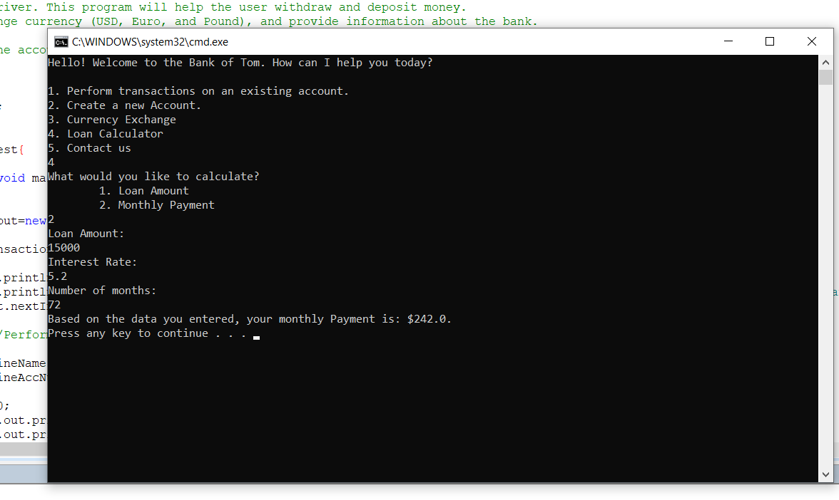

1. Create a new Account

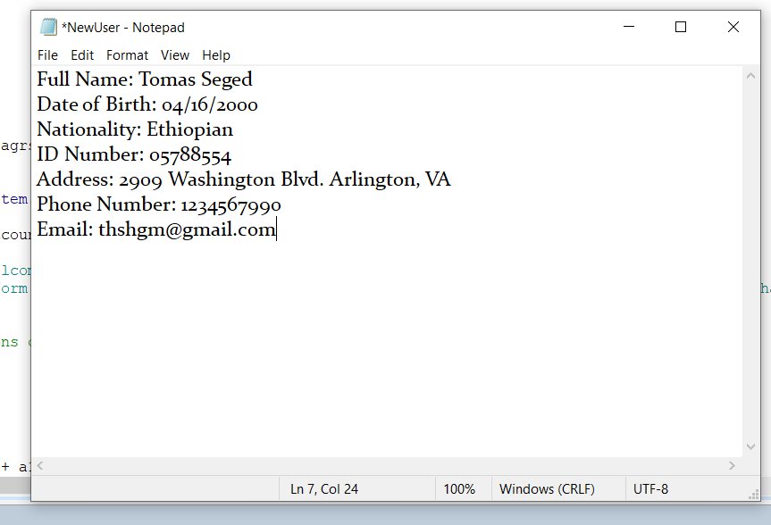

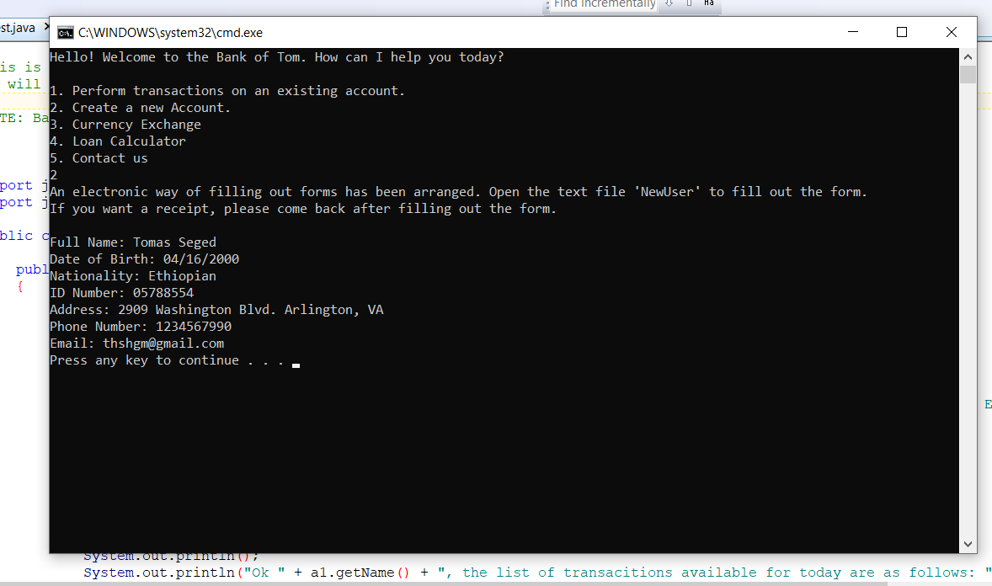

1. Bank Information

