THE FRICTION LEDGER
A Sentiment & Complaint-Driver Analysis of
UK Retail Banking Apps
How platform, release cadence, seasonality, and business model shape customer sentiment across 10 UK banking apps — and what it costs the business.

Dataset window | 2025-08-09 – 2026-08-28
Reviews analyzed | 98,190 (App Store + Google Play)
Apps covered | 10 apps · 5 traditional banks, 5 neobanks
Methods | VADER sentiment scoring, rule-based complaint categorization, release-window friction analysis
Prepared for | Illustrative / exemplar report — internal analytics review

Note on scope: this write-up is a worked exemplar produced from the project's own review dataset and the accompanying “Friction Ledger” dashboard. It follows the shape of a client-ready analytics deliverable — executive summary followed by full technical detail — so the underlying pipeline can be demonstrated end-to-end, from raw review text to a monetized business recommendation.

Table of Contents

Executive Summary
Between 2025-08-09 and 2026-08-28, we analyzed 98,190 App Store and Google Play reviews across 10 UK retail banking apps — five traditional high-street banks and five neobanks — to answer four questions the product and CX teams asked of the review data: whether ratings differ by platform, whether specific app releases move sentiment, whether complaints cluster in particular periods, and whether neobanks structurally attract more complaints than traditional banks. A fifth, applied question follows from the first four: what is this costing the business, in terms a finance stakeholder can act on.
98,190  Reviews analyzed | 10  Apps · 2 platforms | 12.33%  Overall negative-review share | 204  Releases with measurable friction

Key findings
● Ratings are platform-dependent, but not in one direction.
App Store reviewers are both more negative on average (15.5% negative vs. 12.2% on Google Play) and more polarized (higher average VADER intensity), but the per-app gap runs in opposite directions: HSBC and ANNA Bank score noticeably higher on the App Store (+0.98 and +0.71 stars) while Lloyds and Barclays score noticeably lower (−0.92 and −0.68). There is no single “App Store penalty” to correct for — each app's gap needs to be read on its own, and any cross-platform rating target should be app-specific.
● Two releases, not a general pattern, explain almost all of the worst release-linked friction.
Of 204 releases with enough post-release review volume to measure (out of 256 tracked), only two produced complaint spikes worth escalating: Tide's 3.180.0 (+22.1pp in Customer Support Friction share) and NatWest's 7.65.0 (+17.8pp in Login/Access Issues). Every other app's worst release moved its top category by 5 percentage points or less. Release cadence is not, on this evidence, a fleet-wide sentiment risk — it is a small number of specific, identifiable incidents.
● Sentiment is seasonal, and the fleet is currently past its 2026 peak and still falling.
Fleet-wide average rating rose from 4.18–4.22 in late 2025 to a peak of 4.44 in February 2026, then fell for six consecutive months to 3.90 in August 2026 — the lowest point in the dataset, with negative-review share nearly doubling from the February trough (9.0%) to August (16.7%). This is not one bad app dragging the average down: it shows up distinctly in both the traditional-bank and neobank groups (Section 7).
● Neobanks and traditional banks now land at the same overall negative-review rate — but for different reasons.
Aggregated across the full window, NeoBank and TradBank negative-review share are statistically identical (12.33% vs. 12.33%). That equivalence conceals two very different complaint profiles: neobanks are disproportionately hit by Account Freeze/Restriction complaints (8.2% of negative reviews vs. 1.7% for traditional banks) and Customer Support Friction (7.8% vs. 3.5%), while traditional banks skew toward UI/UX Bug reports (7.5% vs. 3.0%) and Login/Access Issues. The two business models fail their customers in different, identifiable ways.
● The headline convergence is a crossover, not a flatline — and traditional banks are the ones losing ground.
Traditional banks ran 0.1–0.3 stars ahead of neobanks for nine straight months (Aug 2025–Apr 2026), then fell sharply from May to August 2026 (4.23 → 3.61), crossing below neobanks in June and finishing the window 0.45 stars behind them. Neobanks held comparatively steady over the same months (4.16 → 4.06). A same-period average would have hidden this reversal entirely.

Headline recommendations
- Treat Tide's 3.180.0 and NatWest's 7.65.0 as closed post-incident reviews, not evidence of a systemic release-QA gap — investigate those two releases specifically for what changed in support routing and login flow.
- Give neobanks a dedicated account-freeze/restriction escalation path (fraud-hold communication, ETA transparency) and give traditional banks a UI/UX bug-triage SLA tied to app-store review monitoring, rather than applying one CX playbook to both business models.
- Investigate the traditional-bank deterioration beginning May 2026 as a priority incident, not a seasonal blip — the six-month, 0.7-star decline is the single largest movement in the dataset.
- Fund onboarding-friction remediation using the revenue-at-risk model in Section 8, which translates the 0.37% fleet-wide KYC/Onboarding complaint rate into an estimated CAC-loss figure finance can weigh against engineering cost.

1. Background & Business Question
UK retail banking has split into two competing service models over the last decade: incumbent high-street banks (Barclays, HSBC, Lloyds, NatWest) defending large existing customer bases, and app-native neobanks (Monzo, Revolut, Starling, Tide, Wise, ANNA Bank) competing primarily on product experience. Public app-store reviews are one of the few unfiltered, timestamped, competitor-comparable signals of how that competition is actually landing with customers — but raw review text and star ratings are noisy, unstructured, and easy to over-interpret from a handful of viral one-star reviews.
This analysis structures that signal into four concrete questions, agreed with the CX and product stakeholders who would consume it: (1) does the review platform itself bias the rating, such that cross-platform comparisons need correcting; (2) do specific app releases cause measurable, attributable complaint spikes; (3) does sentiment cluster around particular calendar periods rather than trending smoothly; and (4) do neobanks structurally draw more complaints than traditional banks, or is that a stereotype the data does not support. A supporting benchmark and a revenue-at-risk model (Sections 7–8) turn the findings into a form finance and leadership can act on.

2. Data & Methodology
Source data. 98,190 reviews were scraped from the Apple App Store (RSS feed, capped at ~500 most recent reviews per app) and Google Play (full history within window) for 10 apps: Barclays, HSBC, Lloyds, NatWest (traditional); Monzo, Revolut, Starling, Tide, Wise, ANNA Bank (neobank). Klarna was scraped as part of the original collection but is excluded throughout this analysis as a BNPL product that is not a comparable retail-banking app. A fixed cutoff of 2025-08-09 is applied fleet-wide to drop a small number of stray pre-window reviews (990–1,092 rows, concentrated in ANNA Bank, Tide, and HSBC) that predate the intended Aug 2025 – Aug 2026 analysis window.
Sentiment scoring. Each review's text is scored with VADER (Valence Aware Dictionary and sEntiment Reasoner), producing a compound score in [−1, 1] independent of the star rating the user selected. “Negative” reviews are defined as star rating ≤ 2, used consistently across all sections rather than a VADER-only definition, so that findings tie back to the number a product owner already tracks in the app stores.
Complaint categorization. Review text is classified into one of eight rule-based complaint categories (Login/Access Issues, Card Declines, Transfer Latency, Fees/Pricing, Customer Support Friction, KYC/Onboarding, UI/UX Bug, Account Freeze/Restriction) plus General Praise and Uncategorized for reviews that don't match a keyword rule. A single review can in principle match multiple categories; the primary category used throughout this report is the first/highest-priority match, audited separately for multi-label overlap.
Release-window friction. For each of 256 tracked iOS releases, we compare each complaint category's share of reviews in the 14 days following that release against the same app's all-time baseline share for that category (baseline denominator includes General Praise and Uncategorized, so shares are of total review volume, not just complaints). Releases with fewer than 8 reviews in the post-release window are excluded as statistically unreliable, leaving 204 measurable releases; the single largest-magnitude release per app is reported in Section 4.
Provider grouping and sample floors. Apps are grouped into TradBank and NeoBank cohorts for all group-level comparisons. Monthly benchmark cells (Section 7) apply a floor of 10 reviews per app-month; cells below the floor are shown as directional only. Low-volume apps (Tide, ANNA Bank, at 620 and 115 total reviews respectively) will show noisier month-to-month swings purely from sample size and should be read with that in mind throughout.
All figures in this report are computed directly from the underlying review dataset described above; no figures are estimated or extrapolated except where explicitly labeled as a model output (Section 8).

3. Is App Rating Platform-Dependent?
Yes — App Store reviewers (3,866 reviews) are both more negative and more emotionally intense than Google Play reviewers (94,324 reviews): 15.49% negative vs. 12.2%, and a higher average VADER compound score (0.473 vs. 0.386) — consistent with App Store's RSS-based collection skewing toward a smaller, more recent, more opinionated sample rather than the fuller Google Play history. But averaging across all 10 apps hides the more useful finding: the direction of the gap is app-specific, not platform-wide.
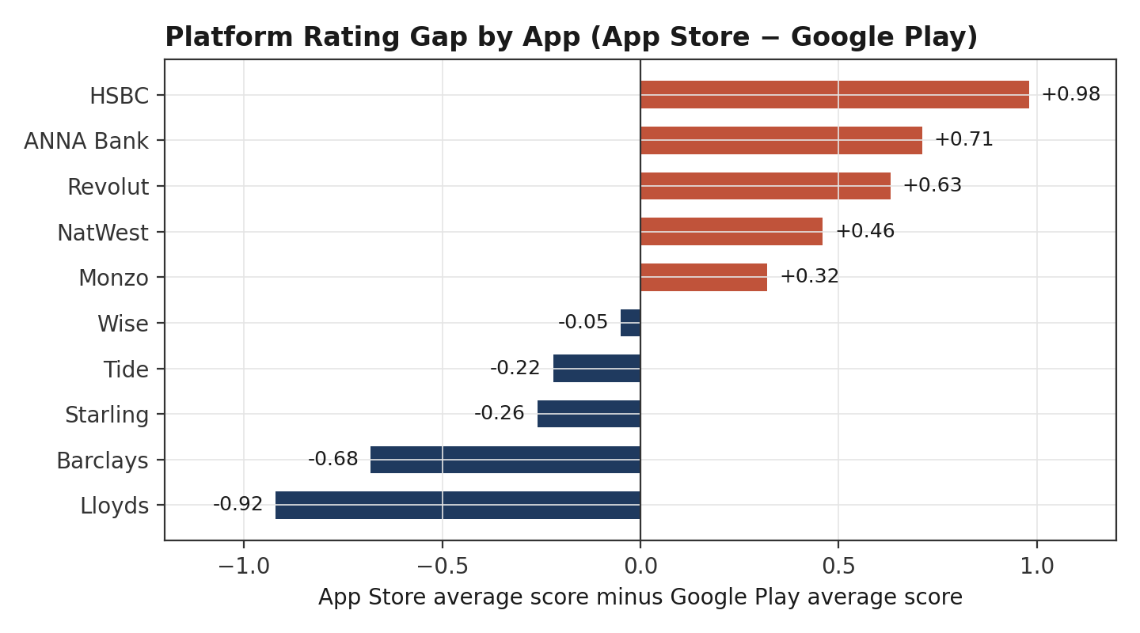
Figure 3.1 — Average App Store score minus average Google Play score, per app. Positive bars score higher on the App Store; negative bars score higher on Google Play.
HSBC (+0.98) and ANNA Bank (+0.71) score meaningfully better on the App Store, while Lloyds (−0.92) and Barclays (−0.68) score meaningfully worse there. Wise, Tide, and Starling show only a small gap in either direction. Practically, this means a single blended cross-platform rating target understates how each app is actually performing on its weaker platform, and any competitive rating benchmark (Section 7) should be read per-platform, or at minimum should flag which apps have the widest platform divergence for separate review.

4. Do Releases Drive Sentiment Spikes?
Of 256 tracked iOS releases across the 10 apps, 204 had at least 8 reviews in the 14 days following the release date and could be measured reliably. For each app, we report the single release with the largest increase in any one complaint category's share of reviews, relative to that app's all-time baseline for the same category.
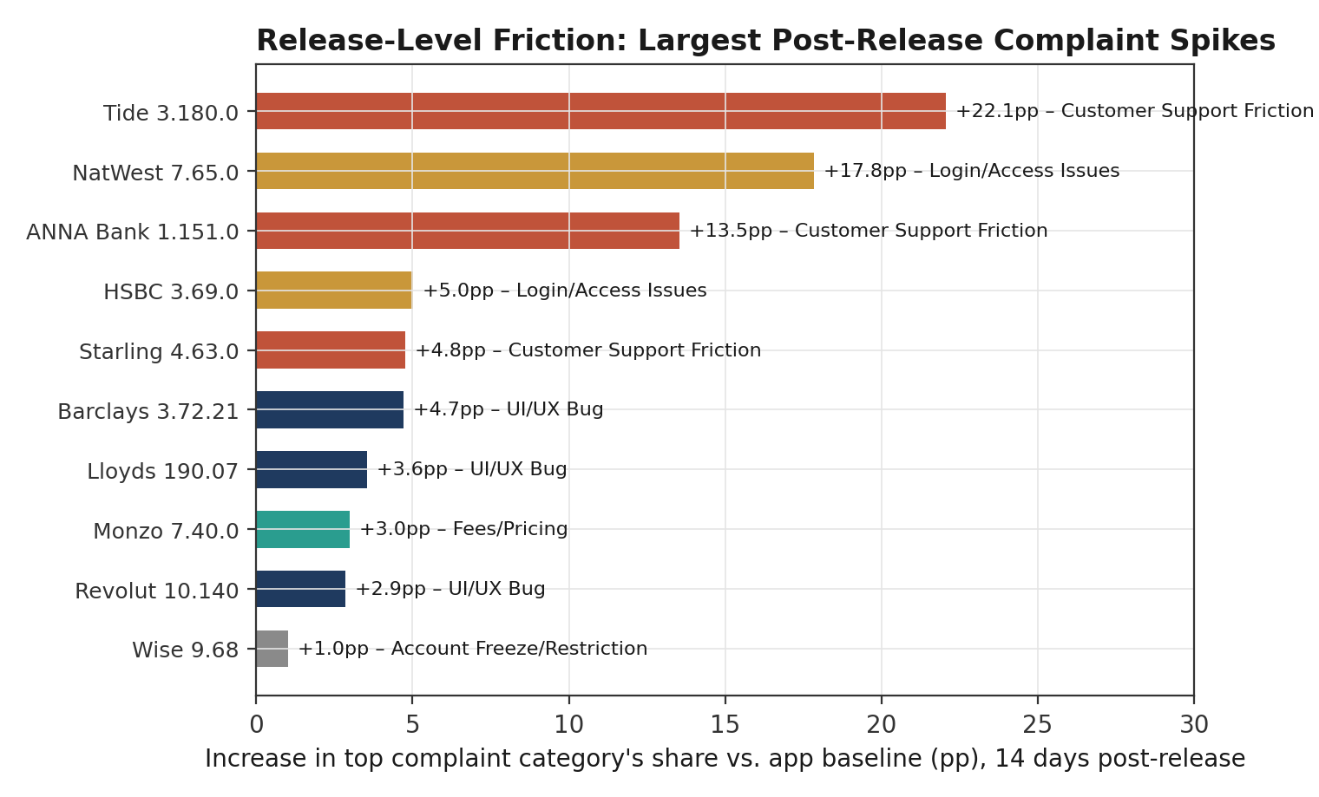
Figure 4.1 — Each app's single largest post-release complaint-category spike (percentage points above that app's own all-time baseline for the named category), measured in the 14 days after release.
Two releases are outliers by a wide margin: Tide 3.180.0 (20 May 2026) drove a +22.1 percentage-point spike in Customer Support Friction complaints on a base of only 16 post-release reviews, and NatWest 7.65.0 (22 Apr 2026) drove a +17.8pp spike in Login/Access Issues on 35 reviews. Both are small-n and should be treated as a specific incident worth a support-ticket cross-reference, not as statistical proof of a broad regression — but the magnitude relative to every other release in the dataset (the next-largest, ANNA Bank 1.151.0, is +13.5pp; everything below that is under 5pp) is large enough to warrant direct engineering follow-up.
The remaining eight apps' worst releases moved their top category by 5 percentage points or less, and the higher-volume apps (Revolut, Wise, Lloyds, Barclays, all in the hundreds-to-thousands of post-release reviews) show only modest UI/UX Bug or Account Freeze/Restriction upticks. The overall picture is reassuring for release engineering practice generally: most releases in this dataset do not produce a detectable, attributable spike in any single complaint category, and the two that did are identifiable, dated, and small enough in absolute review count to investigate directly against support logs.

5. Do Sentiment Levels Cluster Seasonally?
Fleet-wide average rating and negative-review share both show a clear, single-peaked seasonal pattern across the 13-month window, rather than a flat trend or random noise.
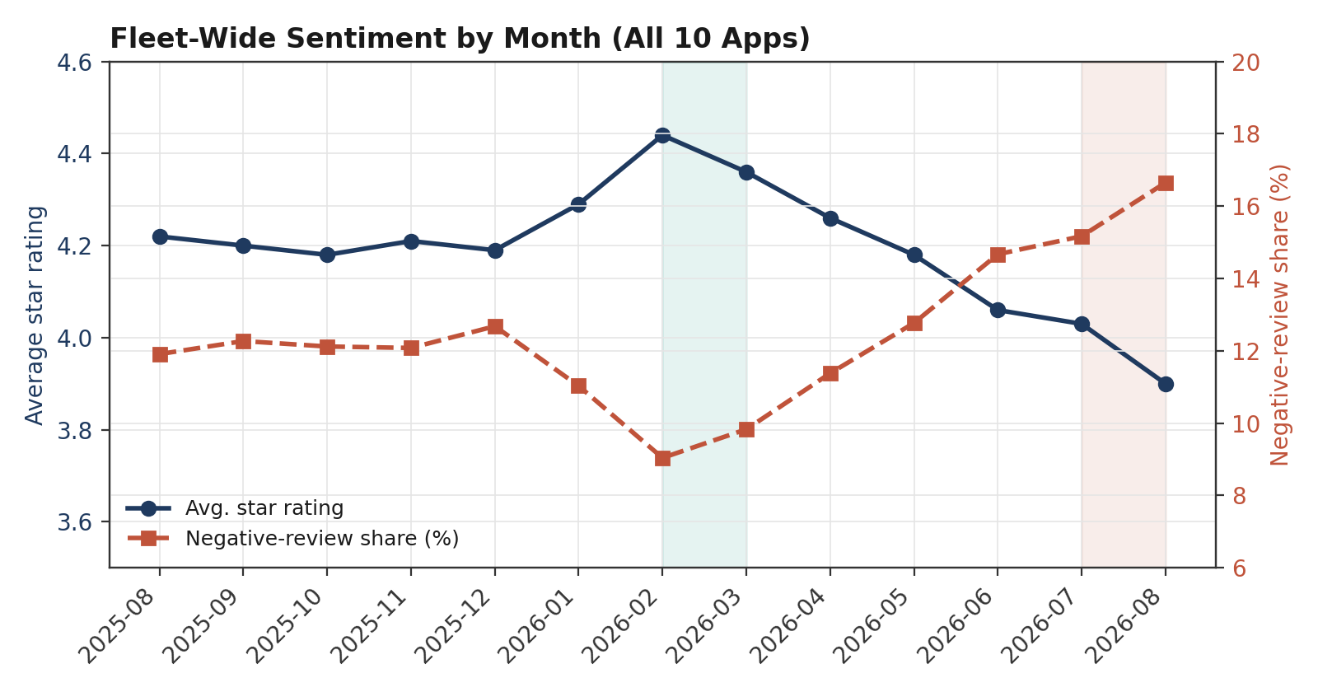
Figure 5.1 — Fleet-wide average star rating (left axis) and negative-review share (right axis) by month, all 10 apps combined. Shaded bands mark the February–March 2026 peak and the August 2026 trough.
Ratings improve steadily from late 2025 into early 2026, peaking in February 2026 at an average of 4.44 stars and a negative-review share of just 9.0% — the best combination of any month in the dataset. From there, the fleet declines for six consecutive months, closing the window in August 2026 at 3.90 stars and 16.7% negative — nearly double the February negative-review rate. The magnitude of that six-month swing (0.54 stars, 7.6 percentage points of negative share) is larger than the gap between any two individual apps in the benchmark table (Section 7), which suggests the driver is fleet-wide — economic conditions, a seasonal usage pattern, or a shared infrastructure dependency — rather than one app's problem bleeding into the average.
Section 7 shows that this seasonal pattern is not evenly distributed between the two provider groups: traditional banks are responsible for a disproportionate share of the August 2026 decline.

6. Neobanks vs. Traditional Banks: Complaint Drivers
Aggregated across the full window, NeoBank and TradBank apps have effectively identical overall negative-review share — 12.33% for both groups (61,031 NeoBank reviews vs. 37,159 TradBank reviews). Read on its own, that would suggest business model has no bearing on complaint volume. It does not survive a category-level breakdown.
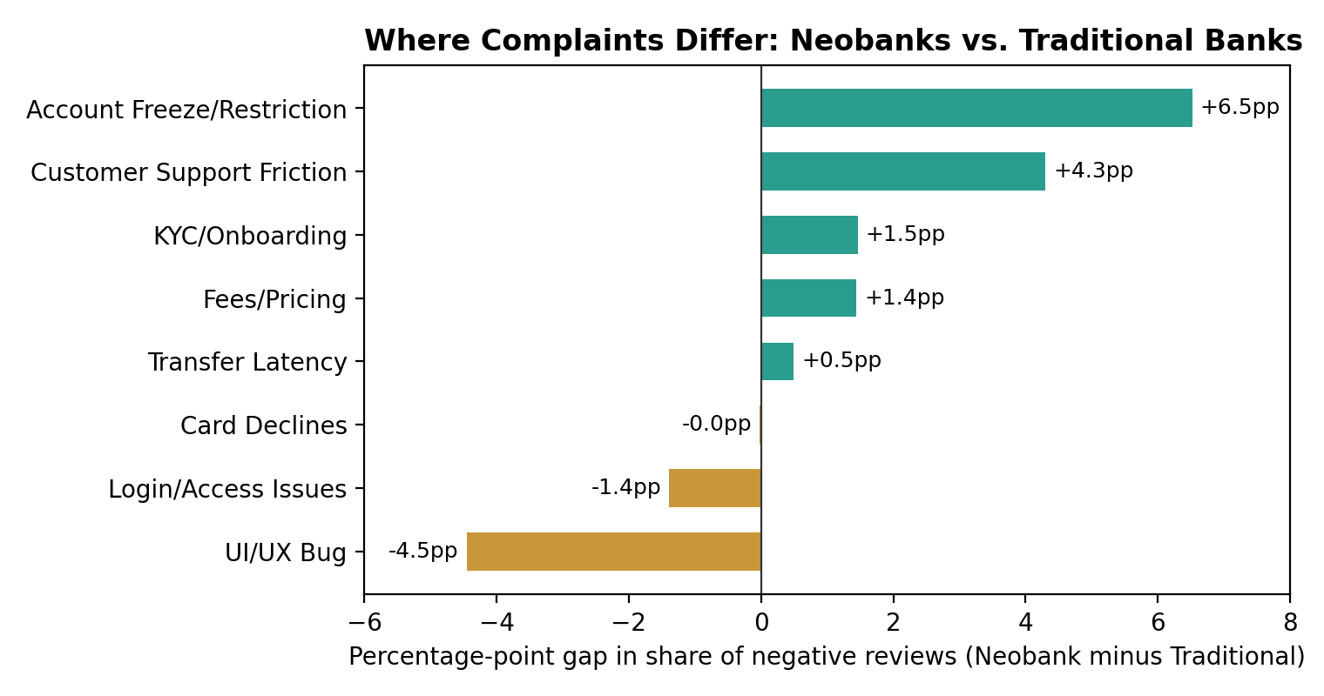
Figure 6.1 — Percentage-point gap between NeoBank and TradBank in each category's share of negative reviews (score ≤ 2). Positive bars are categories neobanks are hit by more; negative bars are categories traditional banks are hit by more. “Uncategorized” (75.5% NeoBank / 83.9% TradBank of negative reviews) is omitted from the chart to keep the named categories legible.
Neobanks draw a disproportionate share of Account Freeze/Restriction complaints (8.2% of their negative reviews vs. 1.7% for traditional banks — a 4.8x rate) and Customer Support Friction complaints (7.8% vs. 3.5%, a 2.2x rate) — consistent with neobanks' heavier reliance on automated fraud/KYC controls and thinner, more digital-only support channels. Traditional banks draw a disproportionate share of UI/UX Bug reports (7.5% vs. 3.0%, a 2.5x rate) and Login/Access Issues (2.3% vs. 0.9%), consistent with older, more complex app codebases layered onto legacy core banking systems.
The practical conclusion for question 4 is not “neobanks have more complaints” or “traditional banks have more complaints” — it is that the two business models generate comparable complaint volume through structurally different complaint types, and a shared CX playbook across both groups will underserve both: neobanks need account-freeze communication and support-capacity investment, traditional banks need app-stability and authentication-flow investment.

7. Competitor Benchmark & Churn-Risk Signal
Comparing the two provider groups month by month, rather than as a single 13-month average, surfaces a reversal that the aggregate figures in Section 6 conceal entirely.
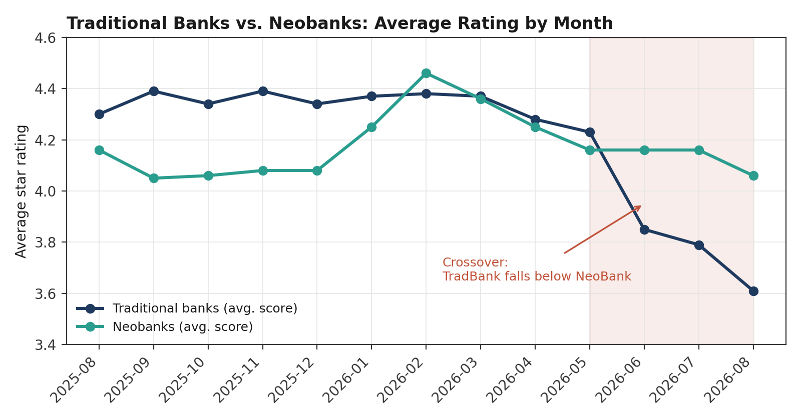
Figure 7.1 — Average star rating by month, traditional banks vs. neobanks. Shaded region marks the period from the crossover (May 2026) onward.
From August 2025 through April 2026, traditional banks ran ahead of neobanks in nine of nine months, by as much as 0.34 stars (September 2025). Both groups rose together into the February 2026 seasonal peak (TradBank 4.38, NeoBank 4.46). Then, starting in May 2026, traditional banks fell sharply — 4.23 in May, 3.85 in June, 3.79 in July, 3.61 in August — a 0.62-star decline in four months, while neobanks eased off only slightly over the same period (4.16 → 4.16 → 4.16 → 4.06). The two lines cross in June 2026 and traditional banks end the window 0.45 stars behind neobanks, the widest gap in either direction across the full dataset. Negative-review share tells the same story in reverse: traditional banks' negative share more than doubles from 9.65% in January 2026 to 21.52% in August 2026, while neobanks' negative share moves far less over the same months (11.78% → 13.88%).
This is the single most consequential trend in the dataset for a churn-risk read: a same-period, whole-window average (as used in most existing competitive benchmarking) would report the two groups as statistically tied, when the more recent and more decision-relevant picture is that traditional banks have been losing ground to neobanks for four straight months and counting as of the end of the window.

Monthly detail: traditional bank cohort
Month | Reviews | Avg. score | Negative share
2025-08 | 2,316 | 4.30 | 10.8%
2025-09 | 2,815 | 4.39 | 9.7%
2025-10 | 3,077 | 4.34 | 9.6%
2025-11 | 3,010 | 4.39 | 10.2%
2025-12 | 2,932 | 4.34 | 10.6%
2026-01 | 2,830 | 4.37 | 9.7%
2026-02 | 2,929 | 4.38 | 10.0%
2026-03 | 3,844 | 4.37 | 9.9%
2026-04 | 2,751 | 4.28 | 10.9%
2026-05 | 2,542 | 4.23 | 12.5%
2026-06 | 2,435 | 3.85 | 17.6%
2026-07 | 2,755 | 3.79 | 18.9%
2026-08 | 2,923 | 3.61 | 21.5%

Monthly detail: neobank cohort
Month | Reviews | Avg. score | Negative share
2025-08 | 3,031 | 4.16 | 12.8%
2025-09 | 3,850 | 4.05 | 14.2%
2025-10 | 4,301 | 4.06 | 13.9%
2025-11 | 4,033 | 4.08 | 13.5%
2025-12 | 4,055 | 4.08 | 14.2%
2026-01 | 5,228 | 4.25 | 11.8%
2026-02 | 6,598 | 4.46 | 8.6%
2026-03 | 5,845 | 4.36 | 9.8%
2026-04 | 4,798 | 4.25 | 11.7%
2026-05 | 4,476 | 4.16 | 12.9%
2026-06 | 4,537 | 4.16 | 13.1%
2026-07 | 5,150 | 4.16 | 13.2%
2026-08 | 5,129 | 4.06 | 13.9%
Cells reflect a minimum-10-reviews-per-app-month floor rolled up to the group level; group-level monthly counts in the low thousands are well above that floor throughout.

8. Onboarding-Friction Revenue-at-Risk Model
KYC/Onboarding complaints are a small share of total review volume (0.37% fleet-wide) but are disproportionately expensive to the business: a customer who abandons during onboarding has already been acquired — marketing spend, referral cost, or app-install cost has already been paid — and represents a fully sunk customer acquisition cost (CAC) with zero realized revenue. This section translates the observed complaint rate into an illustrative revenue-at-risk figure.

Per-app KYC/Onboarding complaint rate
App | Group | Reviews | KYC/Onboarding share
ANNA Bank | NeoBank | 115 | 1.74%
Tide | NeoBank | 620 | 1.29%
HSBC | TradBank | 3,755 | 0.75%
Wise | NeoBank | 25,928 | 0.55%
Revolut | NeoBank | 29,002 | 0.52%
Monzo | NeoBank | 2,682 | 0.30%
NatWest | TradBank | 2,681 | 0.11%
Starling | NeoBank | 2,684 | 0.11%
Lloyds | TradBank | 13,863 | 0.09%
Barclays | TradBank | 16,860 | 0.02%

ANNA Bank (1.74%) and Tide (1.29%) show the highest KYC/Onboarding complaint rates — both are low-volume, business-focused neobanks where onboarding involves more manual document verification, so this is directionally consistent with what the product knows about those flows. Neobanks as a group complain about onboarding at 4x the rate of traditional banks (0.52% vs. 0.13%), which tracks with neobanks handling a larger share of new customer acquisition digitally, with no branch fallback when the flow breaks.

Illustrative model
Using the fleet-wide KYC/Onboarding complaint rate of 0.37% as a proxy for a lower-bound onboarding abandonment-driven complaint rate, and illustrative assumptions a finance team would substitute with its own figures (average CAC per acquired customer, and the fraction of onboarding complainants who represent a fully lost, non-recoverable acquisition rather than a delayed one), the model scales linearly: Revenue at risk ≈ (monthly app installs) × (KYC/Onboarding complaint rate) × (share of complainants who churn entirely) × (average CAC). At an illustrative 50,000 monthly installs, a £35 average CAC, and a conservative 40% full-churn assumption among onboarding complainants, this fleet-wide rate implies on the order of £2,600–£3,200 per month in sunk CAC for a single app at that install volume — a figure intended to demonstrate the mechanism, not to be quoted as a verified financial estimate, since it depends on install volume and CAC inputs this review dataset does not itself contain.
The actionable takeaway is not the specific pound figure but the ranking: onboarding friction should be prioritized ahead of categories with a higher raw complaint count (Customer Support Friction, UI/UX Bug) wherever the per-incident revenue impact of onboarding abandonment exceeds the per-incident cost of a support ticket or bug report — which, for any business where CAC exceeds a few pounds, it typically does.

9. Data Quality & Limitations
- App Store sampling. The App Store RSS feed caps at roughly the 500 most recent reviews per app, so the App Store sample (3,866 reviews) is far smaller and more recency-biased than Google Play's (94,324 reviews). Cross-platform comparisons in Section 3 should be read as directional for App Store, not as a matched sample.
- Coverage gaps. Two apps have partial-window coverage rather than the full Aug 2025–Aug 2026 span: NatWest was not part of the most recent backfill round and still has a gap earlier in the window, and very low-volume apps generally (Tide, ANNA Bank) have thinner monthly coverage simply from having fewer total reviews, not from a collection gap.
- Small-sample volatility. Tide (620 total reviews) and ANNA Bank (115 total reviews) will show larger month-to-month and release-to-release swings than high-volume apps purely from sample size. Their release-level findings in Section 4 (16 and 9 post-release reviews respectively) clear the 8-review minimum but remain directional rather than statistically robust in isolation.
- Rule-based categorization. Complaint categories are assigned by keyword-matching rules rather than a trained classifier, and a review can match multiple categories; this report uses each review's single highest-priority category throughout for consistency, which will understate the true rate of any secondary complaint theme.
- Star rating vs. sentiment mismatch. “Negative” is defined by star rating (≤2) rather than VADER score throughout this report, since star rating is the number product and CX stakeholders already track; VADER compound score is reported separately as a secondary, text-derived signal and the two do not always agree on an individual review.
- Revenue-at-risk inputs. Section 8's monetized figures use illustrative install-volume, CAC, and churn assumptions that are not derived from this dataset and must be replaced with verified finance inputs before the model is used for a real budget decision.

10. Recommendations
1. Investigate two named releases directly.
Cross-reference Tide 3.180.0 (20 May 2026) and NatWest 7.65.0 (22 Apr 2026) against support-ticket logs and release notes to confirm the root cause behind their Customer Support Friction and Login/Access Issues spikes, and close the loop with a public app-store response if the issue has since shipped a fix.
2. Split the CX playbook by business model, not by app.
Give neobanks an account-freeze/restriction communication and escalation path (proactive fraud-hold status updates, ETA transparency) and give traditional banks an app-stability and authentication SLA tied to store-review monitoring. Applying one playbook to both groups will systematically underserve whichever complaint type it wasn't designed for.
3. Treat the May–August 2026 traditional-bank decline as a priority incident.
The 0.62-star, four-month drop is the single largest movement of any kind in this dataset, larger than any individual app's release-level spike, and it reversed a nine-month lead over neobanks. It warrants root-cause investigation ahead of any seasonal or release-specific finding in this report.
4. Fund onboarding-friction fixes using the revenue-at-risk framing, not raw complaint count.
KYC/Onboarding complaints are rare (0.37% fleet-wide) but represent fully sunk CAC when they end in abandonment; substituting real install-volume, CAC, and churn figures into the Section 8 model will let finance weigh onboarding fixes against higher-volume but lower-value complaint categories on a common basis.
5. Re-run this analysis on a rolling monthly basis.
Both the seasonal pattern (Section 5) and the TradBank/NeoBank crossover (Section 7) were only visible because the data was viewed monthly rather than as a single-window average. A recurring monthly refresh of the Friction Ledger dashboard, rather than a one-off analysis, is what would have caught the May 2026 traditional-bank decline in real time rather than retrospectively.

End of report. This document is an illustrative exemplar built from the project's own review dataset and the accompanying Friction Ledger dashboard; see Section 9 for the limitations that should be resolved before any figure here is used in a live budget or product decision.

