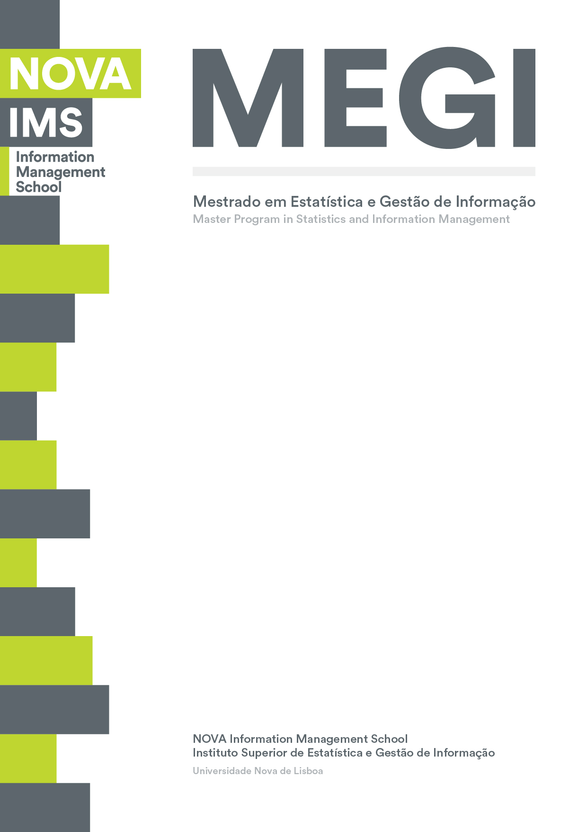

**Data Visualization Project**

**MASTER DEGREE PROGRAM IN DATA SCIENCE AND ADVANCED ANALYTICS**

**Happiness In the World:**

**An Analysis of Socio-Economic Factors**

Diogo Morgado, number: 20221394

Tomás Bourdain number: 20221354

April 2023

INDEX

1. Introduction iii

2. Datasets iv

3. Results and Discussion v

4. Conclusion vi

5. References vii

6. Appendix (Doesn’t count for the 10page limit) viii

# Introduction

The World Happiness Report is an annual publication that aims to measure and understand subjective well-being and happiness across countries and cultures. It is produced by the Sustainable Development Solutions Network, a global initiative launched by the United Nations in 2012, and ranks countries based on a variety of factors such as income, social support, freedom to make life choices, generosity, and perceptions of corruption.

As people around the world continue to grapple with the Ukraine War and its socio-economic impacts, understanding the factors that contribute to happiness and well-being has become more important than ever. In this context, data visualization projects can be a powerful tool for exploring and communicating complex data in an accessible and engaging way.

The project we developed aims to highlight the relationship between socio-economic factors and happiness levels around the world. By analyzing data from the World Happiness Report and other sources, we created interactive visualizations that allow users to explore how factors such as income, education, and social support impact happiness levels in different countries and regions.

By making this data more accessible and engaging, our project can help raise awareness of the importance of socio-economic factors in shaping happiness and well-being, and contribute to ongoing efforts to build a more equitable and sustainable world for all.

o Explain what the inspiration for this work was (paper? Website?)

o Explain what the type of interaction is going to be available to users

# Datasets

Having access to multiple datasets is a great advantage for any data analysis project. In our case, we have 15 datasets that comprise data from the World Happiness Report for the years 2015 to 2023. This is a valuable resource for understanding how happiness levels have changed over time and identifying trends and patterns across different countries and regions.

In addition to the World Happiness Report datasets, we also have data on unemployment rates in countries from 2015 to 2021 and inflation rates in countries from 2015 to 2022. These datasets provide important contextual information that can help explain changes in happiness levels over time. For example, if a country experienced a spike in unemployment or inflation during a particular year, this may have had an impact on the happiness levels of its citizens.

To help the user analyze and visualize this data, we also have a dataset for country codes, which will allow us to match data from different datasets based on the country in question. Similarly, we have a dataset for coordinates, which we use to create maps and spatial visualizations of the data. Finally, we have a dataset that provides population details for countries, including population size, growth rate, density, and area. This information will be useful for understanding how changes in happiness levels are related to population dynamics.

Overall, the combination of these datasets provides a rich and nuanced picture of happiness levels around the world, and the socio-economic factors that contribute to them. By using advanced data analysis techniques and creating powerful visualizations, we can uncover insights and patterns that may be missed by a simple analysis of individual datasets. This information can help inform policies and interventions aimed at improving happiness levels and well-being for people around the world.

o Dataset description (you are free to select what dataset you prefer).

o Technical aspects (explain how you implemented the project, e.g., provide the code used in a GitHub page).

o Visualization and interaction choices.

# Results and Discussion

When reading a visualization using a data visualization (DV) perspective, it is important to consider the data encoding and data filtering used in the visualization. These factors can greatly impact the user's ability to interact with and interpret the data.

In the Dashboard the user will be able to select data for interactive visualization based on several parameters. Specifically, the user will be able to filter the data by happiness score and the factors that contribute to it, as well as by region (such as Western Europe or North America) and by individual country. This level of interactivity allows the user to explore the data in greater detail, and to identify specific relationships and patterns within the data that may not be immediately apparent.

The use of data encoding and data filtering in this visualization can greatly enhance the user's ability to explore and understand the data. By providing multiple ways to interact with the data and representing it in a clear and intuitive way, this visualization has the potential to facilitate deeper insights and understanding about the factors that contribute to happiness levels around the world.

Reading the visualization using a DV perspective.

▪ Data encoding (what data encodings were used?).

▪ Data filtering (will the user be able to select data for interactive visualization).

# Conclusion

In conclusion, the data visualization project aimed at building a dashboard for the World Happiness Report has been a valuable tool for exploring and understanding the factors that contribute to happiness levels around the world. By bringing together multiple datasets and using advanced data visualization techniques, we were able to create an interactive and engaging dashboard that allows users to explore the data in greater detail and identify patterns and relationships that may not be immediately apparent.

However, there is still much more work to be done in this area. In particular, we would like to obtain more specific information about individual countries in order to better analyze the factors that may influence happiness levels. For example, by collecting data on cultural factors, economic indicators, and social policies, we could gain a deeper understanding of how these factors contribute to happiness levels in different countries.

Additionally, we could incorporate machine learning algorithms and predictive analytics to create models that can identify patterns and trends in the data, and make predictions about future happiness levels in different regions or countries. By continuing to refine and expand our data visualization and analysis techniques, we can gain valuable insights into the complex factors that contribute to happiness levels, and work towards developing policies and interventions that can improve the well-being of people around the world.

# References

Munzner, T. (2015). *Visualization analysis and design.* CRC Press. Taylor and Francis.

Schroeder, A., Mayer, C., & Ward, A. M. (2022). *The Book of Dash: Build Dashboards with Python and Plotly.* No Starch Press.

*World Happiness Report 2023*. (n.d.). Retrieved from World Happiness Report: https://worldhappiness.report/

# Appendix (Doesn’t count for the 10page limit)