**RNGFighter Testing**

**G00349242 Tomas Brazas**

1. Successfully compile and run.
2. Display MainMenu page with images as shown in Fig 2.0.
3. Background Sound is playing.
   1. Mute/Unmute function is evident and working as shown in Fig 3.1.
4. Can Exit the Application by clicking “Quit” as shown in Fig 4.0.
5. New Game button navigates to MainPage.
6. Load Game button navigates to Saves Page.
7. Return button in Saves Page returns to main Menu
   1. Loading a save deserializes the json file and start new game.
8. On MainPage all images/buttons load as shown on Fig 8.0.
9. Clicking randomly on buttons eventually gives a score as shown in Fig 9.0.
10. Spamming a button eventually gives a score.
11. Clicking Start begins the stopwatch as shown in Fig 11.0.
12. Clicking Mute, mutes the background music, clicking again resumes.
13. 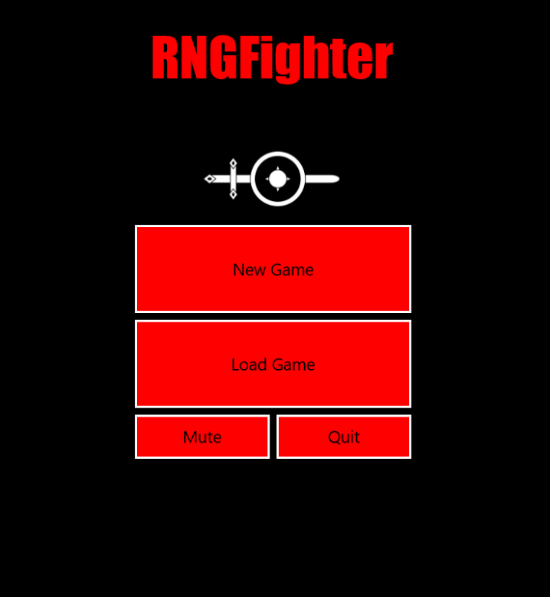Pressing arrow key to return to main menu.



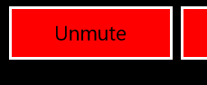

Fig 3.1



Fig 4.0

Fig 2.0

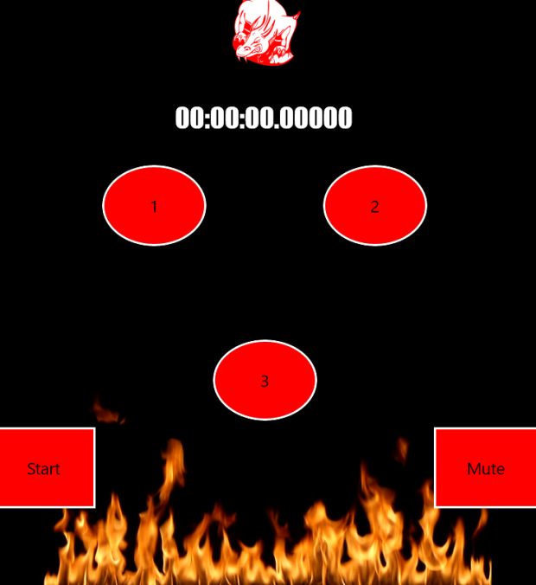

Fig 8.0

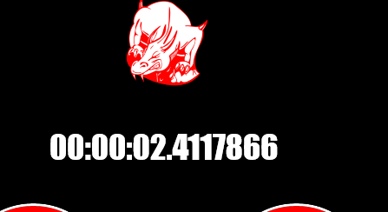

Fig 11.0

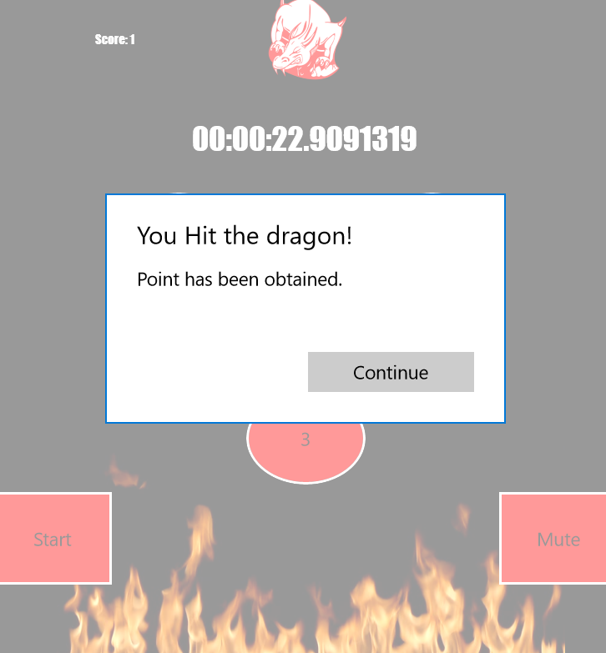

Fig 9.0