Orange Pi 5 Pro: Booting from eMMC (Hardcore Mode)
Partition • Clone microSD → eMMC • Fix fstab + orangepiEnv • Install U-Boot to eMMC

Orange Pi 5 Pro board overview (for finding the MaskROM button and ports).

What this guide does
This is a simple, step-by-step “hardcore mode” guide to move an existing Orange Pi OS install from a microSD card to the onboard eMMC and then boot from eMMC with the microSD removed.
It assumes you can boot from microSD right now. We will:
• Identify which device is microSD vs eMMC
• Wipe + partition + format eMMC
• Clone the running system to eMMC (rsync)
• Fix /etc/fstab and orangepiEnv.txt to point to the eMMC UUIDs
• Install U-Boot bootloader to eMMC (so it actually starts without the microSD)

Before you start
You need: a working bootable microSD, keyboard/monitor (or SSH), and reliable power. If you have important data, back it up first.
Tip: On Orange Pi 5 Pro, Linux usually shows the eMMC as /dev/mmcblk0 and the microSD as /dev/mmcblk1 (but always verify on YOUR board).

1) Identify microSD vs eMMC
Boot from your microSD and run:
lsblk -f
findmnt /
findmnt /boot
If you are currently booted from microSD you’ll typically see / mounted from /dev/mmcblk1p2 and /boot from /dev/mmcblk1p1.
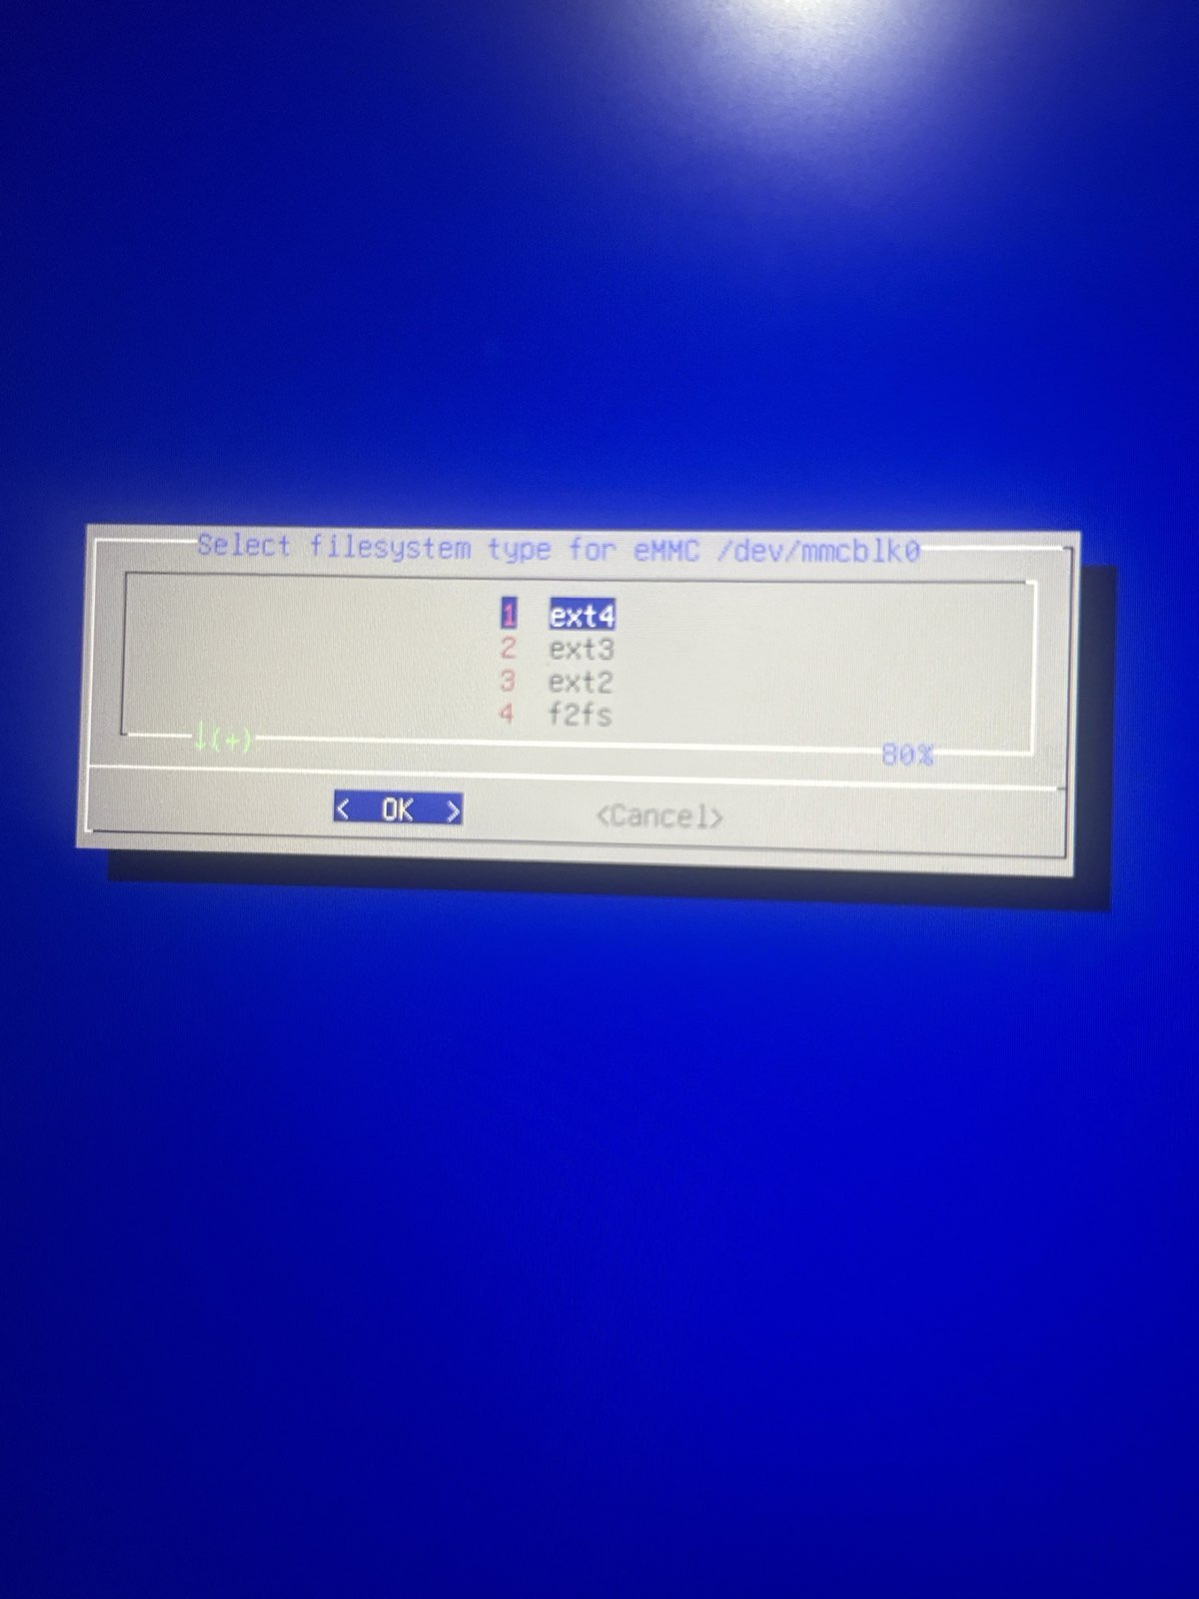
Example: lsblk output while booted from microSD (both mmcblk0 and mmcblk1 visible).

2) Wipe the eMMC (optional but recommended)
WARNING: This erases the eMMC completely. Double-check the device name before running any wipe commands.
To wipe signatures and the first ~64MiB:
sudo wipefs -a /dev/mmcblk0
sudo dd if=/dev/zero of=/dev/mmcblk0 bs=1M count=64 conv=fsync
sync

3) Partition the eMMC (GPT)
We’ll create two partitions (simple and works well):
• p1: 1GiB FAT32 for /boot
• p2: the rest as ext4 for /
sudo parted -s /dev/mmcblk0 mklabel gpt
sudo parted -s /dev/mmcblk0 mkpart primary fat32 16MiB 1050MiB
sudo parted -s /dev/mmcblk0 set 1 boot on
sudo parted -s /dev/mmcblk0 mkpart primary ext4 1050MiB 100%
sudo partprobe /dev/mmcblk0
sudo udevadm settle

4) Format the eMMC partitions
sudo mkfs.vfat -F 32 -n opi_boot /dev/mmcblk0p1
sudo mkfs.ext4 -F -L opi_root /dev/mmcblk0p2

5) Mount and clone the system (rsync)
Mount the new eMMC root and boot partitions:
sudo mkdir -p /mnt/emmcroot
sudo mount /dev/mmcblk0p2 /mnt/emmcroot
sudo mkdir -p /mnt/emmcroot/boot
sudo mount /dev/mmcblk0p1 /mnt/emmcroot/boot
Clone the running system from microSD → eMMC. This copies files while keeping permissions and links:
sudo rsync -aAXH --numeric-ids --exclude={"/dev/*","/proc/*","/sys/*","/run/*","/tmp/*","/mnt/*","/media/*","/lost+found","/var/log.hdd/*"} / /mnt/emmcroot/
sync

6) Get the new eMMC UUIDs
Now read the UUIDs for the eMMC partitions (you will paste these into config files):
sudo blkid /dev/mmcblk0p1 /dev/mmcblk0p2

7) Fix /etc/fstab on the eMMC
Edit the eMMC copy of fstab (NOT the one on the running microSD):
sudo nano /mnt/emmcroot/etc/fstab
Replace the / and /boot UUIDs with the ones from mmcblk0p2 and mmcblk0p1. Example:
UUID=<UUID-of-mmcblk0p2> / ext4 defaults,noatime,commit=600,errors=remount-ro 0 1
UUID=<UUID-of-mmcblk0p1> /boot vfat defaults 0 2
tmpfs /tmp tmpfs defaults,nosuid 0 0
If you accidentally have /tmp twice, remove the duplicate line (keep only one).

8) Point orangepiEnv.txt to the eMMC root UUID
Orange Pi OS uses /boot/orangepiEnv.txt to pass boot parameters. On the eMMC, edit:
sudo nano /mnt/emmcroot/boot/orangepiEnv.txt
Change rootdev=UUID=... to the UUID of /dev/mmcblk0p2 (your eMMC root). Example:
rootdev=UUID=<UUID-of-mmcblk0p2>
rootfstype=ext4
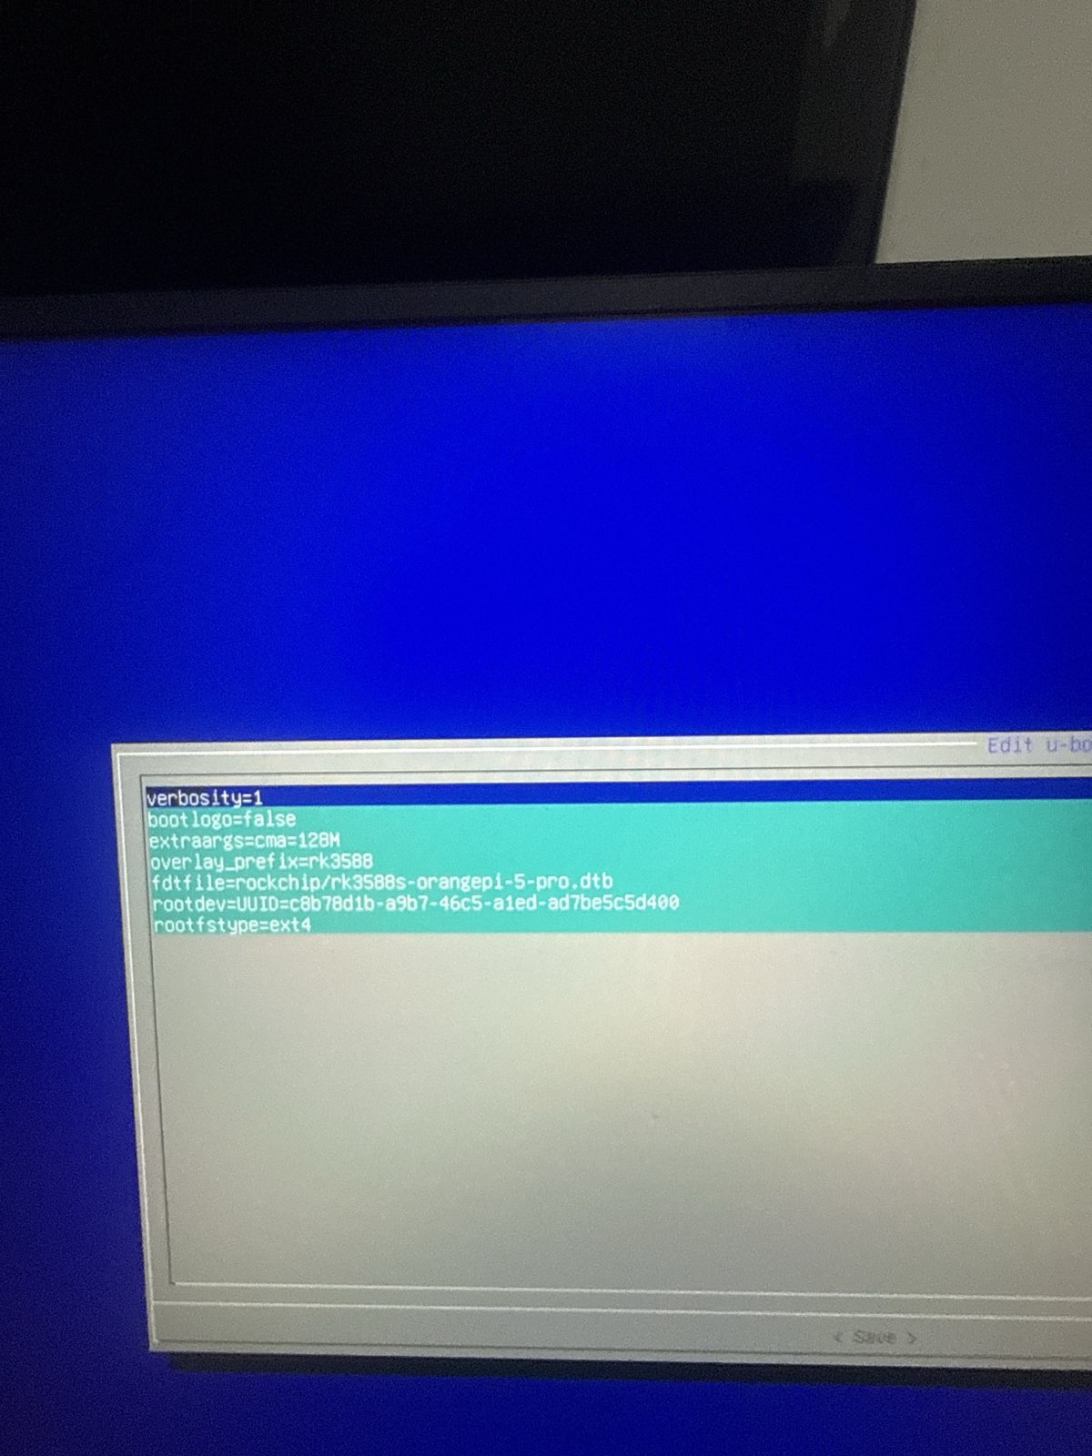
orangepiEnv.txt editor screen: rootdev should match the eMMC root UUID.

9) Install the bootloader to eMMC (the step that usually fixes “red light only”)
If the system copies fine but the board will not start without the microSD, it’s almost always because U-Boot is still only present on the microSD.
Orange Pi OS includes U-Boot images in /usr/lib/linux-u-boot-current-orangepi5pro_*/. First find them:
sudo find /usr/lib -type f \( -name "idbloader.img" -o -name "u-boot.itb" \) 2>/dev/null
Then write them to the standard RK3588 offsets on the eMMC (mmcblk0):
# idbloader at sector 64 (32KiB)
sudo dd if=/usr/lib/linux-u-boot-current-orangepi5pro_1.0.4_arm64/idbloader.img of=/dev/mmcblk0 bs=512 seek=64 conv=fsync
# u-boot.itb at sector 16384 (8MiB)
sudo dd if=/usr/lib/linux-u-boot-current-orangepi5pro_1.0.4_arm64/u-boot.itb of=/dev/mmcblk0 bs=512 seek=16384 conv=fsync
sync
Optional sanity check (you should see signatures like “RKNS” and “FIT Image…”):
sudo dd if=/dev/mmcblk0 bs=512 skip=64 count=1 | hexdump -C | head
sudo dd if=/dev/mmcblk0 bs=512 skip=16384 count=1 | hexdump -C | head

10) Unmount, power off, remove microSD, boot
sync
sudo umount /mnt/emmcroot/boot
sudo umount /mnt/emmcroot
sudo poweroff
After the board is fully off, remove the microSD and power on. First boot may take a bit longer.

How to confirm you’re actually on eMMC
After booting with the microSD removed, run:
lsblk
findmnt /
findmnt /boot
You should see / mounted from /dev/mmcblk0p2 and /boot from /dev/mmcblk0p1.

Troubleshooting
• Still red light only: re-check the bootloader write (Step 9). If you wrote U-Boot to the wrong device, it won’t start.
• It boots but drops to initramfs / can’t mount root: your fstab or orangepiEnv.txt rootdev UUID is wrong (Steps 7–8).
• Missing /boot/extlinux: On Orange Pi OS, /boot may use boot.scr/orangepiEnv.txt instead of extlinux. That’s OK.
• RockUSB/MaskROM not detected: use the board’s MaskROM key and a data-capable USB-C cable; connect to the OTG USB-C port.

Appendix: The orangepi-config menus (optional) — why they sometimes “don’t work”
orangepi-config can automate parts of the eMMC migration. The menu usually offers options like:
- Boot from eMMC — system on eMMC
- Install/Update the bootloader on SD/eMMC
These options can work, but sometimes you select them, power off, remove the microSD… and the board still won’t boot (red light only), or it keeps booting from microSD when it’s inserted.

Why this happens (the important bit)
On the Orange Pi 5 Pro (RK3588), Linux root filesystem location (your / partition) and the bootloader location are two different things:
- Your OS files may be correctly copied to eMMC (/dev/mmcblk0p2)
- Your fstab and orangepiEnv.txt may correctly point to the eMMC UUID
- But if the eMMC does not have a valid Rockchip bootloader written in the correct boot sectors, the board can’t start from it.
So the menu may successfully clone the filesystem but still fail booting because the actual boot chain (idbloader + u-boot.itb) is missing or written only to the microSD.

The “chip that points to microSD” (what’s really happening)
It’s not a special “chip” you configure in Linux — it’s the boot ROM boot order of the RK3588 plus whatever bootloader is present on the storage devices:
- If microSD has a valid bootloader, the ROM happily boots from it.
- If eMMC has no bootloader (or a broken one), it won’t boot alone → red light only.
- Some boards can also boot from SPI flash if installed (many are empty by default).
That’s why it can feel like the board is “stuck to microSD”: it’s simply the only device that contains a working bootloader.

What “Boot from eMMC” is supposed to change
That menu option mainly tries to change what the bootloader loads as the root filesystem (for example, by adjusting rootdev= / UUID settings).
But it cannot boot from eMMC unless the bootloader itself exists on eMMC.
So if you want it to be reliable, you must ensure BOTH are correct:
- Filesystem is on eMMC
- partitions created
- files copied (often via rsync)
- /etc/fstab updated (eMMC UUIDs)
- /boot/orangepiEnv.txt updated (rootdev=UUID=... pointing to eMMC)
- Bootloader is installed to eMMC
- idbloader.img and u-boot.itb must be written to the correct offsets on /dev/mmcblk0
- if this step is missing, removing microSD will still fail

Why your menu selection can “look successful” but still fail
Common reasons:
- Bootloader never got written to eMMC, only the OS was copied.
- eMMC was erased/repartitioned after a previous install, wiping boot sectors.
- The script runs but errors are hidden / scroll by and you don’t notice.
- The board still prefers microSD when it’s present, so you think nothing changed.

Key takeaway
If orangepi-config doesn’t result in a bootable eMMC, it’s almost always because:
- root filesystem cloning succeeded
- bootloader is missing or not correctly installed on eMMC
That’s why the manual steps (copy OS + set UUIDs + write bootloader to eMMC) are the “hardcore mode” that works even when the menu doesn’t.

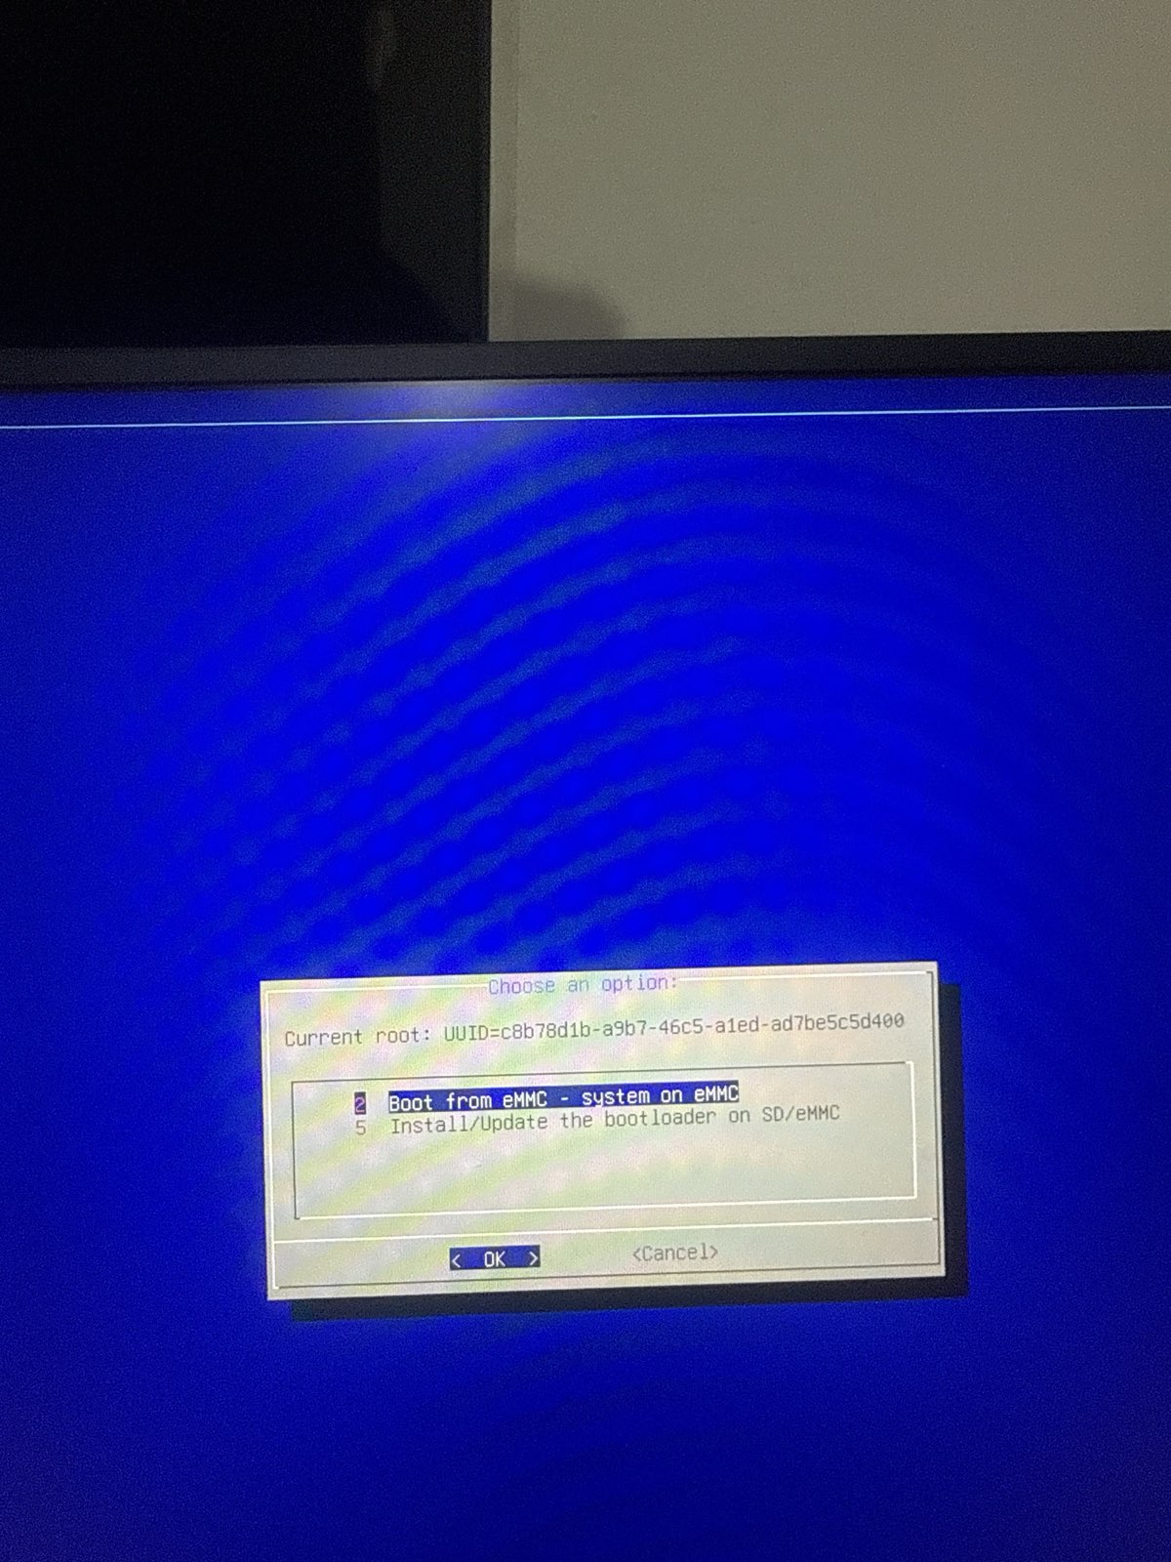
orangepi-config: Boot/Install menu example.
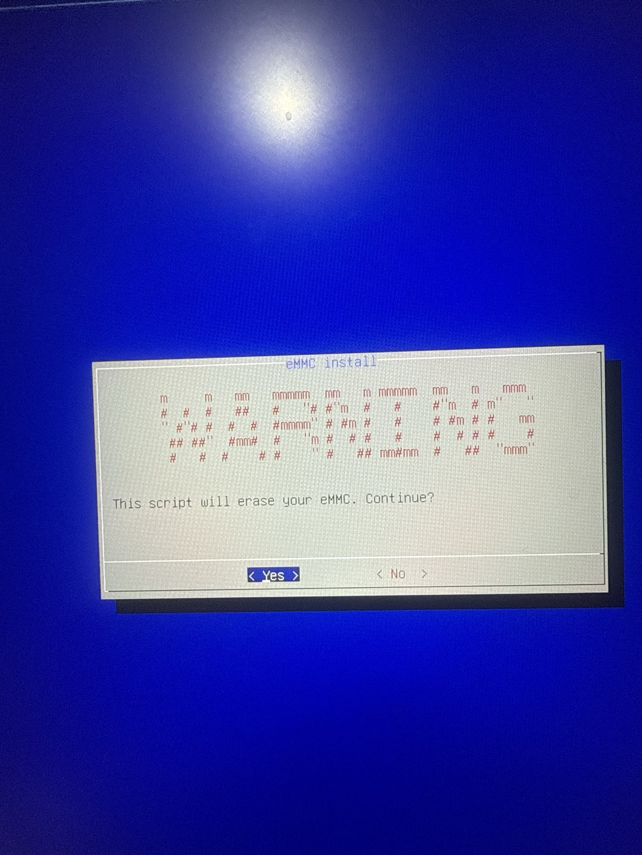
orangepi-config: eMMC install warning prompt.

