Project 1 - Traffic sign detection and classification
José Maçães  201806622  Afonso Caiado  201806789  Afonso Caiado  201806789 | Tomás Gonçalves  201806763  Visão por Computador – 2022

- Introduction
The main goal of the following project was to develop a program allowing the automatic detection of the different subsets of road signs available in Portugal.
This detection was done based on the identification of the signs’ shapes as well as colors: being red octagonals, red circles and blue rectangles. The development was done in python via Jupiter Notebook.

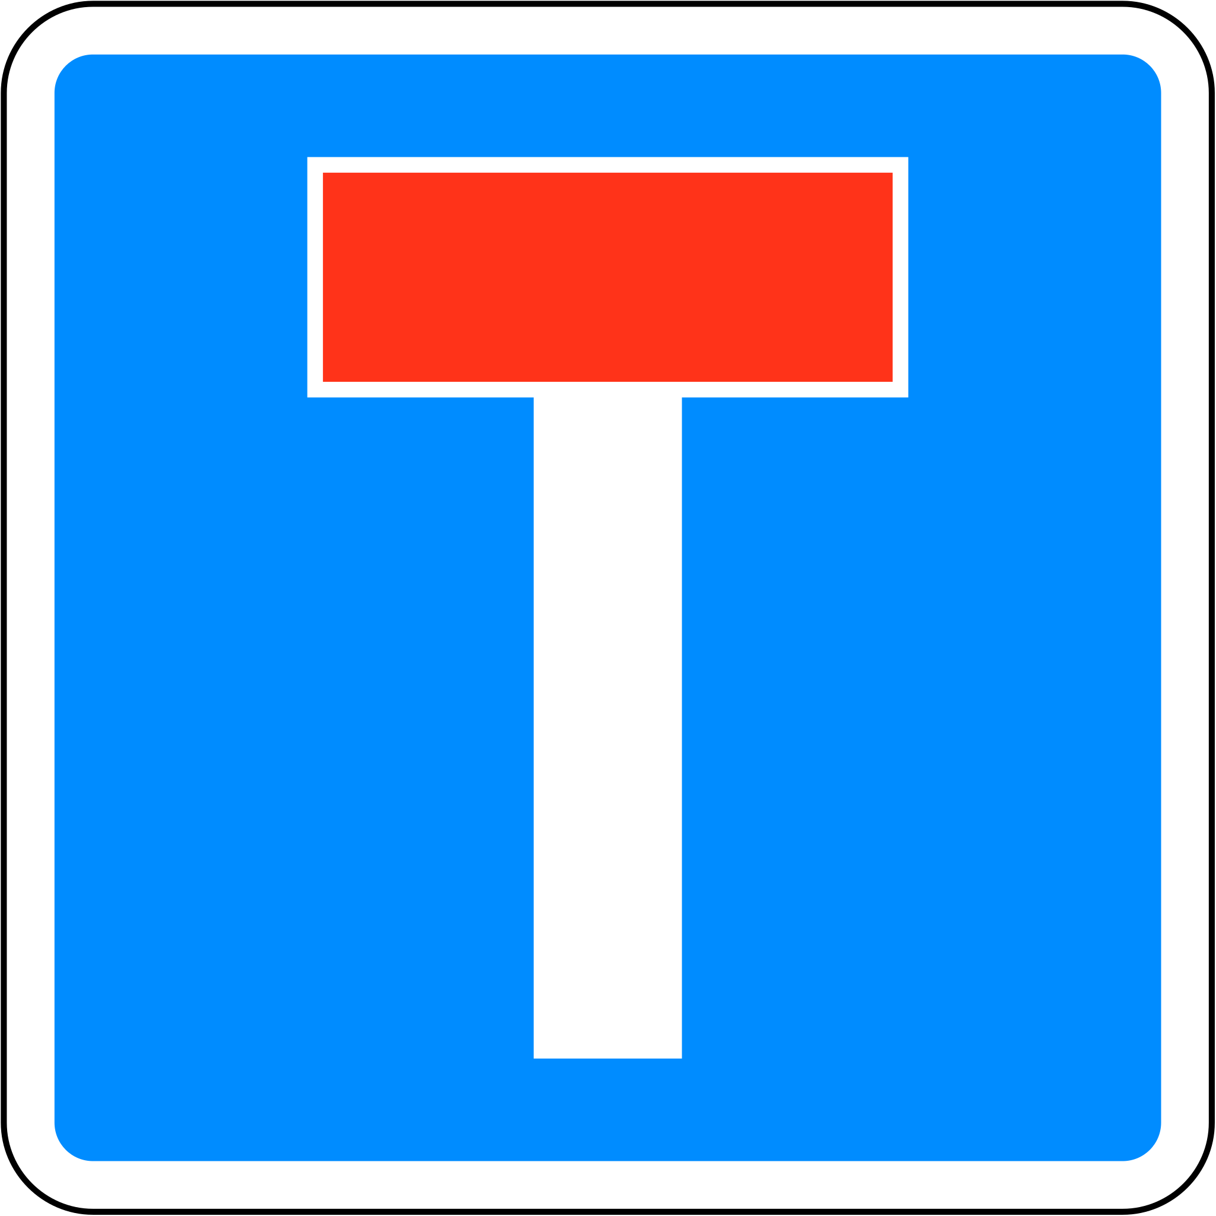

a) b) c)

- Approach
2.1 Image Pre-processing
The first step in our approach was to pre-process the image, in order to get rid of background noise and enhance the colors for our next steps.
(…)
2.2 Color Detection
Our next step consisted of doing Color Detection. Here, we isolated, colors belonging to intervals of both blue and red using color masks, since our studied road signs would consist of only colors belonging to these two groups.
(…)
2.3 Shape Detection
In this phase, we detected the shapes present in the images by finding the number of sides of the identified signs. By later combining the number of sides found and the color, we should be able to associate the image to one of the subset of signs.
(…)

- Success and improving points of current methods
- Performance
- Conclusion

