**E-Business Card**

* bifurcate : basic information, social, contact , education , experience. Etc

**Our Comments :** we will separate all the information to separate forms

* Dashboard : xls download options in reports and enquiry. bulk vcf download option in contacts

**Our Comments :** we will implement download options in report, enquiry, bulk vcf of contacts

* Below error in social links

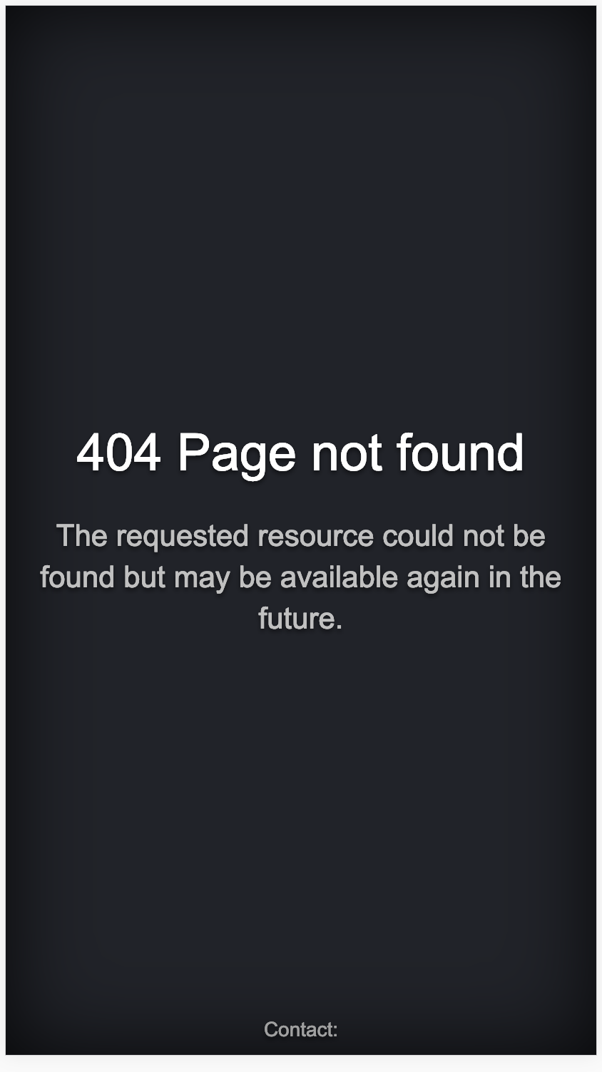

url comes : <https://dreamstech.co.in/www.facebook.com>

**Our Comments : we can fix it**

* Messahe for share link (Hi this is <Name > Please check my Awesome Profile : https://dreamstech.co.in/7c9918)

https://dreamstech.co.in/7c9918

<https://dreamstech.co.in>

**Our Comments :** we can analyze and let you know before fixing it

* images are stretched while uploading. instead give a ruler to crop image before adding. Quality of image also gets bad .

**Our Comments : We can include the cropping feature for profile and fix it.**

* in resume when deleting education getting error . but when we re-login it gets deleted

**Our Comments : We can fix it.**

* summary : separate Admin and every user .

**Our Comments :**

If it’s a subdomain concept like

**http://profile1.xyz.com ->** then we can change the current application to separate login systems

If it’s a url concept like

**http://**[**www.xyz.com/profile1**](http://www.xyz.com/profile1) **->** then we have to analyze and do rework and let you know before fixing it.

* keep single edit for for every content except showcase. keep showcase as it is

**Our Comments :**

1. So for showcase it should be a every item edit
2. For other items profile, social, education, experience etc.. it should be a single edit with “add such quick skip bar with icon in form”
3. Change existing design to below designs

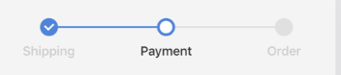

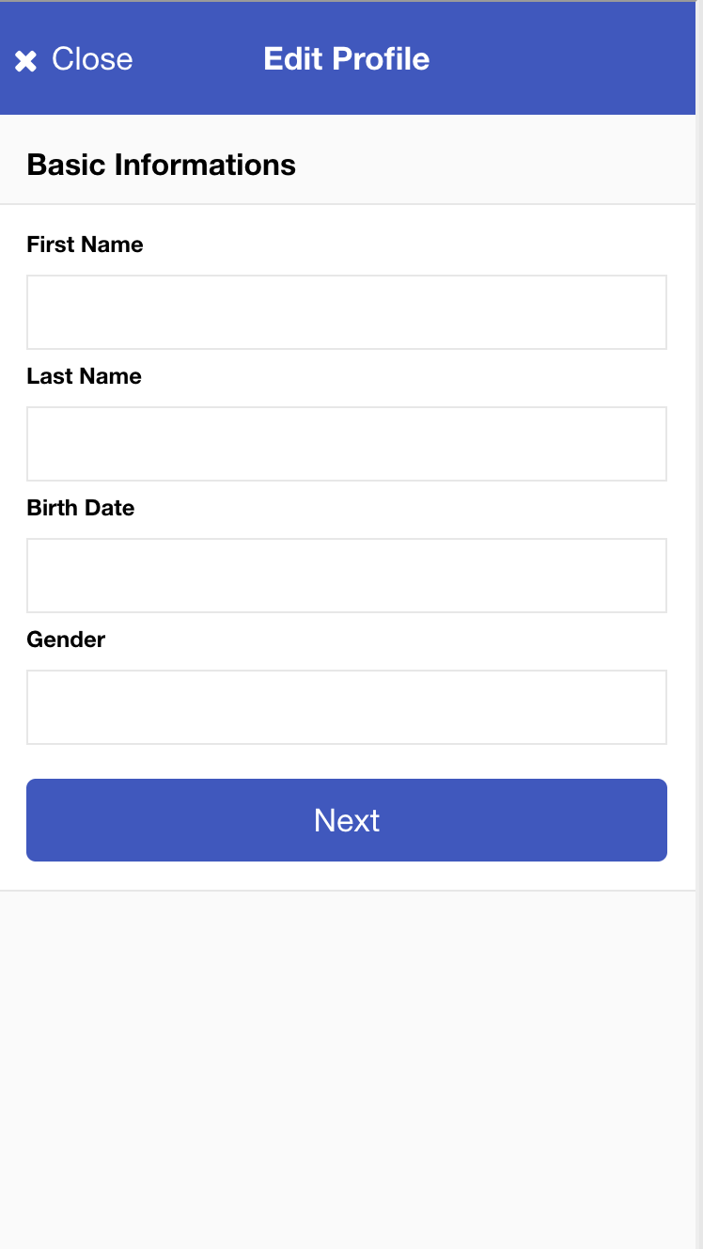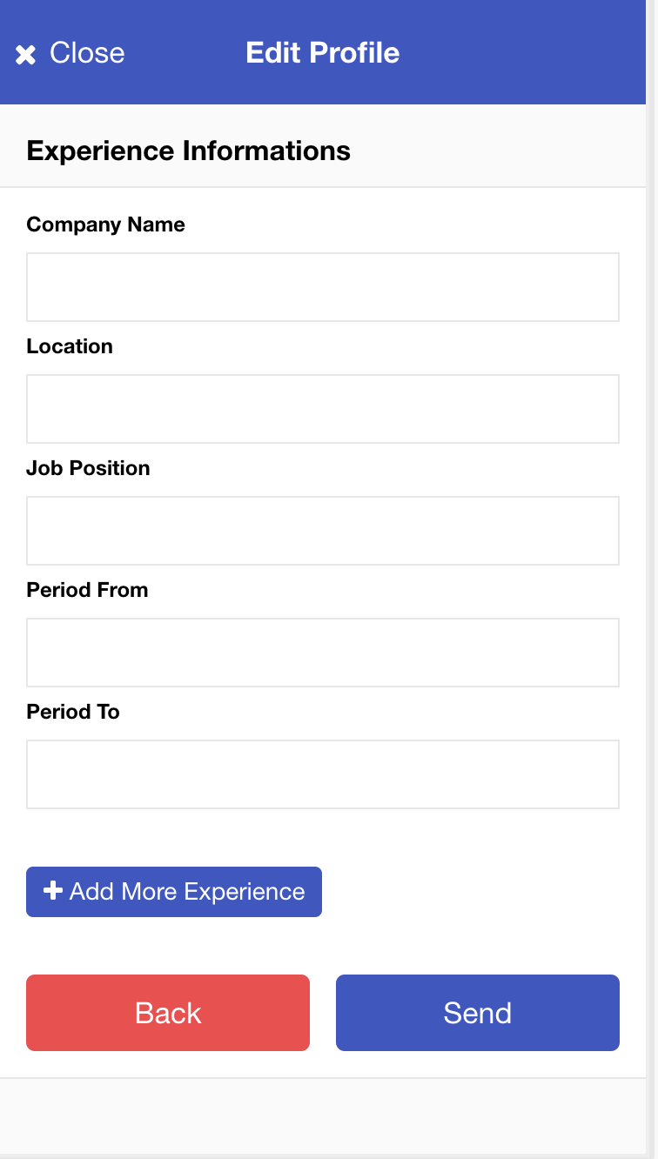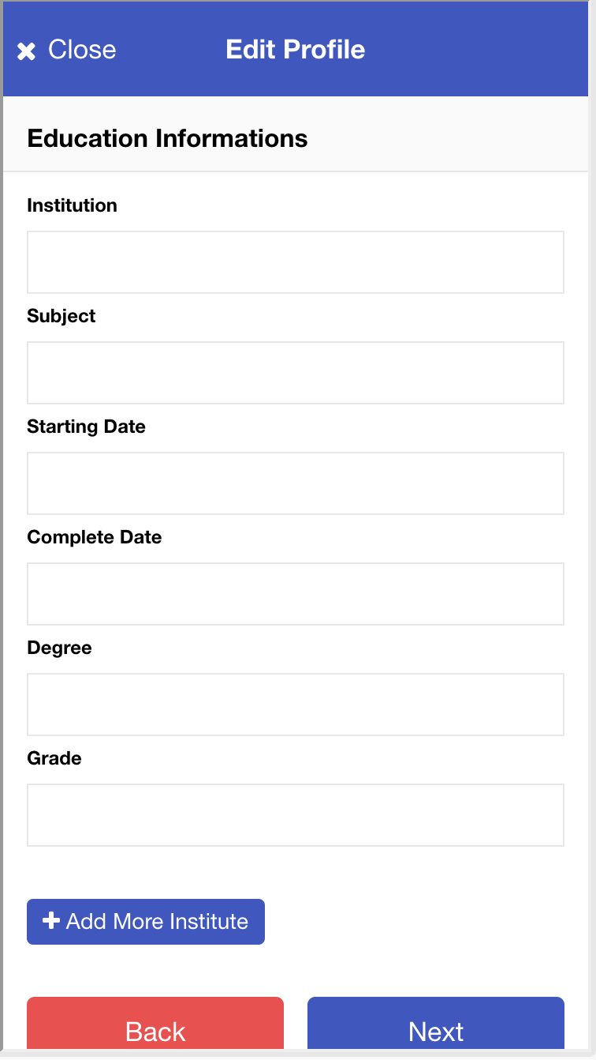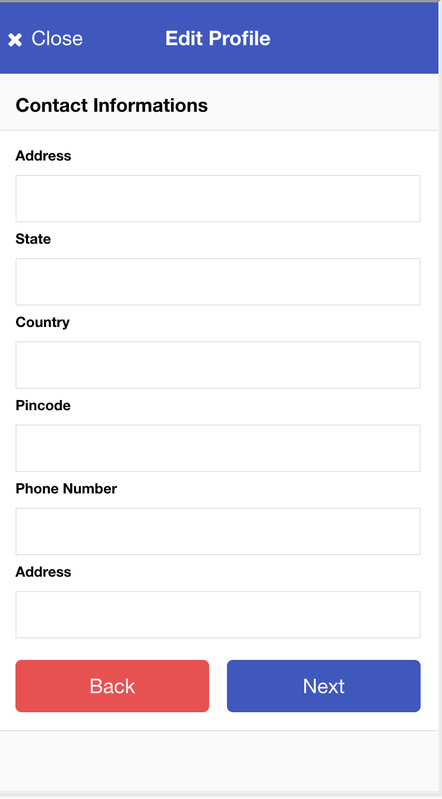

* change theme gradient 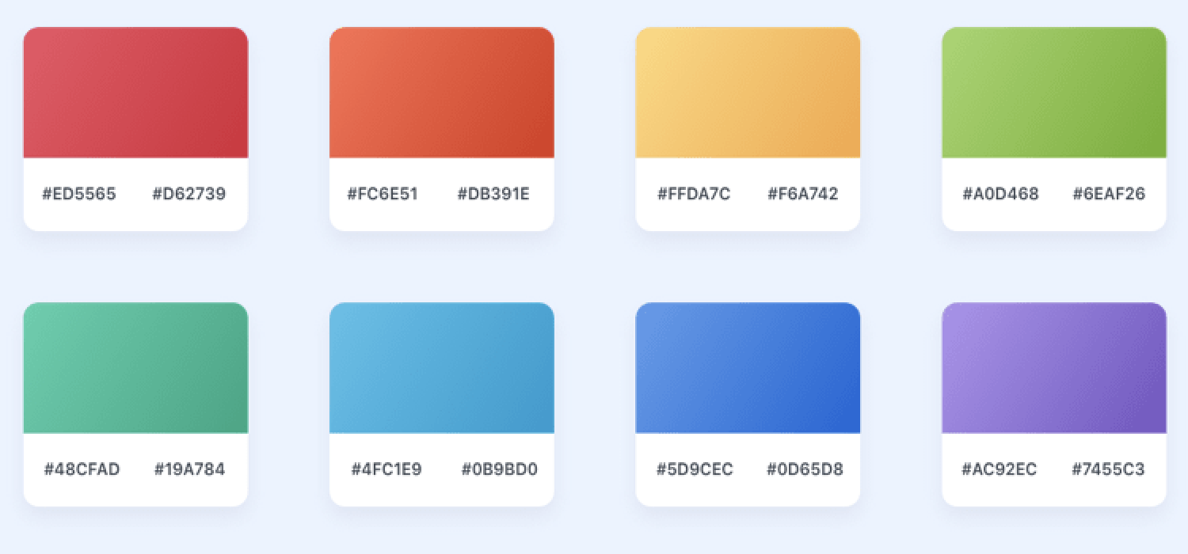

**Our Comments :** We will fix it up with the above mentioned gradient colors

* Complete remove navigation menu and icon, use close button wherever needed to come back. disable back page



**Our Comments :** So we have to remove three dots at right corner of only edit pages and add close button by removing back button

* Position icon as below sent images

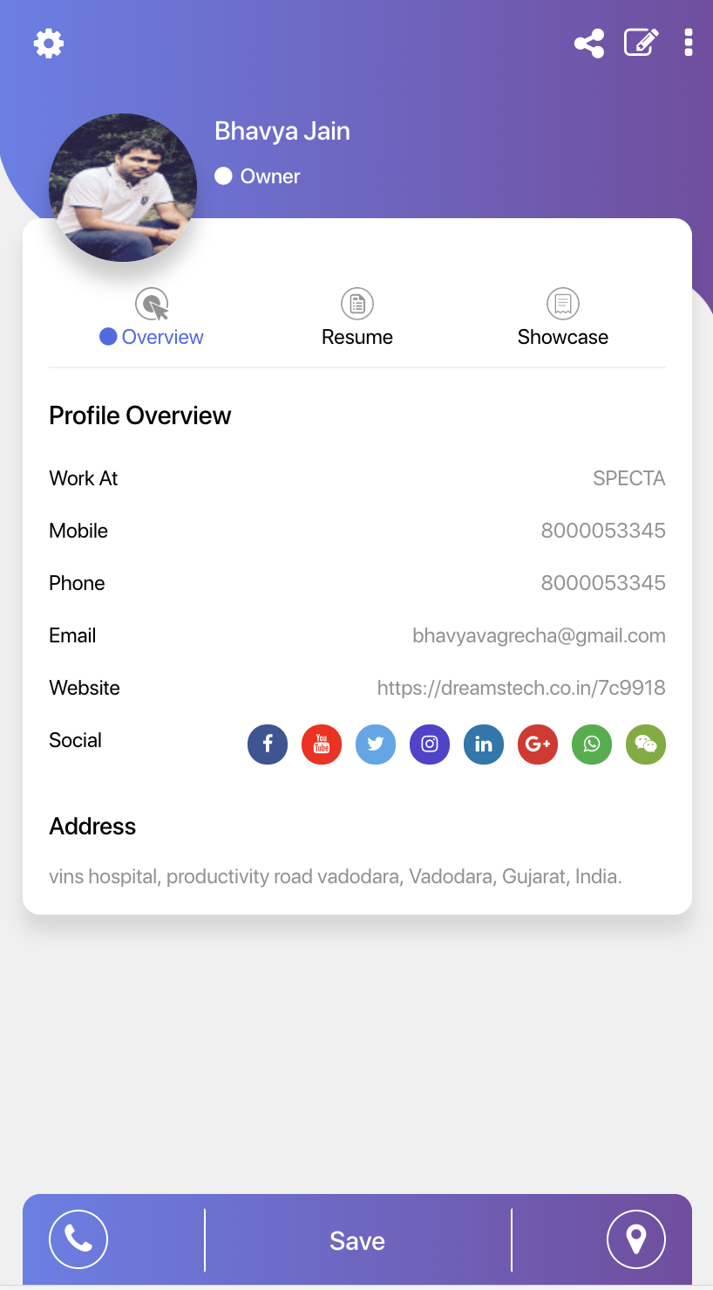

* remove showcase and resume from dashboard menu

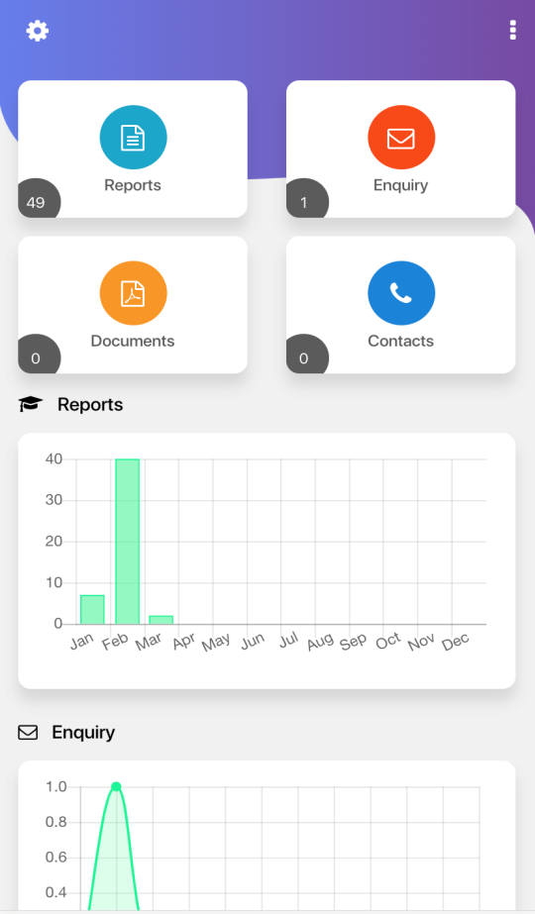

**Our Comments :** We will remove it from dashboard

* Search & filter option in enquiry and reports and contacts

**Our Comments :** We will implement the search and filter option of enquiry/reports/contacts pages

* in admin : need option to generate bulk qr code. remove limit of 5

**Our Comments :** We will fix it.

* download bulk qr code with excel sheets. with a filter of active , inactive and all

**Our Comments :** Already we implemented in such a way like if we are viewing all domains, after download you will get all active and inactive domains. if we are viewing only active domains, after download you will get only active domains.

* rectify 404, 500 etc kind of errors.

**Our Comments :** We will fix it up.

* change password is missing

**Our Comments :** We will implement it.

* while signup if user enters mobile number and dont enter otp . then it should be reset within few minutes

**Our Comments :** We will implement it.

* one mobile number can activate multiple accounts. if its a case then we have to give edit/delete option for QR code at admin side

**Our Comments :** This one we cannot implement it at this stage. Before kickstart the project we confirmed with you that one mobile number will have one domain.

* Theme is not working correctly in mobile devices

**Our Comments :** We will check and fix it up.